Supplementary Table 1. GSEA enrichment analysis results in hematological tumors

ID | setSize | enrichmentScore | NES | pvalue | p.adjust | qvalue
REACTOME_DOWNSTREAM_SIGNAL
ING_EVENTS_OF_B_CELL_RECEPT
OR_BCR | 81 | 0.526806998 | 2.303030476 | 4.28006E-08 | 8.46576E-07 | 4.70754E-07
BIOCARTA_MAPK_PATHWAY | 81 | 0.504290705 | 2.2045965 | 3.35165E-07 | 5.36265E-06 | 2.98199E-06
REACTOME_REGULATION_OF_RAS_
BY_GAPS | 68 | 0.475950303 | 2.026826418 | 2.01397E-05 | 0.000187208 | 0.0001041
REACTOME_PTEN_REGULATION | 139 | 0.447640885 | 2.025409993 | 2.28753E-08 | 4.82879E-07 | 2.68514E-07
REACTOME_SIGNALING_BY_HEDGE
HOG | 150 | 0.404013371 | 1.883343379 | 1.28992E-06 | 1.72355E-05 | 9.58409E-06
REACTOME_TRANSCRIPTIONAL_RE
GULATION_BY_RUNX1 | 237 | 0.3792509 | 1.859235666 | 3.31307E-09 | 8.76046E-08 | 4.87141E-08
REACTOME_SIGNALING_BY_WNT | 330 | 0.345474661 | 1.768049654 | 1.32716E-08 | 2.95505E-07 | 1.64321E-07
PID_MYC_ACTIVE_PATHWAY | 79 | 0.402520465 | 1.754330867 | 0.000708059 | 0.003585979 | 0.001994047
REACTOME_REGULATION_OF_TP53
_ACTIVITY | 160 | 0.345993332 | 1.630102769 | 8.29068E-05 | 0.000619827 | 0.000344666

Supplementary figure 1
DUSP23 expression in tumor and normal tissues in pan-cancer data of The Cancer Genome Atlas (TCGA) and GTEx. The blue box presented the results of normal tissues and the red box presented tumor tissues (*P < 0.05; **P < 0.01; ***P < 0.001).

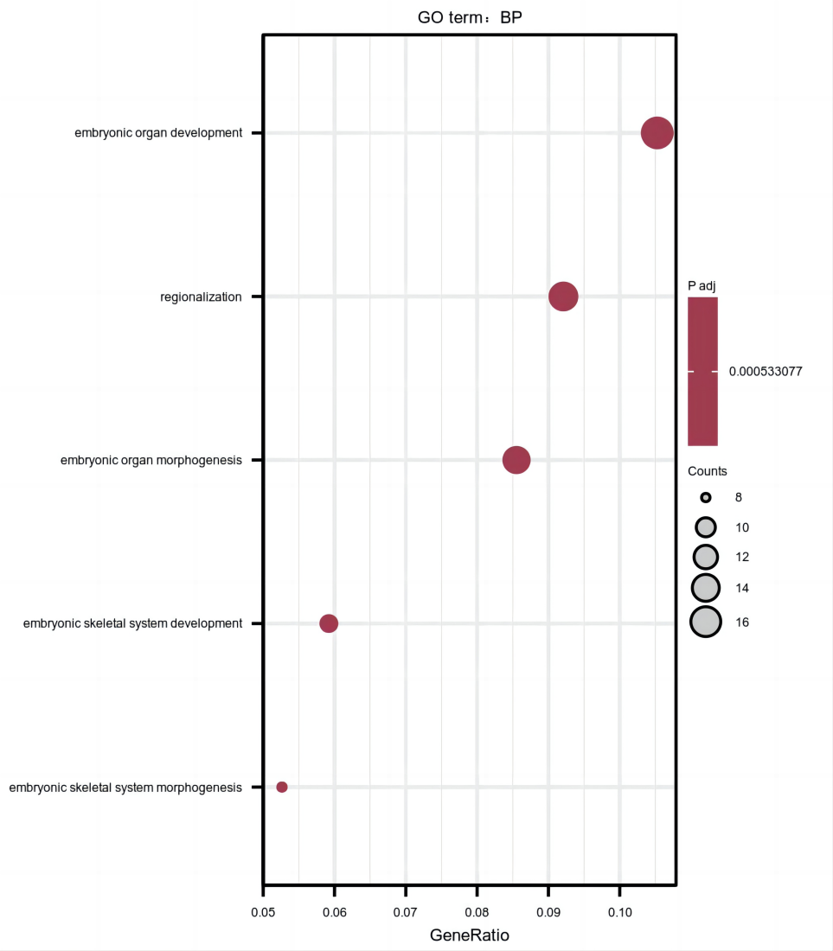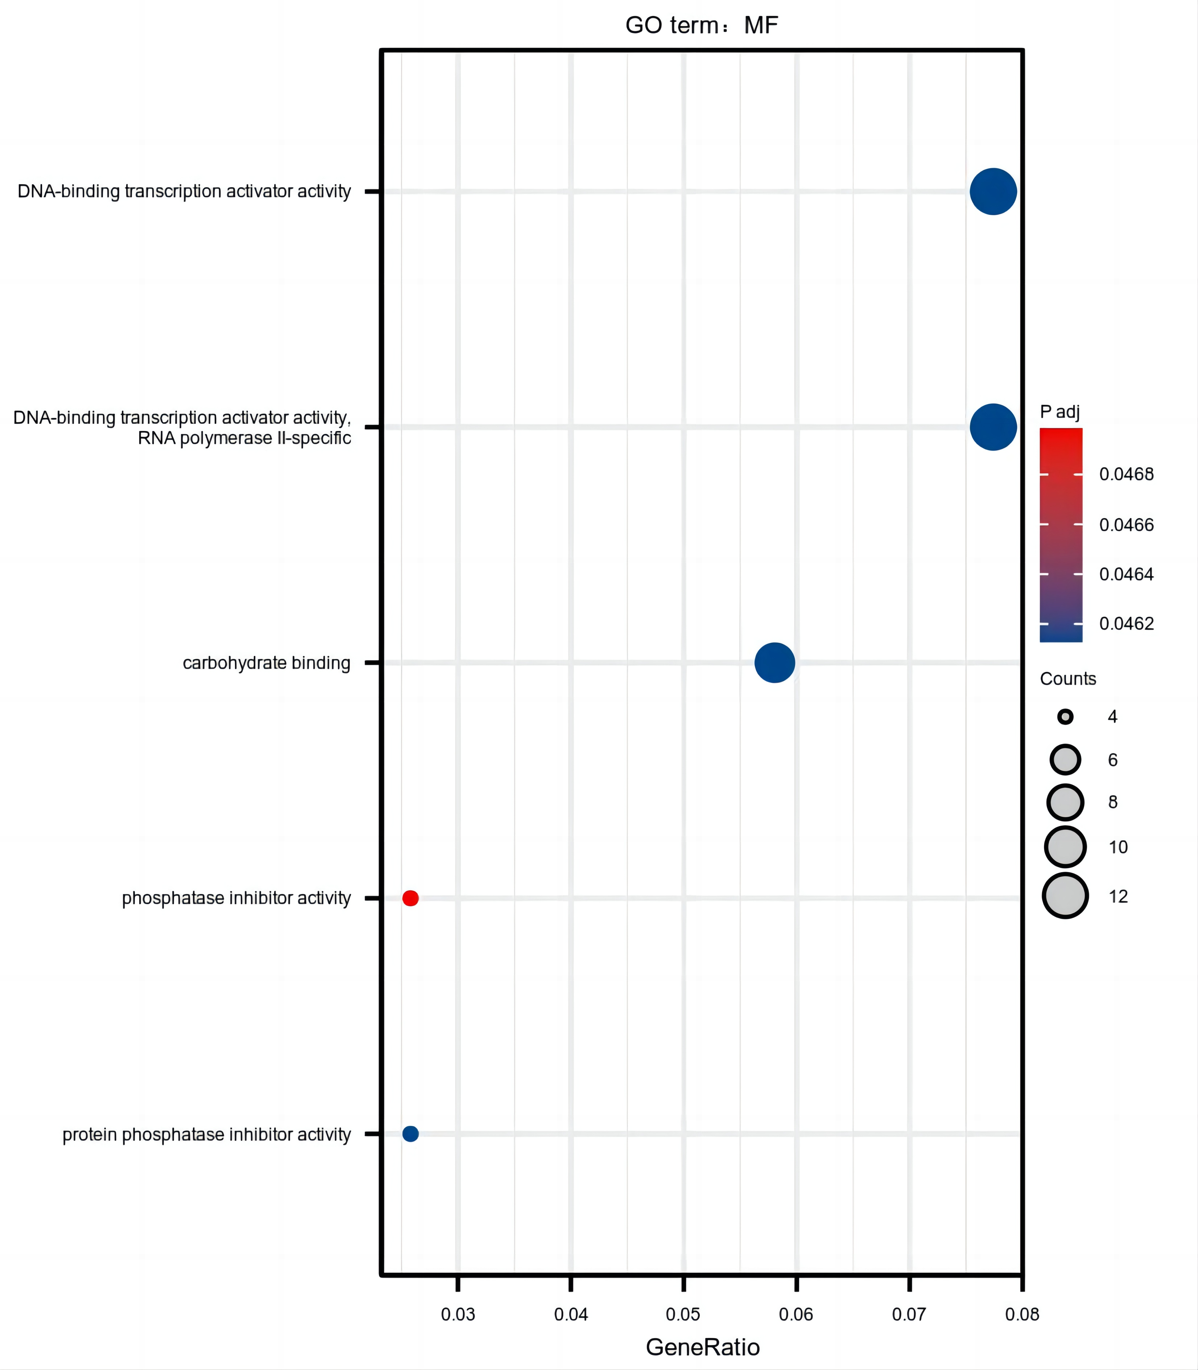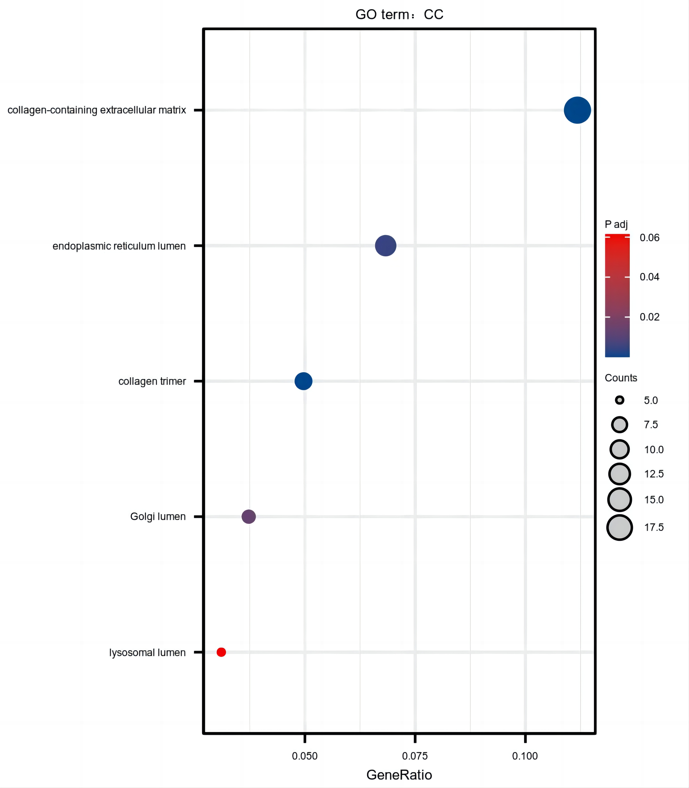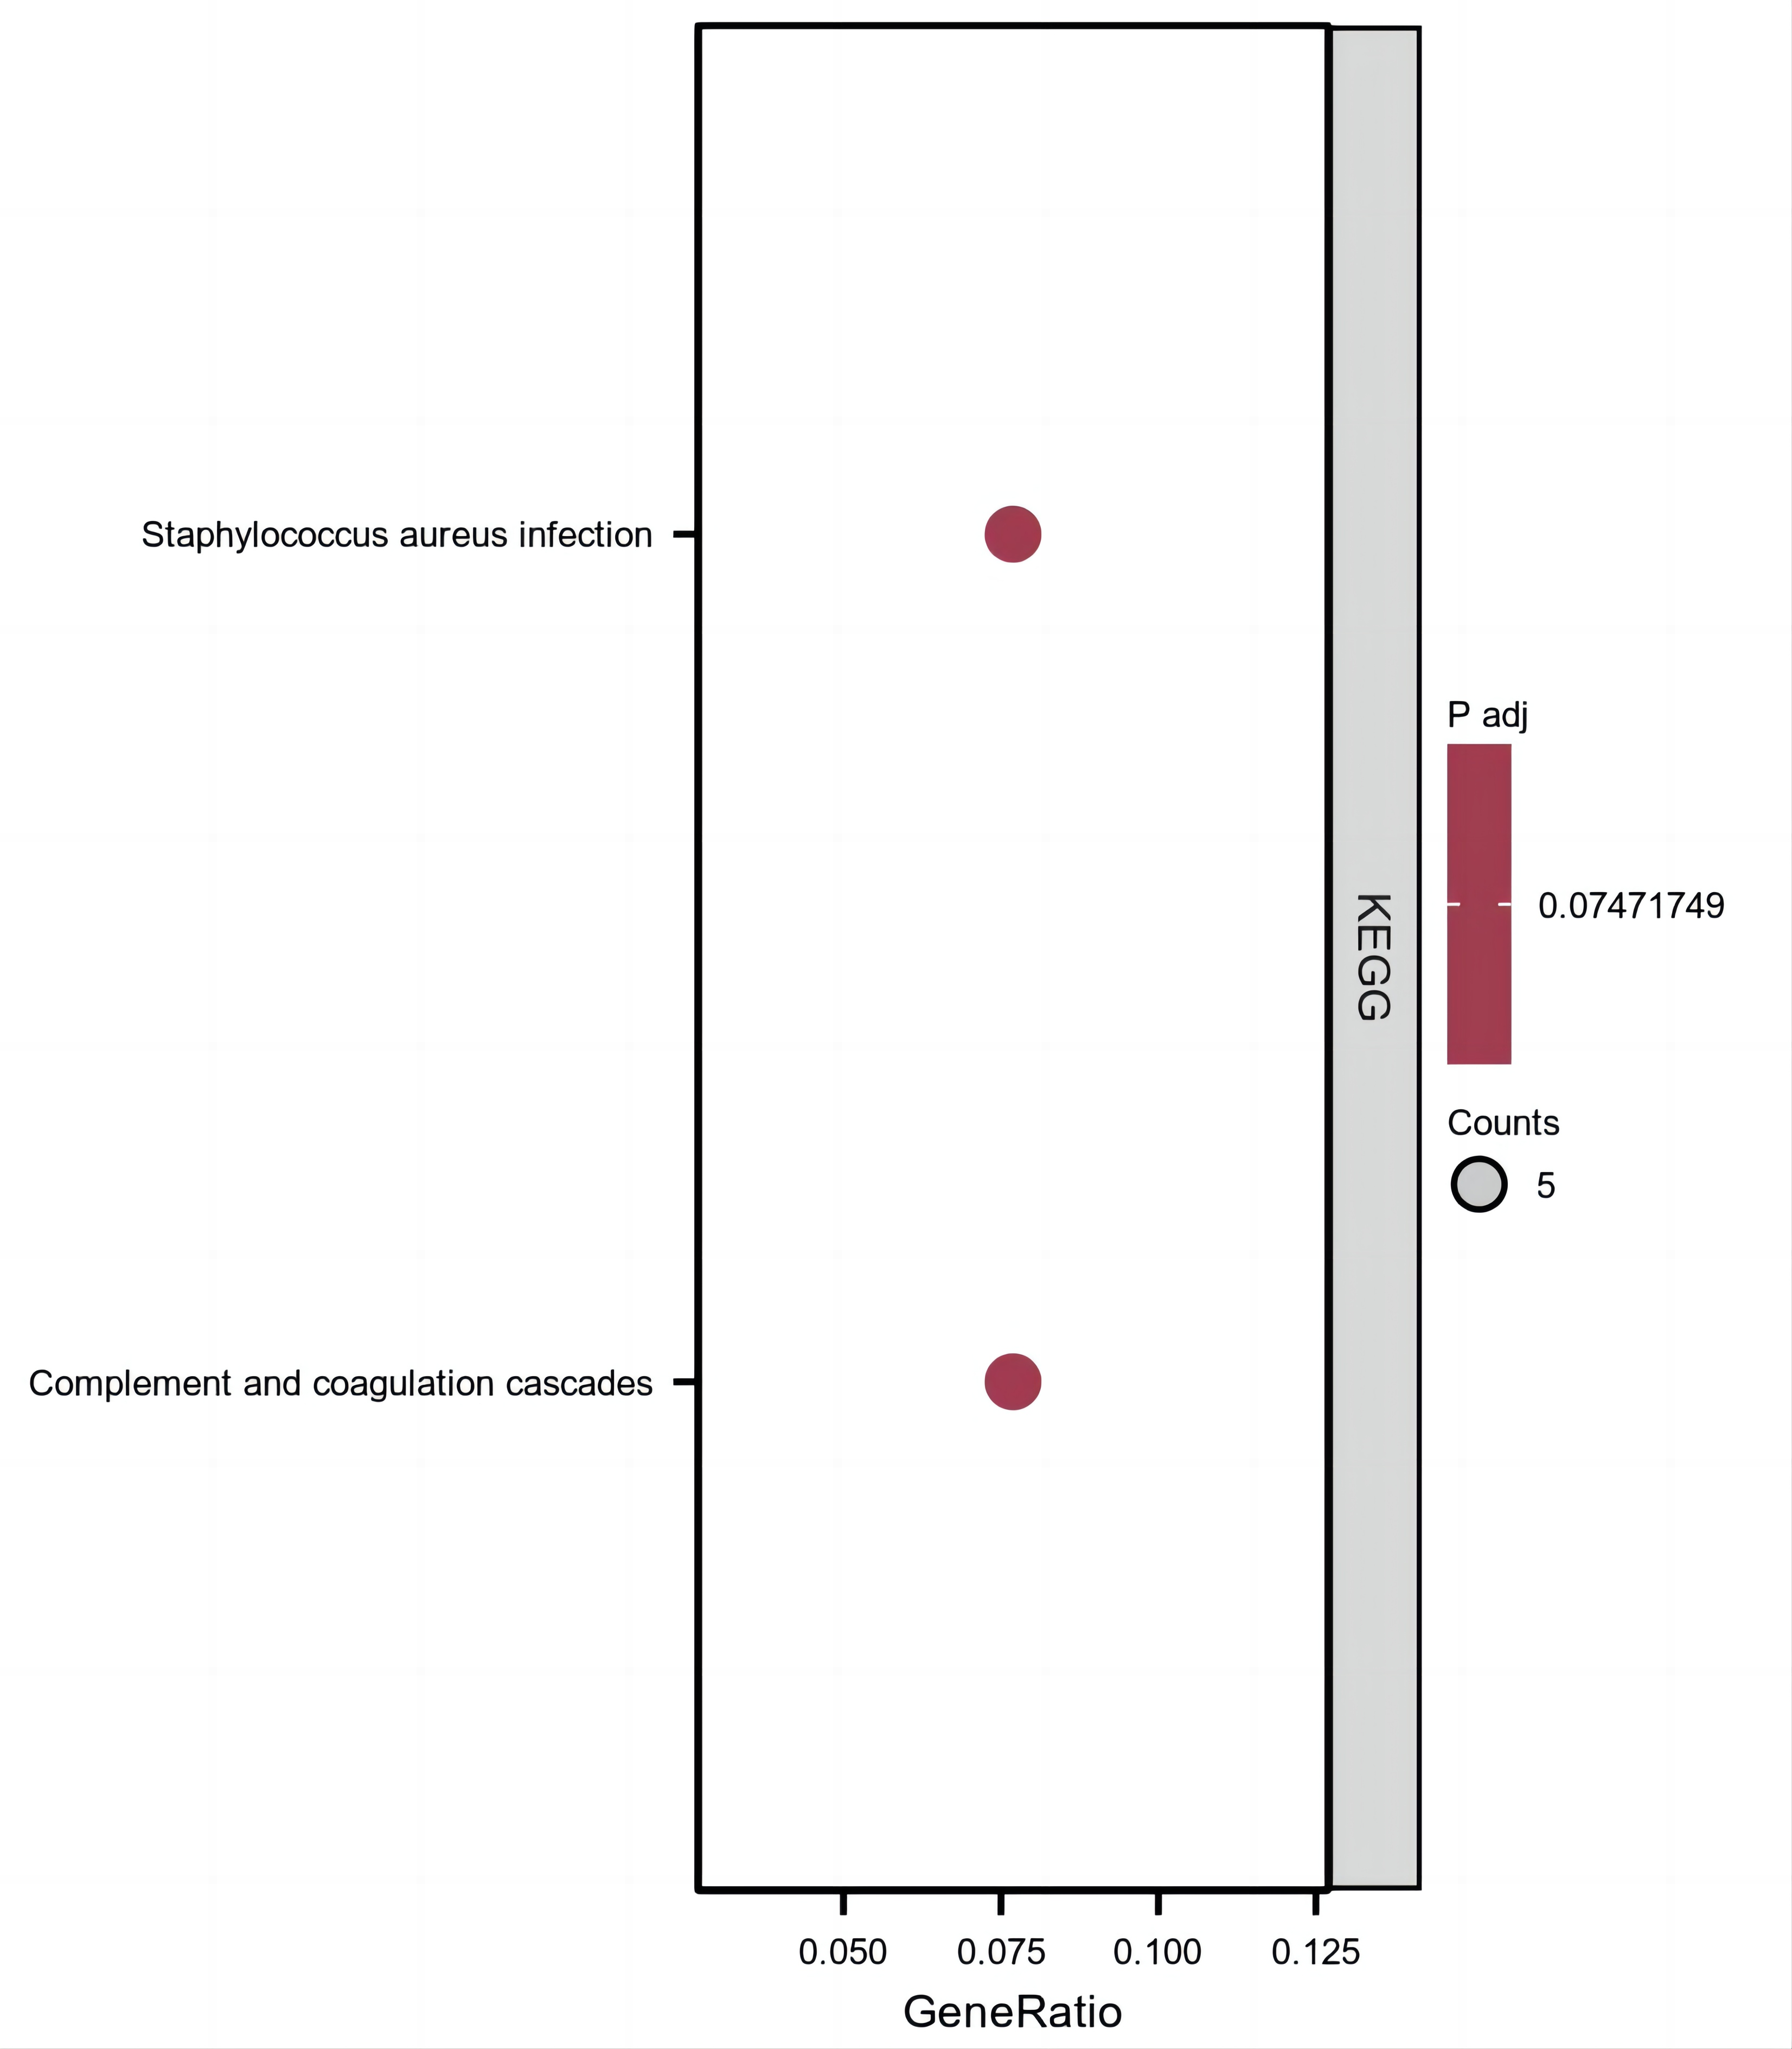
A B C D

Supplementary figure 2
(A)biological process (BP);(B) molecular functions (MF);(C) cellular components (CC);(D) KEGG pathways of DUSP23-related DEGs. Each red plot in the graph represents a specific gene included in the gene-set. Each blue plot represents the enriched gene-sets. The size of the blue plot represents the number of gene read counts in the gene-sets.

