Supplementary Figures
Supplementary Figure 1: Patient Disposition For The 6-month Follow-up Cohort 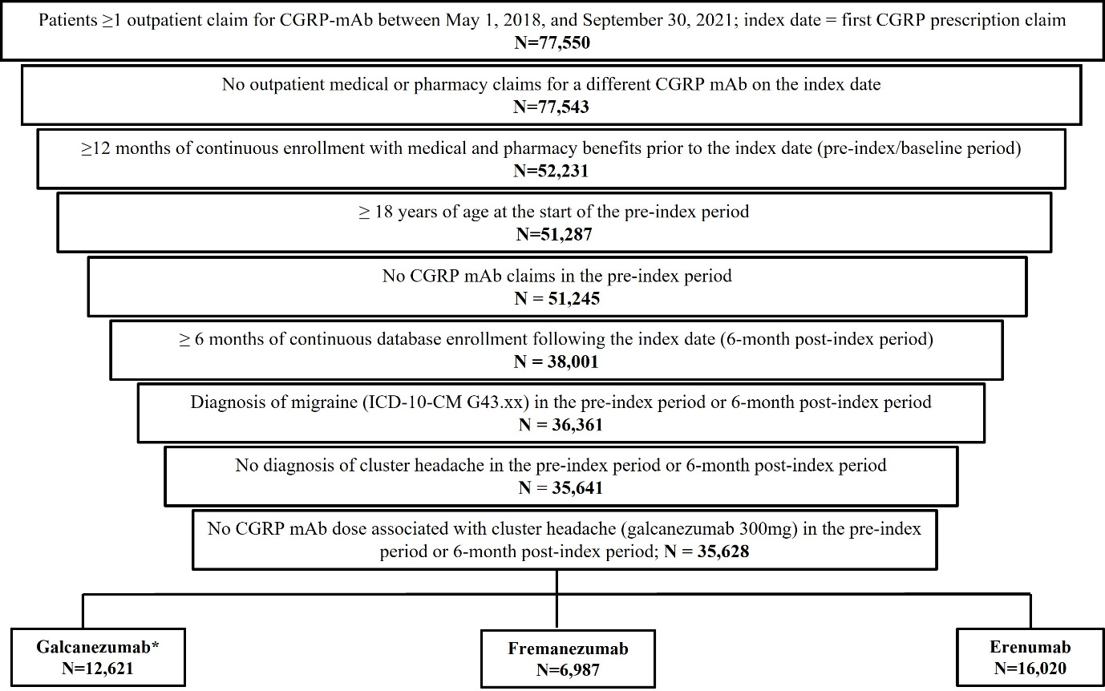
*Reference Cohort.

Supplementary Figure 2: Proportion of Patients That Remain Persistent to Index Drug During 6-month Follow-up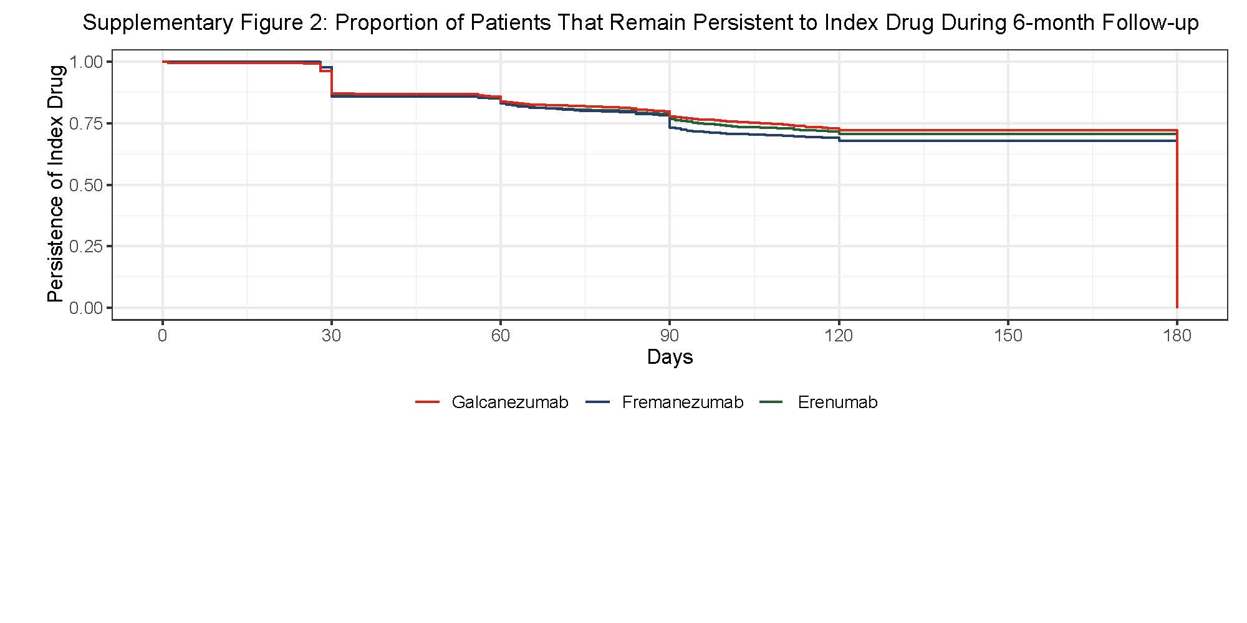

Supplementary Figure 3: Common Therapies Switched To Over the 6-Month Follow-Up Period Post-matching *#
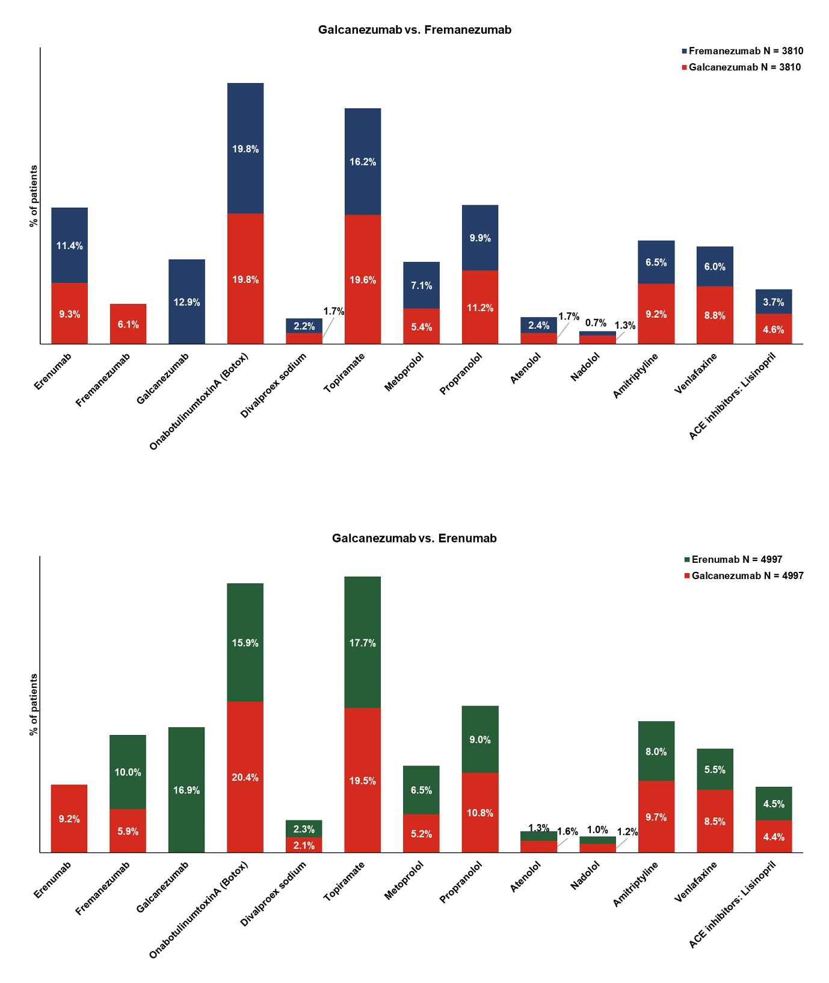
*For non-CGRP preventive therapies, drug classes with ≤3 patients were not presented in the graph. These include Eptinezumab, Divalproex sodium, Sodium valproate, Metoprolol, Propranolol, Atenolol, Amitriptyline, Venlafaxine, ACE inhibitors: Lisinopril.# Drugs classes were classified as follows: CGRP mAbs (Erenumab, Fremanezumab, Galcanezumab, Eptinezumab) and Non-CGRP mAb Migraine Treatment: Angiotensin receptor blockers (Candesartan); Antiepileptic drugs (Divalproex sodium, Sodium valproate, Topiramate); Beta-blockers (Metoprolol, Propranolol, Timolol, Atenolol, Nadolol); Antidepressants (Amitriptyline, Venlafaxine) and NMDA receptor antagonists (Memantine)

Supplementary Tables
Supplementary Table 1: List of Baseline and Follow-up Acute And Preventative Migraine Treatments
American Headache Society (AHS) Consensus Acute Migraine Treatments ¹⁶
Established efficacy
Triptans*
Ergotamine derivatives
Gepants (ubrogepant rimegepant, atogepant)
Lasmiditan
NSAIDs# (aspirin, celecoxib, diclofenac, ibuprofen, naproxen)
Non-opioid analgesics and combinations (eg. acetaminophen + aspirin + caffeine)
Probably effective
Ergotamine/other forms of dihydroergotamine
NSAIDs# (flurbiprofen, ketoprofen, and ketorolac intra-venous and intra-muscular)
Antiemetics (chlorpromazine, droperidol, metoclopramide, prochlorperazine, promethazine)
IV Magnesium
Isometheptene-containing compounds
Additional acute treatments^ ^{17,18}
Opioids ¹⁰
Barbiturates (eg. butalbital and combinations)
AHS Consensus Preventative Migraine Treatments
Established efficacy
Candesartan
OnabotulinumtoxinA (botox)
Antiepileptic drugs (divalproex sodium, sodium valproate, topiramate)
Beta-blockers (metoprolol, propranolol, timolol)
Probably effective
Antidepressants (amitriptyline, venlafaxine)
Memantine
Lisinopril
Beta-blockers (atenolol, nadolol)
*Includes triptans as well as triptan combinations (e.g. triptan/naproxen sodium); # Only prescription NSAIDs are reflected in claims; this study will not be able to assess over the counter NSAID use; ^Although these drug classes are not listed medications with evidence of efficacy as acute or preventative migraine treatments, they were included to capture real world prescribing patterns. These drug classes were also examined in the acute medication overuse variable. Further, opioids were included as an acute treatment with established efficacy in the AHS Consensus recommendations and guidelines published in 2019, which is within the study period of this study.¹⁰

Supplementary Table 2: Patient Demographics and Baseline Clinical Characteristics For The 6-month Follow-up Cohort: Galcanezumab versus Fremanezumab
 | Pre-Matching |  |  | Post-Matching
 | Galcanezumab | Fremanezumab | Standard Difference^{b} | Galcanezumab | Fremanezumab | Standard Difference
 | N=12,621 | N=6,987 | Standard Difference^{b} | N=3,810 | N=3,810 | Standard Difference
Demographic characteristicsª
Age, years (Mean, SD) | 43.7±11.5 | 44.2±11.4 | 4.39 | 43.9±10.0 | 44.0±11.4 | 0.16
Female (N, %) | 11,052, 87.6% | 6,129, 87.7% | 0.46  0.46 | 3,298, 86.6% | 3,298, 86.6% | 0.00  0.00
Geographic region (N, %)
Northeast | 1,170, 9.3 | 770, 11.0% | 5.80 | 389, 10.2% | 359, 9.4% | 2.65
North Central | 2,893, 22.9% | 1,167, 16.7% | 15.65 | 795, 20.9% | 674, 17.7% | 8.02
South | 7,064, 56.0% | 4,134, 59.2% | 6.47 | 2,136, 56.1% | 2,263, 59.4% | 6.75
West | 1,475, 11.7% | 911, 13.0% | 4.11 | 479, 12.6% | 512, 13.4% | 2.58
Unknown | 19, 0.2% | 5, 0.1% | 2.37 | 12, 0.3% | 2, 0.1% | 5.93
Insurance plan type (N, %)
Comprehensive/indemnity | 394, 3.1% | 223, 3.2% | 0.40 | 123, 3.2% | 120, 3.2% | 0.37
EPO/PPO | 6,407, 50.8% | 3,724, 53.3% | 5.07 | 1,886, 49.5% | 2,011, 52.8% | 6.59
POS/POS with capitation | 655, 5.2% | 414, 5.9% | 3.21 | 197, 5.2% | 192, 5.0% | 0.60
HMO | 1,736, 13.8% | 802, 11.5% | 6.86 | 532, 14.0% | 464, 12.2% | 5.30
CDHP/HDHP | 3,265, 25.9% | 1,752, 25.1% | 1.82 | 1,034, 27.1% | 979, 25.7% | 3.25
Other/Unknown | 164, 1.3% | 72, 1.0% | 2.51 | 40, 1.0% | 44, 1.2% | 1.13
Index year (N, %)
2018 | 486, 3.9% | 679, 9.7% | 23.49 | 243, 6.4% | 308, 8.1% | 6.59
2019 | 6,242, 49.5% | 3,588, 51.4% | 3.79 | 1,920, 50.4% | 1,780, 46.7% | 7.33
2020 | 4,822, 38.2% | 2,080, 29.8% | 17.88 | 1,327, 34.8% | 1,352, 35.5% | 1.37
2021 | 1,071, 8.5% | 640, 9.2% | 2.38 | 321, 8.4% | 370, 9.7% | 4.53  4.53
Clinical characteristics^{c}
Deyo- Charlson Comorbidity Index (DCI) (Mean, SD) | 0.6±1.1 | 0.6±1.1 | 2.04  2.04 | 0.6±1.0 | 0.6±1.1 | 2.24
Clinical conditions (N, %)
Anxiety | 4,459, 35.3% | 2,497, 35.7% | 0.85  0.85 | 1,314, 34.5% | 1,397, 36.7% | 4.55  4.551.31
Depression | 3,617, 28.7% | 1,974, 28.3% | 0.90  0.90 | 1,094, 28.7% | 1,071, 28.1% | 1.31
Hypertension | 3,132, 24.8% | 1,823, 26.1% | 2.93  2.93 | 957, 25.1% | 1,029, 27.0% | 4.31
Sleep disorders | 3,688, 29.2% | 2,118, 30.3% | 2.39  2.39 | 1,108, 29.1% | 1,149, 30.2% | 2.39
Sinusitis | 3,377, 26.8% | 1,893, 27.1% | 0.76  0.76 | 1,014, 26.6% | 1,050, 27.6% | 2.16
Gastroesophageal reflux disease (GERD) | 2,630, 20.8% | 1,452, 20.8% | 0.14  0.14 | 751, 19.7% | 741, 19.5% | 0.66  0.66

CDHP: Consumer-driven health plan; EPO: Exclusive provider organization; HDHP: High deductible health plan; HMO: Health maintenance organization; POS: Point of service; PPO: Preferred provider organization; SD: Standard deviation.ªDemographic characteristics were measured on the index date; ^{b}Standardized differences were multiplied by 100; thus, standardized differences >10 indicate imbalances between cohorts, ^{c} Clinical characteristics were measured during the 12-month pre-index period.
Supplementary Table 3: Patient Demographics and Baseline Clinical Characteristics For The 6-month Follow-up Cohort: Galcanezumab versus Erenumab
 | Pre-Matching |  |  | Post-Matching
 | Galcanezumab | Erenumab | Standard Differenc^{b} | Galcanezumab | Erenumab | Standard Difference
 | N=12,621 | N=16,020 | Standard Differenc^{b} | N=4,997 | N=4,997 | Standard Difference
Demographic characteristicsª
Age, years (Mean, SD) | 43.7±11.5 | 44.4±11.5 | 6.45 | 44.0±11.5 | 44.0±11.6 | 0.32  0.32
Female (N, %) | 11,052, 87.6% | 13,867, 86.6% | 3.00  3.00 | 4,290, 85.9% | 4,290, 85.9% | 0.00  0.00
Geographic region (N, %)
Northeast | 1,170, 9.3 | 1,740, 10.9% | 5.29 | 520, 10.4% | 481, 9.6% | 2.60
North Central | 2,893, 22.9% | 3,672, 22.9% | 0.00 | 1,067, 21.4% | 958, 19.2% | 5.43
South | 7,064, 56.0% | 8,561, 53.4% | 5.09 | 2,746, 55.0% | 2,904, 58.1% | 6.38
West | 1,475, 11.7% | 2,020, 12.6% | 2.82 | 651, 13.0% | 643, 12.9% | 0.48
Unknown | 19, 0.2% | 27, 0.2% | 0.45 | 13, 0.3% | 11, 0.2% | 0.82
Insurance plan type (N, %)
Comprehensive/indemnity | 394, 3.1% | 453, 2.8% | 1.73 | 157, 3.1% | 129, 2.6% | 3.36
EPO/PPO | 6,407, 50.8% | 8,644, 54.0% | 6.40 | 2,497, 50.0% | 2,692, 53.9% | 7.82
POS/POS with capitation | 655, 5.2% | 989, 6.2% | 4.25 | 260, 5.2% | 273, 5.5% | 1.16
HMO | 1,736, 13.8% | 2,043, 12.8% | 2.96 | 689, 13.8% | 647, 13.0% | 2.47
CDHP/HDHP | 3,265, 25.9% | 3,657,22.8% | 7.09 | 1,341, 26.8% | 1,195, 23.9% | 6.72
Other/Unknown | 164, 1.3% | 234, 1.5% | 1.38 | 53, 1.1% | 61, 1.2% | 1.51
Index year (N, %)
2018 | 486, 3.9% | 3,896, 24.3% | 61.57 | 328, 6.6% | 512, 10.3% | 13.30
2019 | 6,242, 49.5% | 5,276, 32.9% | 34.05 | 2,448, 49.0% | 2,143, 42.9% | 12.27
2020 | 4,822, 38.2% | 5,686, 35.5% | 5.63 | 1,795, 35.9% | 1,939, 38.8% | 5.96
2021 | 1,071, 8.5% | 1,162, 7.3% | 4.58 | 426, 8.5% | 403, 8.1% | 1.67
Clinical characteristics^{c}
Deyo- Charlson Comorbidity Index (DCI) (Mean, SD) | 0.6±1.1 | 0.6±1.2 | 1.52  1.52 | 0.6±1.2 | 0.6±1.1 | 1.69  1.69
Clinical conditions (N, %)
Anxiety | 4,459, 35.3% | 5,599, 35.0% | 0.80  0. | 1,742, 34.9% | 1,735, 34.7% | 0.29  0.29
Depression | 3,617, 28.7% | 4,565, 28.5% | 0.36  0.363 | 1,433, 28.7% | 1,415, 28.3% | 0.80  0.80
Hypertension | 3,132, 24.8% | 4,089, 25.5% | 1.63  1.63 | 1,262, 25.3% | 1,292, 25.9% | 1.38  1.38
Sleep disorders | 3,688, 29.2% | 4,693, 29.3% | 0.16  0.16 | 1,478, 29.6% | 1,496, 29.9% | 0.79  0.79
Sinusitis | 3,377, 26.8% | 4,044, 25.2% | 3.45  3.45 | 1,326, 26.5% | 1,275, 25.5% | 2.33  2.33
Gastroesophageal reflux disease (GERD) | 2,630, 20.8% | 3,195, 19.9% | 2.22  2.22 | 983, 19.7% | 1,030, 20.6% | 2.35  2.35

CDHP: Consumer-driven health plan; EPO: Exclusive provider organization; HDHP: High deductible health plan; HMO: Health maintenance organization; POS: Point of service; PPO: Preferred provider organization; SD: Standard deviation.ªDemographic characteristics were measured on the index date; ^{b}Standardized differences were multiplied by 100; thus, standardized differences >10 indicate imbalances between cohorts,^{c} Clinical characteristics were measured during the 12-month pre-index period.

Supplementary Table 4: Medications Used During 6-month Baseline And Follow-up Period
 | 6-month baseline |  |  |  |  |  | 6-month follow-up
 | Galcanezumab  N=3,810 | Fremanezumab  N=3,810 | Fremanezumab vs Galcanezumab p-Value | Galcanezumab  N=4,997 | Erenumab,  N=4,997 | Erenumab vs Galcanezumab  p-Value | Galcanezumab  N=3,810 | Fremanezumab  N=3,810 | Fremanezumab vs Galcanezumab  p-Value | Galcanezumab  N=4,997 | Erenumab,  N=4,997 | Erenumab vs Galcanezumab  p-Value
Any acute migraine treatment newly initiated (N, %)
Established efficacy
Triptans | 2,581, 67.7% | 2,582, 67.8% | 0.971 | 3,387, 67.8% | 3,324, 66.5% | 0.180 | 1,936, 50.8% | 1,952, 51.2% | 0.714 | 2,553, 51.1% | 2,560, 51.2% | 0.889
Ergotamine derivatives | 4, 0.1% | 14, 0.4% | 0.012 | 6, 0.1% | 14, 0.3% | 0.073 | 5, 0.1% | 5, 0.1% | - | 6, 0.1% | 9, 0.2% | 0.438
Gepantsª | 120, 3.1% | 159, 4.2% | 0.016 | 164, 3.3% | 138, 2.8% | 0.129 | 271, 7.1% | 375, 9.8% | <0.001 | 370, 7.4% | 348, 7.0% | 0.394
Lasmiditan | 6, 0.2% | 5, 0.1% | 0.763 | 8, 0.2% | 1, 0.0% | 0.039 | 16, 0.4% | 13, 0.3% | 0.639 | 20, 0.4% | 8, 0.2% | 0.023
Non-opioid analgesics and combinations^{b} | 2,318, 60.8% | 2,362, 62.0% | 0.295 | 3,018, 60.4% | 3,107, 62.2% | 0.068 | 1,618, 42.5% | 1,633, 42.9% | 0.728 | 2,101, 42.1% | 2,157, 43.2% | 0.257
NSAIDs | 1,947, 51.1% | 1,945, 51.1% | 0.973 | 2,534, 50.7% | 2,531, 50.7% | 0.952 | 1,216, 31.9% | 1,239, 32.5% | 0.565 | 1,576, 31.5% | 1,614, 32.3% | 0.415
Isometheptene-containing compounds | 13, 0.3% | 10, 0.3% | 0.531 | 16, 0.3% | 17, 0.3% | 0.862 | 1, 0.0% | 0, 0.0% | 1.000 | 1, 0.0% | 4, 0.1% | 0.375
Barbiturates (butalibtal-containing combinations#,* | 657, 17.2% | 698, 18.3% | 0.214 | 861, 17.2% | 896, 17.9% | 0.358 | 383, 10.0% | 393, 10.3% | 0.691 | 505, 10.1% | 548, 11.0% | 0.161
Opioids^{c,^} | 1,661, 43.6% | 1,779, 46.7% | 0.007 | 2,204, 44.1% | 2,339, 46.8% | 0.007 | 1,198, 31.4% | 1,260, 33.1% | 0.126 | 1,569, 31.4% | 1,605, 32.1% | 0.439
Probably effective
Other forms of dihydroergotamine | 82, 2.1% | 67, 1.8% | 0.229 | 111, 2.2% | 97, 1.9% | 0.327 | 41, 1.1% | 45, 1.2% | 0.664 | 51, 1.0% | 65, 1.3% | 0.191
Antiemetics | 1,240, 32.6% | 1,228, 32.2% | 0.769 | 1,627, 32.6% | 1,567, 31.4% | 0.198 | 679, 17.8% | 709, 18.6% | 0.365 | 890, 17.8% | 876, 17.5% | 0.713
Magnesium, IV | 84, 2.2% | 109, 2.9% | 0.068 | 118, 2.4% | 119, 2.4% | 0.948 | 43, 1.1% | 49, 1.3% | 0.494 | 57, 1.1% | 55, 1.1% | 0.849
Any preventive migraine treatment newly initiated (N, %)
Established efficacy
Candesartan | 27, 0.7% | 27, 0.7% | 0.945 | 36, 0.7% | 60, 1.2% | 0.014 | 21, 0.6% | 20, 0.5% | 0.876 | 28, 0.6% | 53, 1.1% | 0.005
Onabotulinumtoxin A | 606, 15.9% | 528, 13.9% | 0.013 | 799, 16.0% | 704, 14.1% | 0.008 | 432, 11.3% | 414, 10.9% | 0.523 | 570, 11.4% | 497, 10.0% | 0.018
Antiepileptic drugs | 1,503, 39.4% | 1,454, 38.2% | 0.254 | 1,955, 39.1% | 1,915, 38.3% | 0.411 | 860, 22.6% | 872, 22.9% | 0.743 | 1,122, 22.5% | 1,092, 21.9% | 0.470
Beta-blockers | 848, 22.3% | 804, 21.1% | 0.221 | 1,108, 22.2% | 1,099, 22.0% | 0.828 | 593, 15.6% | 594, 15.6% | 0.962 | 776, 15.5% | 814, 16.3% | 0.299
Probably effective
Antidepressants | 901, 23.6% | 936, 24.6% | 0.342 | 1,190, 23.8% | 1,186, 23.7% | 0.925 | 636, 16.7% | 638, 16.8% | 0.951 | 842, 16.9% | 826, 16.5% | 0.668
Memantine | 33, 0.9% | 41, 1.1% | 0.350 | 44, 0.9% | 56, 1.1% | 0.228 | 26, 0.7% | 38, 1.0% | 0.132 | 36, 0.7% | 29, 0.6% | 0.384
Lisinopril | 196, 5.1% | 194, 5.1% | 0.938 | 258, 5.2% | 263, 5.3% | 0.822 | 167, 4.4% | 174, 4.6% | 0.678 | 226, 4.5% | 239, 4.8% | 0.537
Beta-blockers | 147, 3.9% | 127, 3.3% | 0.218 | 190, 3.8% | 187, 3.7% | 0.875 | 109, 2.9% | 98, 2.6% | 0.438 | 140, 2.8% | 136, 2.7% | 0.807
The following medications were included within each drug class: Gepants: Ubrogepant, Rimegepant; NSAIDs: Aspirin, Celecoxib oral solution, Diclofenac, Ibuprofen, Naproxen, Flurbiprofen, Ketoprofen, Ketorolac, IV and IM; Antiemetics: Droperidol, Chlorpromazine, Metoclopramide, Prochlorperazine, Promethazine; Antiepileptic drugs: Divalproex sodium, Sodium valproate, Topiramate; Beta-blockers: Metoprolol, Propranolol, Timolol (Established efficacy); Antidepressants: Amitriptyline, Venlafaxine; Beta-blockers: Atenolol, Nadolol (Probably effective).
ªAtogepant use was also examined, but no claims were found for any of the study participants. Atogepant was FDA approved September 28, 2021- two days before the end of the present study period; ^{b}In addition to NSAIDS, isometheptene- containing compounds, and barbiturates, this category also contained other non-opioid analgesics acetaminophen, phenylbutazone, bromfenac sodium, salicylates, meloxicam, clonidine, diflunisal, etodolac, fenoprofen, indomethacin, meclofenamate, mefenamic acid, nabumetone, nepafenac, oxaprozin, oxyphenbutazone, piroxicam, rofecoxib, sulindac, suprofen, tolmentin, valdecoxib, and ziconotide acetate;^{c}Included buprenorphine, butorphanol, codeine, dezocine, fentanyl, hydrocodone, hydromorphone, levomethadyl, levorphanol, meperidine, methadone, morphine, nalbuphine, oxycodone, oxymorphone, pentazocine, propoxyphene, tapentadol, tramadol, and combinations. #Bigal, M.E. and R.B. Lipton, Neurology, 2008. 71(22): p. 1821-1828,¹⁷ *Silberstein, S., et al. Cephalalgia, 2005. 25(6): p. 460-465,¹⁸ ^AHS Consensus Statement. Headache. 2018. doi: 10.1111/head.13456.¹⁰

Supplementary Table 5: Non-indexed Medications Newly Initiated During 6-month Follow-up Period
 | Galcanezumab  N=3,810 | Fremanezumab  N=3,810 | Fremanezumab vs Galcanezumab  p-Value | Galcanezumab  N=4,997 | Erenumab  N=4,997 | Erenumab vs Galcanezumab  p-Value
Any acute migraine treatment newly initiated during the follow-up (N, %)
Established efficacy
Triptans | 159, 4.2% | 140, 3.7% | 0.262 | 206, 4.1% | 198, 4.0% | 0.685
Ergotamine derivatives | 4, 0.1% | 2, 0.1% | 0.687 | 5, 0.1% | 4, 0.1% | 1.000
Gepantsª | 194, 5.1% | 260, 6.8% | 0.001 | 268, 5.4% | 268, 5.4% | 1.000
Lasmiditan | 11, 0.3% | 10, 0.3% | 0.827 | 14, 0.3% | 8, 0.2% | 0.200
Non-opioid analgesics and combinations^{b} | 263, 6.9% | 265, 7.0% | 0.910 | 347, 6.9% | 361, 7.2% | 0.585
NSAIDs | 267, 7.0% | 305, 8.0% | 0.099 | 352, 7.0% | 399, 8.0% | 0.075
Isometheptene-containing compounds | 0, 0.0% | 0, 0.0% | 1.000 | 0, 0.0% | 0, 0.0% | 1.000
Barbiturates (butalibtal-containing combinations)#,* | 64, 1.7% | 80, 2.1% | 0.164 | 82, 1.6% | 99, 2.0% | 0.202
Opioids ^{c,^} | 341, 9.0% | 302, 7.9% | 0.108 | 435, 8.7% | 382, 7.6% | 0.053
Probably effective
Other forms of dihydroergotamine | 23, 0.6% | 26, 0.7% | 0.667 | 27, 0.5% | 32, 0.6% | 0.514
Antiemetics | 207, 5.4% | 213, 5.6% | 0.763 | 268, 5.4% | 276, 5.5% | 0.724
Magnesium, IV | 29, 0.8% | 32, 0.8% | 0.651 | 38, 0.8% | 38, 0.8% | 1.000
Any preventive migraine treatment newly initiated during the follow-up (N, %)
Established efficacy
Candesartan | 7, 0.2% | 8, 0.2% | 0.693 | 8, 0.2% | 10, 0.2% | 0.637
Onabotulinumtoxin A | 103, 2.7% | 104, 2.7% | 0.944 | 135, 2.7% | 130, 2.6% | 0.756
Antiepileptic drugs | 81, 2.1% | 85, 2.2% | 0.724 | 108, 2.2% | 108, 2.2% | 1.000
Beta-blockers | 88, 2.3% | 98, 2.6% | 0.458 | 113, 2.3% | 137, 2.7% | 0.124
Probably effective
Antidepressants | 120, 3.1% | 86, 2.3% | 0.018 | 155, 3.1% | 131, 2.6% | 0.150
Memantine | 12, 0.3% | 13, 0.3% | 0.761 | 16, 0.3% | 5, 0.1% | 0.016
Lisinopril | 26, 0.7% | 30, 0.8% | 0.592 | 37, 0.7% | 37, 0.7% | 1.000
Beta-blockers | 7, 0.2% | 19, 0.5% | 0.018 | 11, 0.2% | 15, 0.3% | 0.432

The following medications were included within each drug class: Gepants: Ubrogepant, Rimegepant; NSAIDs: Aspirin, Celecoxib oral solution, Diclofenac, Ibuprofen, Naproxen, Flurbiprofen, Ketoprofen, Ketorolac, IV and IM; Antiemetics: Droperidol, Chlorpromazine, Metoclopramide, Prochlorperazine, Promethazine; Antiepileptic drugs: Divalproex sodium, Sodium valproate, Topiramate; Beta-blockers: Metoprolol, Propranolol, Timolol (Established efficacy); Antidepressants: Amitriptyline, Venlafaxine; Beta-blockers: Atenolol, Nadolol (Probably effective).
ªAtogepant use was also examined, but no claims were found for any of the study participants. Atogepant was FDA approved September 28, 2021- two days before the end of the present study period; ^{b}In addition to NSAIDS, isometheptene- containing compounds, and barbiturates, this category also contained other non-opioid analgesics acetaminophen, phenylbutazone, bromfenac sodium, salicylates, meloxicam, clonidine, diflunisal, etodolac, fenoprofen, indomethacin, meclofenamate, mefenamic acid, nabumetone, nepafenac, oxaprozin, oxyphenbutazone, piroxicam, rofecoxib, sulindac, suprofen, tolmentin, valdecoxib, and ziconotide acetate;^{c}Included buprenorphine, butorphanol, codeine, dezocine, fentanyl, hydrocodone, hydromorphone, levomethadyl, levorphanol, meperidine, methadone, morphine, nalbuphine, oxycodone, oxymorphone, pentazocine, propoxyphene, tapentadol, tramadol, and combinations. #Bigal, M.E. and R.B. Lipton, Neurology, 2008. 71(22): p. 1821-1828,¹⁷ *Silberstein, S., et al. Cephalalgia, 2005. 25(6): p. 460-465,¹⁸ ^AHS Consensus Statement. Headache. 2018. doi: 10.1111/head.13456.¹⁰

Supplementary Table 6: Acute Medication Overuse During 6-month Baseline And Follow-up Period
 | 6-month baseline |  |  |  |  |  | 6-month follow-up
 | Galcanezumab  N=3,810 | Fremanezumab  N=3,810 | Fremanezumab vs Galcanezumab  p-Value | Galcanezumab  N=4,997 | Erenumab,  N=4,997 | Erenumab vs Galcanezumab  p-Value | Galcanezumab  N=3,810 | Fremanezumab  N=3,810 | Fremanezumab vs Galcanezumab  p-Value | Galcanezumab  N=4,997 | Erenumab  N=4,997 | Erenumab vs Galcanezumab  p-Value
Any Overuse (Opioids, Triptans, Barbiturates, or Combination) | 2,071, 54.4% | 2,188, 57.4% | 0.007 | 2,708, 54.2% | 2,737, 54.8% | 0.560 | 1,995, 52.4% | 2,065, 54.2% | 0.106 | 2,623, 52.5% | 2,720, 54.4% | 0.052
Opioids (≥8 days possession per month) | 356, 9.3% | 427, 11.2% | 0.007 | 471, 9.4% | 520, 10.4% | 0.101 | 349, 9.2% | 423, 11.1% | 0.005 | 459, 9.2% | 503, 10.1% | 0.136
Triptans (≥5 days possession per month) | 1,594, 41.8% | 1,645, 43.2% | 0.237 | 2,081, 41.6% | 2,101, 42.1% | 0.685 | 1,477, 38.8% | 1,486, 39.0% | 0.823 | 1,953, 39.1% | 2,023, 40.5% | 0.153
Barbiturates (≥8 days possession per month) | 121, 3.2% | 141, 3.7% | 0.209 | 159, 3.2% | 181, 3.6% | 0.225 | 119, 3.1% | 138, 3.6% | 0.228 | 160, 3.2% | 202, 4.0% | 0.025
Combination overuse* | 1,719, 45.1% | 1,868, 49.0% | 0.001 | 2,250, 45.0% | 2,307, 46.2% | 0.252 | 1,675, 44.0% | 1,768, 46.4% | 0.032 | 2,200, 44.0% | 2,267, 45.4% | 0.178
*Defined as possession of any combination of triptans, analgesics, ergotamines, and/or opioids within a 10 day period during follow-up period.

Supplementary Table 7: Treatment Patterns of Prescribed Index Treatment of Galcanezumab, Fremanezumab, or Erenumab During 6-month Follow-Up
Treatment pattern | Post-match
Treatment pattern | Galcanezumab | Fremanezumab | Fremanezumab vs Galcanezumab |  | Galcanezumab | Erenumab | Erenumab vs Galcanezumab
Treatment pattern | N=3,810 | N=3,810 |  |  | N=4,997 | N=4,997
Treatment pattern | N=3,810 | N=3,810 | p-value | Std Diff | N=4,997 | N=4,997 | p-value | Std Diff
Adherence to index drug
Proportion of days covered (PDC) for index treatment (Mean, SD) | 0.7±0.2 | 0.7±0.3 | 0.485 | 1.599 | 0.7±0.3 | 0.7±0.3 | 0.808 | 0.485
PDC ≥ 0.80 (N, %) | 2,087, 54.8% | 2,107 55.3% | <0.001 | 1.055 | 2730, 54.6% | 2,744, 54.9% | 0.531 | 0.563
Medication possession ratio (MPR) for index treatment (Mean, SD) | 0.7±0.3 | 0.7±0.3 | 0.727 | 0.800 | 0.7±0.3 | 0.7±0.3 | 0.524 | 1.274
MPR ≥ 0.80 (N, %) | 2,126, 55.8% | 2,130, 55.9% | <0.001 | 0.211 | 2,781, 55.7% | 2,771, 55.5% | 0.775 | 0.403
Persistence of index drug
Days of persistent use, among all patients (Mean, SD) | 146.1±49.8 | 141.7±58.5 | 0.000 | 8.144 | 146.1±57.1 | 144.4±57.9 | 0.139 | 2.958
Patients persistent throughout follow-up (N, %) | 2,746, 72.1% | 2,590, 68.0% | <0.001 | 8.946 | 3,601, 72.1% | 3,535, 70.7% | 0.144 | 2.923
Patients persistent for at least 3 months, but less than 6 months (N, %) | 290, 7.6% | 388, 10.2% | <0.001 | 9.093 | 383, 7.7% | 395, 7.9% | 0.654 | 0.896
Discontinuation of index drug, 60-day gap
Patients that discontinue index drug during follow-up (N, %) | 1,064, 27.9% | 1,220, 32.0% | <0.001 | 8.946 | 1,396, 27.9% | 1,462, 29.3% | 0.144 | 2.923
Switching to non-index preventive migraine treatment
Switch to a non-index preventive migraine treatment during follow-up (N, %) | 434, 40.8% | 464, 38.0% | 0.178 | 5.644 | 575, 41.2% | 598, 40.9% | 0.876 | 0.582
Days to switch (Mean, SD) | 100.6±34.5 | 99.7±37.3 | 0.724 | 2.362 | 100.6±39.4 | 101.0±41.7 | 0.871 | 0.949
SD: Standard deviation

