Halicka et al, Reduced visuospatial attention in personal space is not limited to the affected limb in Complex Regional Pain Syndrome

Supplement

Binocular peripheral vision
Participants completed a test of binocular peripheral vision, where they indicated the orientation (left/right/up/down) of Landolt C optotypes (2 by 2 degrees of visual angle) presented at six different eccentricities, from 3 to 23 degrees of visual angle horizontally relative to the central fixation cross, either in the left or the right visual field, at 50cm viewing distance. The stimuli were presented for 200ms, pseudo-randomly three times in each orientation, at each eccentricity and visual field (3 x 4 x 6 x 2), resulting in 144 trials. Further details of the procedure can be found in our previous publication.¹ The accuracy of key-press responses was compared between each visual field and eccentricity and between groups (UL-CRPS, LL-CRPS, control) using an ANOVA. Consistent with the analyses reported in the main text, the data was analyzed both as coded relative to the affected(/non-dominant) and unaffected(/dominant) visual field, and relative to the left and visual field.
Due to technical issues, data on binocular peripheral vision for one control participant was missing. There were no effects of Group or interactions between Group and Eccentricity (ps > 0.447) both when the data was analyzed relative to the affected and unaffected visual field, and right and left visual field, indicating that peripheral vision of each group was comparable in both sides of space (Supplementary Figure S1). There were main effects of Eccentricity (ps < 0.001), where all participants were less accurate in the unaffected and right than the affected and left visual field at 23 degrees, and in the affected and left than the unaffected and right visual field at 17 degrees (ps < 0.05). Their accuracy was also lower at these most peripheral eccentricities compared to more central from 12 degrees inwards (ps < 0.001).
In conclusion, there were no group differences or asymmetries between the two visual fields that could bias the assessment of visuospatial attention, as the visual Temporal Order Judgement (TOJ) task stimuli were presented at eccentricities smaller than 12 degrees from central fixation.

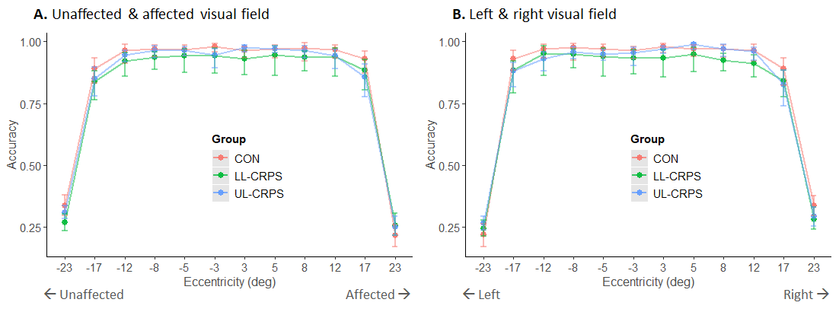
Supplementary Figure S1 Mean (± BCa 95% CIs, bootstrap corrected and accelerated 95% confidence intervals) accuracy of pain-free control participants (CON), participants with upper limb Complex Regional Pain Syndrome (UL-CRPS), and lower limb CRPS (LL-CRPS) in the test of binocular peripheral vision at different eccentricities (degrees of visual angle). (A) In the data expressed relative to the CRPS-affected(/non-dominant) side, negative eccentricities correspond to the unaffected visual field. (B) In the data expressed relative to the right and left side, negative eccentricities correspond to the left visual field.

Mechanical Detection Thresholds
All participants underwent an assessment of Mechanical Detection Threshold according to a standardized Quantitative Sensory Testing protocol.² Von Frey filaments (0.008 - 300g force; Bioseb, model Bio-VF-M) were applied to the dorsum of participants’ left and right hands and feet. Geometric means of five subthreshold and five suprathreshold values were calculated for each limb. A positive ratio of thresholds for affected(/non-dominant) versus unaffected(/dominant) side would indicate hypoesthesia (ie increased tactile detection threshold) on the affected(/non-dominant) side of the body; or hypoesthesia on the left side of the body when the data is analyzed relative to the left and right side.
In both analyses, ANOVAs revealed no significant differences in the hands or feet Mechanical Detection Threshold ratios between the groups (ps > 0.202; Supplementary Figure S2).
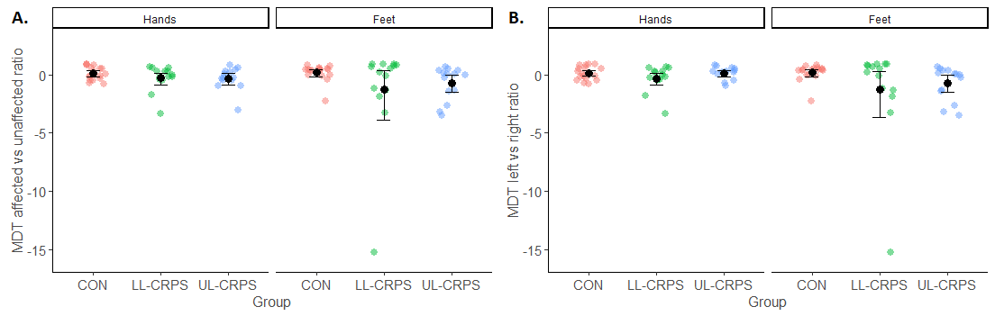
Supplementary Figure S2 Black circles represent the mean (± BCa 95% CIs, bootstrap corrected and accelerated 95% confidence intervals) Mechanical Detection Threshold (MDT) ratios for (A) affected(/non-dominant) versus unaffected(/dominant), and (B) left versus right hands and feet, in healthy control participants (CON), participants with upper limb Complex Regional Pain Syndrome (UL-CRPS), and lower limb CRPS (LL-CRPS). Colored dots represent individual data points.

Temporal acuity (secondary analysis)
Previous research has reported lower temporal acuity for TOJs under conditions where people with CRPS show spatial bias, reflecting reduced precision of their judgements.³ As a secondary hypothesis, we therefore expected the temporal acuity in the TOJ tasks to be lower in participants with CRPS compared to controls, and in the affected region of the body compared to the unaffected region of the body.
For the secondary analysis to address this hypothesis, we derived Just Noticeable Differences (JNDs) for each condition of the TOJ task. JNDs were calculated as the difference between the 75% and 25% points of the cumulative Gaussian. Larger JNDs would reflect lower temporal acuity, ie participants would need larger time intervals between the visual stimuli to reliably indicate their order. We conducted the same ANOVA on the JND as was specified for the primary analysis of the Point of Subjective Simultaneity (PSS; see main text).
Three observations (one in each group) were identified as outliers on the JND outcome and removed from this analysis. There was a significant small interaction between Group and Body Region (Supplementary Table S1; Supplementary Figure S3A), however, none of the planned contrasts remained statistically significant following the Holm-Bonferroni correction (ps_{adj} > 0.126). There was also a significant small main effect of Body Region indicating larger JND values for hands compared to feet, regardless of Group (Supplementary Figure S3B).

Supplementary Table S1 Results of the ANOVAs on the JND outcome
Effect | F | df | p | eta²
JND (outliers removed)
Group | 0.67 | 2, 39 | 0.519 | 0.03
Body Region | 12.73 | 1, 39 | 0.001 | 0.04
Group x Body Region | 4.23 | 2, 39 | 0.022 | 0.03
JND (outliers retained)
Group | 0.91 | 2, 42 | 0.411 | 0.03
Body Region | 0.79 | 1, 42 | 0.280 | 0.01
Group x Body Region | 0.14 | 2, 42 | 0.867 | < 0.01
Notes: P-values depicted in bold indicate statistically significant effects. Row headings in bold indicate the type of analysis.
Abbreviations: eta^{2,} effect size; df, degrees of freedom; F, F test statistic; JND, Just Noticeable Difference; p. p value.

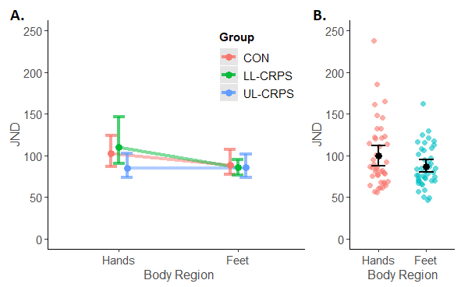
Supplementary Figure S3 Just Noticeable Difference (JND). (A) Interaction between Group (CON, control; LL-CRPS, lower limb Complex Regional Pain Syndrome; UL-CRPS, upper limb CRPS) and Body Region. (B) Main effect of Body Region. Smaller dots indicate individual observations. Larger dots with error bars represent means with bootstrap corrected and accelerated 95% confidence intervals. Three outliers were removed from this figure and the analysis.

When outliers were retained in the analysis, there were no significant main effects or interaction (Supplementary Figure S4).

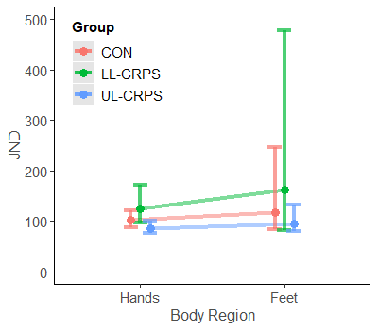
Supplementary Figure S4. Interaction between Group (CON, control; LL-CRPS, lower limb Complex Regional Pain Syndrome; UL-CRPS, upper limb CRPS) and Body Region on Just Noticeable Difference (JND; not statistically significant). Dots with error bars represent means with bootstrap corrected and accelerated 95% confidence intervals. Three outliers were retained in this figure and analysis.

We found no group differences in temporal acuity on TOJ tasks, suggesting that both participants with CRPS and pain-free controls could judge the temporal order of the visual stimuli with comparable precision. This finding is consistent with another recent TOJ study in CRPS,⁴ however, it contrasts the results in which individuals with CRPS presented with reduced temporal acuity relative to controls.³ The latter study used a more narrow range of time intervals between the visual stimuli, which could have been insufficient for the CRPS group to be able to reliably judge their temporal order. Regardless of group, our participants were more precise in judging the temporal order of the visual stimuli presented on their feet than those presented on their hands. During visual TOJs, the precision has been shown to increase with decreasing distance between the visual stimuli.^{5–7} Therefore, one possible explanation is that this advantage in the feet condition could be due to a greater viewing distance while retaining the same physical distance of the visual stimuli relative to fixation, ie the visual stimuli on the feet would have appeared less in the periphery than the visual stimuli on the hands.

Analyses of visuospatial attention (PSS) with the outliers retained in the data
Data of the PSS per group in which the outliers were retained in the data are visualized in Supplementary Figure S5, and results of the ANOVAs are reported in Supplementary Table S2. When retaining the outliers in the data for the ANOVA on the PSS expressed relative to the affected(/non-dominant) and unaffected(/dominant) side of the body, there was no significant interaction between Group and Body Region (Supplementary Figure S5A), and no main effect of the Body Region. We found a significant large main effect of Group (Supplementary Figure S5B), where controls had a more positive PSS (stronger bias towards the affected/non-dominant side) than LL-CRPS (t[58] = 2.53, p_{adj} = 0.028, d = 0.63, 95% CI [0.13, 1.14], moderate effect) and UL-CRPS (t[51] = 3.67, p_{adj} = 0.002, d = 0.91, 95% CI [0.39, 1.42], large effect), but the two CRPS groups did not differ (t[50] = 1.09, p_{adj} = 0.280, d = 0.29, 95% CI [-0.24, 0.82]).

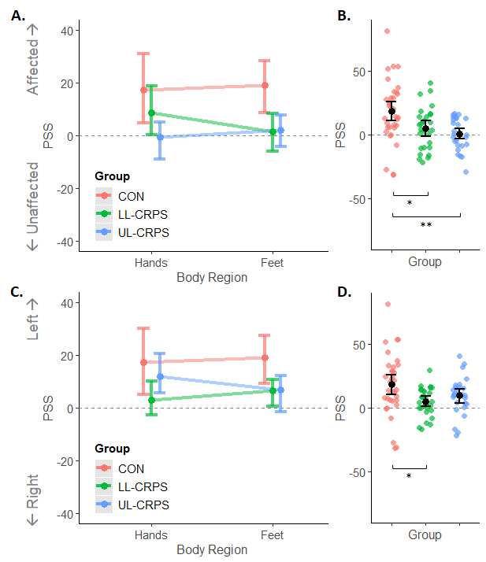
Supplementary Figure S5. Point of Subjective Simultaneity (PSS) expressed relative to the affected(/non-dominant) versus unaffected(/dominant) side (A, B) and relative to the left versus right side of the body (C, D). (A, C) Interactions between Group (CON, control; LL-CRPS, lower limb Complex Regional Pain Syndrome; UL-CRPS, upper limb CRPS) and Body Region (not statistically significant). (B, D) Main effects of Group. Smaller dots indicate individual observations (B, D). Larger dots with error bars represent means with bootstrap corrected and accelerated 95% confidence intervals. **p_{adj} < 0.01, *p_{adj} < 0.05.

Supplementary Table S2 Results of the ANOVAs on the PSS outcomes, with the outliers retained in the data
Effect | F | df | p | eta²
PSS affected(/non-dominant) versus unaffected(/dominant)
Group | 6.65 | 2, 42 | 0.003 | 0.15
Body Region | 0.02 | 1, 42 | 0.885 | < 0.01
Group x Body Region | 0.65 | 2, 42 | 0.528 | 0.01
PSS left versus right
Group | 4.31 | 2, 42 | 0.020 | 0.09
Body Region | < 0.01 | 1, 42 | 0.956 | < 0.01
Group x Body Region | 0.46 | 2, 42 | 0.633 | 0.01
Notes: P-values depicted in bold indicate statistically significant effects. Row headings in bold indicate the type of analysis.
Abbreviations: eta^{2,} effect size; df, degrees of freedom; F, F test statistic; p. p value; PSS, Point of Subjective Simultaneity.

Exploratory correlation analysis between the PSS expressed relative to the affected versus unaffected side and the CRPS symptom severity score indicated a marginally significant moderate negative association between these factors when two influential observations were retained in the data (Supplementary Figure S6).

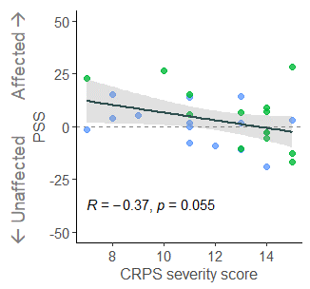
Supplementary Figure S6 Scatterplot of the relationship between the Point of Subjective Simultaneity (PSS) and the Complex Regional Pain Syndrome (CRPS) severity score for participants with lower (green) and upper limb (blue) CRPS. PSS is expressed relative to the affected side of the body. Dots correspond to individual observations (PSS averaged across Body Region conditions; two influential observations were retained in this figure and analysis), with a fitted regression line (black) and 95% confidence intervals (grey shaded area). R represents the Pearson’s correlation coefficient with the corresponding p value.

An exploratory ANOVA on the PSS expressed relative to the left versus right side of the body revealed a significant moderate main effect of Group (Supplementary Figure S6C-D), driven by a more positive PSS (stronger leftward bias) in controls compared to LL-CRPS (t[49] = 2.86, p_{adj} = 0.019, d = 0.71, 95% CI [0.20 to 1.21], moderate effect), whereas the difference between controls and UL-CRPS did not reach statistical significance (t[55] = 1.75, p_{adj} = 0.170, d = 0.44, 95% CI [-0.06 to 0.93]). There was no significant difference between the CRPS groups (t[51] = -1.33, p_{adj} = 0.189, d = -0.36, 95% CI [-0.88, 0.17]).

References
1. Halicka M, Vittersø AD, Proulx MJ, Bultitude JH. Attention upturned: Bias toward and away from the affected side of the body and near space in a case of complex regional pain syndrome. Neuropsychologia. 2021;163:108079.
2. Rolke R, Magerl W, Campbell KA, et al. Quantitative sensory testing: a comprehensive protocol for clinical trials. Eur J Pain. 2006;10(1):77-77. doi:10.1016/j.ejpain.2005.02.003
3. Bultitude JH, Walker I, Spence C. Space-based bias of covert visual attention in complex regional pain syndrome. Brain. 2017;140(9):2306-2321. doi:10.1093/brain/awx152
4. Filbrich L, Kuzminova A, Molitor V, et al. Characterizing biased visuospatial perception in complex regional pain syndrome. Eur J Pain. Published online 2023.
5. Allik J, Kreegipuu K. Multiple Visual Latency. Psychol Sci. 1998;9(2):135-138. doi:10.1111/1467-9280.00025
6. Westheimer G, McKee SP. Perception of temporal order in adjacent visual stimuli. Vision Res. 1977;17(8):887-892. doi:10.1016/0042-6989(77)90062-1
7. Strybel TZ, Manligas CL, Chan O, Perrott DR. A comparison of the effects of spatial separation on apparent motion in the auditory and visual modalities. Percept Psychophys. 1990;47(5):439-448. doi:10.3758/BF03208177

