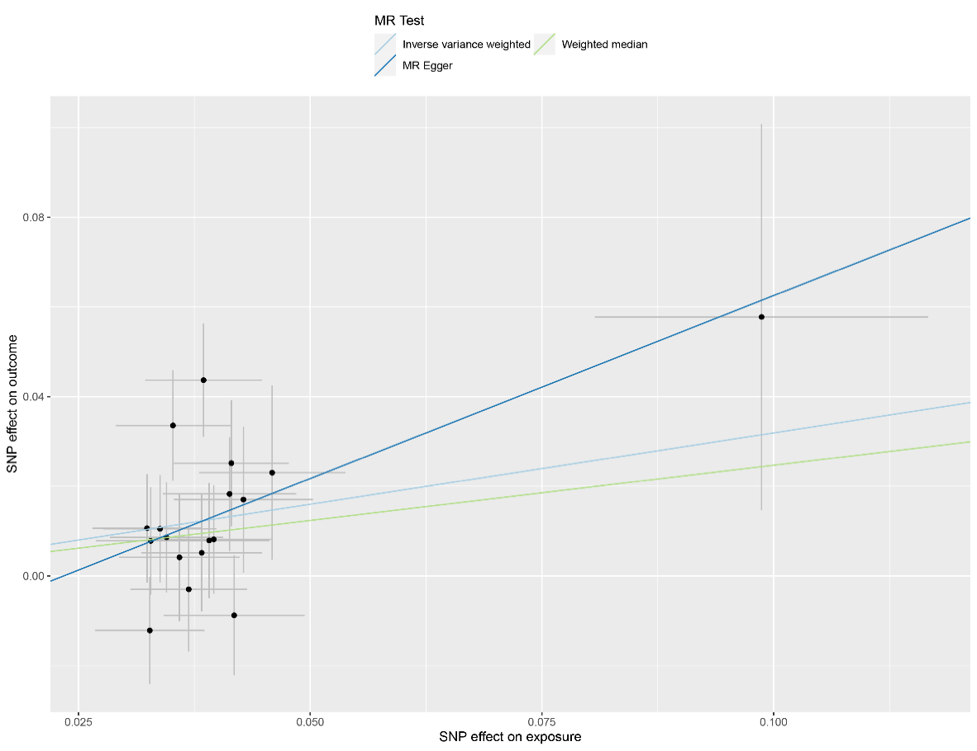
Figure S1A Scatter plot of the causal effect of GERD on COPD using different MR methods.
MR, mendelian randomization; SNP, single-nucleotide polymorphism
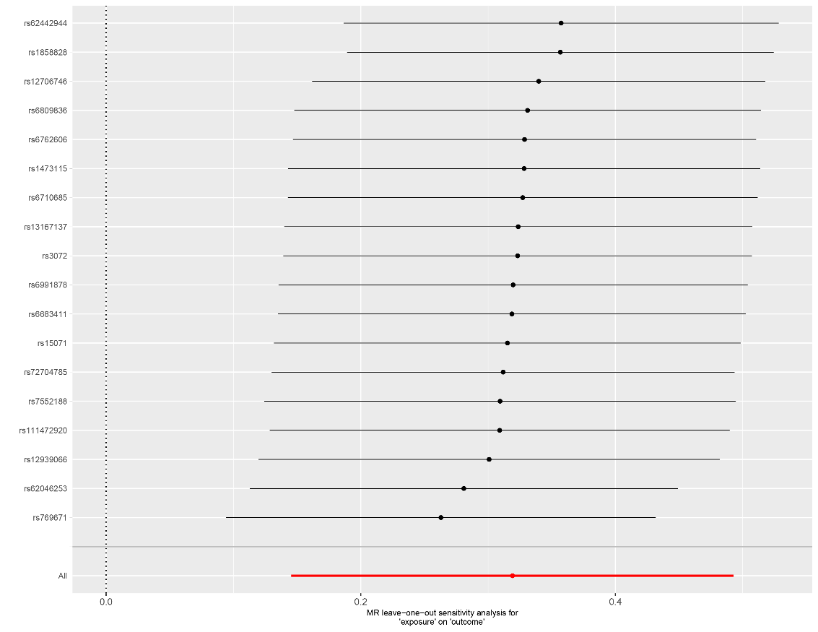
Figure S1B Leave-one-SNP-out of SNPs associated with GERD and their risk of COPD.
MR, mendelian randomization; SNP, single-nucleotide polymorphism

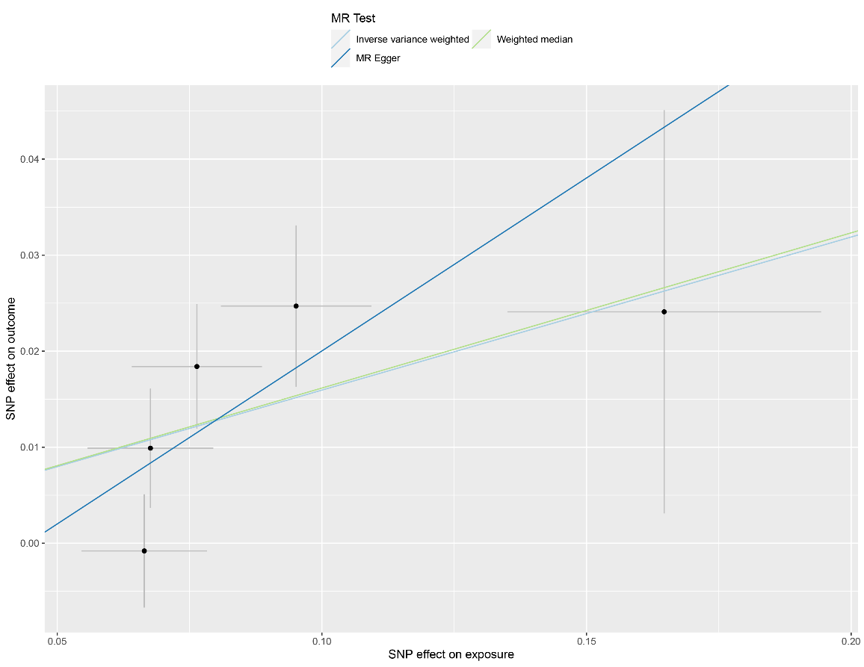
Figure S2A Scatter plot of the causal effect of COPD on GERD using different MR methods.
MR, mendelian randomization; SNP, single-nucleotide polymorphism

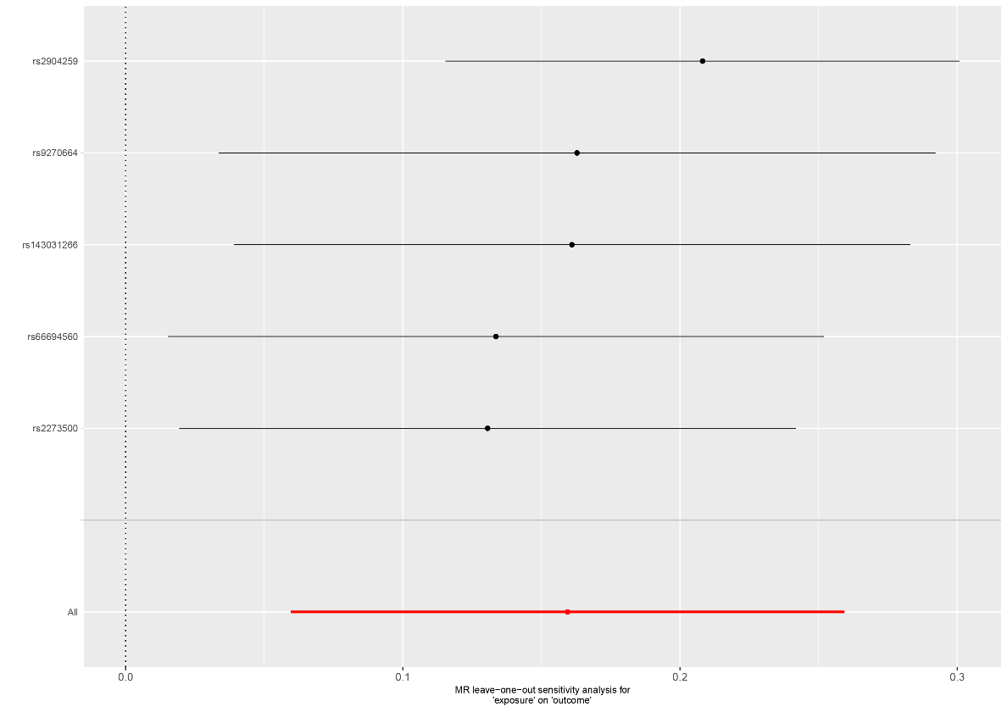
Figure S2B Leave-one-SNP-out of SNPs associated with COPD and their risk of GERD.
MR, mendelian randomization; SNP, single-nucleotide polymorphism

