Table S1 The distribution of gene mutations associated with rifampicin resistance.
rpoB mutation  (codon position) |  | No. of isolates with  resistant phenotype | No. of isolates with  sensitivity phenotype
H445D |  | 4
H445Y |  | 2
L430P |  | 0 | 2
L452P |  | 0 | 3
S450L |  | 9
S450L+I480V |  | 3
Total |  | 18 | 5

Table S2 The distribution of gene mutations associated with isoniazid resistance
katG mutation  (codon position) |  | fabG1 mutation  (codon position) | No. of isolates with  resistant phenotype | No. of isolates with  sensitivity phenotype
 | S315T |  | 15 | 1
 | S315N |  | 1
 |  | c.-15C>T |  | 1
 | Total |  | 16 | 2

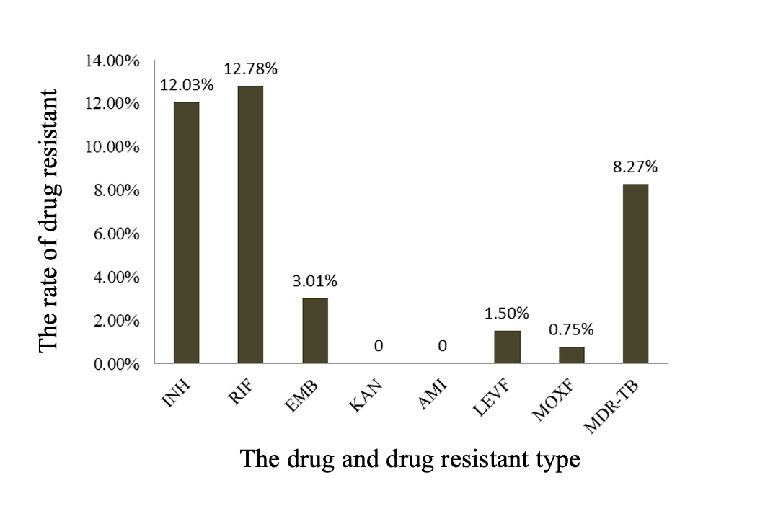
Figure S1. The rate of drug resistant among 133 Mtb strains in this study.

