Figure S1. The particle size stability of ICG-PEI@HM NPs stored in PBS.

Figure S2. Fluorescence images (A) and flow cytometry analysis (B) of H1975 cells
after 12 h uptake of nanoparticles.

Figure S3. ROS levels in tumor tissue in vivo.

Figure S4. The potential toxicity exhibited by NIH-3T3 and H1975 cells treated with
ICG-PEI@HM NPs under different concentration.

Figure S5. Viability of H1975 cells after treated with various concentrations of ICGPEI@HM NPs.

Figure S6. Viability of H1975 cells treated with different power irradiation.

Figure S7. Cell viability after combined laser irradiation with ICG-PEI@HM NPs (808
nm, 10 min, 5 μg/mL).

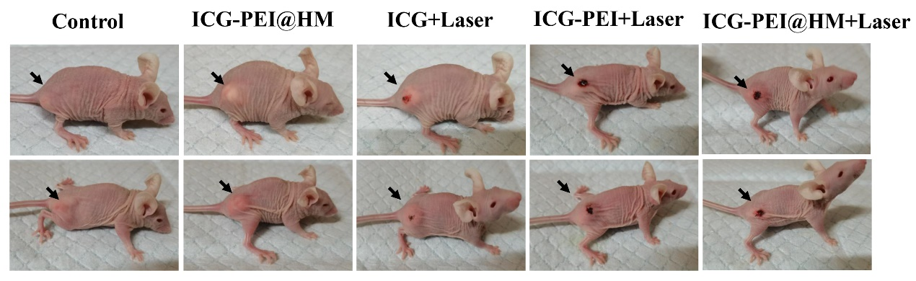

Figure S8. Photographs of mice after different treatments at different days. The arrow indicates the tumor.

Figure S9. H&E analysis of main organs (Normal group represents mice without
tumors). The scale bar is 50 μm.

Figure S10. Blood routine examination was detected at the 21th day after different
treatments. AST (a), BUN (b) and AST (c) were measured.

