SUPPLEMENTAL FIGURES AND LEGENDS

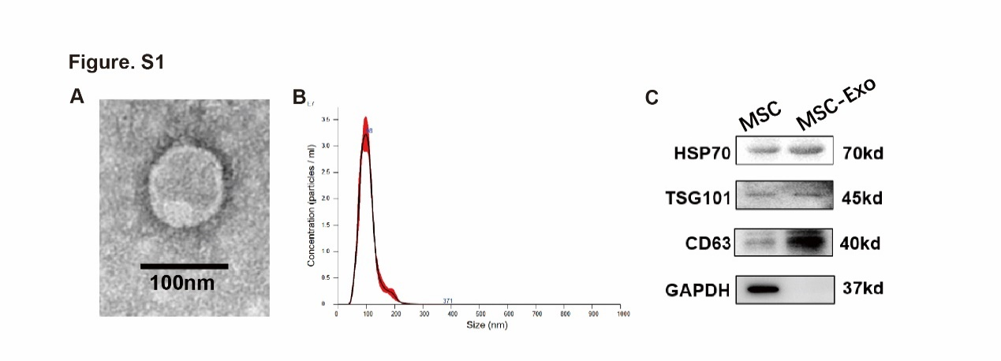
Figure S1. Characterization of bone marrow-derived MSC exosomes. (A) Transmission electron micrograph of MSC‐derived exosomes. Scale bar=100 nm. (B) Nanoparticle trafficking analyzed the diameters and concentration of exosomes. (C) Representative images of Western blot to assess the presence of HSP70, CD63 and TSG101 in MSC lysates and MSC-derived exosomes.

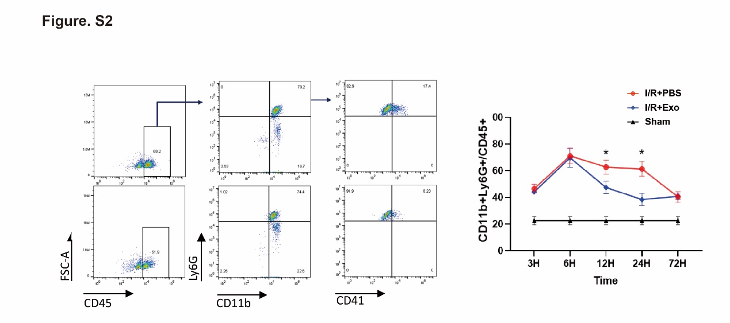
Figure S2. MSC-Exo reduced neutrophil elevation in peripheral blood. Representative flow cytometry scatter plot and statistical analysis of CD45+CD11b+Ly6G+ neutrophils in peripheral blood from mice treated with either MSC-Exo or PBS at 3, 6, 12, 24,72 hours after I/R or sham operation (n=5 each group). *P<0.05 (two-way ANOVA followed by Bonferroni’s multiple comparisons test).
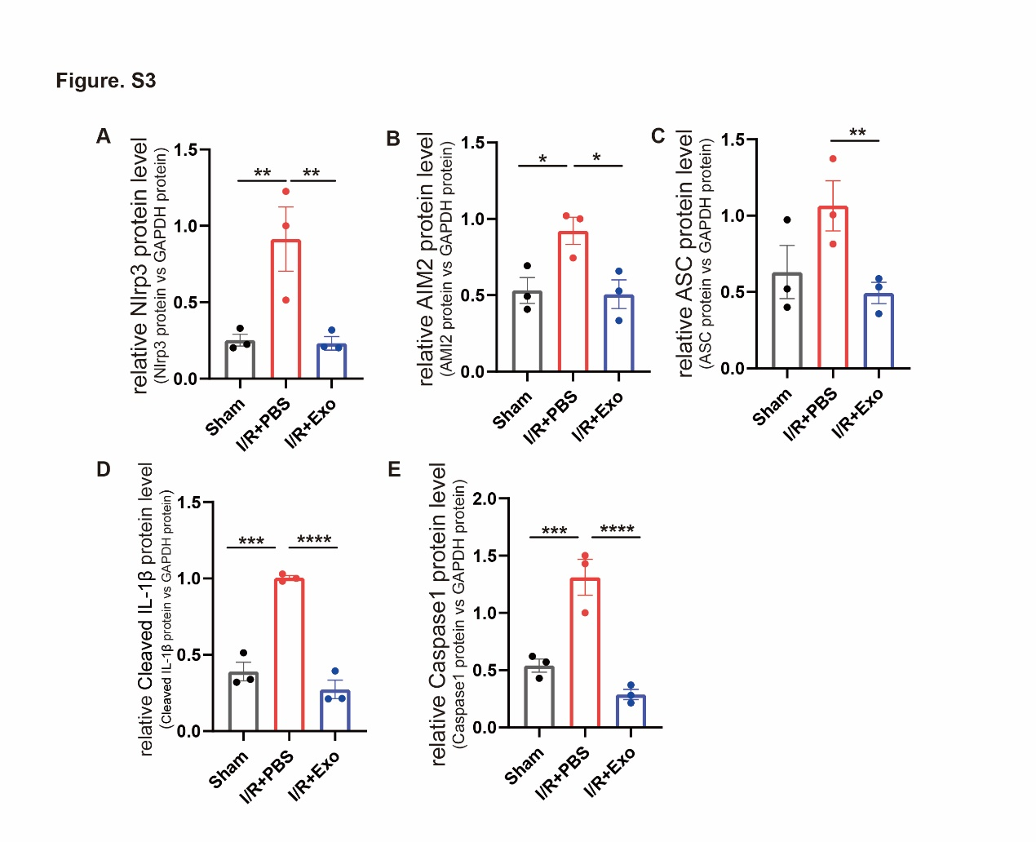

Figure S3. MSC-Exo suppressed the NLRP3 signal pathway. (A-E) The corresponding analysis of NLRP3 pathways in the hearts of mice treated with PBS or MSC-Exo 24 hours after I/R. *P<0.05, **P<0.01; ***P < 0.001; ****P < 0.0001; (one-way ANOVA with Bonferroni correction).

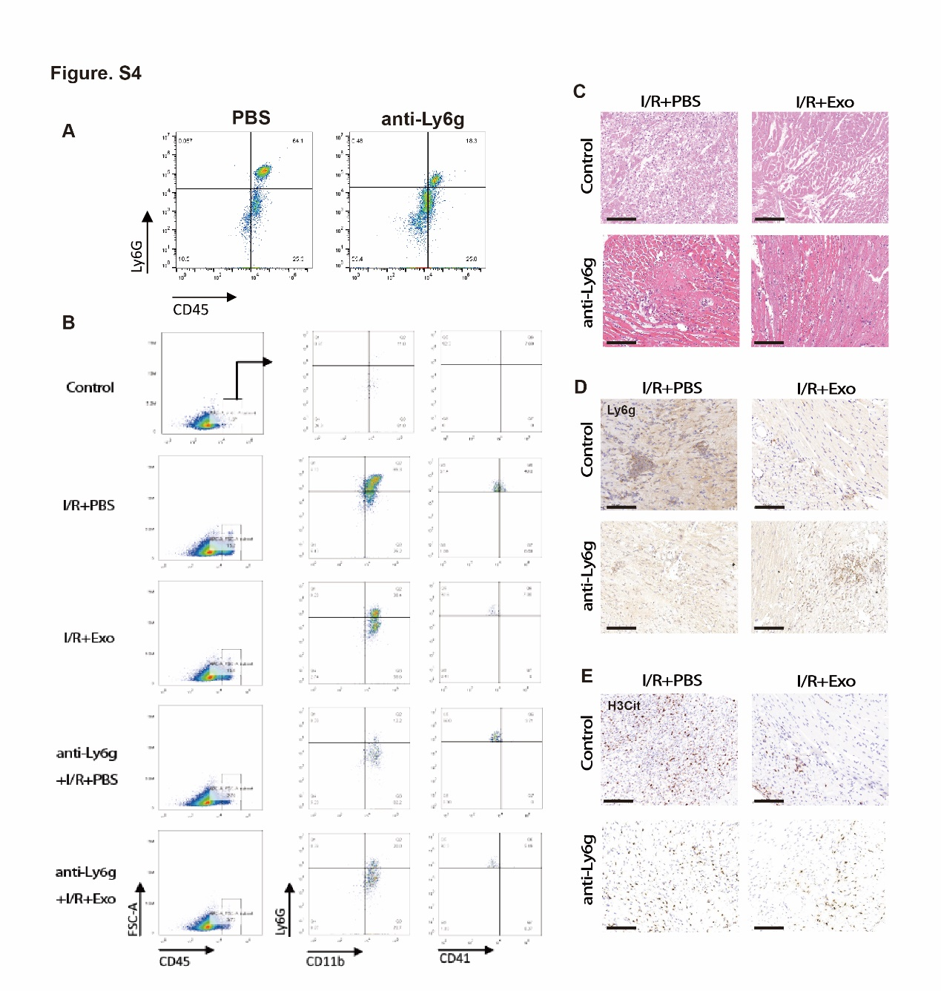
Figure S4. Systemic depletion of neutrophils reduced the efficacy of MSC-Exo treatment after I/R injury. (A) Representative flow cytometry scatter plot of CD45+Ly6G+ neutrophils after Ly6g antibody treatment. (B) Representative flow cytometry scatter plot of CD45+CD11b+Ly6G+ neutrophils and Ly6G+CD11b+CD41+ neutrophil-platelet complex in the heart from mice sacrificed 3 days after injection of either MSC-Exo or PBS with (n=4) or without (n=5) neutrophil depletion prior to myocardial I/R injury or in Sham group (n=4). (C) Representative images of HE staining in heart sections. Scale bar= 100 μm. (D-E) Representative images of immunohistochemical staining for Ly6G+ neutrophils and H3Cit+ NETs in heart sections. Scale bar= 100 μm.

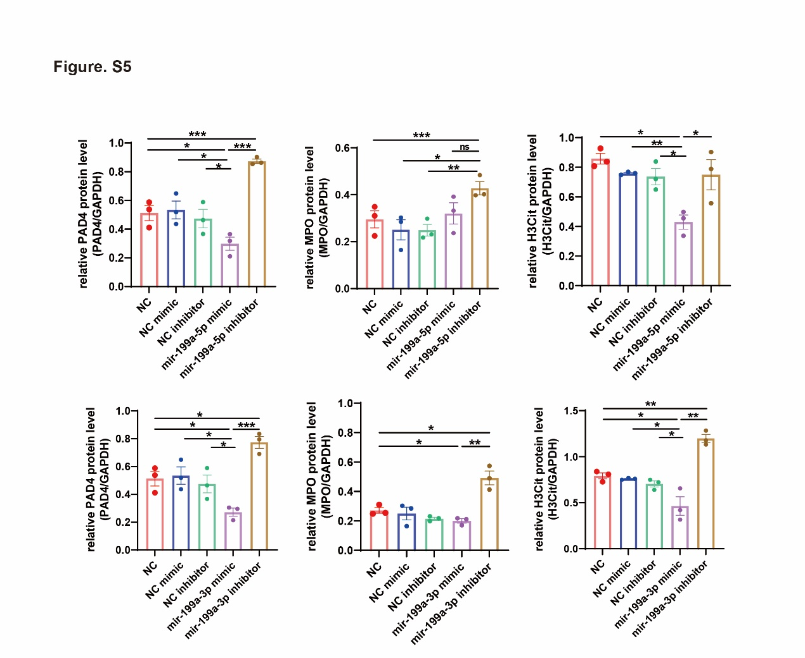

Figure S5. Mir-199a reduced the NETs releasing after PMA stimulation. The corresponding analysis of PAD4, MPO and H3Cit in neutrophils after 24 hours of PMA stimulation following mimic or inhibitor treatment (n=3). *P<0.05; **P<0.01; ***P<0.001; ns, not significant (one-way ANOVA with Bonferroni correction).

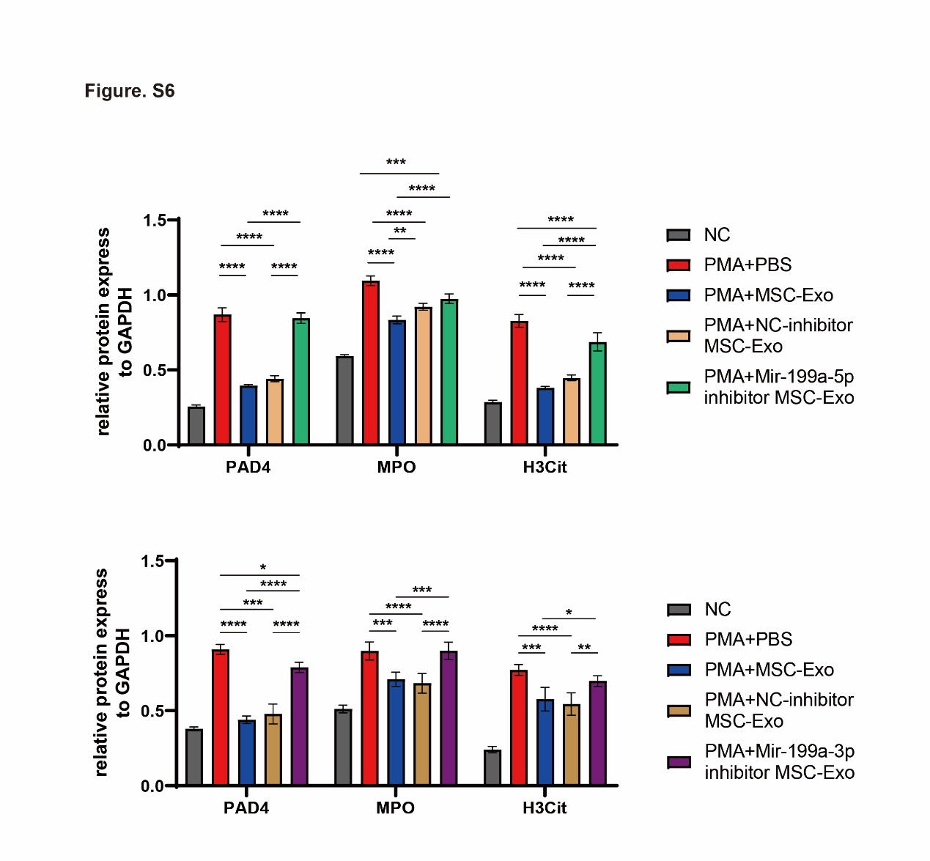
Figure S6. Mir-199a inhibitor suppressed the efficacy of MSC-Exo. The corresponding analysis of PAD4, MPO and H3Cit in neutrophils after 24 hours of PMA stimulation following MSC-Exo, NC-inhibitor MSC-Exo, mir-199a-5p inhibitor MSC-Exo or mir-199a-3p MSC-Exo inhibitor treatment (n=3). *P<0.05; **P<0.01; ***P<0.001; ****P < 0.0001 (one-way ANOVA with Bonferroni correction).

SUPPLEMENTAL TABLE
Table S1 List of primers used for quantitative real‐time PCR
Gene | Forward primer | Reverse primer
Mouse S100a8 | AAATCACCATGCCCTCTACAAG | CCCACTTTTATCACCATCGCAA
Mouse S100a9 | ATACTCTAGGAAGGAAGGACACC | TCCATGATGTCATTTATGAGGGC
Mouse Nlrp3 | ATTACCCGCCCGAGAAAGG | TCGCAGCAAAGATCCACACAG
Mouse IL-1β | GCAACTGTTCCTGAACTCAACT | ATCTTTTGGGGTCCGTCAACT
Mouse CXCL1 | CTGGGATTCACCTCAAGAACATC | CAGGGTCAAGGCAAGCCTC
Mouse CXCL2 | CCAACCACCAGGCTACAGG | GCGTCACACTCAAGCTCTG
Mouse 18S | AGGGGAGAGCGGGTAAGAGA | GGACAGGACTAGGCGGAACA

