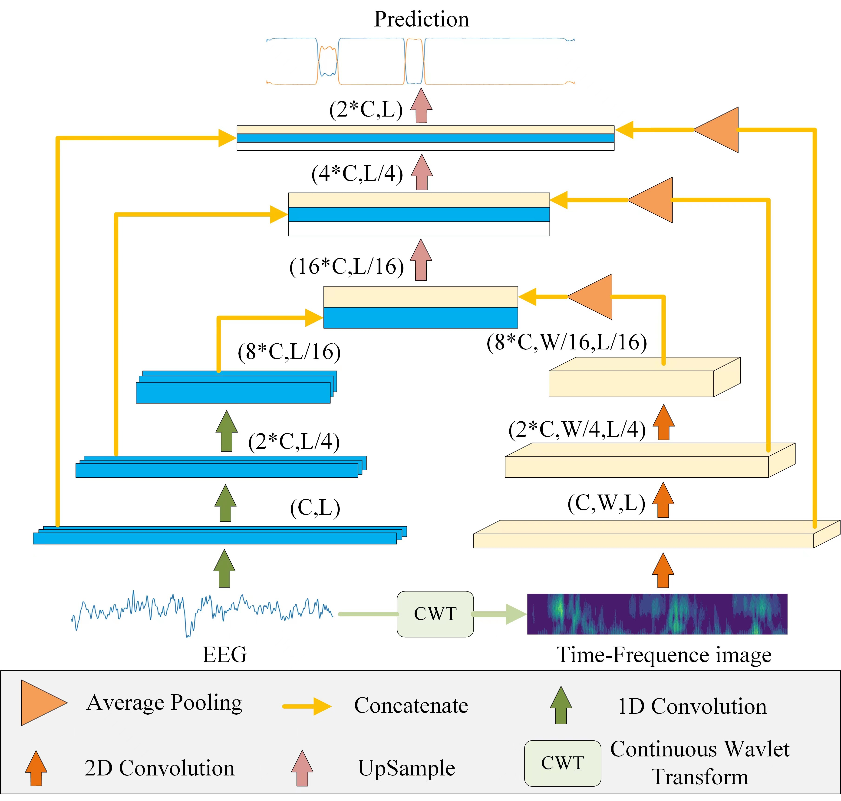
Figure S1. The U-Net model integrating time domain and the time-frequency domain

Table S1. The validation of different models
IOU=0.4 | Accuracy | Recall | F1 Score
A7 | 71% | 73% | 72%
SUMO | 85% | 79% | 82%
Automated real-time | 83% | 78% | 81%
TransU+time domain | 83% | 78% | 80.5%
TransU+time domain  +time-frequency domain | 84% | 81.5% | 82.7%
Notes:
IOU, Intersection over Union; TransU, transformer+U-net. Key information about the U-net model integrating time domain and the time-frequency domain is highlighted in bold.

