Supplemental Table 1. Summary of demographic features of large immunotherapy HCC studies.
Study Name or PMID | Montefiore data | IMbrave 150 | Keynote-240 | CheckMate - 459 | REACH-2 | HIMALAYA | De Wilde et. al (PMID 36157862) | Himmelsbach et. al (PMID 35406493) | Saeed et. al (PMID 32824968) | Uhlig et. al (PMID 35172633)
Study Design | Retro-spective | Open label, phase 3 | Double blind, Phase 3 | Open label, Phase 3 | Double blind, Phase 3 | Open label, phase 3 | Retro-spective | Retro-spective | Retro-spective | Retro-spective database study
Specific IO agent | NA | Atezolizumab + Bevacizumab | Pembrolizumab  second line | Nivolumab first line | Ramucirumab | Tremelimumab + Durvalumab | Nivolumab | Atezolizumab + Bevacizumab | All agents, second line | Pembrolizumab or Nivolumab
Sample Size in IO arm, (n) | 194 | 336 | 278 | 371 | 197 | 393 | 29 | 66 | 41 | 1770
Median age, (yr) | 65 | 64 | 67 | 65 | 64 | 65 | 69 | 65 | 62 | 65
Gender
Male | 137 (71) | 277 (82) | 226 (81) | 314 (85) | 154 (78) | 327 (83) | 21 (72) | 54 (82) | 30 (73) | 1407 (79)
Female | 52 (28) | NR | 52 (19) | 57 (15) | 43 (22) | 66 (17) | 8 (28) | 12 (18) | 11 (27) | 363 (21)
Race and Ethnicity
Asian, not Hispanic | 9 (5) | 188 (56) | 113 (41) | 165 (44) | 102 (52) | 195 (50) | NR | NR | NR | 97 (6)
Black, not Hispanic | 39 (21) | 6 (2) | 13 (5) | 3 (<1) | 1 (<1) | 7 (2) | NR | NR | NR | 194 (11)
Hispanic | 77 (42) | 9 (3) | 22 (8) | 5 (1) | 12 (<1) | 21 (5) | NR | NR | NR | 13 (<1)
White, not Hispanic | 24 (13) | 123 (37) | 143 (51) | 199 (54) | 60 (30) | 182 (46) | NR | NR | NR | 968 (55)
Unknown, Other | 34 (18) | 19 (6) | 0 (0) | 4 (1) | 35 (18) | 9 (2) | NR | NR | NR | 283 (12)
Etiology
Hepatitis C | 72 (39) | 72 (21) | 43 (15) | 87 (23) | 48 (24) | 110 (28) | 2 (7) | 14 (21) | 22 (54) | 795 (45)
Hepatitis B | 16 (9) | 164 (49) | 72 (26) | 116 (31) | 71 (36) | 122 (31) | 4 (14) | 9 (14) | 3 (7) | 158 (9)
Non-Viral | 94 (51) | 100 (30) | 163 (59) | 168 (45) | 94 (48) | 161 (41) | 23 (79) | NR | NR | 817 (46)
Alcohol | 25 (14) | 35 (10) | NR | NR | 48 (24) | NR | 7 (24) | 25 (38) | 9 (22) | 699 (40)
NAFLD | 15 (8) | NR | NR | NR | 19 (10) | NR | 3 (10) | 18 (27) | NR | NR
Other, Multiple etiologies | 35 (19) | 38 (11) | NR | NR | 27 (14) | NR | 12 (41) | NR | 7 (17) | NR
Unknown | 19 (10) | 27 (8) | NR | NR | NR | NR | 1 (3) | NR | NR | NR
Biopsy-Proven Diagnosis
Yes | 77 (40) | 116 (35) | NR | NR | 102 (52) | NR | NR | NR | NR | NR
No | 117 (60) | 150 (45) | NR | NR | 95 (48) | NR | NR | NR | NR | NR
Child Pugh Class
A | 94 (51) | 335 (100) | 278 (100) | 365 (98) | 123 (62) | 387 (98) | 10 (34) | 35 (53) | NR | NR
B | 66 (36) | 1 (<1) | 1 (<1) | NR | 74 (38) | 4 (1) | 8 (28) | 23 (35) | NR | NR
C | 19 (10) | NA | 0 (0) | NR | NA | NR | NA | 5 (8) | 6 (15) | NR
Unknown | 2 (1) | NA | NA | NR | NA | 2 (<1) | 1 (3) | NR | NR | NR
AFP
<400 | 96 (52) | NR | NR | NR | NR | 243 (62) | NR | NR | NR | NR
>400 | 73 (40) | 126 (38) | NR | 124 (33) | NR | 145 (37) | NR | 19 (29) | NR | NR
Unknown | 14 (8) | NR | 0 (0) | NR | NR | 5 (1) | NR | NR | NR | NR
ECOG score
0 | NR | 209 (62) | 162 (58) | 271 (73) | 133 (57) | 224 (62) | 5 (17) | NR | NR | 236 (13)
1 | NR | 127 (38) | 116 (42) | 99 (27) | 55 (28) | 148 (38) | 21 (72) | NR | NR | 347 (20)
2 or above | NR | NA | NA | NA | NA | 1 (<1) | 3 (10) | NR | 7 (17) | 145 (8)
Barcelona Clinic Liver Cancer Stage
0 | NR | NA | NA | NA | NA | NA | NA | NA | NR | NR
A | NR | 8 (2) | 0 (0) | 15 (4) | NA | NA | NA | 1 (2) | NR | NR
B | NR | 52 (15) | 56 (20) | 53 (14) | 34 (17) | 77 (20) | 1 (3) | 22 (33) | NR | NR
C | NR | 276 (82) | 222 (80) | 303 (82) | 163 (83) | 316 (80) | 28 (97) | 35 (53) | NR | NR
D | NR | NA | 0 (0) | NA | NA | NA | NA | 8 (12) | NR | NR
Geographic Region
Asia, excluding Japan | NA | 133 (40) | 67 (24) | 92 (25) | 55 (28) | 156 (40) | NA | NA | NA | NA
United States | 194 (100) | NR | 21 (8) | NR | NR | NR | NA | NA | 41 (100) | 1770(100)
Rest of the World | NA | 203 (60) | 211 (76) | 279 (75) | 142 (72) | 237 (60) | 29 (100) | 66(100) | NA | NA
Presence of macrovascular invasion +/- extrahepatic spread
Macrovascular invasion | NR | 129 (38) | 36 (13) | 124 (33) | 70 (36) | 103 (26) | 8 (28) | 29 (44) | NR | NR
Extrahepatic spread | NR | 212 (63) | 195 (70) | 222 (60) | 141 (72) | 209 (53) | 13 (45) | 18 (27) | 12 (29) | NR
Both | NR | 258 (77) | NR | 280 (75) | NR | NR | NR | NR | NR | NR
Data presented as number n (%). Abbreviations: HCC, hepatocellular carcinoma; IO, immuno-oncology; NAFLD, non-alcoholic fatty liver disease; AFP, alpha-fetoprotein; ECOG, Eastern Cooperative Oncology Group.

Supplemental Table 2. Rates of death stratified by hepatocellular carcinoma screening status.
 | Screened (n = 38) | Unscreened (n = 135) | p-value
OS≤3 months | 0 (0%, 95% CI=0-9.3%) | 14 (10.4%, 95% CI=5.8-16.8%) | 0.042
OS≤6 months | 1 (2.6%, 95% CI=0.07-13.8%) | 31 (23.0%, 95% CI=16.2-31.0%) | 0.004
Note: Fisher's exact test was used to estimate the death rates in each group.

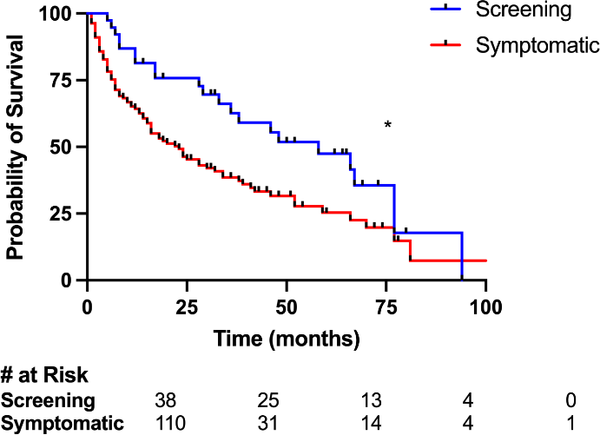

Supplemental Figure 1: Kaplan-Meier survival analysis with patients stratified by hepatocellular carcinoma screening status.
*p-value<0.05. Note: screening or symptomatic status refers to the time and method of diagnosis.

