Supplement Figures

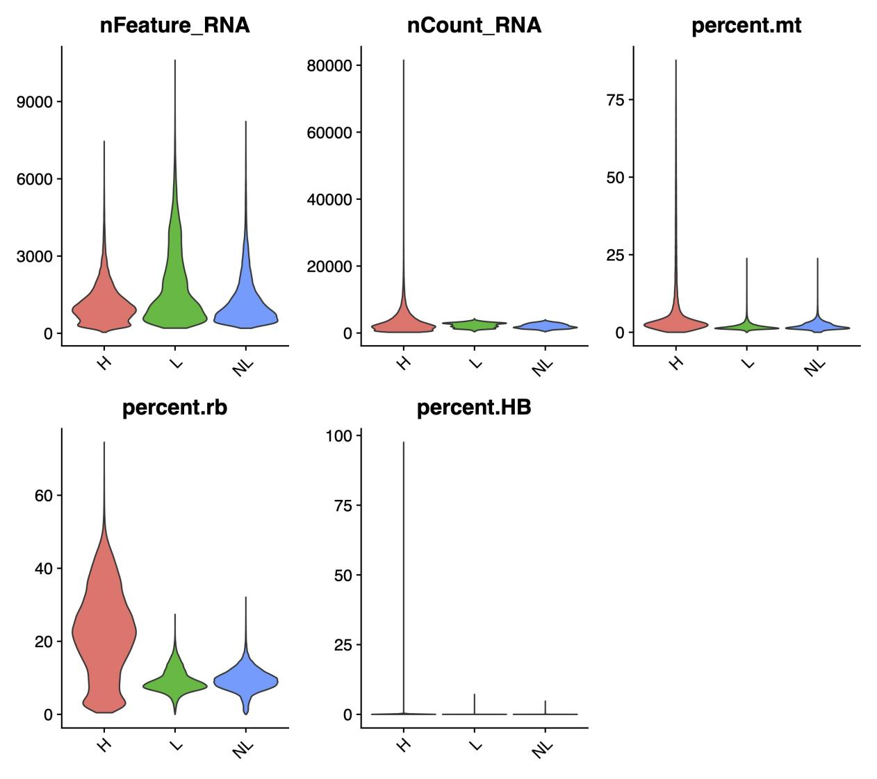
Figure S1 Overall quality of data before quality control

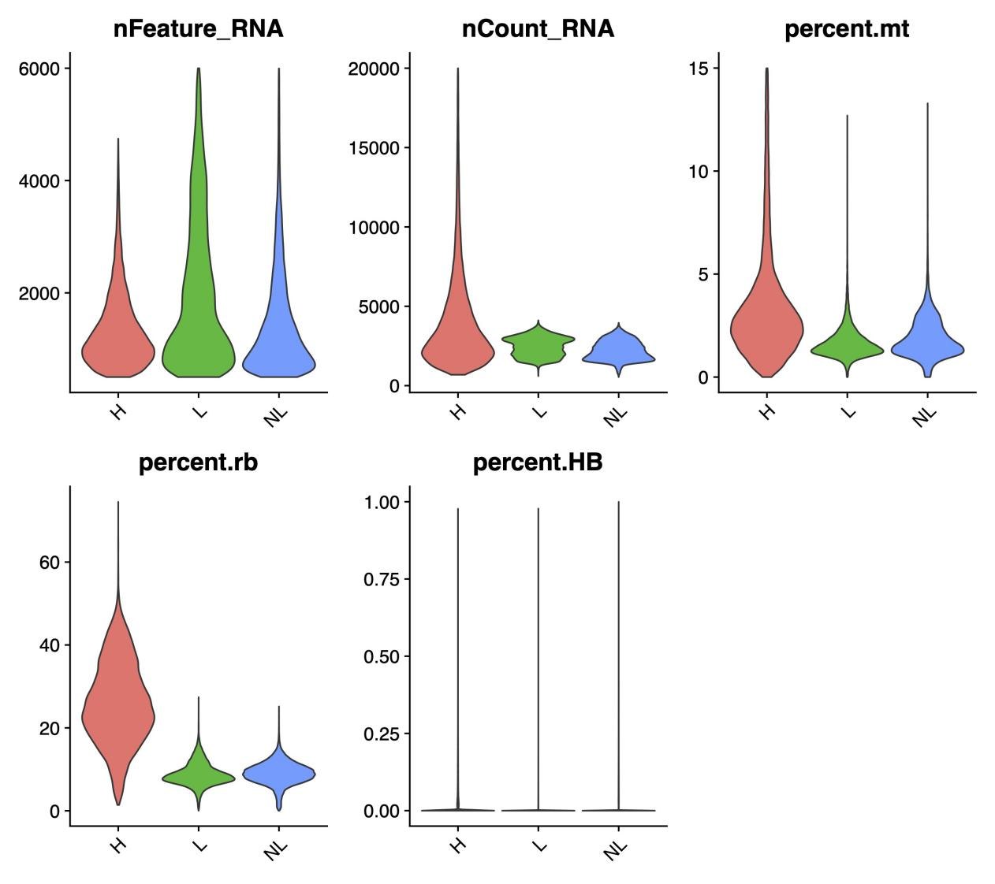
Figure S2 Overall quality of data after quality control

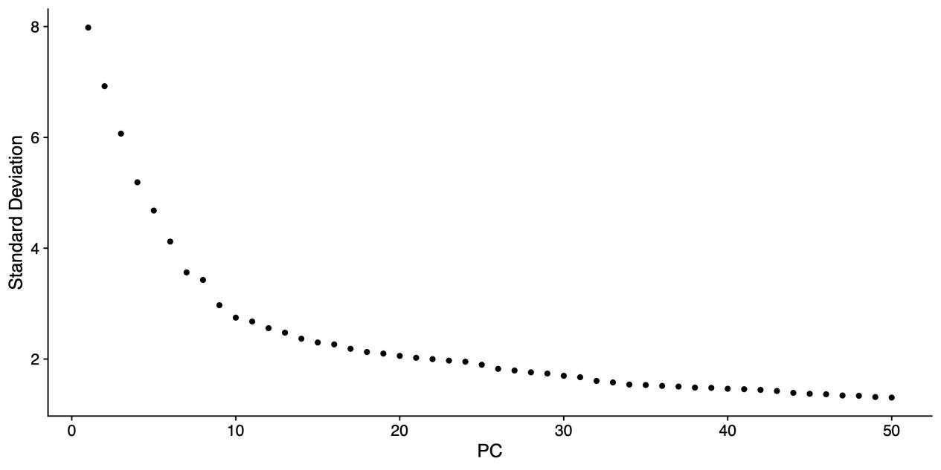
Figure S3 Elbow diagram of PCA
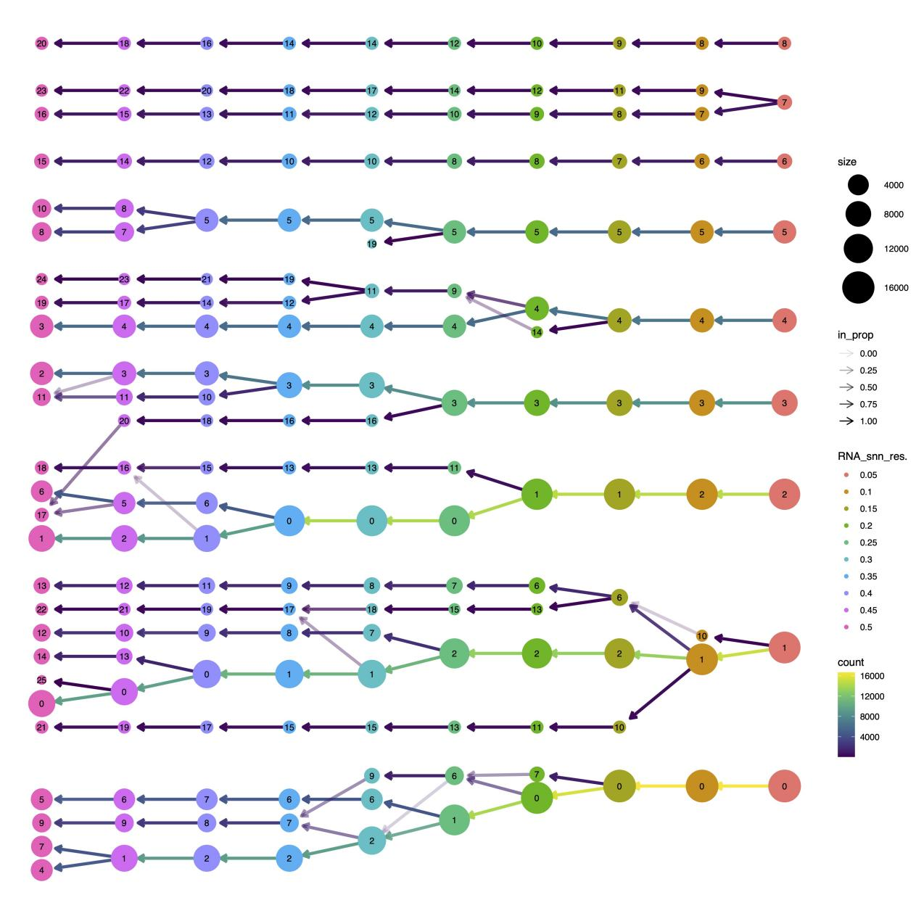
Figure S4 Change of cell cluster number at different resolutions

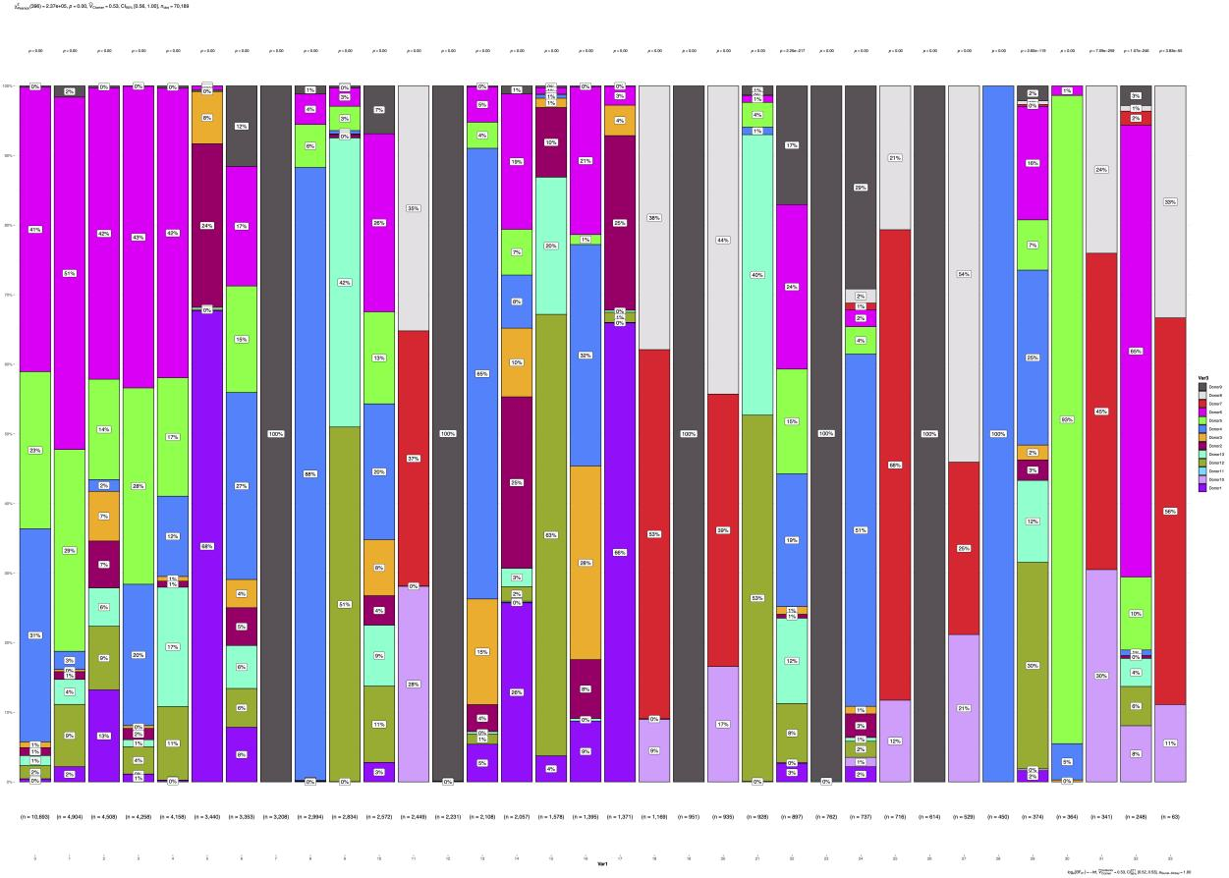

Figure S5 Comparison of source cells of each cell cluster without batch correction

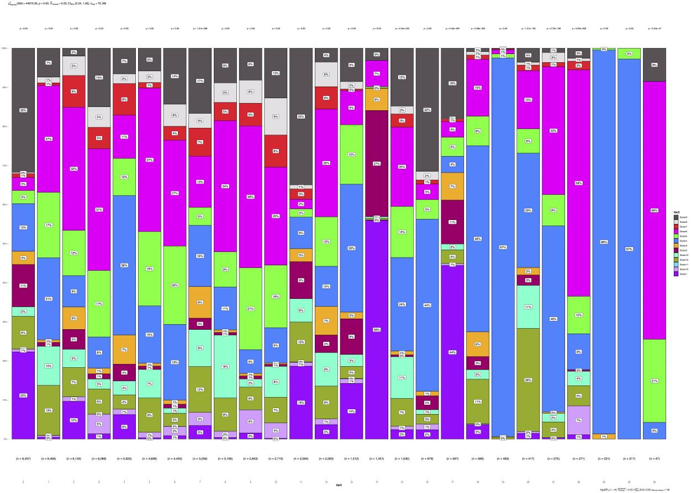
Figure S6 Comparison of source cells of each cell cluster with harmony batch correction

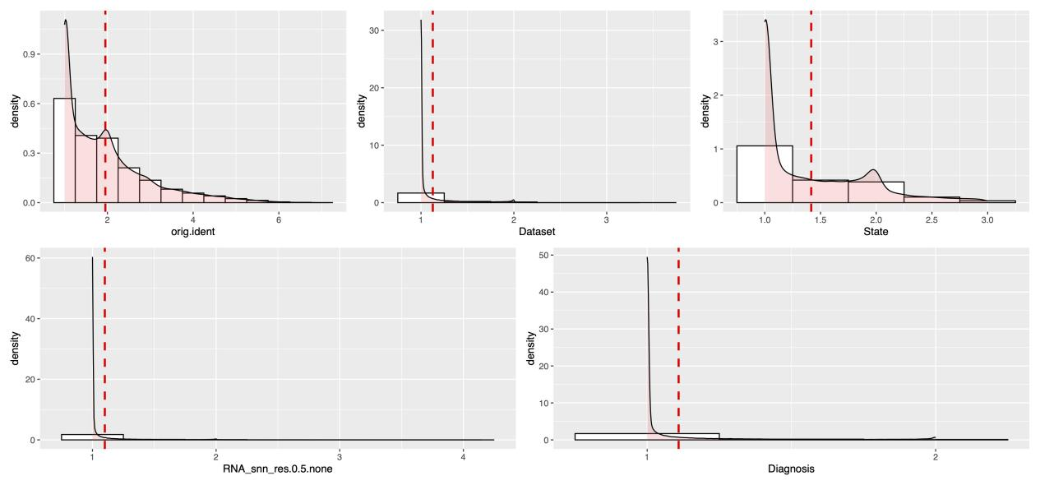
Figure S7 Comparison of lisi score of different situation without batch correction

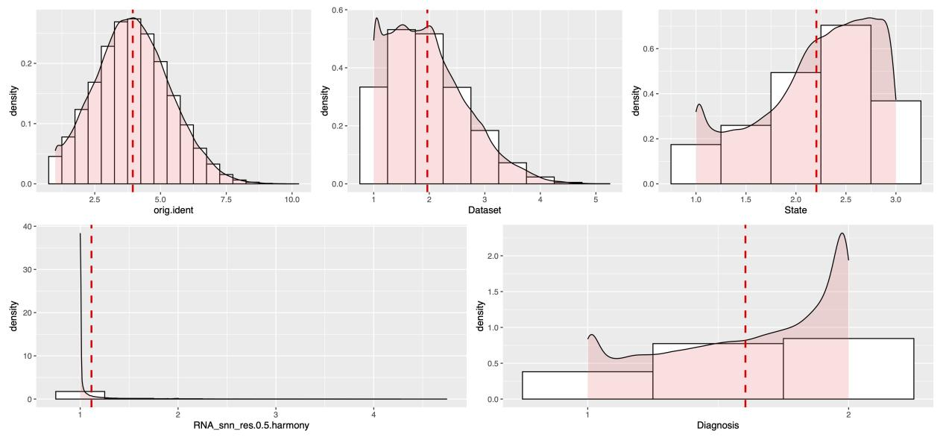
Figure S8 Comparison of lisi score of different situation with harmony batch correction
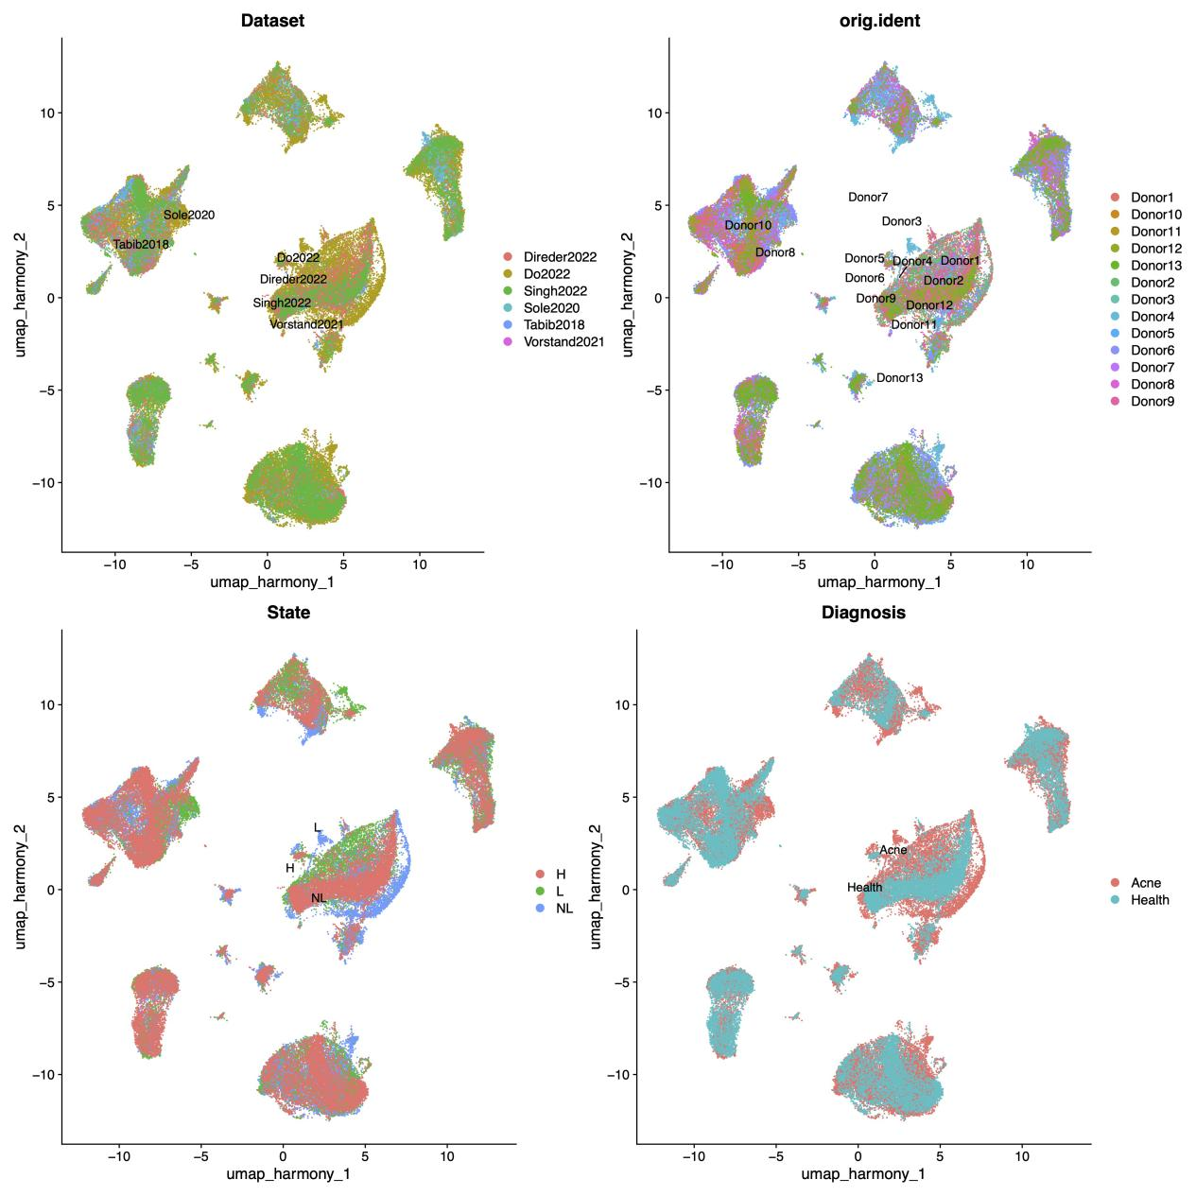
Figure S9 UMAP shows differences in batch effects

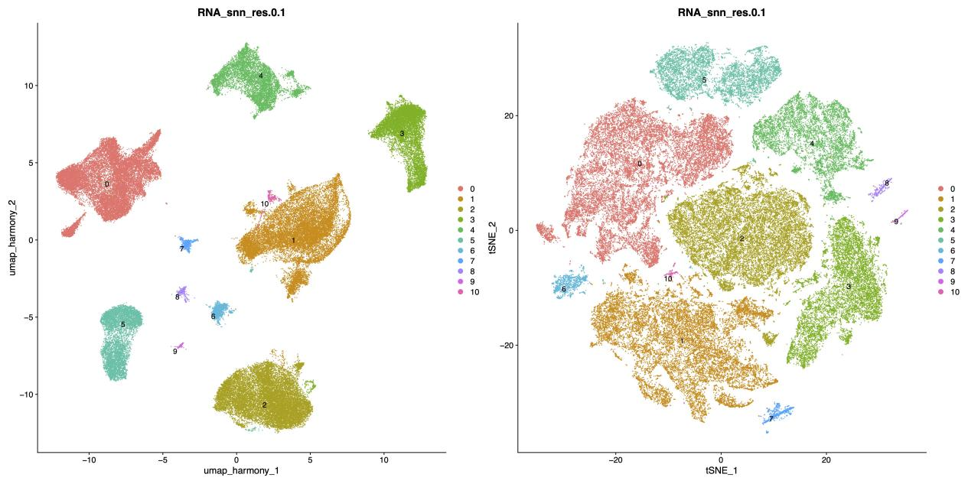
Figure S10 UMAP and tsne shows the cell clusters

