Supporting Information
Figure S1. The QQ plots of AUC_{(0-T)}, AUC_{(0-∞)}, MRT_{(0-t)}, MRT_{(0-∞)}, t_{1/2}, T_{max}, Vz/F, CLz/F and C_{max}.
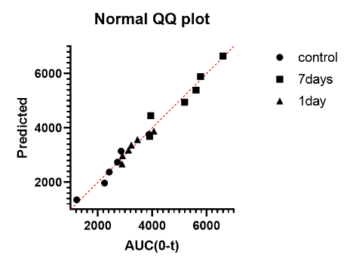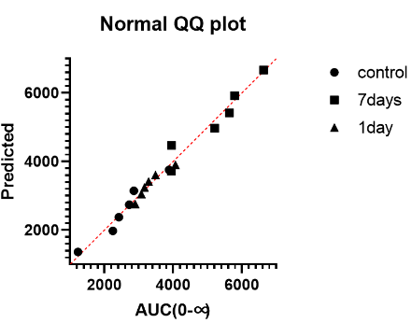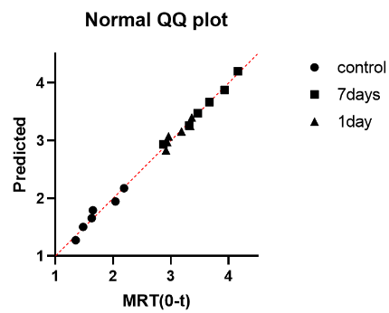
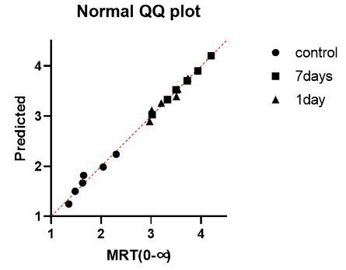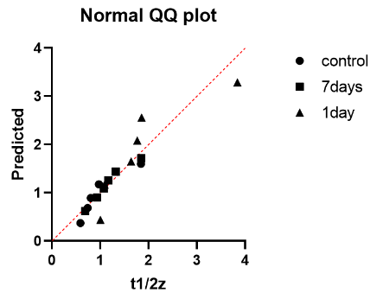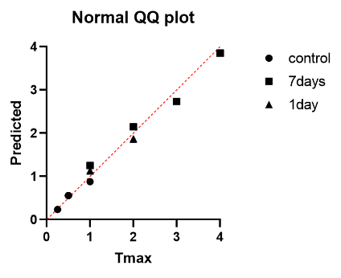
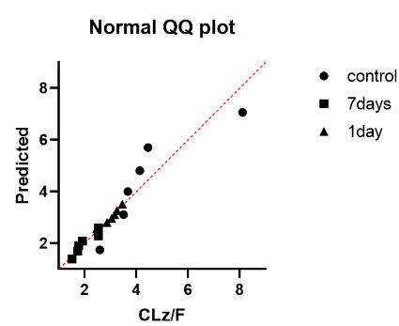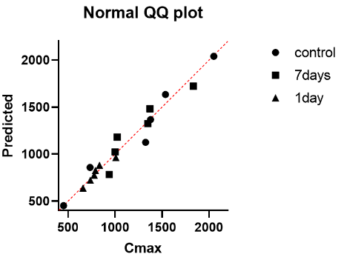

Figure S2. The results of Hypothesis Test Summary and Independent-Samples Kruskal-Wallis Test of Tmax and Vz/F.
Hypothesis Test Summary
 | Null Hypothesis | Test | Sig. | Decision
1 | The distribution of Tmax is the same across categories of group. | Independent-Samples Kruskal-Wallis Test | .002 | Reject the null hypothesis.
2 | The distribution of V is the same across categories of group. | Independent-Samples Kruskal-Wallis Test | .020 | Reject the null hypothesis.
Asymptotic significances are displayed. The significance level is .05.
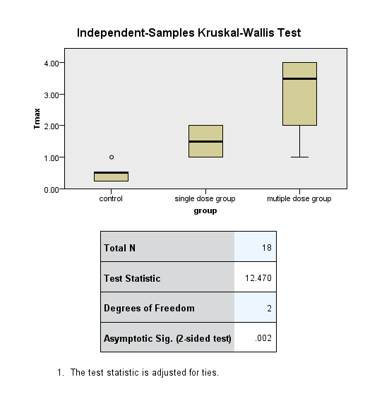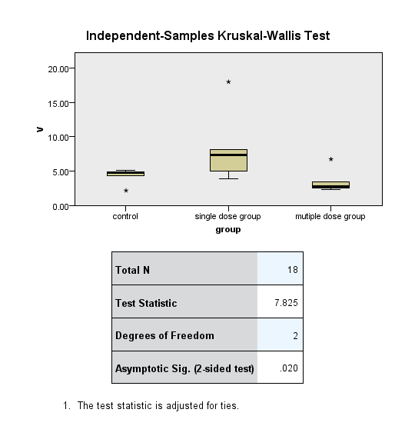

Figure S3. The Continuous Field information of Tmax and Vz/F.
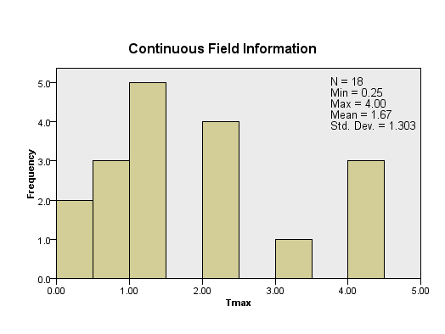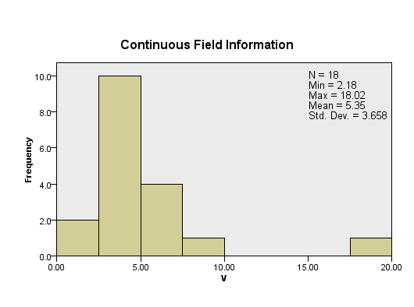

Figure S4. The Kruskal-Wallis test results. (A) T_{max} Pairwise Comparisons of group; (B) Vz/F Pairwise Comparisons of group.
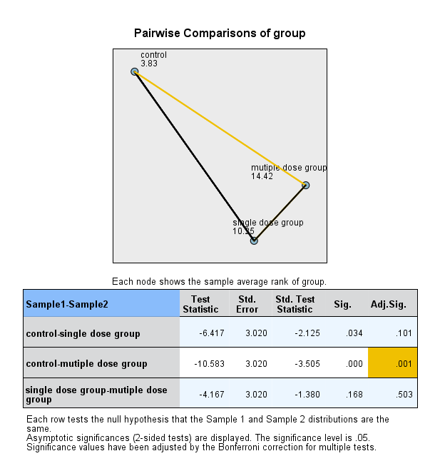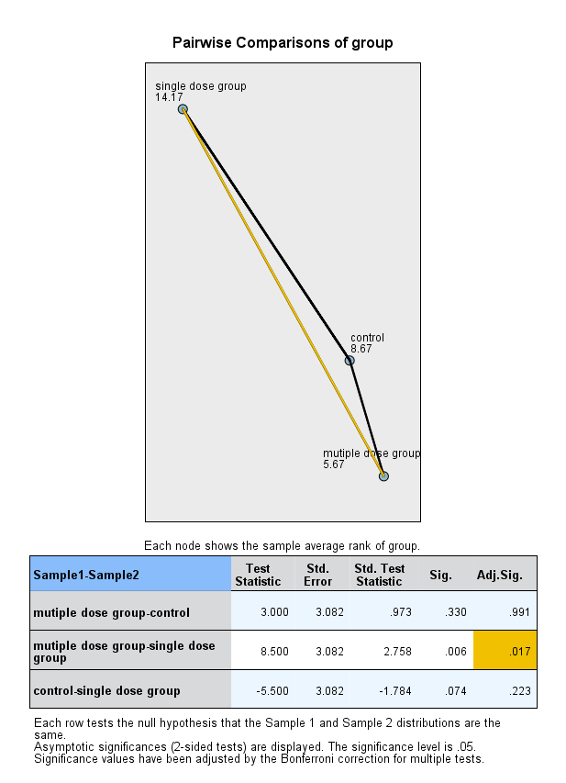
B
A

