A patient with left-sided superior VN had dynamic changes of calorigram in caloric test at onset, 4 weeks and 12 weeks after onset
Supplementary Figure 1
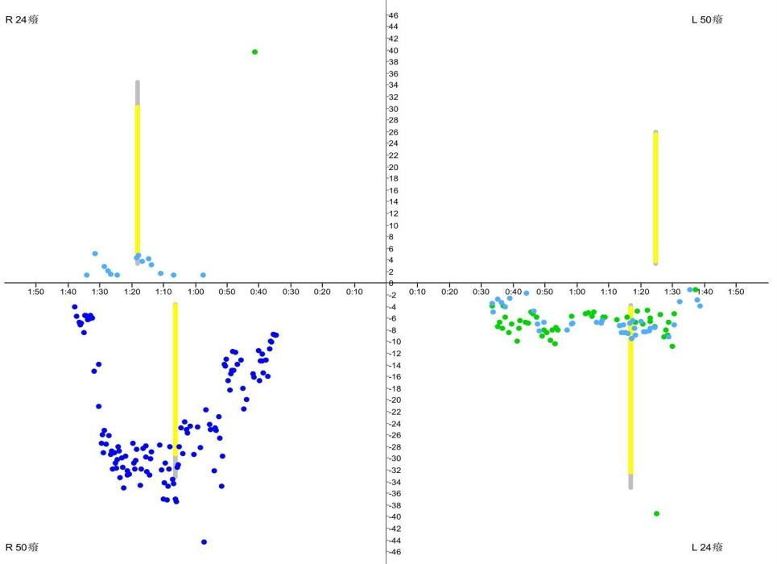
Supplementary Figure 1，That shows a significant reduction in left vestibular function at onset,velocities of left nystagmus includ ing 24°and 50°stimulation are slow than right observably,with a unilateral weakness(UW) value of 100%,which refered to severe canal paresis,as seen in the opposite direction of the recording point at L50 degrees due to large spontaneous nystagmus(SPN).
Y axis:Maximum slow phase velocity(SPV) of SPN normal range:12-140°/s,Cold stimulation：5-30°/s,hot stimulation：20-140°/s.X axis:time.The same applies to Figure2,3.

Supplementary Figure 2
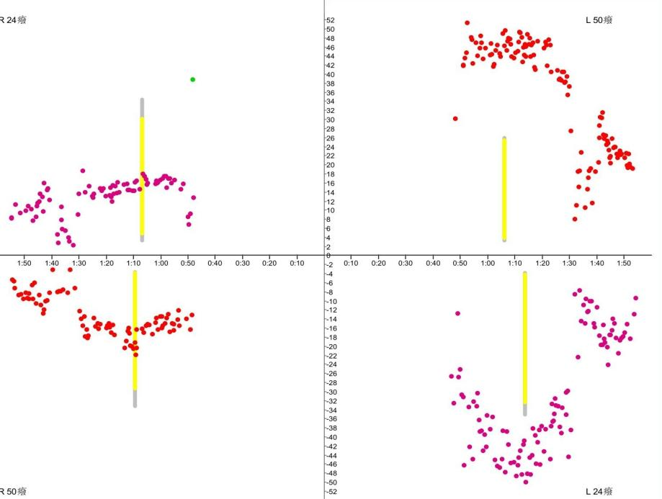
Supplementary Figure 2,That shows a significant improvement in the vestibular function of this patient with VN at 4 weeks,velocities of left nystagmus includ ing 24°and 50°stimulation are slow than right partly,with a UW value of 40%,which refered to intermediate canal paresis,It is a significant improvement contrasted to the severe canal paresis detected during the first examination.

Supplementary Figure 3
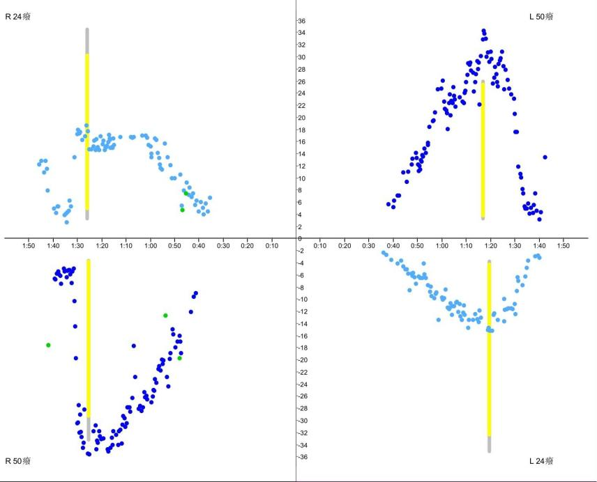
Supplementary Figure 3,That shows complete improvement of reduced left vestibular function function at 12 weeks,velocities of bilateral nystagmus includ ing 24°and 50°stimulation are similar, with a UW value of 21%,which refered to normal.

Dynamic changes in video head impulse test(vHIT) at onset, 4 weeks and 12 weeks in a patient with right-sided superior VN(only the horizontal canal curves)
Supplementary Figure 4
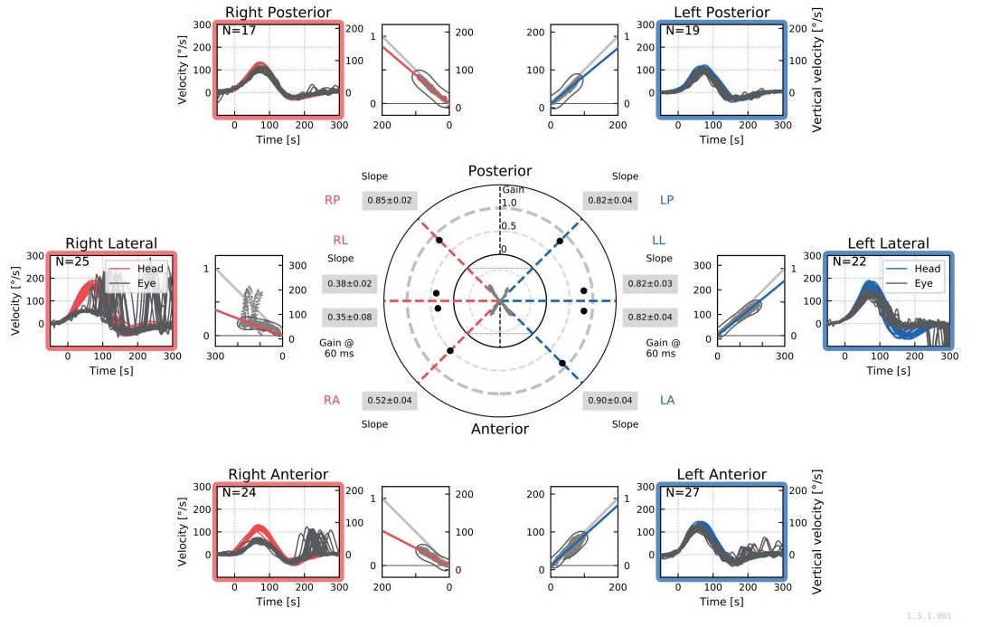
Supplementary Figure 4 shows the typical situation of bilateral triple semicircular canal gain. at onset of VN;

Supplementary Figure 5
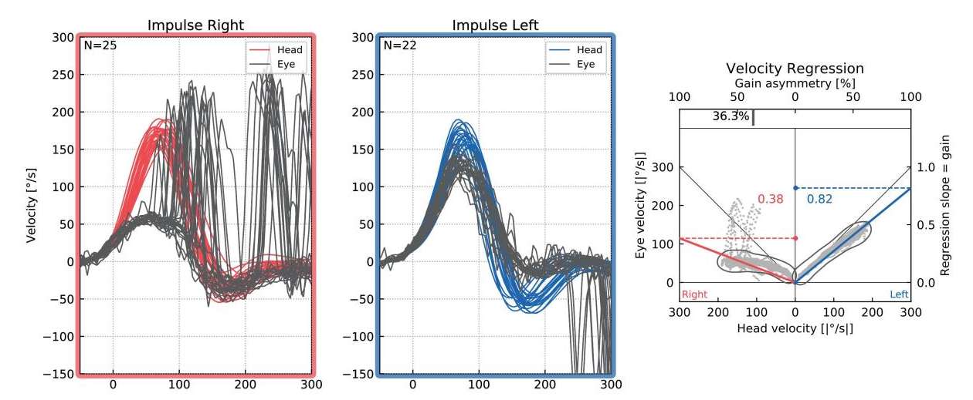
Supplementary Figure 5 shows that the velocity peak of eye movement curve of right horizontal semicircular canal at onset was significantly slower and smaller than the velocity peak of head movement curve,and intensive corrective saccades were visible,with a Gain value of 0.38.Gain asymmetry ratio=0.367.However the velocity peak of eye movement curve of left horizontal semicircular canal was matched similarly the velocity peak of head movement curve,This means that the eye movement can basically follow the head movement.

Supplementary Figure 6
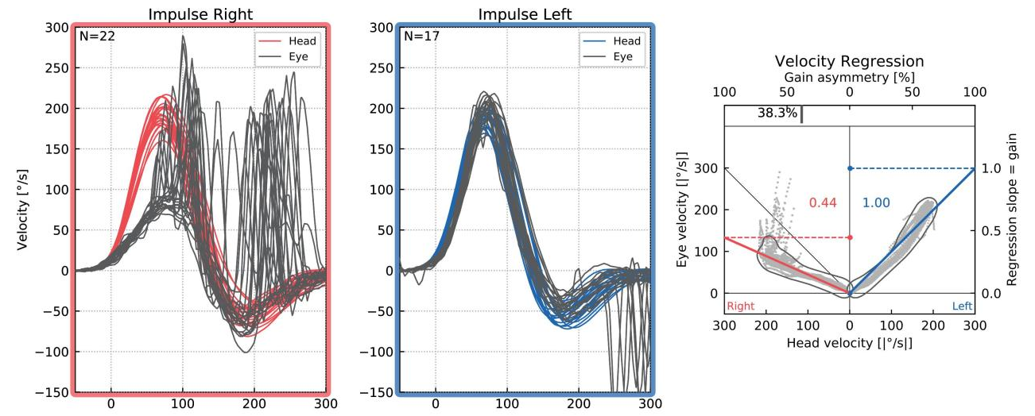
Supplementary Figure 6 shows that the velocity peak of eye movement curve at onset was still slower and smaller than the velocity peak of head movement curve,and some corrective saccades were still visible, with a gain value of 0.44 which was still under 0.8.Gain asymmetry ratio=0.306.However, contrasted to the previous curve (Figure 5.), a slight improvement can be observed.

Supplementary Figure 7
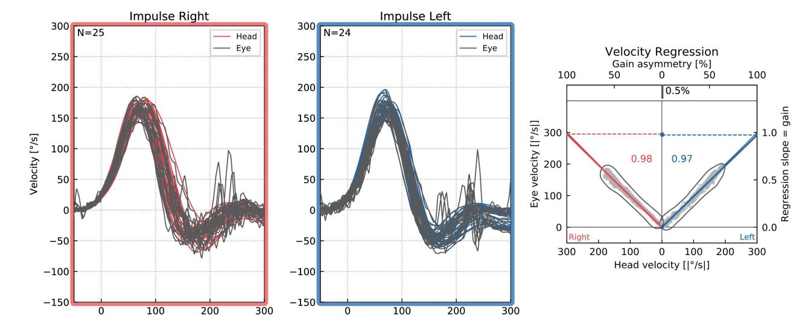
Supplementary Figure 7 velocity peak of eye movement curve at 12 weeks was basically matched with the velocity peak of head movement curve, and only a few corrective saccades were visible, Gain value of 0.98 whicih a significant improvement in the function of the right horizontal canal,can be found in the normal range.Gain asymmetry ratio=0.005.Based on the gain asymmetry, there is no asymmetry in the functioning of the two sides.

Dynamic changes in oVEMP(ocular vestibular evoked myogenic potentials) and cVEMP at onset, at 4 weeks of onset, and at 12 weeks in a patient with VN.
Supplementary Figure 8
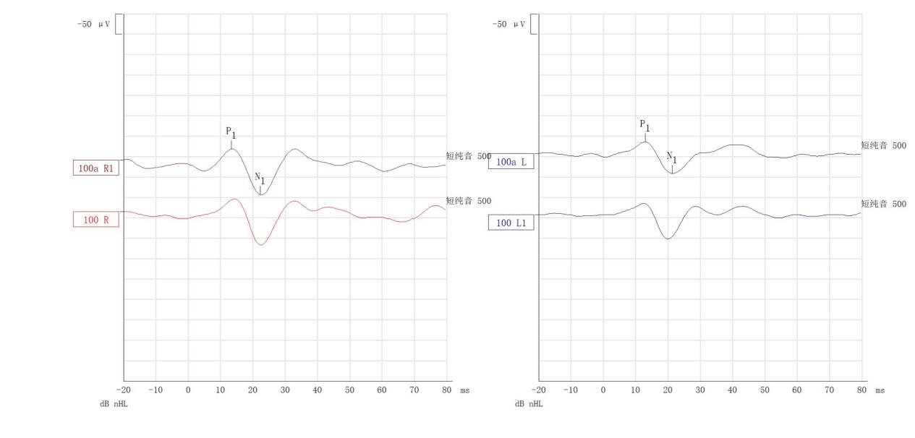
Supplementary Figure 8, no significant abnormality in cVEMP at onset, with an amplitude asymmetry ratio of 25%.N1-P1is the difference value between negative wave recorded and the first positive wave. The calculation of the asymmetry can be found in the methods section of the manuscript.

Supplementary Figure 9
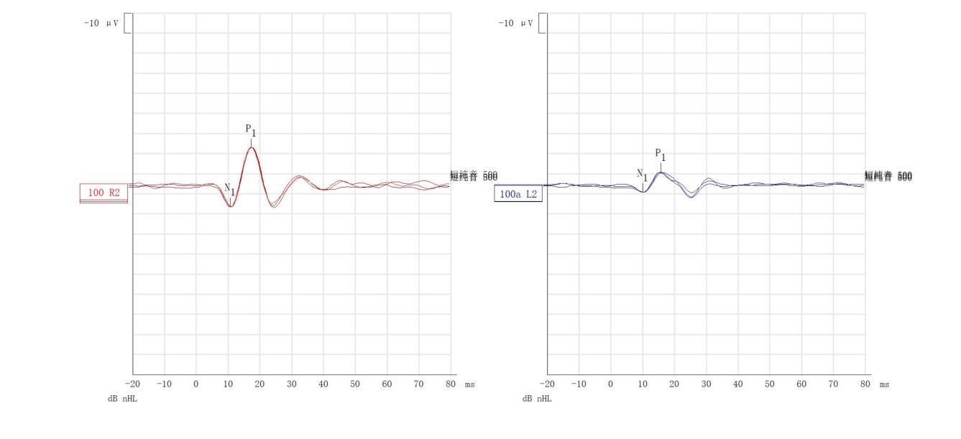
Supplementary Figure 9, oVEMP at onset suggests low amplitude on the left side, N1-P1 is significantly reduced compared to the right side, amplitude asymmetry ratio 44%.The asymmetry presented in this case refers to a significant asymmetry between the functioning of the two sides.We inferred that this was a left-side superior VN because of the presence of abnormal oVEMP and normal cVEMP.

Supplementary Figure 10
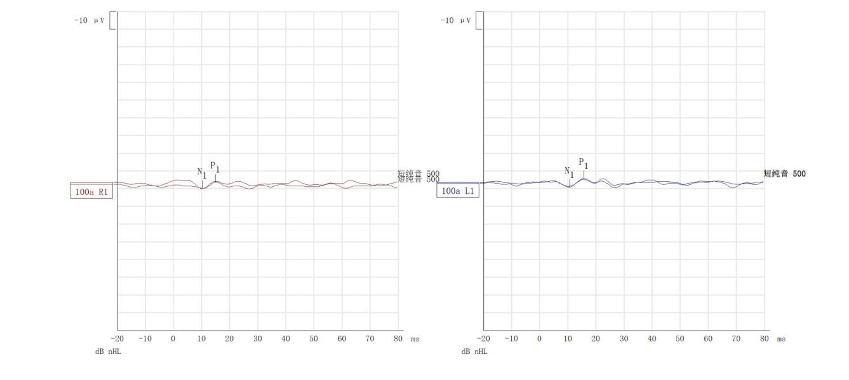 Supplementary Figure 10, oVEMP at 4 weeks after onset suggests basic recovery of left-sided low amplitude bilateral N1-P1 is basically similar, amplitude asymmetry ratio 15%.

Supplementary Figure 11
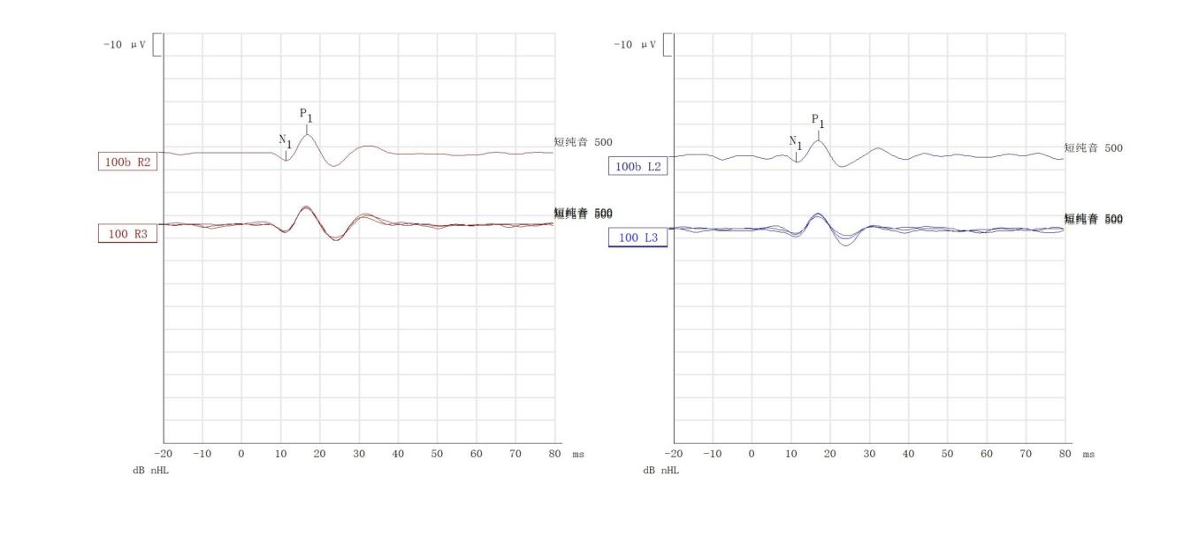
Supplementary Figure 11, oVEMP at 12 weeks after onset suggests basic recovery of left-sided hypoamplitude, bilateral N1-P1 is basically similar, and amplitude asymmetry ratio is 9%.

