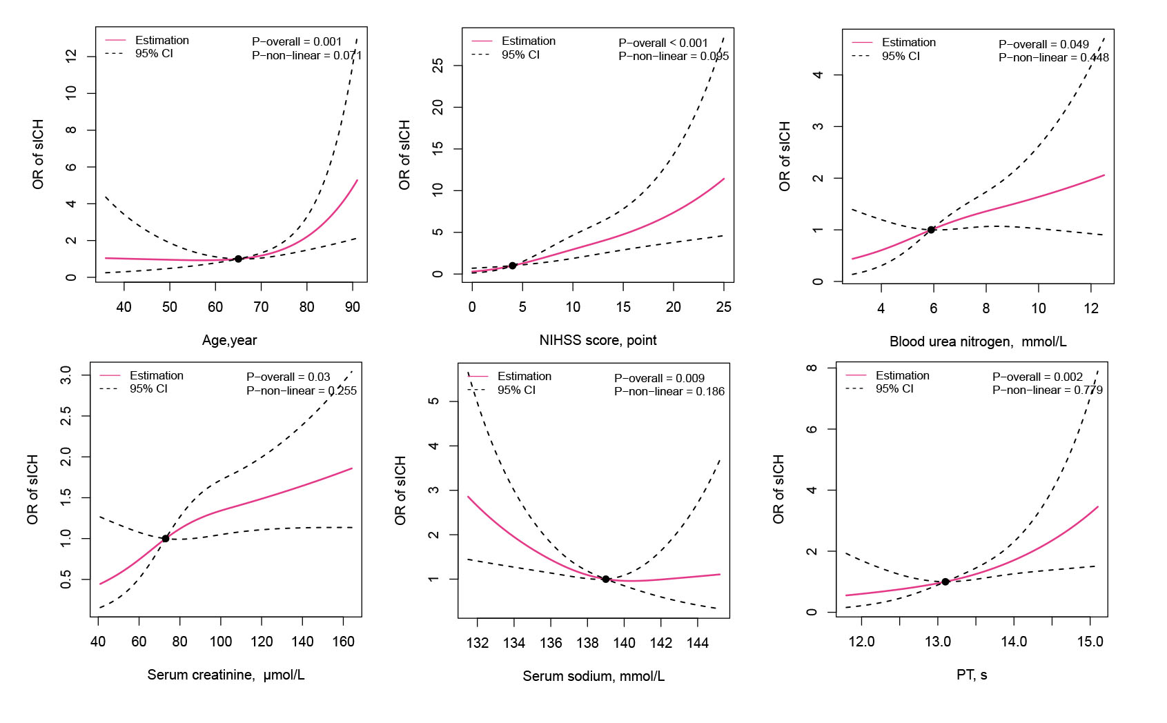
Supplementary Figure 1: Restricted cubic spline illustrated a linear relationship between all continuous variables and sICH. (P overall＜0.05, P nonlinear＞0.05).

