Supporting information
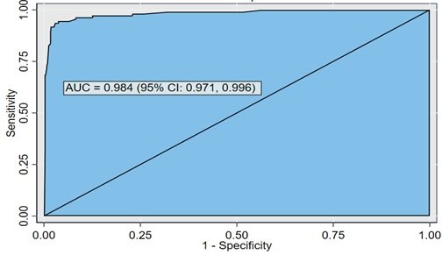
S1 Figure: ROC curve of stroke prediction model
S1 Table: Predictor scores for stroke risk prediction model nomogram at UoGCSH, 2012-2022
Predictor | Category | Score
Sex
 | Female | 0
 | Male | 4.7
Residence
 | Rural | 0
 | Urban | 4.4
Baseline DBP
 | 80-99mmHg | 0
 | ≥100mmHg | 10
Comorbidity
 | No | 0
 | Yes | 5.8
DM
 | No | 0
 | Yes | 3.7
Uncontrolled HTN
 | No | 0
 | Yes | 7

S2 Table: Performance of the risk scores at different cutoff points
Cutoff Point | Sensitivity | Specificity | PPV | NPV | LR+ | LR-
>0.15 | 94.59% | 91.14% | 65.22% | 98.97% | 10.68 | 0.06
>0.16 | 92.79% | 92.88% | 69.59% | 98.66% | 13.03 | 0.08
>0.20 | 92.79% | 93.51% | 71.53% | 98.66% | 14.3 | 0.08
>0.22 | 90.99% | 93.67% | 71.63% | 98.34% | 14.38 | 0.1
>0.24 | 90.99% | 94.46% | 74.26% | 98.35% | 16.43 | 0.1
S3 Table: the ANN estimated importance of predictors in classifying stroke at UoGCSH, 2012-2022.
Independent Variable Importance
 | Importance | Normalized Importance
Sex | 0.077 | 63.6%
Residence | 0.067 | 55.3%
Salt reduction in meal | 0.025 | 20.8%
Baseline SBP | 0.111 | 92.2%
Baseline DBP | 0.098 | 81.4%
Stroke history | 0.047 | 39.0%
Comorbidity | 0.112 | 92.7%
DM | 0.048 | 39.4%
Uncontrolled HTN | 0.121 | 100.0%
Cholesterol | 0.016 | 12.9%
HDL | 0.097 | 80.4%
LDL | 0.108 | 89.8%
Triglyceride | 0.074 | 61.0%

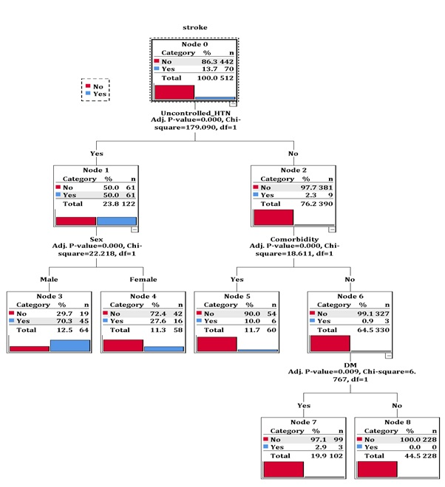
S2 Figure: Classification and decision tree model of the training data
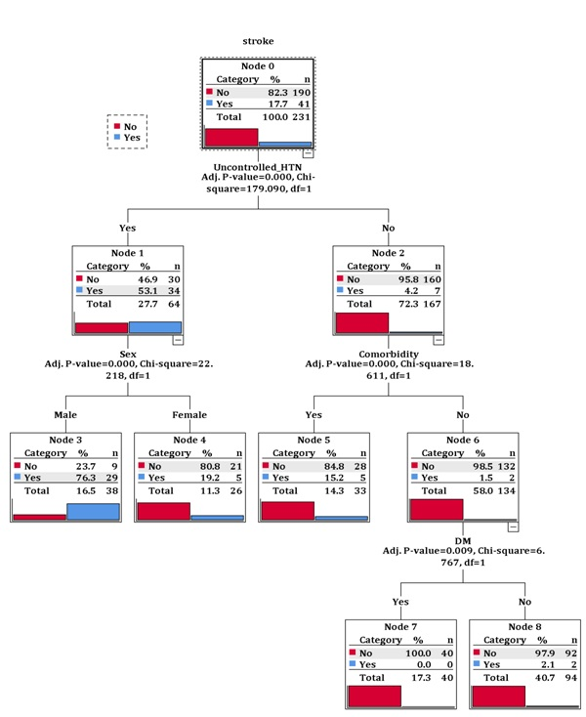
S3 Figure: Classification and decision tree model of the test data
S4 Table: Comparison of multivariable logistic regression model and machine learning algorithms at UoGCSH, 2012-2022
Model | Cutoff  point | AUC  (CI) | Sensitivity  (CI) | Specificity  (CI) | PPV  (CI) | NPV  (CI) | Accuracy  (CI)
Logistic regression | 0.20 | 97.3%  (95.9, 98.7) | 92.8%  (86.3, 96.8) | 93.5%  (91.3, 95.3) | 71.5%  (63.4, 78.7) | 98.7%  (97.4, 99.4) | 93.4%  (91.4, 95.1)
Artificial Neural Network (ANN) | 0.44 | 97.3%  (95.8, 98.8) | 90.1%  (83.0, 95.0) | 96.2%  (94.4, 97.6) | 80.7%  (72.6, 87.2) | 98.2  (96.8, 99.1) | 95.3%  (93.5, 96.7)
Decision tree (DT) | 0.11 | 94.8%  (92.4, 97.2) | 93.7%  (87.4, 97.4) | 86.1%  (83.1, 88.7) | 54.2%  (46.8, 61.4) | 98.7%  (97.4, 99.5) | 87.2%  (84.6, 89.5)
Random forest | 0.28 | 96.5%  (95.1, 97.9) | 93.7%  (87.4, 97.4) | 91.9%  (89.5, 93.9) | 67.1%  (59.1, 74.4) | 98.8%  (97.6, 99.5) | 92.2%  (90.0, 94.0)
Note: AUROC: Area under the Roc Curve, CI: Confidence Interval, PPV: Positive Predictive Value, NPV: Negative Predictive Value

