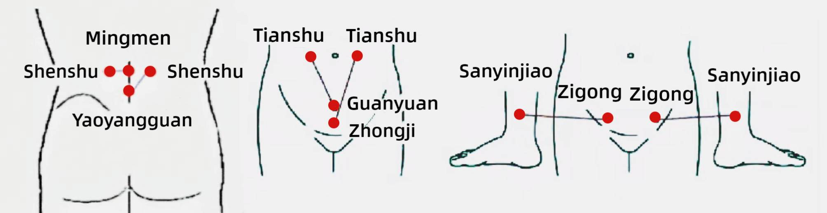
Figure S1. The acupuncture points stimulated in this study: Guanyuan (RN4), Zhongji (RN3), bilateral Sanyinjiao (SP6), bilateral Zigong (EX-CA1), bilateral Tianshu (ST25), bilateral Shenshu (BL23), Yaoyangguan (DU3), and Mingmen (DU4).

