Appendix 1. Patient survey included and programmed in the D-Foot

Heading/question | Field text in D-Foot | Alternative
Occupation |  | Work (state your level of employment in %)  Pensioner  Student  Other
Height | cm
Weight | kg
Body mass index | kg/m²
In which year were you diagnosed with diabetes? | If you do not know exactly, give an approximate answer
Which type of diabetes do you have? |  | Diabetes type 1  Diabetes type 2
Which HbA1c value (known as “long-term blood sugar”) did you have at your last check-up? | If you do not know exactly, give an approximate answer (mmol/mol)
Do you smoke? |  | Yes  No
Do you use snuff? |  | Yes  No
Do you take medicine for high blood pressure? |  | Yes  No
Do you take medicine for cardiovascular disease? |  | Yes  No
Have you previously received shoes or insoles because of your diabetes? |  | Yes  No
If so, in which year did you make your first visit? | YYYY If you do not know exactly, give an approximate answer
Do you think you can walk normally? |  | Yes  No
Do you think you have normal feeling in your feet? |  | Yes  No
Indicate on the scale how much of the day you sit/lie or stand/walk. This applies to the past week. | A scale from “Sit and lie all day” to “Stand or walk all day”
During the past 12 months… | Relates to the following three questions
… have your feet been examined by a doctor or diabetes nurse? |  | Yes  No
… have you received podiatry? |  | Yes  No
… do you think you have received sufficient information relating to self-care of your feet? |  | Yes  No
Does the healthcare professional think you have reduced circulation in your feet? |  | Yes  No
Do you feel numbness/tingling in your feet? |  | Yes  No
Do you feel that your feet are less sweaty now compared with previously? |  | Yes  No
How much pain do you have in your right foot? | A scale from “No pain” to “Extreme pain”
How much pain do you have in your left foot? | -“-
Have you had ulcers on your right foot? |  | Yes  No
Have you had ulcers on your left foot? |  | Yes  No
Note: In the first column (Heading/Question), the question are shown, followed by a column (Field text in D-Foot) describing the text that was programmed in the D-Foot. In the column to the right (Alternative), the different alternative answers are presented.
Appendix 2. Questionnaire to patients with diabetes regarding the self-care of their feet
The survey is in Swedish and translated into English.
Datum: ............... Date: KOD: ............... CODE

Enkätfrågor i syfte att undersöka din uppfattning om egenvård samt dina behov av egenvård. Kryssa i ett svarsalternativ eller skriv ett kort svar Questionnare designed to investigate your perception of self-care and your need for self-care. Put a cross next to one alternative answer or write a short answer.

Om dig About you
- Är du: Are you
☐ Kvinna Female
☐ Man Male
☐ Annan könsidentitet eller uttryck Another gender identity or description

- Din ålder: …………………. Your age

- Motionerar/tränar du? Do you exercise/train?
☐ Aldrig Never
☐ Varannan vecka Every other week
☐ 1 gång i veckan Once a week
☐ Flera gånger i veckan Several times a week
☐ Varje dag Every day

Daglig egenvård Daily self-care

- Gör du en daglig inspektion av dina fötter för att upptäcka sår, rodnad eller svullnad? Do you perform a daily inspection of your feet to identify ulcers, redness or swelling?
Ja Nej Yes No
- Tvättar du dina fötter varje dag? Do you wash your feet every day?
Ja Nej Yes No
- Torkar du fötterna torra efter tvätt? Do you dry your feet after washing them?
Ja Nej Yes No
- Torkar du även mellan tårna? Do you also dry between your toes?
Ja Nej Yes No
- Hur ofta luftar du dina fötter? How often do you expose your feet to the air?
☐ Aldrig Never
☐ Varannan vecka Every other week
☐ 1 gång i veckan Once a week
☐ Flera gånger i veckan Several times a week
☐ Varje dag Every day

- Har du torr hud på fötterna? Do you have dry skin on your feet?
Ja Nej Yes No
- Om ja, använder du mjukgörande krämer eller oljor? If yes, do you use moisturising creams or oils?
Ja Nej Yes No
Om ja, kommer du ihåg namn på produkten du använder dig av? If yes, can you remember the name of the product you use?
  - Namn på produkt: ………………… Name of product
- Har du sprickor på fötterna? Do you have cracked skin on your feet?
Ja Nej Yes No
Om ja, använder du mjukgörande krämer eller oljor? If yes, do you use moisturising creams or oils?
Ja Nej Yes No
Om ja, kommer du ihåg namn på produkten du använder dig av? If yes, can you remember the name of the product you use?
  - Namn på produkt: ………………… Name of product

- Smörjer du mellan tårna? Do you apply cream between your toes?
Ja Nej Yes No
- Går du barfota utomhus? Do you walk barefoot outdoors?
Ja Nej Yes No
- Går du barfota inomhus? Do you walk barefoot indoors?
Ja Nej Yes No
Naglar/ Sår/ Vårtor Nails/Ulcers/Warts
- Kan du klippa dina tånaglar själv? Can you cut your toenails yourself?
Ja Nej Yes No
- Har du svårigheter att nå din vänstra stortå med din högra hand och vice versa? Do you have difficulty reaching your big left toe with your right hand and vice versa?
☐ Ingen svårighet No difficulty
☐ Viss svårighet Some difficulty
☐ Kan ej Unable to do so

- Har du nagelförändringar till exempel nageltrång och/eller förtjockad nagel? Do you have nail deformities, such as ingrown toenails and/or thickened nails?
Ja Nej Yes No
- Har du fotvårtor? Do you have foot warts?
Ja Nej Yes No
Om ja, hur behandlar du vårtan? If yes, how do you treat them?
☐ Produkt som innehåller syra (tex salicylsyra) Product containing acid (such as salicylic acid)
☐ Frysbehandling Cryotherapy
☐ Behandlar ej Don’t treat them
☐ Kommer inte ihåg vilken produkt jag använder mig av I don’t remember what product I use

Lämpliga skor/ strumpor Suitable shoes/socks/stockings
- Har du en lämplig sko som sitter bra på foten med t.ex. med snörning eller kardborreband? D.v.s. en sko som har rätt längd, bredd, tåhöjd för dina fötter och som passar foten. Do you have suitable shoes that fit your feet snugly and have laces or velcro, for example? In other words, shoes that are the right length, width, toe height for your feet and fit them snugly?

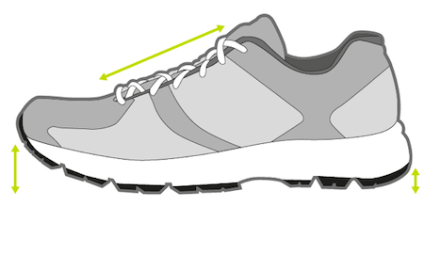
Ja Nej Yes No
- Använder du skor utan att använda strumpor? Do you wear shoes without wearing socks/stockings?
☐ Aldrig Never
☐ Varannan vecka Every other week
☐ 1 gång i veckan Once a week
☐ Flera gånger i veckan Several times a week
☐ Varje dag Every day

- Byter du strumpor varje dag? Do you change your socks/stockings every day?
Ja Nej Yes No
- Vilka material är det i dina strumpor? What material/s are your socks/stockings made of?
☐ Mer än 60% bomull More than 60% cotton
☐ Mer än 60% ull More than 60% wool
☐ Mer än 60% syntet More than 60% synthetic
☐ Vet ej Don’t know
☐ Annat: ............................... Something else
- Använder du stödstrumpor? Do you wear compression socks/stockings?
Ja Nej Yes No
- Använder du hälskydd mot torr hud med sprickor? Do you use heel protection against dry skin with cracks?
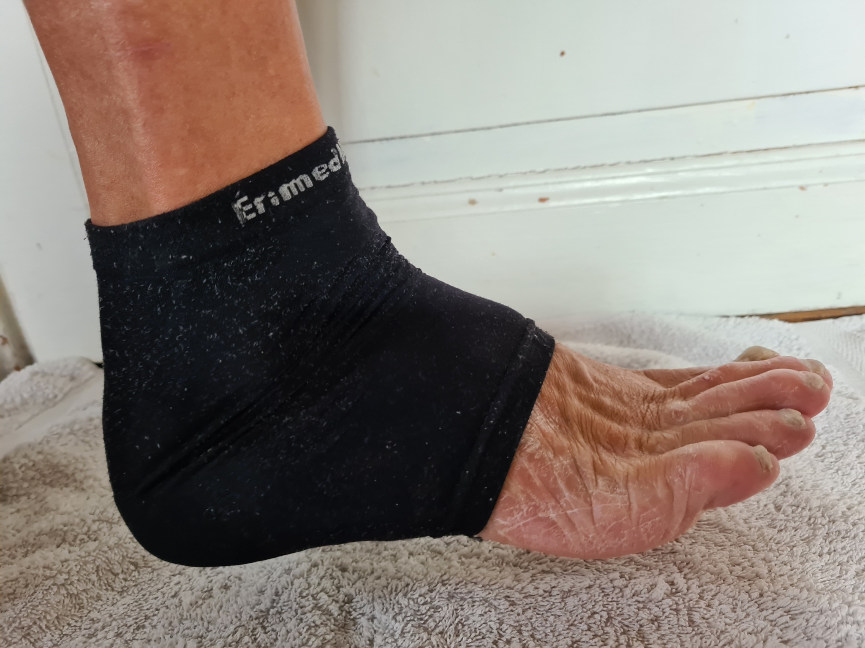

Ja Nej Yes No
- Har du tår som sitter tätt tillsammans? Are your toes very close together?
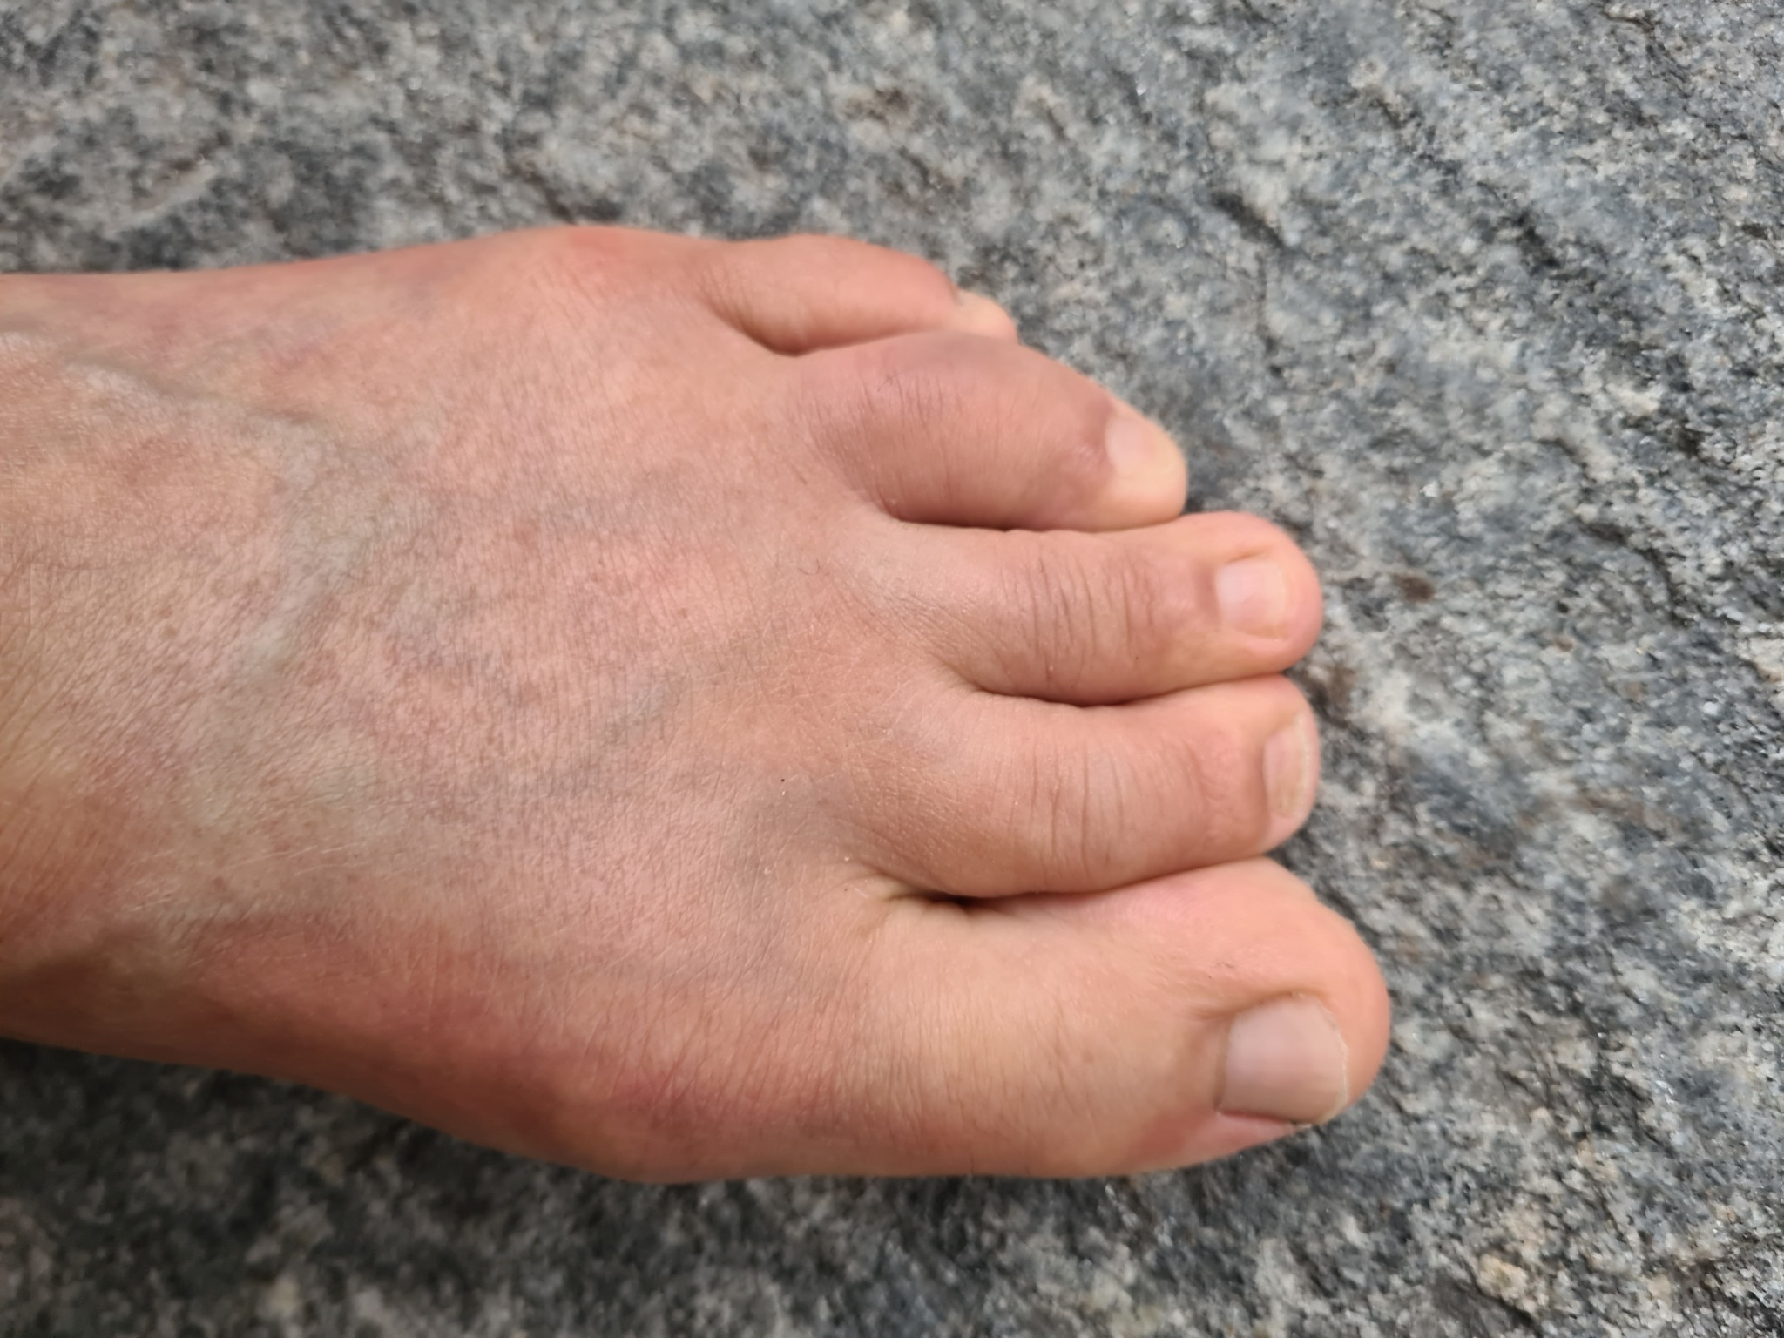
Ja Nej Yes No
- Om ja, använder du tåspridare? If yes, do you use toe separators?
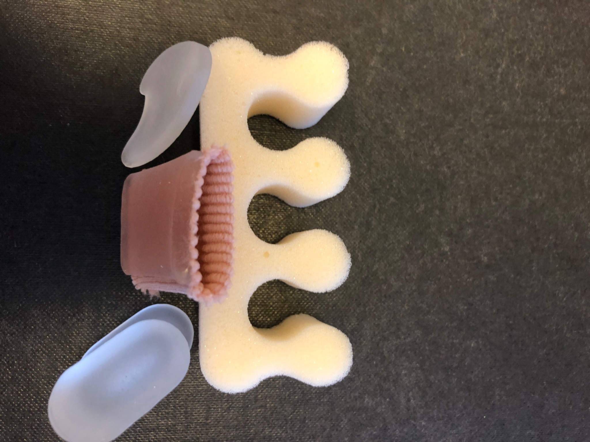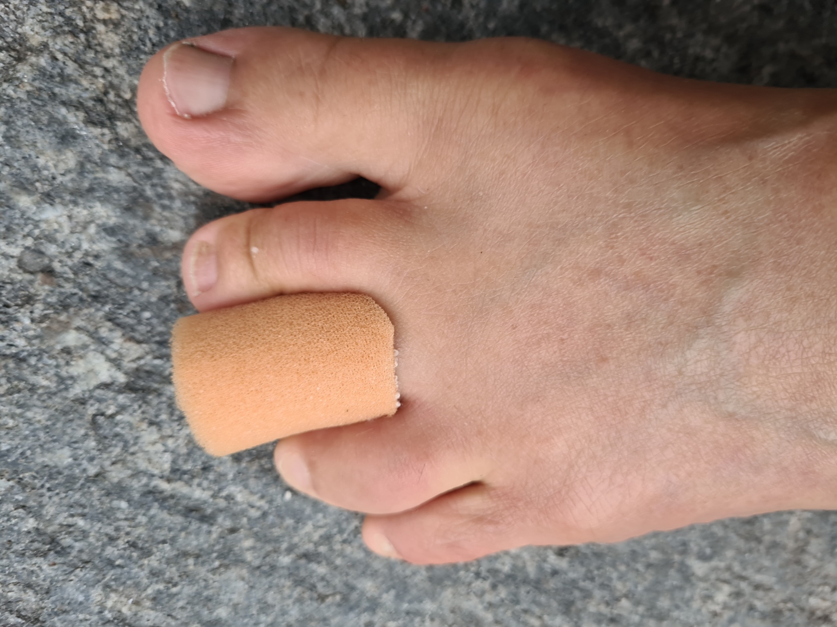

Ja Nej Yes No

- Har du svårigheter att gå i trappor? Do you have difficulty going up and down stairs?

Ja Nej Yes No

- Har du svårigheter att resa dig från en stol? Do you have difficulty getting out of chairs?

Ja Nej Yes No

- Har du fotsmärta på natten? Do you have pain in your feet at night?

Ja Nej Yes No

Om ja, markera med ett kryss i respektive ruta 0–10 där 0 = ingen smärta, 10 = extrem smärta If yes, please put a cross in the relevant square, 0–10, where 0 = no pain and 10 = extreme pain.

0 | 1 | 2 | 3 | 4 | 5 | 6 | 7 | 8 | 9 | 10

På en skala 0–10 hur mycket smärta har du i fötterna i vila? On a scale of 0-10, how much pain do you have in your feet when resting?

Markera med ett kryss i respektive ruta 0–10 där 0 = ingen smärta, 10 = extrem smärta Please put a cross in the relevant square, 0–10, where 0 = no pain and 10 = extreme pain.

0 | 1 | 2 | 3 | 4 | 5 | 6 | 7 | 8 | 9 | 10

På en skala 0–10 hur mycket smärta har du i fötterna när du går? On a scale of 0-10, how much pain do you have in your feet when walking?

Markera med ett kryss i respektive ruta 0–10 där 0 = ingen smärta, 10 = extrem smärta Please put a cross in the relevant square, 0–10, where 0 = no pain and 10 = extreme pain.

0 | 1 | 2 | 3 | 4 | 5 | 6 | 7 | 8 | 9 | 10

- Känner du oro över din fothälsa? Are you worried about the health of your feet?

Ja Nej Yes No

Om ja, vad är det du är orolig för? If yes, what are you worried about?

Answer: …….

- Har du tidigare fått information om hur du ska egenvårda dina fötter via apoteket? Have you previously received information from the pharmacy on how to perform self-care on your feet?

Ja Nej Yes No

- Hur skulle du vilja att Apoteket hjälper dig att ta hand om dina fötter? How would you like the pharmacy to help you take care of your feet?

Answer: …….

- Vad gör du i din vardag för att förebygga fotsår? What do you do every day to prevent foot ulcers?

Answer: …….

