Sensitivity analyses of nonsignifcant results

Table S 1 Sample characteristcs, sensitivity analyses of nonsignificant results
Variable |  | n  (each group) | Obtained ES (95% CI) (interpretation) | ES able to detectª  (interpretation)
Gender | Female | 183 (59 + 124) | -0.127^{p} (s) | 0.207^{w} (below m)
Gender | Male | 183 (59 + 124) | -0.127^{p} (s) | 0.207^{w} (below m)
CTO |  | 163 (58 + 105) | -0.077^{p} (s) | 0.219^{w} (below m)
Diagnoses | Psychosis | 182 (59 + 123) | -0.081^{p} (s) | 0.207^{w} (below m)
Diagnoses | Bipolar | 182 (59 + 123) | 0.035^{p} (s) | 0.207^{w} (below m)
Mental health at baseline | OQ-45-2 | 175 (57 + 118) | 0.144^{d} (-0.2; 0.5) (s) | 0.454^{d} (below m)
Mental health at baseline | GAF-S | 177 (58 + 119) | 0.184^{d} (-0.1; 0.5) (s) | 0.451^{d} (below m)
Mental health at baseline | GAF-F | 177 (58 + 119) | -0.158^{d} (-0.5; 0.2) (s) | 0.451^{d} (below m)
Note. MFT = medication-free treatment, TAU = treatment as usual, OQ = Outcome Questionnaire, GAF-F/S = Global Assessment of Functioning, function scale and symptom scale, ES = Effect size, s = small, m = medium, l = large,
ª = Sensitivity analysis of required effect size with power 0.8 and alpha 0.05
^{p} = Phi,
^{w} = w,
^{d} = Cohen’s d

Table S 2 Assessment received, sensitivity analyses of nonsignificant results
 | Source | N valid | ES obtained (interpretation) |  | ES able to detectª (interpretation)
 | Source | N valid | regimen | ward | regimen | ward
 | Source | N valid | Phi | Cramer’s V | W
Received assessment | Clinician | 125 | 0.107  (s) | 0.184  (s-m) | 0.251  (below m) | 0.278  (below m)
Received assessment | Patient | 130 | 0.147  (s) | 0.171  (between s and m) | 0.246  (below m) | 0.272  (below m)
Note. MFT = medication-free treatment, TAU = treatment as usual, ES = Effect size, s = small, m = medium, l = large, *Not enough reports from distant TAU ward to compare.
ª = Sensitivity analysis of required effect size with power 0.8 and alpha 0.05

Table S 3 Patient-rated experiences of admission, sensitivity analyses of nonsignificant results
 | N valid | ES obtained |  | ES able to detectª
 | N valid | η² Point estimate  (95% CI) (interpretation) |  | Cohen’s f  (interpretation)
 | N valid | regimen | ward | regimen | ward
Support for personal recovery (Inspire support) | 134 | 0.02  (0.00; 0.08)  (below m) | 0.03  (0.00; 0.10)  (m) | 0.244  (m) | 0.271  (just above m)
Shared decision making (CollaboRATE) | 128 | 0.02  (0.00; 0.08)  (below m) | 0.01  (0.00; 0.07)  (s) | 0.250  (m) | 0.278  (just above m)
Alliance  (WAI-SP) | 137 | 0.01  (0.00; 0.06)  (s) | 0.01  (0.00; 0.05)  (s) | 0.241  (m) | 0.268  (just above m)
Note. MFT = medication-free treatment, TAU = treatment as usual, ES = Effect size, s = small, m = medium, l = large
ª = Sensitivity analysis of required effect size with power 0.8 and alpha 0.05

Questions from questionnaires used in this study that are not from standardized instruments, translated from Norwegian

Figure S 1 Question about CTO, patient form, baseline
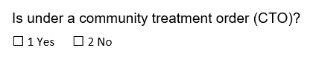

Figure S 2 Benefit of interventions, patient form, end of treatment
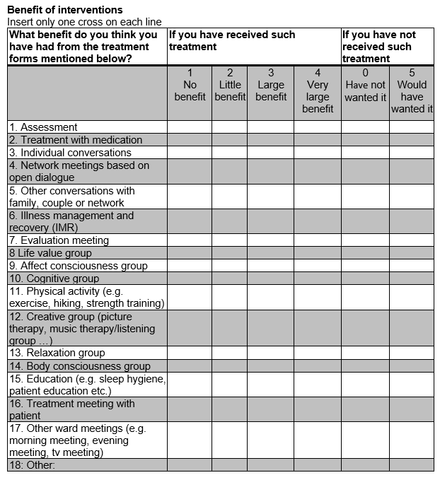
Figure S 3 Use of medication, clinician form, start and end of treatment
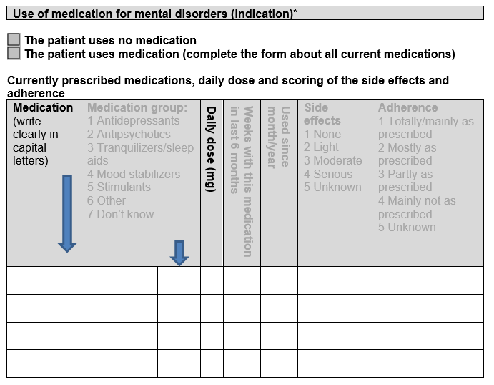
Note. Information in light grey is not used in the current article.
*At the end of treatment, the heading is Use of medication by mental disorders (indication) during admission

Figure S 4 Treatment duration, clinician form, end of treatment

Figure S 5 Diagnosis, clinician form, end of treatment
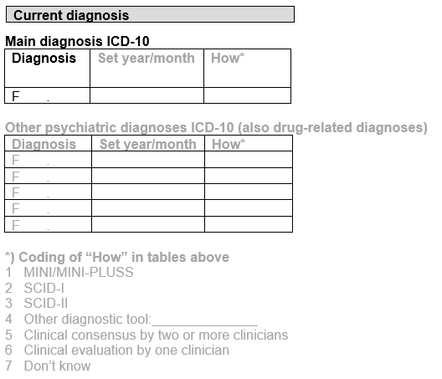
Note. Information in light grey is not used in the current article

Figure S 6 Treatment received, clinician form, end of treatment
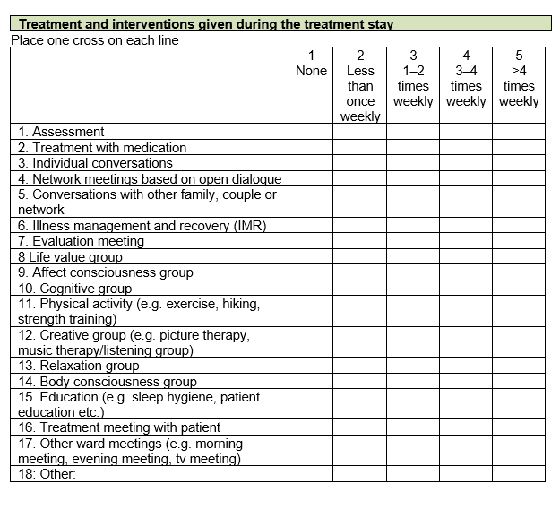

Figure S 7 General introduction, patient form, baseline
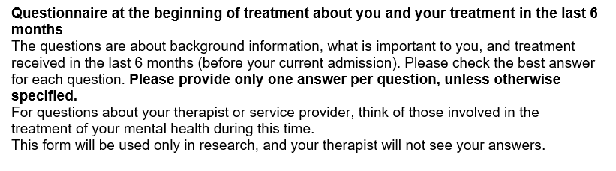
Figure S 8 General intruduction, patient form, end of treatment
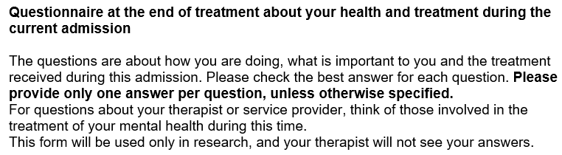

Figure S 9 General introduction, clinician form, baseline and treatment end

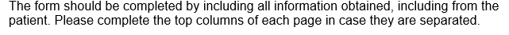

Figure S 10 General ending, patient form, baseline and treatment end


Interview guides
Translated from Norwegian

Interview with patients
Part one: Reasons for medication-free treatment
1. This ward is called a ‘medication-free inpatient ward’. What does this term mean to you?
2. When did you first hear about this phenomenon?
3. Before you came, how did you picture you would notice the difference between a medication-free ward and an ordinary ward?
4. How did you first hear about this ward?
5 What was important to you when being referred for this admission?
Was it important for you to come to a medication-free ward?
If yes | If no
6. Why was this important to you?  7. Do you have any experiences that contribute to this being important for you? Would you like to share some of these?  8. How long have you wanted such a service? | 6. What do you think about the ward being medication free?  7. If you could choose freely between a medication-free and an ordinary ward, all else being equal (treatment offer, duration, waiting time, persons, own reasons, etc.) which would you have chosen?  a. Why?
Part two: Experience of medication-free treatment
9. All in all, what do you think about your stay here on the medication-free ward?
- What have you been most satisfied with during the stay?
- What have you been least satisfied with during the stay?
- If you had met another man or woman who was in need of mental health care, would you recommend this ward?
10. If you have been admitted to another inpatient ward earlier (including this ward before it became a medication-free ward), what would you say is the biggest difference between those wards and this one?
11. During your stay, if you have chosen to not use medication or to reduce medication, what has this been like?
- Do you think you have received help in working with your problems in other ways (than taking medications)?
- Have you been offered alternatives/help you have not received elsewhere?
- Do you feel supported in tackling your challenges without medication?
12. During your stay, did you feel you had an influence on your treatment? (decide, affect, participate, be heard)
- Do you feel you had enough influence, or would you have preferred more?
- If much influence: Do you think this opportunity to decide would be as good on a ward that was not medication free?
14. If you wish to give advice to us working here to improve the treatment, what would it be?
15. If you could choose exactly the treatment you wanted, what would you choose?

If time is left:
1. Do you feel your thoughts about choices and needs regarding treatment were taken into consideration by therapists (therapists in general, not just those you have met)?
2. What kind of experiences do you have from conversations about treatment choices? Some say they do not dare to tell all about how they feel, because they are afraid they will not get to choose the treatment they want but may be forced to take medicines, or even admitted involuntarily. Do you have such thoughts?

Interview with staff

Theme 1: What is medication-free treatment at [ward name]?
- Can you remember the first time you heard about ‘medication-free treatment’? Tell me about that. What did you think? How is it now?
- How do you understand the term ‘medication-free treatment’? What does it entail?

Theme 2: What characterizes the patients in the medication-free ward?
- Can you tell me what kind of people come here? Are they different from patients admitted here earlier?

Theme 3: What characterizes the workday in a medication-free ward?
- Can you describe your most important tasks in the medication-free treatment programme? Are they different from before?
- Can you describe situations that are typical when working in a medication-free ward? Both positive and challenging aspects.
- Can you remember a situation where you experienced conflicts between the concept of medication-free treatment and other concerns?
- Have you experienced conflict between your clinical opinions and the medication-free mandate?

Theme 4: What does medication-free treatment entail for the patients?
- What kind of experiences or benefits do you think patients receive in the medication-free ward? Are these different from earlier?
- Alternatively, in what way do patients benefit from medication-free treatment? Do you think this treatment is better than the treatment they received earlier?

Theme 5: What does medication-free treatment entail for the staff?
- What do you think about the implementation of medication-free treatment at [ward name]? (What do you think the others think? What do you think now?)
- Alternatively, what kind of experiences do you think other employees have working with medication-free treatment at [ward name]?
- Have you changed views in any areas because of working in a medication-free ward? If so, what has changed?

Ending:
- The theme of this interview has been your experiences with medication-free treatment. Is there anything important I have not asked you about?
- Is there anything else you would like to say before finishing? Clarifications, elaborations.

Reliability, multi-item scales
Table S 4 Reliability of multi-item scales in our sample
 | Cronbach’s alpha
Satisfaction (CSQ-8) | .920
Support for personal recovery (Inspire support) | .932
Shared decision-making (CollaboRATE) | .901
Alliance (WAI-SP) | .933

Investigation of patterns between wards on treatment characteristics
Table S 5 Statistics per ward, continuous variables
Continuous variables |  | Source | MFT |  | NTAU |  | DTAU |  | NTAU more similar to MFT or DTAU | Anova ward level
 |  | Source | n valid | M  (SD) | n valid | M  (SD) | n valid | M  (SD) | NTAU more similar to MFT or DTAU | F(B,W) | p value | η²  Point estimate  (95% CI)
Treatment duration, weeks |  | C | 59 | 8.9  (2.2) | 66 | 4.0  (1.9) | 57 | 5.4  (2.3) | DTAU | 84.6  (2, 179) | .000 | 0.49  (0.38; 0.56)
Mean intensity, psychosocial treatment elements |  | C | 56 | 2.5  (0.2) | 52 | 2.2  (0.4) | 19 | 2.3  (0.4) | DTAU | 12.6^{a,b}  (2, 44) | .000^{b} | 0.16  (0.05; 0.26)
Number of psychosocial treatment elements received |  | C | 56 | 9.8  (1.4) | 52 | 8.1  (2.1) | 19 | 9.9  (2.0) | MFT | 13.9  (2, 124) | <.001 | 0.18  (0.07; 0.29)
 |  | P | 49 | 10.5  (2.6) | 42 | 9.7  (3.2) | 42 | 9.2  (3.0) | DTAU | 2.6  (2, 130) | .081 | 0.04  (0.00; 0.11)
Dose^{c} change, all psychotropics |  | C | 59 | –0.4  (1.2) | 66 | 0.0  (1.3) | 57 | 0.0  (1.1) | DTAU | 2.1  (2, 179) | .123 | 0.02  (0.00; 0.08)
Satisfaction (CSQ-8) |  | P | 48 | 28.5  (3.5) | 43 | 26.4  (4.3) | 43 | 26.5  (4.3) | DTAU | 4.0  (2, 131) | .021 | 0.06  (0.00;0.14)
Support for personal recovery (Inspire support) |  | P | 48 | 72.4  (14.7) | 43 | 66.1  (13.2) | 43 | 70.8  (18.0) | DTAU | 2.0  (2, 131) | .140 | 0.03  (0.00; 0.10)
Shared decision-making (CollaboRATE) |  | P | 47 | 7.5  (1.3) | 42 | 7.2  (1.5) | 39 | 7.1  (1.8) | DTAU | 0.9  (2, 125) | .391 | 0.01  (0.00; 0.07)
Alliance (WAI-SP) |  | P | 51 | 5.6  (1.0) | 43 | 5.5  (1.1) | 43 | 5.5  (0.9) | DTAU | 0.5  (2, 134) | .586 | 0.01  (0.00; 0.05)
Being respected for not wanting medication (M7) | All | P | 37 | 4.8  (0.5) | 17 | 3.9  (1.2) | 17 | 3.8  (1.2) | DTAU | 6.9^{a,b}  (2, 36) | .003^{b} | 0.22  (0.06; 0.36)
Being respected for not wanting medication (M7) | Not CTO | P | 36 | 4.8  (0.5) | 16 | 4.1  (0.9) | 14 | 3.8  (1.3) | DTAU | 6,7^{a,b}  (2, 27) | .004^{b} | 0,25  (0,07; 0.39)
Note. N = 183 (MFT, n = 59; Neighboring TAU, n = 66; Distant TAU, n = 58), MFT = medication-free treatment, NTAU = Neighboring comparison ward, DTAU = Distant comparison ward, C = clinician, P = patient, italic = neighboring TAU more similar to MFT than distant TAU
ªAsymptotically F distributed
^{b}Brown-Forsythe test for scewed variables violating Levene’s test of homogeneity of variance
^{c}Dose = Defined daily dose (DDD) according to the WHO

Table S 6 Anova Multiple comparisons at ward level for contiuous variables using the Tukey HSD test
Dependent Variable |  | Wards |  | Mean Difference  (I-J) | SD | p | 95% CI |  | Comment
 |  | I | J
Satisfaction (CSQ-8) |  | MFT | NTAU | 2.1 | 0.8 | 0.042 | 0.1 | 4.1 | MFT higher than both comparisons
 |  | MFT | DTAU | 2.0 | 0.8 | 0.048 | 0.0 | 4.0 | MFT higher than both comparisons
 |  | NTAU | MFT | -2.1 | 0.8 | 0.042 | -4.1 | -0.1 | MFT higher than both comparisons
 |  | NTAU | DTAU | 0.0 | 0.9 | 0.998 | -2.1 | 2.0 | MFT higher than both comparisons
 |  | DTAU | MFT | -2.0 | 0.8 | 0.048 | -4.0 | 0.0 | MFT higher than both comparisons
 |  | DTAU | NTAU | 0.0 | 0.9 | 0.998 | -2.0 | 2.1 | MFT higher than both comparisons
Support for personal recovery (Inspire support) |  | MFT | NTAU | 6.3 | 3.2 | 0.132 | -1.4 | 13.9 | No significant differences  Insufficient power to detect eventual below medium effects.
 |  | MFT | DTAU | 1.6 | 3.2 | 0.877 | -6.1 | 9.2
 |  | NTAU | MFT | -6.3 | 3.2 | 0.132 | -13.9 | 1.4
 |  | NTAU | DTAU | -4.7 | 3.3 | 0.337 | -12.6 | 3.2
 |  | DTAU | MFT | -1.6 | 3.2 | 0.877 | -9.2 | 6.1
 |  | DTAU | NTAU | 4.7 | 3.3 | 0.337 | -3.2 | 12.6
Shared decision making (CollaboRATE) |  | MFT | NTAU | 0.4 | 0.3 | 0.524 | -0.4 | 1.1
 |  | MFT | DTAU | 0.4 | 0.3 | 0.425 | -0.4 | 1.2
 |  | NTAU | MFT | -0.4 | 0.3 | 0.524 | -1.1 | 0.4
 |  | NTAU | DTAU | 0.1 | 0.3 | 0.982 | -0.8 | 0.9
 |  | DTAU | MFT | -0.4 | 0.3 | 0.425 | -1.2 | 0.4
 |  | DTAU | NTAU | -0.1 | 0.3 | 0.982 | -0.9 | 0.8
Alliance (WAI-SP) |  | MFT | NTAU | 0.2 | 0.2 | 0.631 | -0.3 | 0.7
 |  | MFT | DTAU | 0.2 | 0.2 | 0.674 | -0.3 | 0.7
 |  | NTAU | MFT | -0.2 | 0.2 | 0.631 | -0.7 | 0.3
 |  | NTAU | DTAU | 0.0 | 0.2 | 0.998 | -0.5 | 0.5
 |  | DTAU | MFT | -0.2 | 0.2 | 0.674 | -0.7 | 0.3
 |  | DTAU | NTAU | 0.0 | 0.2 | 0.998 | -0.5 | 0.5
Being respected for not wanting medication (M7) | All | MFT | NTAU | 0.9 | 0.3 | 0.003 | 0.3 | 1.5 | MFT higher than both comparisons
Being respected for not wanting medication (M7) | All | MFT | DTAU | 1.0 | 0.3 | 0.001 | 0.3 | 1.6 | MFT higher than both comparisons
Being respected for not wanting medication (M7) | All | NTAU | MFT | -0.9 | 0.3 | 0.003 | -1.5 | -0.3 | MFT higher than both comparisons
Being respected for not wanting medication (M7) | All | NTAU | DTAU | 0.1 | 0.3 | 0.980 | -0.7 | 0.8 | MFT higher than both comparisons
Being respected for not wanting medication (M7) | All | DTAU | MFT | -1.0 | 0.3 | 0.001 | -1.6 | -0.3 | MFT higher than both comparisons
Being respected for not wanting medication (M7) | All | DTAU | NTAU | -0.1 | 0.3 | 0.980 | -0.8 | 0.7 | MFT higher than both comparisons
Being respected for not wanting medication (M7) | Not CTO | MFT | NTAU | 0,8 | 0,2 | 1,5 | 0,8 | 0,2 | MFT higher than both comparisons
Being respected for not wanting medication (M7) | Not CTO | MFT | DTAU | 1,0 | 0,4 | 1,6 | 1,0 | 0,4 | MFT higher than both comparisons
Being respected for not wanting medication (M7) | Not CTO | NTAU | MFT | -0,8 | -1,5 | -0,2 | -0,8 | -1,5 | MFT higher than both comparisons
Being respected for not wanting medication (M7) | Not CTO | NTAU | DTAU | 1,4 | -0,6 | 0,9 | 1,4 | -0,6 | MFT higher than both comparisons
Being respected for not wanting medication (M7) | Not CTO | DTAU | MFT | -1,0 | -1,6 | -0,4 | -1,0 | -1,6 | MFT higher than both comparisons
Being respected for not wanting medication (M7) | Not CTO | DTAU | NTAU | -0,1 | -0,9 | 0,6 | -0,1 | -0,9
Dose change, all psychotropics |  | MFT | NTAU | -0.4 | 0.2 | 0.173 | -0.9 | 0.1 | Differences only significant at regimen level.  MFT had 0.4 standard doses larger dose reduction than both comparison wards.
 |  | MFT | DTAU | -0.4 | 0.2 | 0.179 | -0.9 | 0.1
 |  | NTAU | MFT | 0.4 | 0.2 | 0.173 | -0.1 | 0.9
 |  | NTAU | DTAU | 0.0 | 0.2 | 0.999 | -0.5 | 0.5
 |  | DTAU | MFT | 0.4 | 0.2 | 0.179 | -0.1 | 0.9
 |  | DTAU | NTAU | 0.0 | 0.2 | 0.999 | -0.5 | 0.5
Number of psychosocial treatment elements received (c) |  | MFT | NTAU | 1.7 | 0.4 | <.001 | 0.9 | 2.5 | MFT higher than neighboring TAU  Distant TAU higher than Neighboring TAU
 |  | MFT | DTAU | -0.1 | 0.5 | 0.973 | -1.3 | 1.0
 |  | NTAU | MFT | -1.7 | 0.4 | <.001 | -2.5 | -0.9
 |  | NTAU | DTAU | -1.8 | 0.5 | <.001 | -3.0 | -0.7
 |  | DTAU | MFT | 0.1 | 0.5 | 0.973 | -1.0 | 1.3
 |  | DTAU | NTAU | 1.8 | 0.5 | <.001 | 0.7 | 3.0
Number of psychosocial treatment elements received (p) |  | MFT | NTAU | 0.9 | 0.6 | 0.341 | -0.6 | 2.3 | Number was highest on medication-free ward, but this only reached statistical significance in regimen level analyses.
 |  | MFT | DTAU | 1.4 | 0.6 | 0.072 | -0.1 | 2.8
 |  | NTAU | MFT | -0.9 | 0.6 | 0.341 | -2.3 | 0.6
 |  | NTAU | DTAU | 0.5 | 0.6 | 0.713 | -1.0 | 2.0
 |  | DTAU | MFT | -1.4 | 0.6 | 0.072 | -2.8 | 0.1
 |  | DTAU | NTAU | -0.5 | 0.6 | 0.713 | -2.0 | 1.0
Psychosocial treatment, mean intensity 1→5a |  | MFT | NTAU | 0.3 | 0.1 | 0.000 | 0.2 | 0.5 | MFT higher than neighboring TAU
 |  | MFT | DTAU | 0.1 | 0.1 | 0.221 | -0.1 | 0.4 | MFT higher than neighboring TAU
 |  | NTAU | MFT | -0.3 | 0.1 | 0.000 | -0.5 | -0.2 | MFT higher than neighboring TAU
 |  | NTAU | DTAU | -0.2 | 0.1 | 0.178 | -0.4 | 0.1 | MFT higher than neighboring TAU
 |  | DTAU | MFT | -0.1 | 0.1 | 0.221 | -0.4 | 0.1 | MFT higher than neighboring TAU
 |  | DTAU | NTAU | 0.2 | 0.1 | 0.178 | -0.1 | 0.4 | MFT higher than neighboring TAU
Treatment duration weeks |  | MFT | NTAU | 4.9 | 0.4 | 0.000 | 4.0 | 5.8 | All wards different  MFT>DTAU>NTAU
 |  | MFT | DTAU | 3.5 | 0.4 | 0.000 | 2.6 | 4.4 | All wards different  MFT>DTAU>NTAU
 |  | NTAU | MFT | -4.9 | 0.4 | 0.000 | -5.8 | -4.0 | All wards different  MFT>DTAU>NTAU
 |  | NTAU | DTAU | -1.4 | 0.4 | 0.001 | -2.3 | -0.5 | All wards different  MFT>DTAU>NTAU
 |  | DTAU | MFT | -3.5 | 0.4 | 0.000 | -4.4 | -2.6 | All wards different  MFT>DTAU>NTAU
 |  | DTAU | NTAU | 1.4 | 0.4 | 0.001 | 0.5 | 2.3 | All wards different  MFT>DTAU>NTAU
Note. N = 183 (MFT, n = 59; Neighboring TAU, n = 66; Distant TAU, n = 58), Bold = The mean difference is significant at the 0.05 level, MFT = Medication-free treatment, NTAU = Neighboring TAU, DTAU = Distant TAU, p =patient reported, c = clinician reported

Table S 7 Categorical variables on treatment characteristcs, descriptive statistics on ward level
Categorical variables | Source | MFT |  | NTAU |  | DTAU |  | NTAU more similar to MFT or DTAU
Categorical variables | Source | n valid | Received  n (valid %) | n valid | Received  n (valid %) | n valid | Received  n (valid %) | NTAU more similar to MFT or DTAU
Medication treatment received | Clinician | 56 | 43  (76.8) | 51 | 49  (96.1) | 18 | 17  (94.4) | DTAU
Medication treatment received | Patient | 46 | 25  (54.3) | 42 | 35  (83.3) | 40 | 40  (100) | DTAU
Assessment received | Clinician | 55 | 32  (58.2) | 51 | 32  (62.7) | 19 | 16  (84.2) | MFT
Assessment received | Patient | 48 | 31  (64.6) | 41 | 30  (73.2) | 41 | 34  (82.9) | MFT
Note. N = 183 (MFT, n = 59; Neighboring TAU, n = 66; Distant TAU, n = 58), MFT = medication-free treatment, NTAU = Neighboring comparison ward, DTAU = Distant comparison ward, C = clinician, P = patient, Italic = neighboring TAU more similar to MFT than distant TAU

Table S 8 Categorical variables, analyses of differences on ward level
Variable | Source | Comparisons | χ² | 0.3 | Phi/  Cramer's V | df | Comment
Medication treatment received | Clinician | All wards | assumptions violated |  |  |  | Wards that can be compared differ  Too few clinican reports from DTAU to run all comparisons
Medication treatment received | Clinician | Regimen | 9.9 | .002 | 0.3 | 1
Medication treatment received | Clinician | TAU wards | assumptions violated
Medication treatment received | Clinician | Neighboring wards | 8.2 | 0.004 | 0.3 | 1
Medication treatment received | Clinician | MFT/DTAU | assumptions violated
Medication treatment received | Patient | All wards | 27.1 | <.001 | 0.5 | 2
Medication treatment received | Patient | Regimen | 23.8 | <.001 | 0.4 | 1
Medication treatment received | Patient | TAU wards | 8.5 | 0.004 | 0.3 | 1
Medication treatment received | Patient | Neighboring wards | 8.5 | 0.004 | 0.3 | 1
Medication treatment received | Patient | MFT/DTAU | 24.2 | <.001 | 0.5 | 1
Assessment received | Clinician | All wards | 4.2 | 0.122 | 0.2 | 2 | Insufficient power to detect eventual below medium effects
Assessment received | Clinician | Regimen | 1.0 | 0.311 | 0.1 | 1 | Insufficient power to detect eventual below medium effects
Assessment received | Clinician | TAU wards | 2.0 | 0.152 | 0.2 | 1 | Insufficient power to detect eventual below medium effects
Assessment received | Clinician | Neighboring wards | 0.1 | 0.779 | 0.0 | 1 | Insufficient power to detect eventual below medium effects
Assessment received | Clinician | MFT/DTAU | 3.1 | 0.077 | 0.2 | 1 | Insufficient power to detect eventual below medium effects
Assessment received | Patient | All wards | 3.8 | 0.151 | 0.2 | 2 | Insufficient power to detect eventual below medium effects
Assessment received | Patient | Regimen | 2.1 | 0.143 | 0.1 | 1 | Insufficient power to detect eventual below medium effects
Assessment received | Patient | TAU wards | 0.6 | 0.423 | 0.1 | 1 | Insufficient power to detect eventual below medium effects
Assessment received | Patient | Neighboring wards | 0.4 | 0.522 | 0.1 | 1 | Insufficient power to detect eventual below medium effects
Assessment received | Patient | MFT/DTAU | 2.9 | 0.088 | 0.2 | 1 | Insufficient power to detect eventual below medium effects
Note. N = 183 (MFT, n = 59; Neighboring TAU, n = 66; Distant TAU, n = 58), MFT = Medication-free treatment, DTAU = Distant TAU, Bold = Statistically significant

Diagnoses in the total research sample

Table S 9 Main diagnoses at end of treatment, total research sample
 | n | Valid %
Affectiv disorder, non-bipolar F32-F39 | 48 | 26,5
Bipolar disorder F30-F31 | 28 | 15,5
Trauma/stress F43 | 26 | 14,4
Personality disorders F60-61 | 24 | 13,3
Psychosis F20-F29 | 21 | 11,6
Anxiety F40-41 | 14 | 7,7
Drug related disorders F10-F19 | 5 | 2,8
Hyperkinetic disorder F90 | 4 | 2,2
Dissosiation F44+ F48.1 | 2 | 1,1
Pervasive developmental disorders F84 | 2 | 1,1
Organic mental disorders F00-F09 | 1 | 0,6
Obsessive compulsive disorder F42 | 1 | 0,6
Somatoform disorders F45 | 1 | 0,6
Eating disorders F50 | 1 | 0,6
Enduring personality change F62 | 1 | 0,6
Mental retardation F70-79 | 1 | 0,6
Other/unspecified developmental disorder F88-F89 | 1 | 0,6
Valid | 181ª | 100,0
Note. n research sample = 183.
ª One unknown: one patient received no F diagnosis.

Characteristics of the sample compared with those from other sources
Comparison of our research sample with all registered users included in hospital statistics during the recruitment period, where available.
Table S 10 Gender, age, and treatment duration, compared with hospital statistics
Regimen | Variable | Category | Statistic | Research sample | All registered* | Difference (All – research sample)
MFT | Gender | Female | n (%) | 42 (71.2) | 60 (68.2) | 18 (–3.0)
MFT | Gender | Male | n (%) | 17 (28.8) | 28 (31.8) | 11 (3.0)
MFT | Age |  | M (SD) | 38.6 (13.1) | 40.7 (13.3) | 2.1 (0.2)
MFT |  |  | Valid n | 59 | 88 | 29
MFT | Treatment duration (weeks) |  | M (SD) | 8.9 (2.2) | 7.6 (3.2) | –1,3 (1.0)
MFT |  |  | Valid n | 59 | 88 | 29
TAU | Gender | Female | n (%) | 72 (58.1) | 273 (62.5) | 201 (4.4)
TAU | Gender | Male | n (%) | 52 (41.9) | 164 (37.5) | 112 (–4.4)
TAU | Age |  | M (SD) | 43,7 (12.9) | 43.8 (13.4) | 0.1 (0.5)
TAU |  |  | Valid n | 124 | 437 | 313
TAU | Treatment duration (weeks) |  | M (SD) | 4.7 (2.2) | 3.1 (2.9) | –1.6 (0.7)
TAU |  |  | Valid n | 123 | 437 | 314
Note. n research sample = 183 (n MFT = 59, n TAU = 124), n all registered = 525 (n MFT = 88, n TAU = 437), MFT = Medication-free treatment, TAU = Treatment as usual.
ª Hospital statistics including stays at the units during the recruitment period, excluding emergency admissions and readmissions within 30 days. Because the number of self-referral admissions stays come from a different source, the sample size in the flow chart and Online Resource differ slightly, the flow chart being closest to our inclusion criteria.
Table S 11 Main diagnoses at end of treatment compared with hospital statistics
Regimen | Diagnosis groups | Research sample |  | All registeredª |  | Difference
Regimen | Diagnosis groups | n | Valid % | n | Valid % | n | Valid %
MFT | Personality disorders F60–F61 | 12 | 20.3 | 14 | 16.1 | 2 | –4.2
MFT | Psychosis F20–F29 | 9 | 15.3 | 13 | 14.9 | 4 | –0.3
MFT | Bipolar disorder F30–F31 | 8 | 13.6 | 13 | 14.9 | 5 | 1.4
MFT | Affective disorder. nonbipolar F32–F39 | 11 | 18.6 | 12 | 13.8 | 1 | –4.9
MFT | Trauma/stress F43 | 6 | 10.2 | 10 | 11.5 | 4 | 1.3
MFT | Anxiety F40–F41 | 5 | 8.5 | 8 | 9.2 | 3 | 0.7
MFT | Dissociation F44 + F48.1 | 2 | 3.4 | 4 | 4.6 | 2 | 1.2
MFT | Hyperkinetic disorder F90 | 4 | 6.8 | 4 | 4.6 | 0 | –2.2
MFT | Obsessive compulsive disorder F42 | 0 | 0 | 3 | 3.4 | 3 | 3.4
MFT | Drug-related disorders F10–F19 | 0 | 0 | 2 | 2.3 | 2 | 2.3
MFT | Pervasive developmental disorders F84 | 1 | 1.7 | 2 | 2.3 | 1 | 0.6
MFT | Somatoform disorders F45 | 1 | 1.7 | 1 | 1.1 | 0 | –0.5
MFT | Eating disorders F50 | 0 | 0 | 1 | 1.1 | 1 | 1.1
MFT | Valid | 59 |  | 87 |  | 28
TAU | Affective disorder, nonbipolar F32–F39 | 37 | 30.3 | 92 | 22.5 | 55 | –7.8
TAU | Psychosis F20–F29 | 12 | 9.8 | 82 | 20.0 | 70 | 10.2
TAU | Personality disorders F60–F61 | 12 | 9.8 | 78 | 19.1 | 66 | 9.2
TAU | Bipolar disorder F30–F31 | 20 | 16.4 | 53 | 13.0 | 33 | –3.4
TAU | Trauma/stress F43 | 20 | 16.4 | 46 | 11.2 | 26 | –5.1
TAU | Anxiety F40-41 | 9 | 7.4 | 17 | 4.2 | 8 | –3.2
TAU | Pervasive developmental disorders F84 | 1 | 0.8 | 10 | 2.4 | 9 | 1.6
TAU | Eating disorders F50 | 1 | 0.8 | 8 | 2.0 | 7 | 1.1
TAU | Dissociation F44 + F48.1 | 0 | 0 | 7 | 1.7 | 7 | 1.7
TAU | Drug-related disorders F10–F19 | 5 | 4.1 | 6 | 1.5 | 1 | –2.6
TAU | Organic mental disorders F00–F09 | 1 | 0.8 | 2 | 0.5 | 1 | –0.3
TAU | Obsessive compulsive disorder F42 | 1 | 0.8 | 2 | 0.5 | 1 | –0.3
TAU | Somatoform disorders F45 | 0 | 0 | 1 | 0.2 | 1 | 0.2
TAU | Other neurotic disorders F48 excluding F48.1 | 0 | 0 | 1 | 0.2 | 1 | 0.2
TAU | Enduring personality change F62 | 1 | 0.8 | 1 | 0.2 | 0 | –0.6
TAU | Mental retardation F70–79 | 1 | 0.8 | 1 | 0.2 | 0 | –0.6
TAU | Hyperkinetic disorders F90 | 0 | 0 | 1 | 0.2 | 1 | 0.2
TAU | Mixed disorders of conduct and emotions F92 | 0 | 0 | 1 | 0.2 | 1 | 0.2
TAU | Other/unspecified developmental disorder F88–F89 | 1^{b} | 0.8 | 0 | 0 | –1 | –0.8
TAU | Valid | 122 ^{c} |  | 409 |  | 287
Note. n research sample = 183 (n MFT = 59, n TAU = 124), n all registered= 525 (n MFT = 88, n TAU = 437), MFT = Medication-free treatment, TAU = Treatment as usual.
ªHospital statistics including stays at the units during the recruitment period, excluding emergency admissions and readmissions within 30 days. . Because the number of self-referral admissions stays come from a different source, the sample size in the flow chart and Online Resource differ slightly, the flow chart being closest to our inclusion criteria.
^{b} Our research sample and hospital statistics were drawn from different sources (questionnaires and electronic journals). There may be errors or differences in registration, which may explain some inclusions in our research sample that were not included in the overall statistics.
^{c} One unknown: one patient received no F diagnosis.

