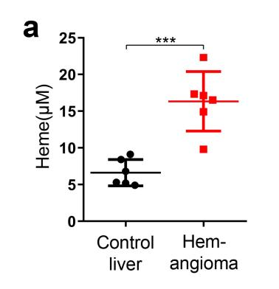
Supplemental Figure 1 Heme elevated in hemangioma compared to that in control liver after RFA. (a) The serum heme level in mice was detected after RFA. There were 6 mice in each group. The data are expressed as mean ± SEM. ***P<0.001.

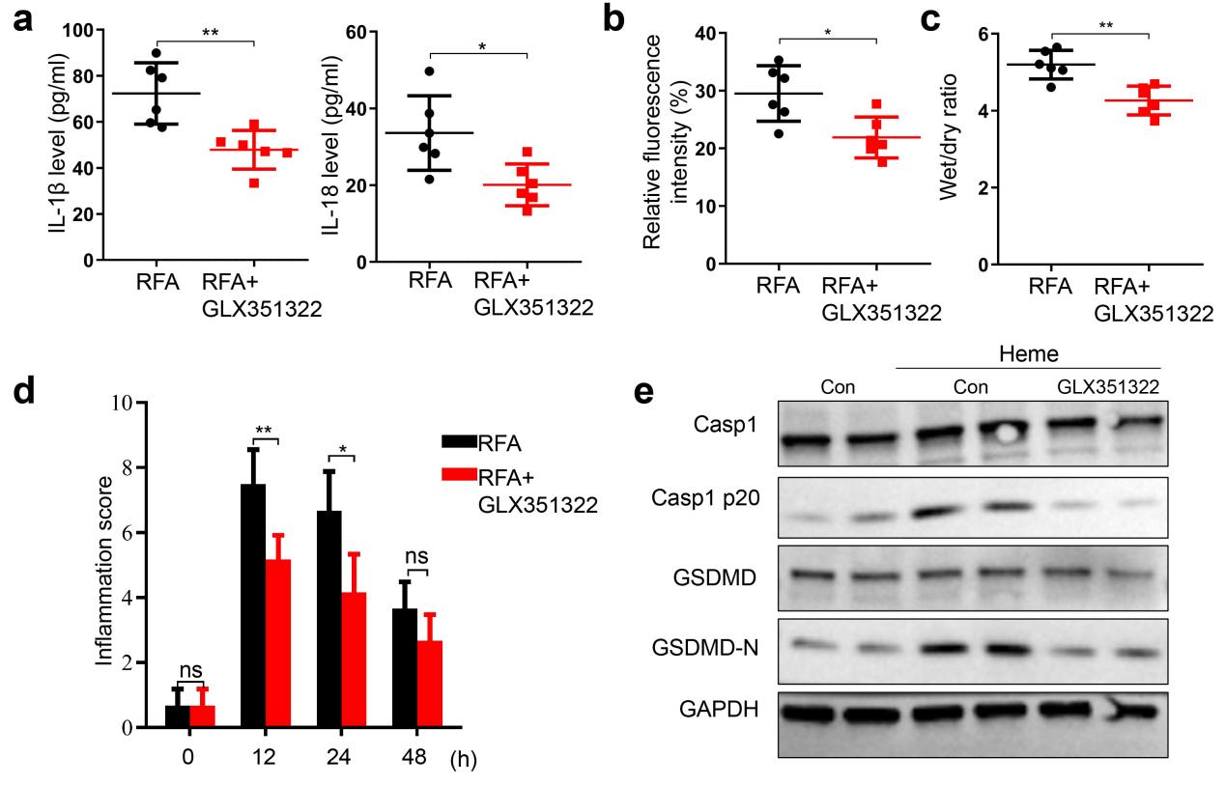
Supplemental Figure 2 GLX351322 alleviates SIRS after RFA of hepatic hemangioma in mice. (a) The levels of IL-1β and IL-18 in mice serum were detected with or without GLX351322 treatment after RFA of hepatic hemangioma. (b) Mice were intravenously injected with tetramelthyrhodamine-dextran with or without GLX351322 treatment after RFA at 24 h and the lung vascular permeability of mice was measured by multi-photon-microscope. (c) The wet-to-dry lung ratio was calculated with or without GLX351322 treatment after RFA of hepatic hemangioma. (d) The inflammation score of mice was measured at 0 h, 12 h, 24 h and 48 h with or without GLX351322 treatment after RFA of hepatic hemangioma. There were 6 mice in each group. (e) The expression of GSDMD, GSDMD-N, Casp1 and Casp1 p20 in HLMVECs were detected by western blotting with or without GLX351322 treatment after heme adminstration. The data are expressed as mean ± SEM. ns: no significance, *P<0.05, **P<0.01.

