Supplementary material

Methods and instrumentation:
Table S1. Operation conditions for Au determination by GFAAS
Signal processing: Peak area; Read time: 5 s
Background correction: Zeeman-effect
Wavelength—242.80 nm
Slit—0.7 nm
Step | Temp (°C) | Ramp (°C/s) | Hold (s) | Time (s)
Drying | 80 | 6 | 20 | 27.5
Drying | 90 | 3 | 20 | 23.3
Drying | 110 | 5 | 10 | 14.0
Pyrolysis | 350 | 50 | 20 | 24.8
Pyrolysis | 500 | 300 | 10 | 10.5
Gas adaption | 500 | 0 | 5 | 5.0
Atomize | 2000 | 1500 | 3 | 4.0
Cleaning | 2450 | 500 | 4 | 4.9

Table S2: Statistical analysis of the data obtained from the bioaccumulation of GNR-D1/Ang2 in the different organs of interest.
Tukey's multiple comparisons test | Summary
Liver
0 hours vs. 0,5 hours | **
0 hours vs. 3 hours | ****
0 hours vs. 6 hours | ***
0 hours vs. 24 hours | ****
0,5 hours vs. 1 hour | *
0,5 hours vs. 2 hours | *
0,5 hours vs. 24 hours | *
1 hour vs. 3 hours | ****
1 hour vs. 6 hours | **
1 hour vs. 24 hours | ****
2 hours vs. 3 hours | ****
2 hours vs. 6 hours | **
2 hours vs. 24 hours | ****
Spleen
0 hours vs. 24 hours | **
0,5 hours vs. 24 hours | **
1 hour vs. 24 hours | **
2 hours vs. 24 hours | **
Note: Only the results with significant values obtained using the Tukey multiple comparison test are shown. *=P ≤ 0.05; **=P ≤ 0.01; ***=P ≤ 0.001; ****=P ≤ 0.0001.

Fit model 1 compartment:

Figure S1: Graph obtained from the adjustment of the pharmacokinetic data of GNR-D1/Ang2 using the 1-compartment model
Non-compartmental model fit:

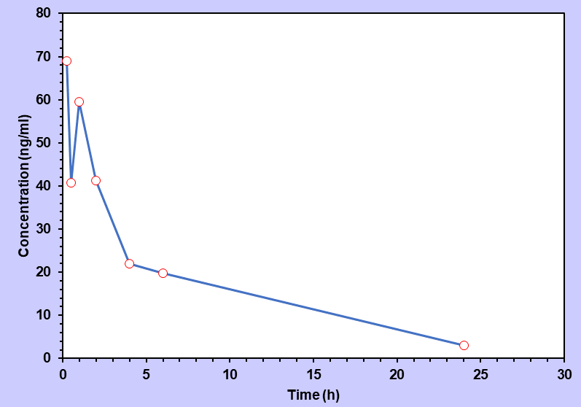
Figure S2: Graph obtained from the adjustment of the pharmacokinetic data of GNR-D1/Ang2 using the non-compartmental model.
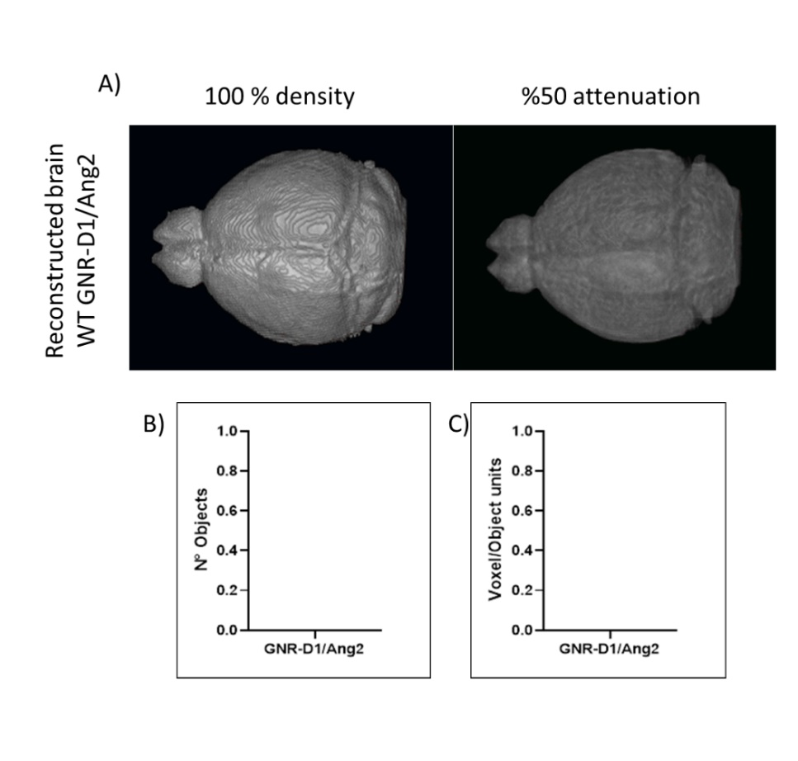
Figure S3: Reconstruction of brains of WT animals treated with GNR-D1/Ang2 by CT and object analysis obtained by Matlab. A) The reconstructed brain can be observed on the left side with 100% density and in the image on the right with 50% attenuation, allowing the content of the objects detected within the animals' brain to be observed. B) Analysis of the number of objects obtained by Matlab C) Analysis of the number of voxels obtained by Matlab (no objects were detected)

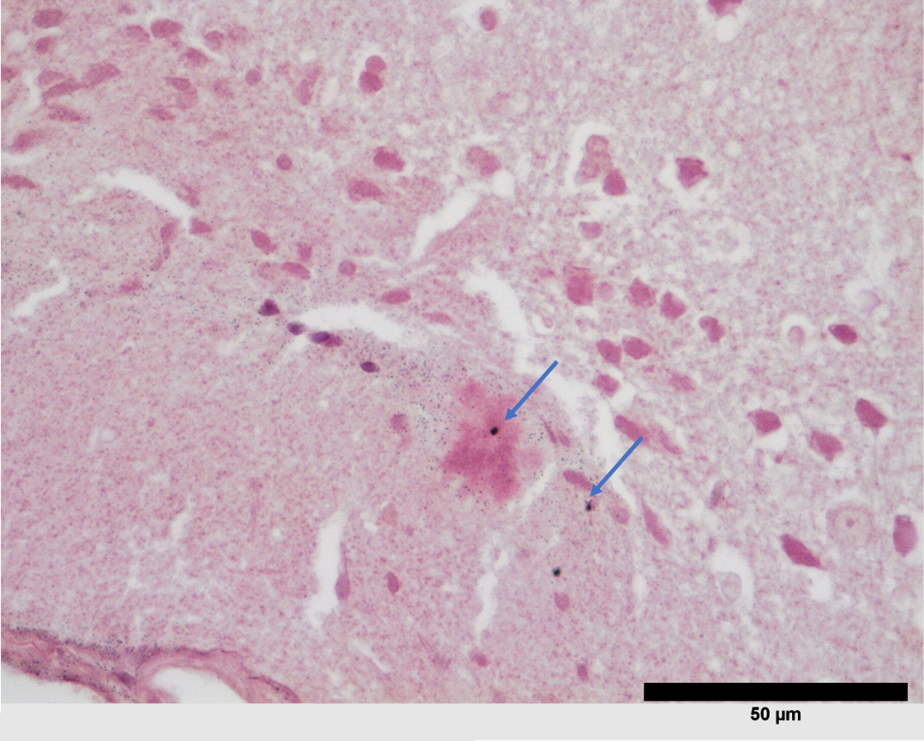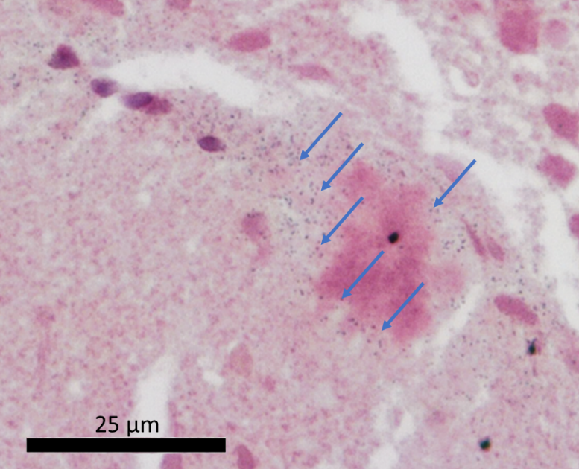
B)
A)
Figure S4: Histology of brain APPswe/PSEN1dE9 treated with GNR-D1/Ang2. A) Corresponds to a section of the cortex where amyloid plaque with nanoparticles is found. B) Corresponds to a crop of image A where an increase was made, visualizing a greater quantity of nanoparticles around the amyloid plaque. Blue arrows mark the location of nanoparticles detected by the gold enhance reagent.

Supplementary Methods 1. Immunohistochemistry gold enhancement and anti Aβ staining.
Materials and Methods

Antibodies and reagents

Primary antibody | Anti-Amyloid β Antibody, clone W0-2 (MABN10) Sigma-Aldrich
Secondary antibody | HRP polymer conjugated Fab'anti-mouse IgG(H+L) (ab269452) Abcam
Blocking Solution | Normal Horse Serum Blocking Solution, 2.5% (S-2012-50) Vector Labs
Diaminobenzidine | 3,3′-Diaminobenzidine (D12384) Sigma-Aldrich
Antigen Retrieval Buffer | Sodium Citrate Buffer (10mM Sodium Citrate, 0.05% Tween 20, pH 6.0):
Wash solution | Tris buffer (20 mM Tris; 150 mM NaCl; pH 7.4)
Gold Enhancement | GoldEnhance™ LM Kit , Nanoprobes

Protocol for anti-Amyloid β immunohistochemistry and Gold Enhancement.

- Immunohistochemistry

- Cut 5 µm thick sections of paraffin blocks, mount the sections in positively charged glass slides and dry in oven at 60°C for 1 hour.
- Deparaffinize in three changes of xylol 5 minutes each.
- Hydrate the sections on a descending scale from ethanol to distilled water (ethanol 100°>100°>95°>70°>distilled water) 5 min each.
- Perform antigen retrieval in citrate buffer, for 20 minutes in a pressure cooker at 120 ºC.
- Let cool for 5 minutes, wash in two changes of TBS (3 min each).
- Block endogenous peroxidase activity with 3% hydrogen peroxide for 15 minutes. Wash in two changes of TBS (3 min each).
- Block nonspecific junctions with 2.5% Normal Horse Serum for 30 minutes at room temperature. Remove excess, do not wash.
- Block with anti-mouse serum from Mouse on Mouse Polymer IHC Kit for 1 hour at room temperature.
- Wash in two changes of TBS (3 min each).
- Incubate with primary antibody Anti-Amyloid ß (MABN10) in 1:50 dilution overnight at 4ºC (15 hours).
- Wash in three changes of TBS (5 min each).
- Incubate with HRP polymer detector from Mouse on Mouse Polymer IHC Kit for 30 minutes at room temperature.
- Wash in three changes of TBS (5 min each).
- Develop reaction with DAB for two minutes, check reaction under the microscope.
- Stop the reaction with distilled water.
- Continue with gold enhancement protocol.

- Gold Enhancement

- Wash with PBS 3X5 minutes.
- Wash in PBS-Glycine 50 mM for 5 minutes.
- Wash in Nanopure water 2x5 minutes
- Incubate in gold enhancement working solution* for 30 min, check the formation of gold deposits under the microscope.
- Stop the reaction with distilled water.
- Dehydrate in ethanol, then xylene and mount in synthetic resin.

(*) Gold Enhancement working solution:
1.- 100 ul solution A + 100 ul solution B, shake and rest for 5 minutes.
2.- Add 100 ul of solution C and 100 ul solution D shake, use immediately.

Notes:
Hematoxylin contrast was not performed because the nuclear stain with aluminic hematoxylins its non-compatible with the Gold Enhancement technique, producing unspecific precipitates that mask the true signal from the gold enhancement.

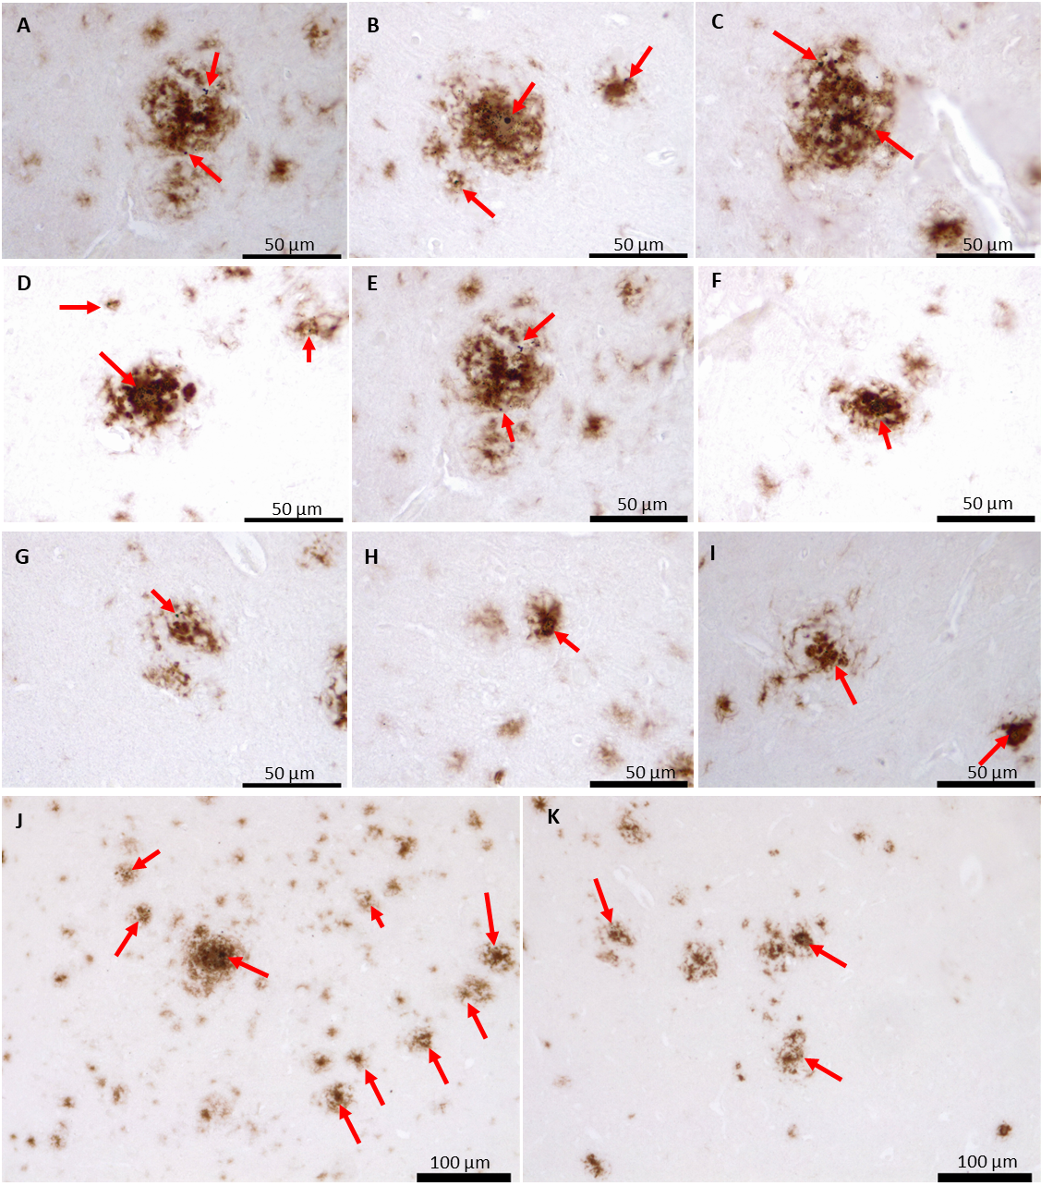
Figure S5. Immunohistology of the brain cortex of 18-months animals APPswe/PSEN1dE9 model administered intravenously with GNR-D1/Ang2 (100 nM, 100 μL). In the slides GNRs were highlighted using the gold enhancement reagent (dark blue stains, pointed out with red arrows) and the amyloid plaques were labeled with the anti Aβ (brownish stains). Figure S5 A-I 63X, J-K 20X.

