Supplementary data
- Most participants (83%; n=25) instilled the eye drops using their right hand.
- Of the 25 participants who instilled eye drops with their right hand at first dropping, 16 started with the left eye and nine started with the right eye.
- Right-handed, left eye ‘droppers’ most frequently produced three drops into the left eye, and two drops into the right eye, respectively (38%, n=6).
- In right-handed participants starting with the right eye, the most frequently observed drop instillation was two drops into the left eye (44%, n=4), and two drops into the right eye (33%, n=3). Of participants instilling eye drops with their left hand at first dropping (n=5), four started with the left eye.
- Left-handed, left eye ‘droppers’ most frequently produced one drop into each eye (left eye, 75% [n=3]; right eye, 50% [n=2]), while the single right eye ‘dropper’ gave two drops into the left eye, and three drops into the right.
- At the second dropping event, participants were more likely to instill a single drop.
- More right-handed participants started with the left eye (n=18) and gave one drop into each eye (left eye, 83% [n=15]; right eye, 56% [n=10]); right-handed, right eye ‘droppers’ instilled one drop into each eye at a greater frequency (left eye, 86% [n=6]; right eye, 71% [n=5]).
- Left-handed participants (n=5) were more likely to instill drops to the left eye first (n=4) and produce a single drop (75%, n=3); the right eye received one or zero drops.
- The single left-handed participant starting with the right eye gave a single drop to both eyes.

Instructions for Use
Users are instructed on the Instructions for Use before using Dropaid™ Single-dose.
How to use the device is summarized below.
- Wash your hands.

- Remove the Dropaid™ Single-dose device from its storage pouch.
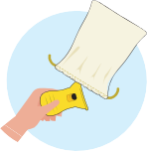
- Twist off the top tab of the single-dose container.
- Without squeezing, place the single-dose container pointing down in the middle section of the Dropaid™ Single-dose device and gently shake the container to make sure the liquid sits in the tip.
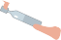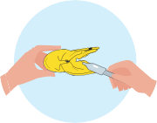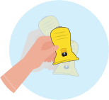
- Tilt the head back and place the Dropaid™ Single-dose device over the eye.


- Squeeze the Dropaid™ Single-dose device handles to dispense an eye drop.
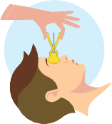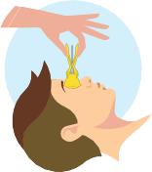
- If required, simply repeat this process to add an eye drop to the other eye.
- After use, remove the used single-dose container and discard in household waste. No particular disposal precautions are necessary. Follow any applicable national environmental disposal requirements.
- Regularly check the device; should you notice any changes to its condition, replace the device.

Cleaning and storage directions are summarized below:
- After use, you can clean the Dropaid™ Single-dose device with soap and water, remembering to rinse thoroughly after every use.
- Dry the Dropaid™ Single-dose device with a clean and lint-free wipe.
- Store the Dropaid™ Single-dose device in its cloth pouch when not in use.
- Regularly wash the pouch in a maximum 30°C water temperature, using a normal or mild detergent. Wash inside out. Preferable air dry or tumble dry at low heat.

The device
