Figure S1

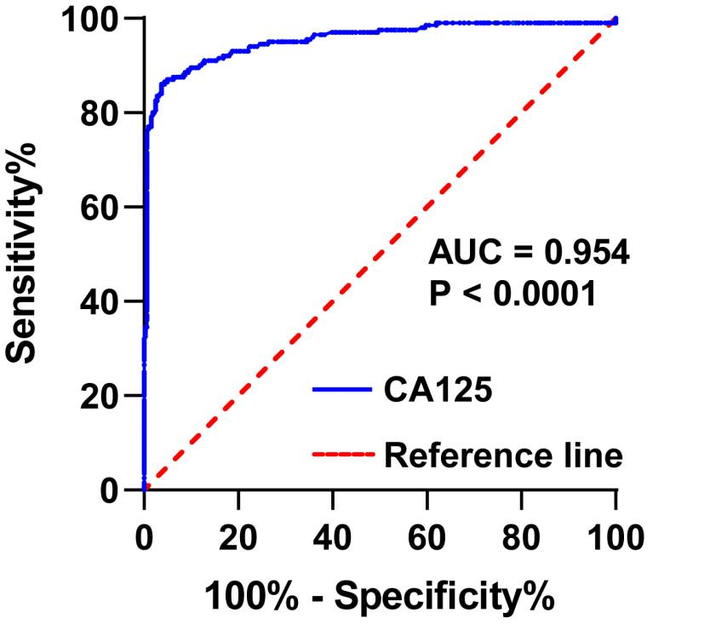

Figure S1: Predictive Value of CA125 in the Diagnosis of Adenomyosis based on the receiver operating characteristic curve.

Table S1. Comparison of coagulation parameters and characteristics between AM and LM group
Covariates | Estimates | SE | Odds Ratio (95% CI) | p-Value
CA125 | 5.775 | 0.688 | 70.479(30.424-159.924) | <0.001
PLT | 0.002 | 0.003 | 1.002(0.996-1.009) | 0.483
PT | 0.005 | 0.524 | 1.005(0.360-2.807) | 0.993
APTT | -0.357 | 0.116 | 1.695(1.280-2.398) | 0.002
FIB | 0.515 | 0.449 | 1.673(0.694-4.036) | 0.252
TT | 0.504 | 0.188 | 1.655(1.144-2.394) | 0.008
D-dimer | 0.148 | 0.332 | 1.159(0.605-2.222) | 0.656
INR | -0.151 | 4.457 | 0.860(0.000-5349.901) | 0.973
Age | -0.241 | 0.707 | 0.786(0.198-3.121) | 0.732
BMI | -0.978 | 0.581 | 0.376(0.120-1.176) | 0.093
Gravidity | -0.861 | 0.406 | 0.423(0.191-0.936) | 0.054
Abortion | 0.307 | 0.451 | 1.359(0.561-3.291) | 0.497
Hb | -0.416 | 0.679 | 0.659(0.174-2.495) | 0.540
Uterinesize | -0.070 | 0.492 | 0.933(0.356-2.444) | 0.887
CA199 | -0.592 | 0.537 | 0.553(0.193-1.584) | 0.270
Menorrhagia | 1.738 | 0.542 | 5.363(1.544-14.315) | 0.001
Dysmenorrhea | 3.102 | 0.543 | 19.590(6.185-57.347) | <0.001
Abbreviations:AM group, patients with adenomyosis; LM group,patients with uterine leiomyoma; Hb, hemoglobin; PLT, platelet count; PT, plasma prothrombin time; APTT, activated partial thromboplastin time; FIB, fibrinogen,TT, thrombin time; FIB, fibrinogen; INR, international normalized ratio; SE, standard erro.

Table S2. Correlation of APTT and TT with Menorrhagia and Dysmenorrhea in Patients with Adenomyosis.
Parameters | Menorrhagia  r value p-value | Dysmenorrhea  r value p-value
APTT (s) | -0.091 0.1667 | 0.0667 0.3483
TT (s) | -0.102 0.1517 | -0.113 0.1096
Abbreviations: APTT, activated partial thromboplastin time; TT,thrombin time.

Table S3. Characteristics and coagulation parameters in TB patients
Variables/Parameters | TB patients  （n=16）
Age (years) | 46.00 (41.00-48.50)
BMI (kg/m²) | 24.73(22.70-27.32)
Gravidity | 3 (1-4)
Abortion | 1.5 (0-3)
Menorrhagia (n, %) | 8 (50.00)
Dysmenorrhea (n, %)  Uterine size (cm3) | 10 (62.50)  245 6 204 5  48 5 (45 7₋51 2) * <0 001  (174.3-435.2) (173 .2-244.9)* '⁵⁽ ' 7 ²⁾ '
Anemia (n, %) | 7 (43.75)
Hb (g/L) | 118.50(77.00-126.25)
Uterine size (cm3) | 286.86(129.07-484.11)
CA199(U/ml) | 12.92(5.31-31.17)
CA125(U/ml) | 78.83 (28.55-202.75)
PT(s) | 11.30(10.93-12.08)
APTT (s) | 26.65 (24.58-28.08)
TT (s) | 17.70 (16.60-18.55)
FIB (g/L) | 2.76 (2.31-3.20)
D-dimer(mg/L) | 0.55 (0.24-1.58)
INR | 0.98 (0.94-1.07)
Data were expressed as M (P25-75);TB patients, Thrombosis in patients with adenomyosis. Abbreviations: BMI, body mass index; Hb, hemoglobin; PLT, platelet count; PT, plasma prothrombin time; APTT, activated partial thromboplastin time; TT,thrombin time; FIB, fibrinogen; INR, international normalized ratio.

