SUPPLEMENT

Supplementary Table 1: Orlinsky score for dream complexity.

Orlinsky Score | Dream Description
0 | No dream recall
1 | White dream (the subject remembers having dreamt but cannot remember any specific content)
2 | Subject remembers a specific topic, but in isolation; for example a fragmentary action, scene, object, word, or idea unrelated to anything else
3 | Subject remembers several disconnected thoughts, scenes, or actions
4 | Subject remembers a short but coherent dream, the parts of which seem related to each other; for example a conversation rather than a word, a problem worked through rather than an idea, a purposeful rather than a fragmentary action
5 | Subject remembers a detailed dream sequence in which 2 events or stages occur
6 | Subject remembers a long, detailed dream sequence involving three or four distinct stages of development
7 | Subject remembers an extremely long and detailed dream sequence of five or more stages; or more than one dream (at least one of which is rated 5) for a single awakening

Supplementary Table 2. Descriptive statistics of 14 graph speech attributes and word count (uncorrected).

Graph Speech Attributes | iRBD |  |  | NREMP
 | Mean | SD | SE | Mean | SD | SE
N | 23.43 | 17.71 | 6.69 | 28.15 | 16.35 | 3.66
E | 27.14 | 23.75 | 8.98 | 36.45 | 27.88 | 6.23
RE | 0.71 | 1.50 | 0.57 | 1.80 | 3.94 | 0.88
PE | 1 | 1.53 | 0.58 | 2.1 | 4.12 | 0.92
L1 | 0 | 0 | 0 | 0 | 0 | 0
L2 | 0.29 | 0.76 | 0.29 | 0.3 | 0.92 | 0.21
L3 | 1.14 | 1.57 | 0.6 | 0.45 | 0.89 | 0.2
LCC | 23.43 | 17.71 | 6.69 | 28.15 | 16.35 | 3.66
LSC | 13.86 | 18.47 | 6.98 | 23.4 | 18.01 | 4.03
ATD | 2.08 | 0.39 | 0.15 | 2.35 | 0.49 | 0.11
Density | 0.17 | 0.16 | 0.06 | 0.12 | 0.07 | 0.02
Diameter | 10.71 | 3.86 | 1.46 | 9.05 | 2.33 | 0.52
ASP | 4.34 | 1.34 | 0.51 | 3.87 | 0.78 | 0.17
CC | 0.05 | 0.07 | 0.03 | 0.03 | 0.06 | 0.01
Word Count | 23.43 | 17.71 | 6.69 | 28.15 | 16.35 | 3.66
Abbreviations: ATD, Average total distance; ASP, Average shortest path; CC, Clustering coefficient; E, edges; LCC, Largest connected component; LSC, Largest strongly connected component; L1, Cycles of one node; L2, Cycles of two nodes; L3, Cycles of three nodes; N, nodes; NREMP, non-rapid eye movement parasomnia; PE, parallel edges; RBD, rapid eye movement sleep disorder; RE, repeated edges; SD, standard deviation; SE, standard error.

Supplementary Table 3. Normalised descriptive statistics of SGA attributes (corrected per number of nodes).

Graph Speech Attributes | iRBD |  |  | NREMP
 | Mean | SD | SE | Mean | SD | SE
E | 1.030 | .179 | .068 | 1.134 | .234 | .052
RE | .020 | .034 | .013 | .037 | .074 | .017
PE | .029 | .037 | .014 | .044 | .076 | .017
L1 | .000 | .000 | .000 | .000 | .000 | .000
L2 | .010 | .025 | .010 | .007 | .018 | .004
L3 | .032 | .046 | .017 | .016 | .035 | .008
LCC | 1.000 | .000 | .000 | .988 | .054 | .012
LSC | .295 | .182 | .069 | .570 | .283 | .063
ATD | .145 | .112 | .042 | .119 | .077 | .017
Density | .024 | .045 | .017 | .012 | .019 | .004
Diameter | .646 | .268 | .101 | .468 | .247 | .055
ASP | .268 | .124 | .047 | .200 | .111 | .025
CC | .002 | .004 | .001 | .002 | .008 | .002
Word Count | 1.123 | .129 | .049 | 1.223 | .222 | .050
Abbreviations: ATD, Average total distance; ASP, Average shortest path; CC, Clustering coefficient; E, edges; LCC, Largest connected component; LSC, Largest strongly connected component; L1, Cycles of one node; L2, Cycles of two nodes; L3, Cycles of three nodes; N, nodes; NREMP, non-rapid eye movement parasomnia; PE, parallel edges; iRBD, rapid eye movement sleep disorder; RE, repeated edges; SD, standard deviation; SE, standard error

Supplementary Table 4. The Mann-Whitney test results statistics of the comparison between the iRBD and NREMP group of non-parametric graph speech attributes.

Attributes | iRBD |  |  |  | NREMP |  |  |  | r | η2 | z | p
Attributes | Mean | SE | 95% BCI lower | 95 BCI upper | Mean | SE | 95% BCI lower | 95 BCI upper
WC | 1.123 | .049 | 1.041 | 1.206 | 1.223 | .050 | 1.135 | 1.321 | .614 | .029 | .885 | .387
Edges | 1.030 | .068 | .895 | 1.142 | 1.134 | .052 | 1.038 | 1.232 | .593 | .019 | .719 | .488
RE | .020 | .013 | .000 | .046 | .037 | .017 | .011 | .071 | .539 | .003 | .304 | .742
PE | .029 | .014 | .008 | .053 | .044 | .017 | .016 | .080 | .507 | .000 | .055 | .975
L1 | - | - | - | - | - | - | - | - | - | - |  | -
L2 | .010 | .010 | .000 | .029 | .007 | .004 | .000 | .015 | .493 | .000 | -.055 | .964
L3 | .032 | .017 | .006 | .067 | .016 | .008 | .003 | .033 | .393 | .026 | -.830 | .320
LCC | 1.000 | .000 | 1.000 | 1.000 | .988 | .012 | .964 | 1.000 | .475 | .001 | -.194 | .612
LSC | .295 | .069 | .176 | .415 | .570 | .063 | .447 | .680 | .779 | .172 | 2.158 | .033*
ATD | .145 | .042 | .082 | .233 | .119 | .017 | .090 | .155 | .443 | .007 | -.443 | .678
Density | .024 | .017 | .004 | .059 | .012 | .004 | .005 | .021 | .443 | .007 | -.443 | .678
Diameter | .646 | .101 | .466 | .825 | .468 | .055 | .367 | .572 | .329 | .065 | -1.328 | .193
ASP | .268 | .047 | .188 | .350 | .200 | .025 | .155 | .248 | .357 | .045 | -1.107 | .281
CC | .002 | .001 | .000 | .005 | .002 | .002 | .000 | .006 | .421 | .014 | -.609 | .503
Notes: * (in bold) denotes statistically significant differences.
Abbreviations: ATD; Average total distance, ASP; Average shortest path, CC; Clustering Coefficient, LCC; Largest Connected Component, LSC; Largest strongly connected component, L1; Cycles of one node, L2; Cycles of two nodes, L3; Cycles of three nodes, NREMP, non-rapid eye movement parasomnia; p; p-value, PE; parallel edges, iRBD; rapid eye movement sleep disorder, RE; repeated edges, SE; standard error, SGA; Speech Graph Attributes, WC; word count, η2; effect size, 95% BCI lower; 95% bootstrap confidence interval lower, 95% BCI upper; 95% bootstrap confidence interval upper, r; effect size.

Supplementary Figure 1: Representative speech graphs from iRBD and NREMP patients

iRBD:

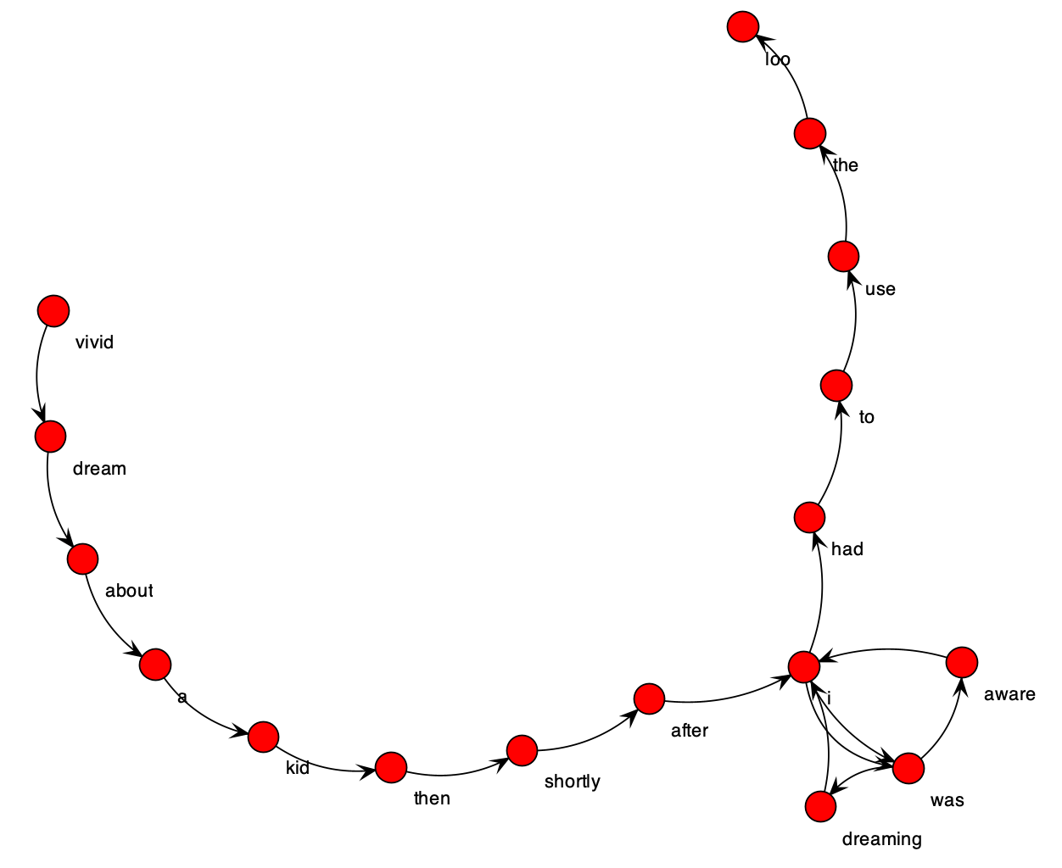

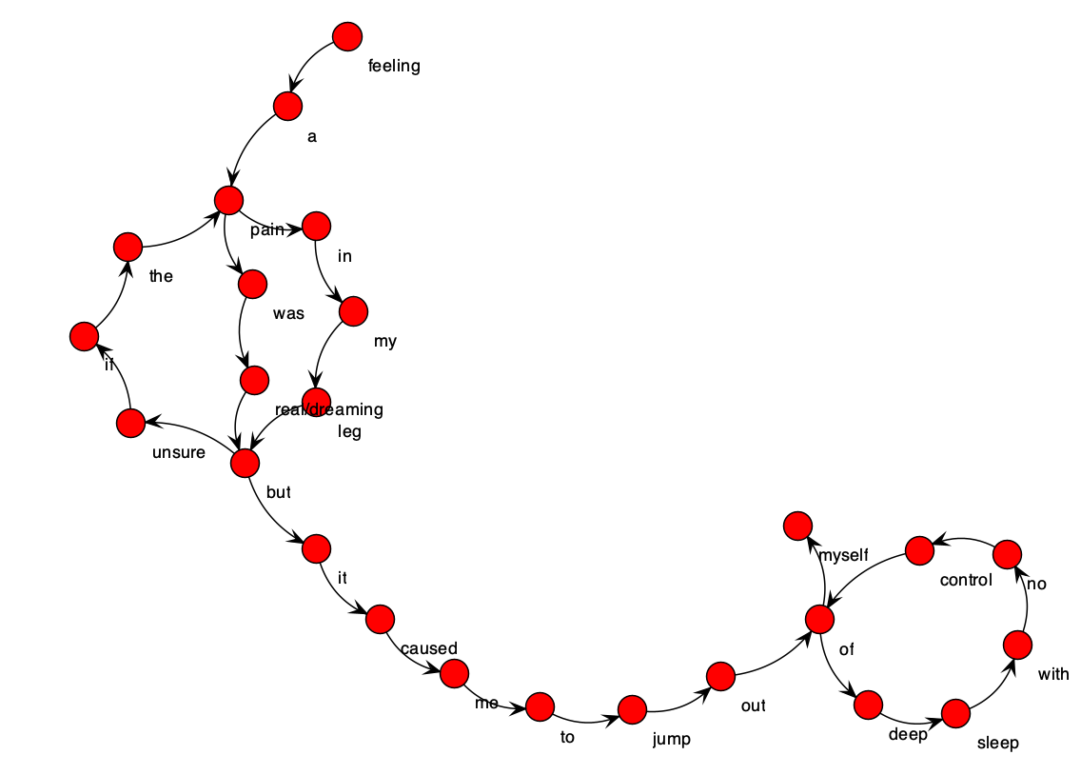

NREMP:
