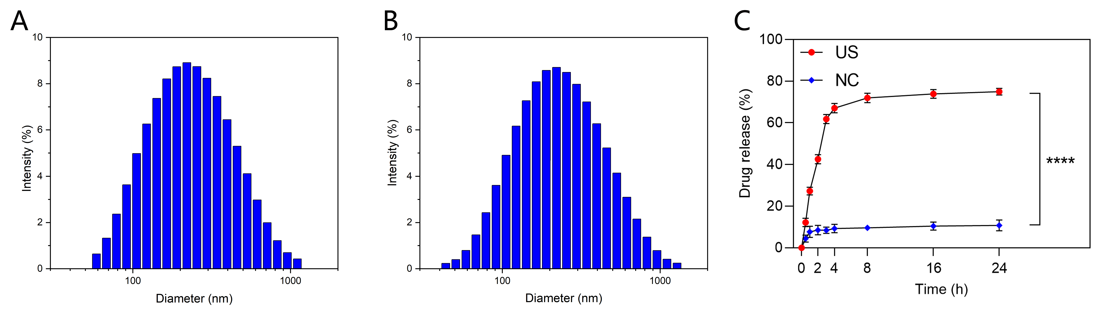

Figure S1 Stability detection of ICG-NBs and in vitro drug release experiments. (A) The particle size distribution of ICG-NBs in PBS solution at for 48 h. (B) The particle size distribution of ICG-NBs after 48 h in DMEM containing 10% FBS. (C) In vitro collective release of ICG from ICG-NBs. ****p < 0.0001.

Figure S2 The cell viability of WRL68 cells treated with different concentrations of ICG.

Figure S3 Biological distribution of ICG-NBs. (A) The biodistribution of ICG-NBs in HepG2 tumor-bearing mice at different time points after injection. (B)The relative fluorescence intensity in organs and tumors 24 h after injection.

