Supporting information
Nano-photosensitizer directed targeted phototherapy effective against oral cancer in animal model
Lina Yu^{1, #,} *, Guanxiong Zhu^{1, #}, Zeyu Zhang^{1 #}, Zidan Xu¹, Weijie Peng^{1, 2}, Liting Zeng¹, Yang Yu⁴, Siran Wang¹, Zhongxiao Lin^{1, 2, 3}, Xin Zhang³, Na Zhou³, Lingmin Zhang^{1, 2} *, Lu Liang^{1, 2} *

¹Department of Preventive Dentistry, Affiliated Stomatology Hospital of Guangzhou Medical University, Guangdong Engineering Research Center of Oral Restoration and Reconstruction, Guangzhou Key Laboratory of Basic and Applied Research of Oral Regenerative Medicine, Guangzhou, 510182, PR China
²Guangzhou Municipal and Guangdong Provincial Key Laboratory of Molecular Target & Clinical Pharmacology, the State & NMPA Key Laboratory of Respiratory Disease, School of Pharmaceutical Sciences & The Fifth Affiliated Hospital, Guangzhou Medical University, Guangzhou, 511436, PR China
³State Key Laboratory of Quality Research in Chinese Medicine, Macau University of Science and Technology, Avenida Wailong, Taipa, Macau, PR China
⁴Department of Sports and Health, Guangzhou Sport University, Guangzhou, PR China
#These authors contributed equally to this work.

*Correspondence to: Lina Yu, Lingmin Zhang, and Lu Liang
E-mails: yulina@gzhmu.edu.cn, zhanglm@gzhmu.edu.cn and lliangaa@gzhmu.edu.cn

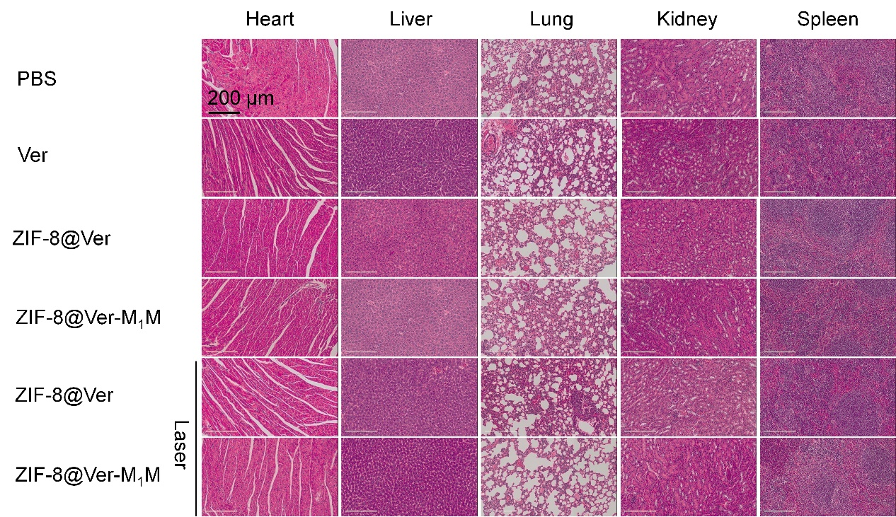
Figure S1. HE staining of major organs. The mice were administered at an equivalent dose of Ver (20 mg/kg) and sacrificed on Day 20. The major organs were extracted and stained with H&E.

