Supplementary Information

Functionalized cerium dioxide nanoparticles with antioxidative neuroprotection for Alzheimer’s disease
Yu Hu^{1,2,3}, Hui Guo^{1,2,3}, Shuai Cheng^{1,2,3}, Junpeng Sun^{2,4}, Jiaqun Du^{2,4}, Xiaobang Liu^{2,4}, Ying Xiong⁵, Liqing Chen⁶, Chang Liu^{3,6}, Chao Wu^{2,4}, He Tian^{1,2,3}

¹School of Basic Medicine, Jinzhou Medical University, Jinzhou, Liaoning, 121001, China
²Liaoning Provincial Collaborative Innovation Center for Medical Testing and Drug Research, Jinzhou Medical University, Jinzhou, Liaoning, 121001, China
³Key Laboratory of Medical Tissue Engineering of Liaoning Province, Jinzhou Medical University, Jinzhou, Liaoning, 121001, China
⁴Pharmacy School, Jinzhou Medical University, Jinzhou, Liaoning, 121001, China
⁵Laboratoire Catalyse et Spectrochimie (LCS), Normandie Université, ENSICAEN, UNICAEN, CNRS, 14050, Caen, France
⁶Department of Endocrinology, The First Affiliated Hospital of Jinzhou Medical University, Jinzhou, Liaoning, 121000, China

Correspondence:
He Tian, tianhe@jzmu.edu.cn.
Chao Wu, wuchao@jzmu.edu.cn.

Supplementary Material 1:
Characterization
The morphology and structure of the material were determined using transmission electron microscopy (TEM) (Tecnai G2F30, FEI, USA). The zeta potential and particle size of the synthesized nanoparticles were determined using a Zetasizer Nano ZS (Malvern Instruments, Malvern, UK). The major elements in the MC were characterized using scanning electron microscopy and energy dispersive X-ray spectroscopy (EDS) as well as X-ray photoelectron spectroscopy (XPS) (Bruker Nano GmbH Berlin，Germany). The materials and state of the drug in the materials were observed using differential scanning calorimetry (DSC，Shimadzu，Inc. Japan) and X-ray diffraction (XRD，Rigaku Denki，Japan).
Supplementary Material 2:
Pharmacokinetic test
SD rats (180–220 g) were and injected with LMC-RES and RES suspension (equivalent to 25 mg/kg RES) via the tail vein. After administration, 1 mL of blood was collected from the fundic venous plexus at a predetermined time, and plasma was obtained by centrifugation and stored at -80°C. Plasma was mixed with root cortin internal standard solution (4 mg/mL) and methanol. The mixed solution was spun, shaken for 3 min, and then centrifuged at 10,000 rpm for 10 min at room temperature. The supernatant (20 μL) obtained was analyzed by high performance liquid chromatography. The mobile phase consisted of 40% water and 60% acetonitrile, with a detection wavelength of 306 nm.
Supplementary Material 3:
Hemolysis test
A hemolysis test was conducted to assess the in vivo safety of MC and LMC. Fresh mouse blood was washed with PBS until the supernatant was not red in color to obtain red blood cells. The red blood cells were then diluted to 2% (v/v) with PBS. Different concentrations of MC and LMC (200, 400, 600, 800, 1000, 1200, 1400 μg/mL) were mixed with 2% erythrocytes, left for 3 h at room temperature, and then centrifuged at 10,000 r/min for 3 min. Finally, the supernatant was transferred to a 96-well plate. The absorbance of the supernatant was measured at 570 nm using a microplate reader, with water and PBS as positive and negative controls, respectively. All experiments were repeated thrice.
A hemolysis rate greater than 5% was considered as hemolysis.
Supplementary Material 4:
FITC labeling
MC was amination treated. The carrier was mixed with ethanol solution in a three neck vial and sonicated for 10 min. 2 ml of APTES and 500 mg of dried MC were added to the solution. Samples were stirred at reflux for 10h at 77 °C, centrifuged, and dried to obtain NMC. Next, 100 mg of NMC was dispersed into 1 mg/ml of FITC DMSO solution, centrifuged, and dried to obtain FITC-labeled MC. Then FITC-labeled MC was coated with lactoferrin, centrifuged, and dried to obtain FITC-labeled LMC.
Supplementary Material 5:
In vitro BBB model and cell uptake
The uptake of LMC by SH-SY5Y cells was assessed using inverted fluorescence microscopy. We constructed a transwell model to simulate the BBB. The bEnd.3 cells were inoculated into the upper chamber to simulate the BBB, and SH-SY5Y cells were placed in a culture dish to simulate brain neurons. FITC-labeled LMC were added to the upper chamber for 12 h of co-culture. Finally, they were examined by inverted fluorescence microscopy.
Supplementary Material 6:
CCK-8 experiment
SH-SY5Y cells were inoculated in 96-well plates until the cell density was about 80%. The cells were incubated with different concentrations of Aβ25-35 for 24h or 48h, respectively. Then LMC at different concentrations was added to co-culture with the cells for 24h. Cell viability was detected with CCK-8.
Supplementary Material 7:
Preparation of Aβ solution
Solid Aβ peptide was dissolved in cold HFIP and incubated for 2h at room temperature. HFIP was removed by evaporation and the resulting film was dissolved in 5 mM DMSO to obtain the final Aβ oligomer for subsequent experiments.
Supplementary Material 8:
Oxidative stress determination
Cells or mice brain tissue homogenates were prepared in cold PBS. The contents of GSH-Px, SOD and MDA were measured by Kit. Cells were induced with Aβ and reactive oxygen levels were measured by the Reactive Oxygen Species Assay Kit.
Supplementary Material 9:
qRT-PCR
Cells from different treatment groups were collected and total RNA was extracted with TRIzol reagent (Ambion, Foster City, CA, USA), and RNA concentration was determined. cDNA was synthesized by reverse transcription with 1 μg of total RNA (Promega, Fitchburg, WI, USA), and then qRT-PCR was performed with Gentier 96E/96R (Tianlong Technology Co., Ltd.). cDNA samples were amplified at the following conditions: 95°C for 3 min, followed by 95°C for 5 s and 60°C for 30 s, for a total of 40 cycles. The expression levels of target genes were normalized relative to the housekeeping gene ribosomal protein S18, and the (1 + e) ΔΔCT method was used to compare target gene expression. The primer sequences were obtained from Beijing Dingguo Changsheng Biotechnology Co. The primers used in this study are shown in Table S1 (n = 3).
Table S1 Primer sequences used in qRT-PCR
Gene | Primer sequence
Nrf-2 | Forward primer: CCGGGGAACAGAACAGGAAA
Nrf-2 | Reverse primer: ACGTTGTCCCCATTTTTGCG
HO-1 | Forward primer: AGGGCAGAAGGGAATTGCTC
HO-1 | Reverse primer: AAAGAGCTGGAGAGCCAACC
RPS18 | Forward primer: AACTCACGGAGGATGAGGTG
RPS18 | Reverse primer: AGAACCTGGCTGTACTTCCC

Supplementary Material 10:
In vivo targeting effect
To verify the targeting effect of LMC, MC were used as a control to verify the effect of the ability of lactoferrin to penetrate the BBB. FITC-labeled LMC (5 mg/kg) and MC (5 mg/kg) were injected into the tail veins of mice. The mice were executed after 3, 6, 9, 12, and 24 h, after which the brain and organs were removed, and fluorescence distribution images of LMC and MC were tracked using Bruker In-vivo FX Pro.
Supplementary Material 11:
In vivo uptake experiments
FITC-labeled LMC and MC were injected into 5xFAD mice via the tail vein. Sections of brain tissues extracted 12 h later were frozen. Neurons, vascular endothelial cells, microglia, and astrocytes were labeled with NeuN, CD31, IBA-1, and GFAP, respectively. The uptake of LMC and MC in brain tissue was analyzed by immunofluorescence.
Supplementary Material 12:
Immunofluorescent staining
The frozen sections of brain tissue were incubated with Triton X-100 (0.3%) for 30 min at 37°C, followed by incubation with goat serum (5%) for 2 h. The sections were incubated with primary antibodies for 16 h at 4°C. The next day, the sections were washed with PBS and then incubated with secondary antibodies for 2 h at room temperature. The nuclei were stained with DAPI. All slides were observed under a fluorescence microscope. The optical density of the fluorescence was analyzed using ImageJ2x software.
Supplementary Material 13:
Nissl and HE staining
Nissl staining: The sections were stained by methylene blue staining solution for 10 min, divided by Nissl differentiation solution for 3 min and observed under the microscope until the Nissl bodies were clear. Then the sections were treated with ammonium molybdate solution for 5 min, rapidly rinsed in distilled water, dehydrated in anhydrous ethanol and transparent in xylene. Finally, nissl stained images of cortical and hippocampal regions were taken by neutral gel fixation and light microscopy.
HE staining: Brain, heart, liver, spleen, lung and kidney paraffin sections were dewaxed in water and stained with hematoxylin and eosin for 10 min. After which they were dehydrated in ethanol, clear in xylene and sealed with neutral glue. Finally, HE images were observed with microscope.

Figures:
Figure S1 SDS gel electrophoresis band positions of lactoferrin and LMC.

Figure S2 The XPS analysis of MC.

Figure S3 The cell viability of SH-SY5Y cells incubated with MC and LMC.

Figure S4 H&E staining of heart, liver, spleen, lung and kidney sections in each group.

Figure S5 TEM images of Aβ fibers.

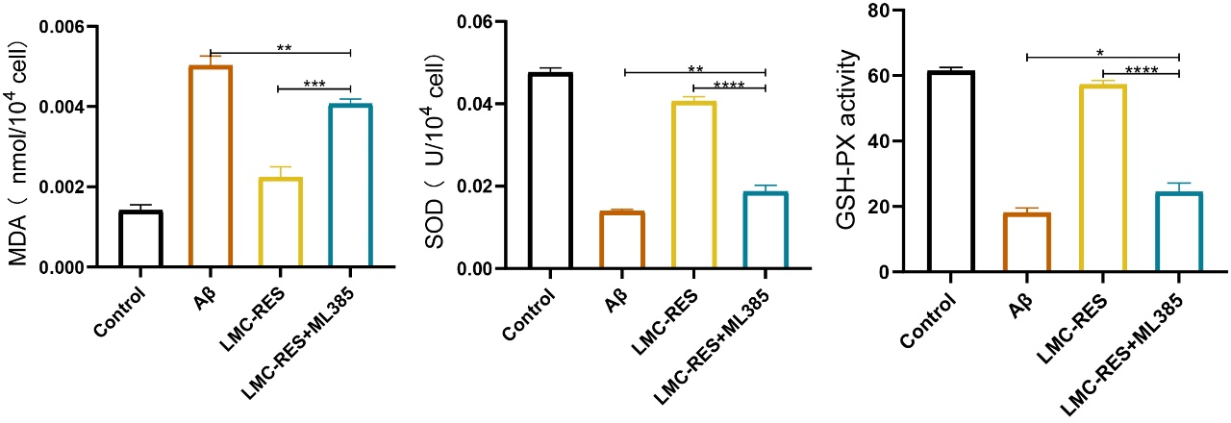
Figure S6 MDA and SOD concentrations and GSH activity of SH-SY5Y cells in different groups. All data are mean ± SD (n=3). *P < 0.05, **P < 0.01, ***P < 0.001, ****P < 0.0001.
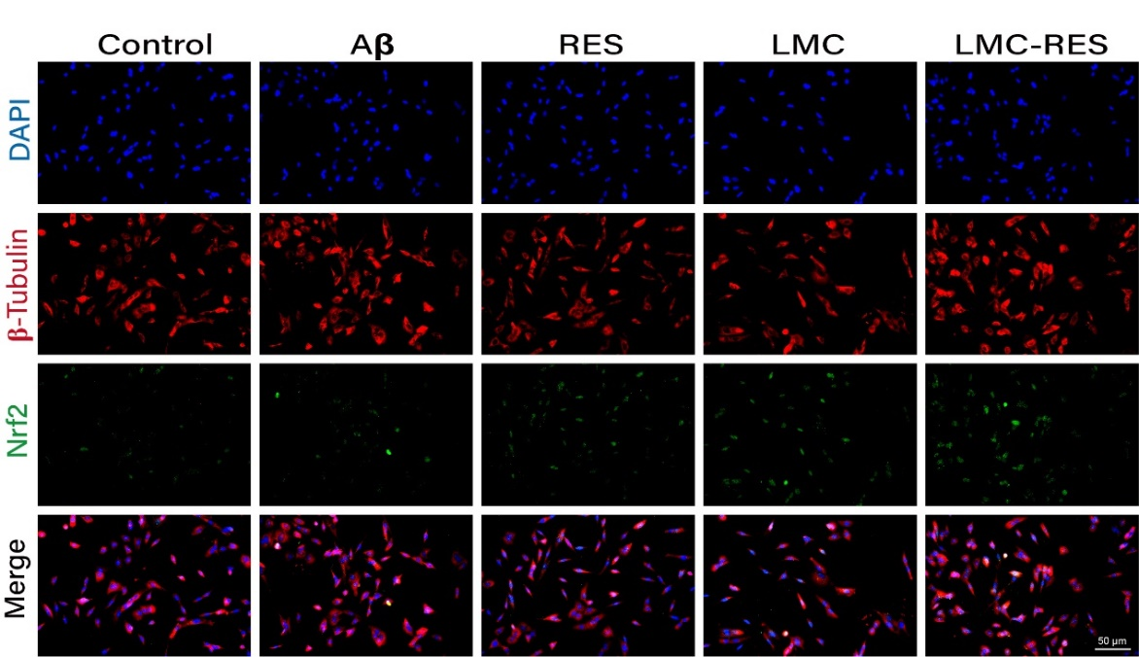
Figure S7 Fluorescence images of Nrf-2 in different groups of SH-SY5Y cells.

Figure S8 The quantitative analysis of the mean fluorescence intensity of Nrf-2 in different groups of SH-SY5Y cells. All data are mean ± SD (n=3). ****P < 0.0001.
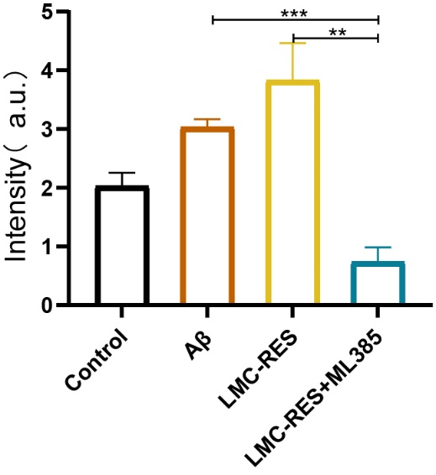
Figure S9 The quantitative analysis of the mean fluorescence intensity of HO-1 in different groups of SH-SY5Y cells. All data are mean ± SD (n=3). **P < 0.01, ***P < 0.001.

