Table S1. Aptamer and complementary DNA sequences used in the experiments
Name | Sequence (5' - 3')
PDGF-B | SH-(CH₂)₆₋TTTTACTCAGGGCACTGCAAGCAATTGTGGTCCCAATGGGCTGAG
thrombin | SH-(CH₂)₆-TTTTTTTTTTTTTTTAGTCCGTGGTAGGGCAGGTGGGGGTGACT
ssDNA1 | CTTGCAGTGCCCTGAGTAAAA-5-FAM
ssDNA2 | CCACCTGCCCTACCACGGACT-Cy5

Table S2. Information of clinical serum samples.
ID | Age | Gender | TNM Stage | ID | Age | Gender | TNM Stage
1 | 39 | male | IA | 1 | 50 | male | health
2 | 56 | male | IA | 2 | 44 | male | health
3 | 47 | male | IA | 3 | 43 | male | health
4 | 49 | female | IA | 4 | 38 | male | health
5 | 44 | male | IA | 5 | 51 | male | health
6 | 45 | female | IB | 6 | 56 | male | health
7 | 47 | male | IB | 7 | 42 | male | health
8 | 54 | male | IB | 8 | 47 | male | health
9 | 39 | male | IB | 9 | 56 | male | health
10 | 42 | male | IIA | 10 | 48 | male | health
11 | 57 | female | IIA | 11 | 59 | male | health
12 | 64 | female | IIA | 12 | 43 | male | health
13 | 51 | male | IIA | 13 | 38 | male | health
14 | 49 | female | IIA | 14 | 35 | male | health
15 | 47 | female | IIA | 15 | 41 | male | health
16 | 52 | female | IIB | 16 | 44 | female | health
17 | 59 | male | IIB | 17 | 47 | female | health
18 | 64 | male | IIB | 18 | 47 | female | health
19 | 57 | female | IIB | 19 | 51 | female | health
20 | 43 | female | IIB | 20 | 53 | female | health
21 | 48 | male | IIB | 21 | 54 | female | health
22 | 56 | female | IIIA | 22 | 56 | female | health
23 | 52 | male | IIIA | 23 | 48 | female | health
24 | 57 | male | IIIA | 24 | 47 | female | health
25 | 45 | female | IIIB | 25 | 57 | female | health
26 | 49 | male | IIIB | 26 | 47 | female | health
27 | 55 | male | IIIB | 27 | 49 | female | health
28 | 50 | male | IIIC | 28 | 47 | female | health
29 | 62 | male | IV | 29 | 51 | female | health
30 | 58 | male | IV | 30 | 54 | female | health

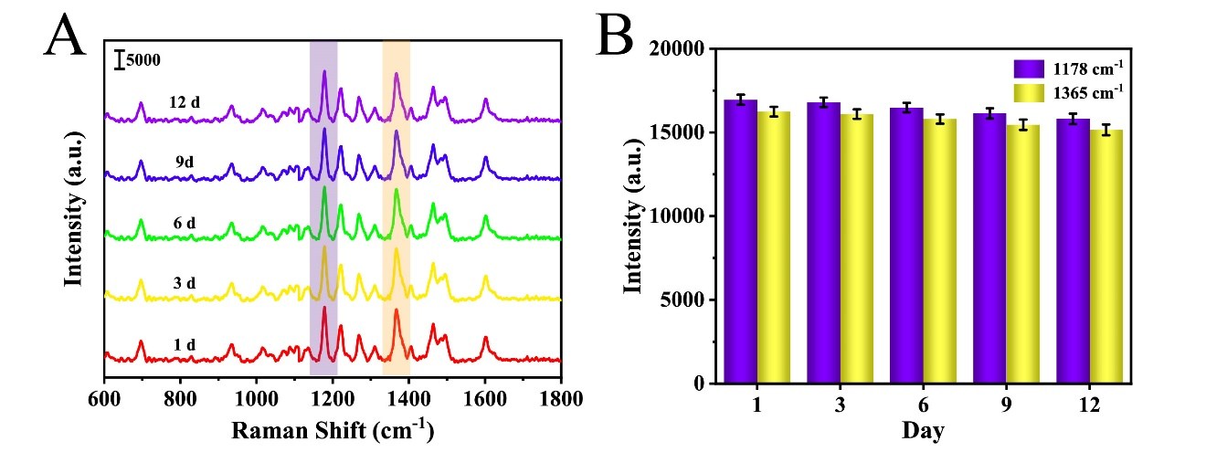
Fig. S1. (A) SERS spectra obtained after storage for different times (1d, 3d, 6d, 9d, and 12d) and (B) the intensities of the peaks corresponding to the features at 1178 cm⁻¹ and 1365 cm⁻¹.

