Table S1 Tumor inhibition rate based on tumor weight
TIR(%) | Without Laser |  |  | With Laser
Num. | GNR | GNR@Lipo | GNR@TM | GNR | GNR@Lipo | GNR@TM
1 | 15.9091 | 35.7955 | 46.0227 | 66.4773 | 79.5455 | 96.5909
2 | 28.9773 | 36.9318 | 75.5682 | 81.8182 | 73.2955 | 96.0227
3 | 25.0000 | 38.0682 | 67.6136 | 72.1591 | 79.5455 | 96.0227
4 | 17.0455 | 30.6818 | 59.0909 | 82.3864 | 90.9091 | 98.8636
5 | 19.8864 | 46.5909 | 64.2045 | 78.9773 | 94.3182 | 98.8636
Ave | 21.3636 | 37.6136 | 62.5000 | 76.3636 | 83.5227 | 97.2727
Abbreviations: TIR, tumor inhibition rate; Num, number; GNR, gold nanorod; Lipo, liposome; TM, tumor cell membrane; Ave, average.
Table S2 Tumor inhibition rate based on tumor volume
TIR(%) | Without Laser |  |  | With Laser
Num. | GNR | GNR@Lipo | GNR@TM | GNR | GNR@Lipo | GNR@TM
1 | 13.0737 | 21.1144 | 30.5894 | 50.7128 | 68.3154 | 96.2730
2 | 1.5125 | 20.6798 | 25.0261 | 52.1905 | 69.4019 | 93.4805
3 | 6.1196 | 18.1589 | 24.6349 | 59.5141 | 72.1836 | 95.1321
4 | 12.0306 | 25.2434 | 26.9819 | 64.7949 | 69.3150 | 99.1851
5 | 2.5556 | 14.8122 | 24.6349 | 52.4731 | 68.5327 | 98.0442
Ave | 7.0584 | 20.0017 | 26.3734 | 55.9371 | 69.5497 | 96.4230
Abbreviations: TIR, tumor inhibition rate; Num, number; GNR, gold nanorod; Lipo, liposome; TM, tumor cell membrane; Ave, average.
Figure S1 Thermal images of PBS, GNR, GNR@Lipo and GNR@TM after receiving NIR irradiation for 5 minutes.
Figure S2 The size and PDI changes of GNR@Lipo and GNR@TM in RPMI 1640 medium (10% FBS) for 3 weeks (n = 3).
Figure S3 Mean fluorescence intensity (MFI) of DIL and FITC in MB49 cells as converted from Figure 2C, n = 3.
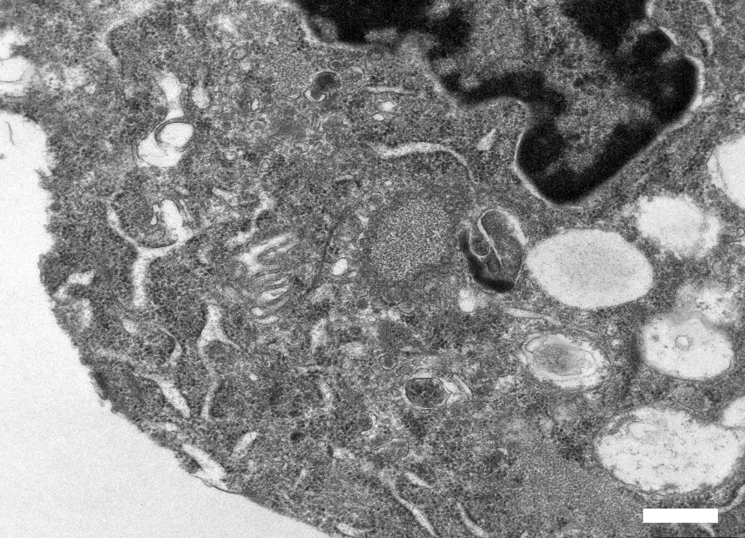
Figure S4 Representative TEM images of MB49 cells control without nanoparticles. Scale bar: 500 nm.
Figure S5 Mean fluorescence intensity (MFI) of PI in MB49 cells as converted from Figure 3G, n = 3. ****P < 0.0001.
Figure S6 Pictures and quantification analysis of the hemolysis test after different treatments under laser irradiation (1.5 W/cm², 5 min). TX-100 as a positive control (n = 3).
Figure S7 Temperature changes at tumor regions during laser irradiation (1.5 W/cm², 5 min) on different days (n = 3).
Figure S8 Individual tumor growth curves after various treatments in each mouse (n = 5).
Figure S9 Tumor inhibition rate based on tumor weight and tumor volume in different groups (n = 5). ****P < 0.0001.
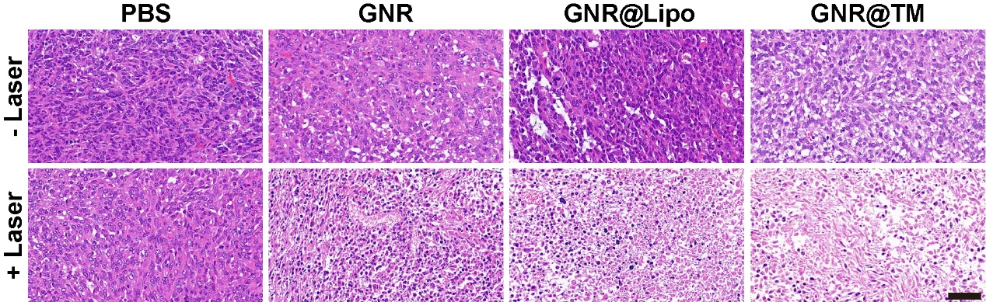
Figure S10 H&E staining of tumor after different treatments. Scale bar: 50 μm.

