Supplementary Information
The Pharmacokinetics, Safety and Tolerability of Aclidinium Bromide 400 μg Administered by Inhalation as Single and Multiple (Twice Daily) Doses in Healthy Chinese Participants
Weimin Li¹, Sami Z Daoud², Roopa Trivedi³, Pradeep B Lukka⁴, Eulalia Jimenez⁵, Eduard Molins⁵, Catherine Stewart⁶, Pranob Bharali^{3,7}, Esther Garcia-Gil⁸
¹Clinical Trial Center, West China Hospital of Sichuan University, Chengdu, Sichuan Province, China
²Respiratory & Immunology, BioPharmaceuticals R&D, AstraZeneca, Gaithersburg, MD, USA
³Late Respiratory & Immunology, BioPharmaceuticals R&D, AstraZeneca, Durham, NC, USA
⁴Clinical & Quantitative Pharmacology, Clinical Pharmacology & Safety Sciences, R&D, AstraZeneca, Gaithersburg, MD, USA
⁵Clinical & Quantitative Pharmacology, Clinical Pharmacology & Safety Sciences, R&D, AstraZeneca, Barcelona, Spain
⁶Statistics, Phastar, Chiswick, London, UK
⁷BioPharmaceuticals R&D Late-stage Development, AstraZeneca India Pvt Ltd., Bangalore, Karnataka, India
⁸Respiratory & Immunology, BioPharmaceuticals R&D, AstraZeneca, Barcelona, Spain

Corresponding author: Sami Z Daoud, Respiratory & Immunology, BioPharmaceuticals R&D, AstraZeneca, One MedImmune Way, Gaithersburg, MD 20878, USA.
Email: Sami.Daoud@astrazeneca.com. Tel: +1 302-598-8614

Supplementary Table 1 Hematology and Chemistry Laboratory Variables Over Time (Safety Analysis Set; N = 20)
Laboratory Parameter | Mean (SD)
Laboratory Parameter | Baseline | Day 11 | Change from Baseline
Basophils (10⁹/L) | 0.05 (0.07) | 0.03 (0.01) | -0.02 (0.07)
Eosinophils (10⁹/L) | 0.17 (0.14) | 0.15 (0.11) | -0.02 (0.07)
Erythrocytes (10¹²/L) | 4.90 (0.54) | 4.81 (0.66) | -0.09 (0.25)
Hematocrit ratio | 0.45 (0.04) | 0.43 (0.04) | -0.01 (0.02)
Hemoglobin (g/L) | 145.65 (13.56) | 144.75 (16.15) | -0.90 (6.42)
Leukocytes (10⁹/L) | 6.57 (1.45) | 6.27 (1.36) | -0.30 (1.26)
Lymphocytes (10⁹/L) | 2.04 (0.53) | 1.98 (0.44) | -0.07 (0.36)
Monocytes (10⁹/L) | 0.47 (0.13) | 0.40 (0.12) | -0.07 (0.08)
Neutrophils (10⁹/L) | 3.86 (1.35) | 3.72 (1.12) | -0.14 (1.14)
Platelets (10⁹/L) | 228.50 (43.44) | 230.65 (39.08) | 2.15 (35.08)
Alanine aminotransferase (μkat/L) | 0.35 (0.14) | 0.40 (0.16) | 0.05 (0.07)
Albumin (g/L) | 48.65 (2.07) | 47.94 (2.15) | -0.72 (1.87)
Alkaline phosphatase (μkat/L) | 1.20 (0.39) | 1.25 (0.36) | 0.05 (0.12)
Aspartate aminotransferase (μkat/L) | 0.32 (0.07) | 0.32 (0.08) | 0.01 (0.04)
Bilirubin (μmol/L) | 11.03 (4.34) | 10.88 (2.78) | -0.15 (3.99)
Calcium (mmol/L) | 2.34 (0.10) | 2.28 (0.07) | -0.06 (0.10)
Chloride (mmol/L) | 102.92 (1.23) | 101.67 (2.13) | -1.25 (1.86)
Cholesterol (mmol/L) | 4.14 (0.74) | 4.09 (0.76) | -0.06 (0.60)
Creatine kinase (μkat/L) | 1.96 (1.22) | 1.26 (0.71) | -0.70 (1.09)
Creatinine (µmol/L) | 71.60 (19.38) | 74.25 (17.22) | 2.65 (5.60)
Gamma glutamyl transferase (μkat/L) | 0.31 (0.16) | 0.35 (0.20) | 0.04 (0.06)
Glucose (mmol/L) | 5.07 (0.36) | 4.75 (0.25) | -0.31 (0.26)
Lactate dehydrogenase (μkat/L) | 2.58 (0.35) | 2.37 (0.26) | -0.20 (0.26)
Phosphate (mmol/L) | 1.07 (0.13) | 1.15 (0.15) | 0.08 (0.10)
Potassium (mmol/L) | 4.21 (0.22) | 4.10 (0.30) | -0.11 (0.33)
Protein (g/L) | 75.05 (4.49) | 74.50 (3.62) | -0.55 (3.41)
Sodium (mmol/L) | 140.67 (1.55) | 138.73 (1.97) | -1.94 (1.81)
Triglycerides (mmol/L) | 1.04 (0.44) | 1.42 (0.56) | 0.38 (0.52)
Urate (µmol/L) | 314.20 (70.07) | 329.35 (71.55) | 15.15 (42.94)
Urea nitrogen (mmol/L) | 4.28 (1.20) | 4.33 (0.95) | 0.06 (0.71)
Notes: Baseline is last non-missing result available prior to first dose. Change from baseline is post-dose visit value – baseline value.
Abbreviations: SD, standard deviation.

Supplementary Figure 1 Semi-logarithmic Geometric Mean Plasma Concentration (pg/mL) of (A) Aclidinium, (B) LAS34823 and (C) LAS35840 Versus Time: Day 1 and Day 9
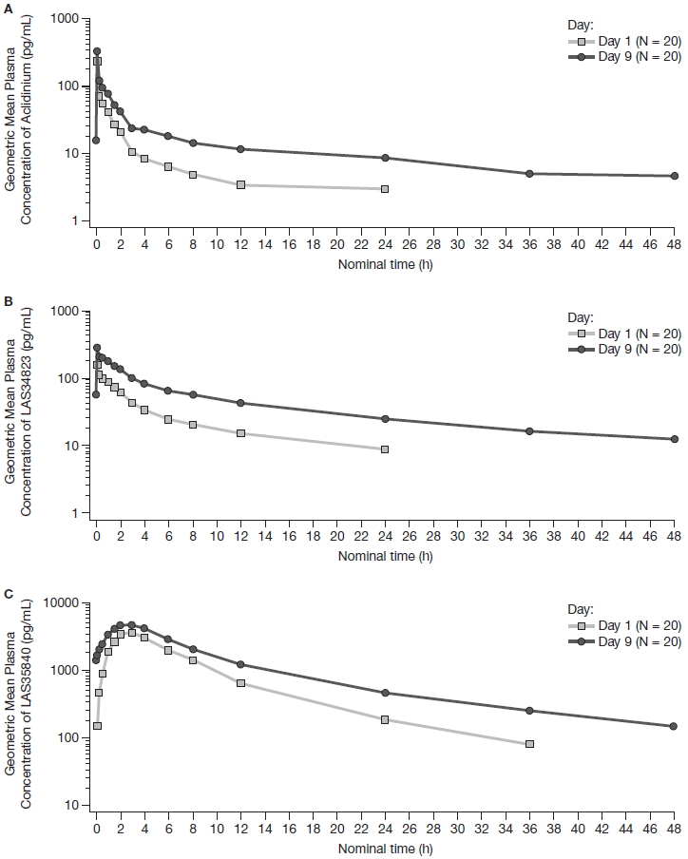
Notes: Plasma concentration axes display a semi-logarithmic scale. Data points are displayed only if ≥3 concentrations are available for each timepoint.
Abbreviations: h, hours.

