Supplementary figure 1. Outcome graphs displaying event rates and adjusted incidence rate ratios.
With and without stratification for coronary artery disease.
A. Myocardial infarction.
B. Ischemic stroke.
C. All-cause mortality.
eGFR, estimated glomerular filtration rate. IRR, incidence rate ratio. CAD, coronary artery disease.

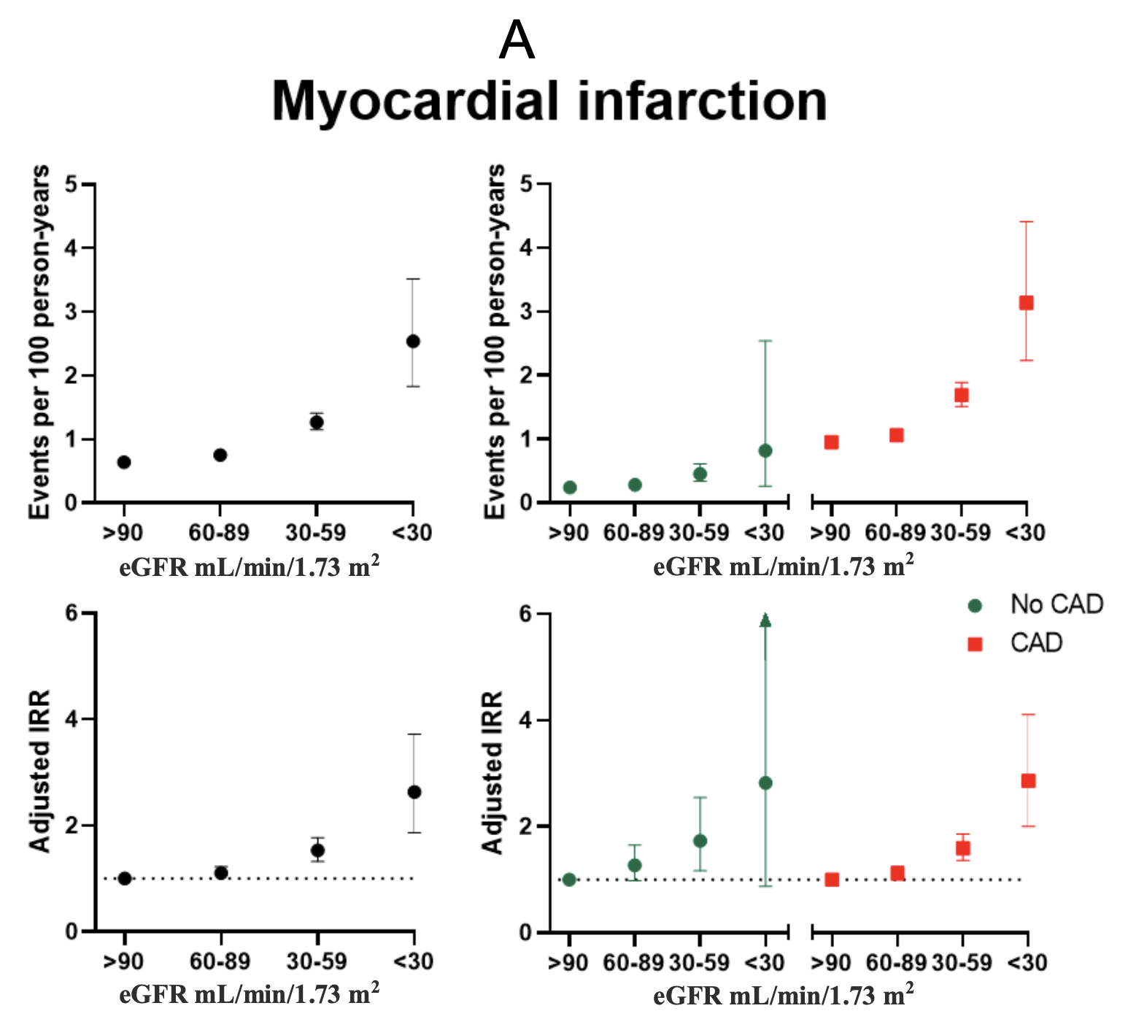
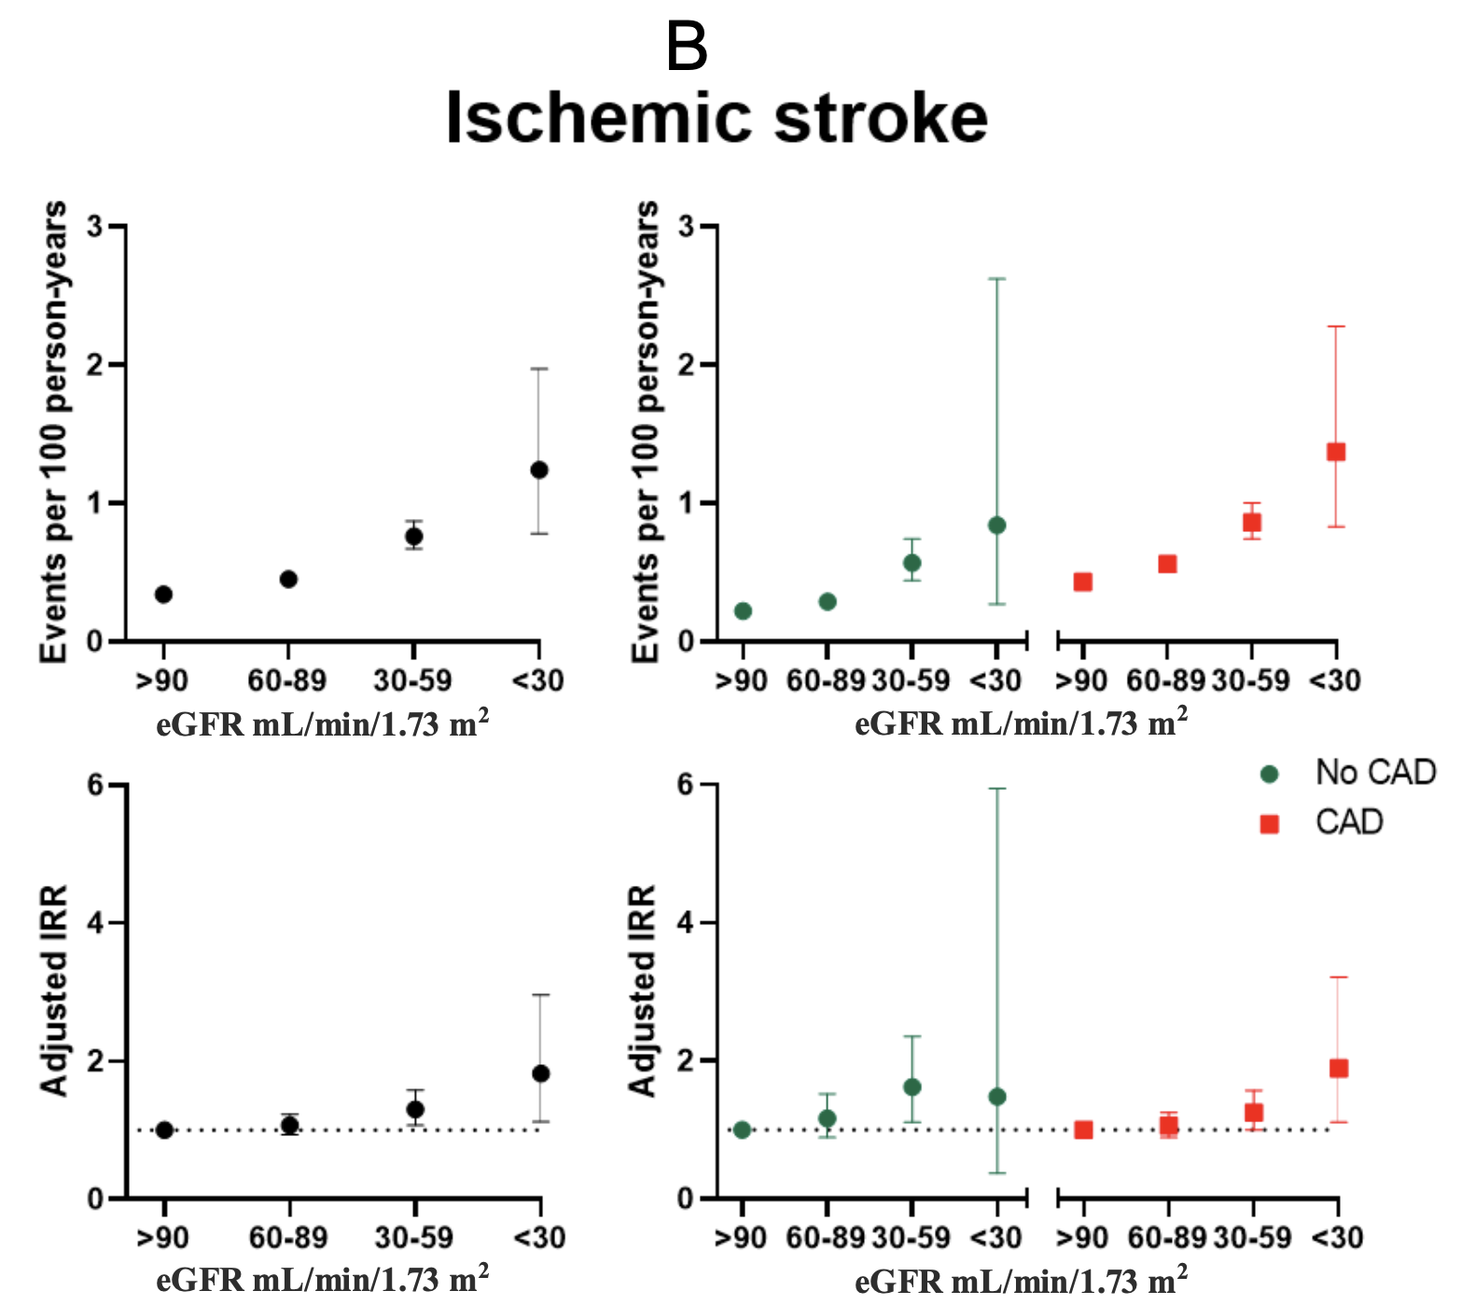
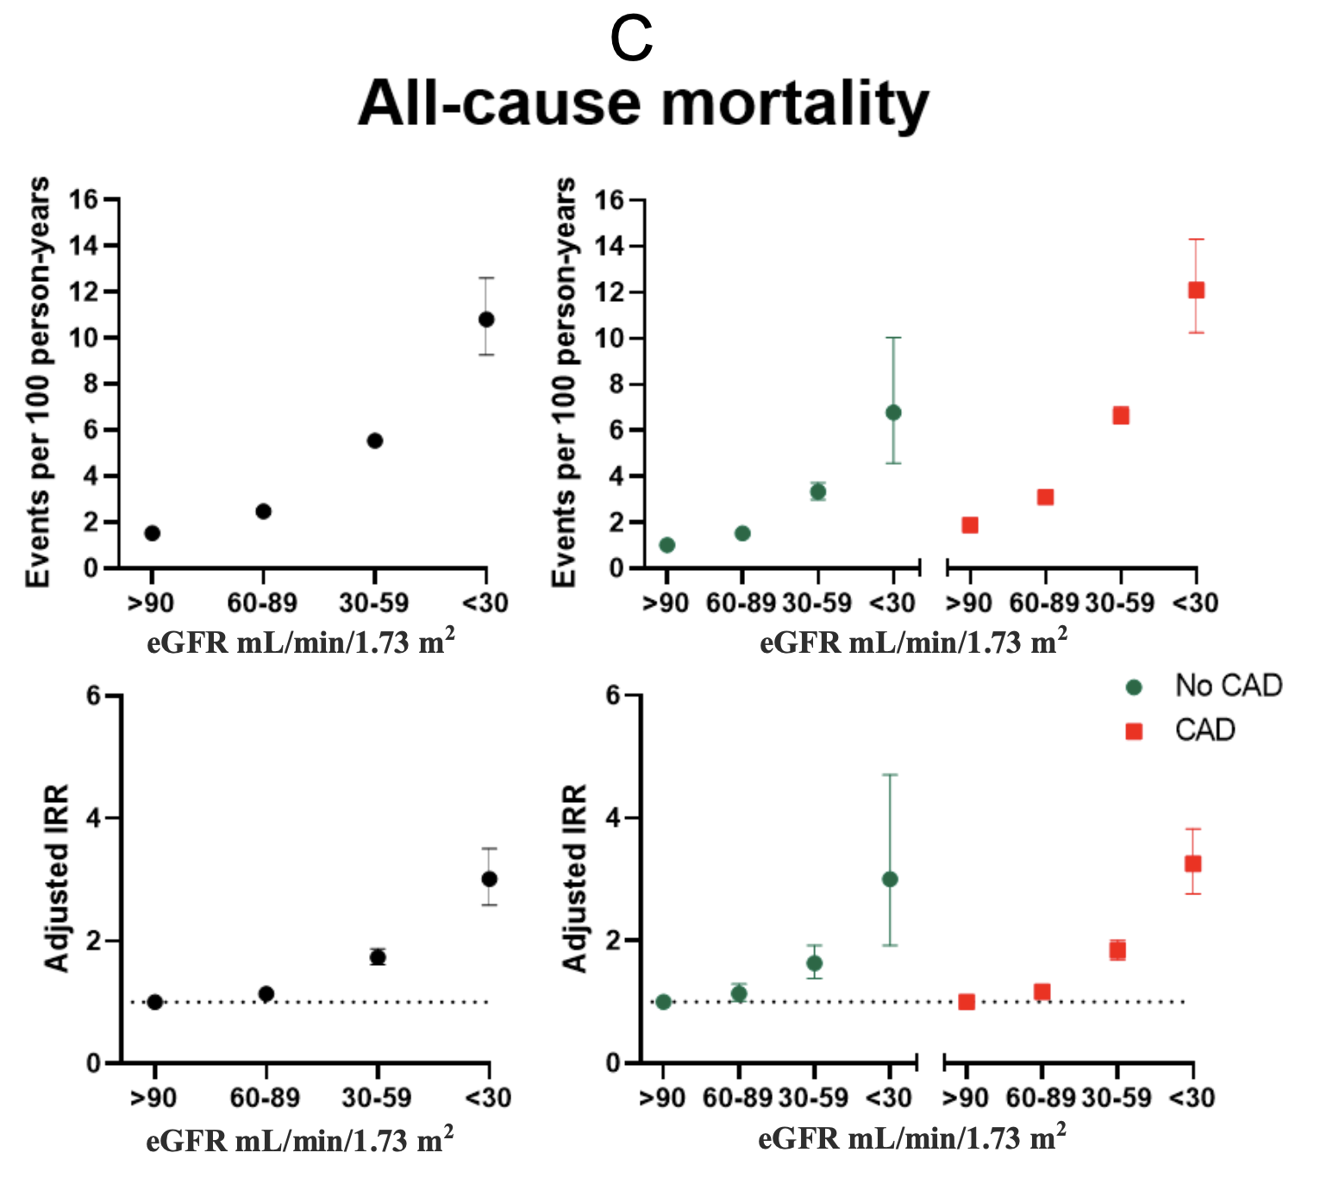

Supplementary figure 2. Cumulative incidence proportions.
A. Myocardial infarction.
B. Ischemic stroke.
C. All-cause mortality.
eGFR, estimated glomerular filtration rate.
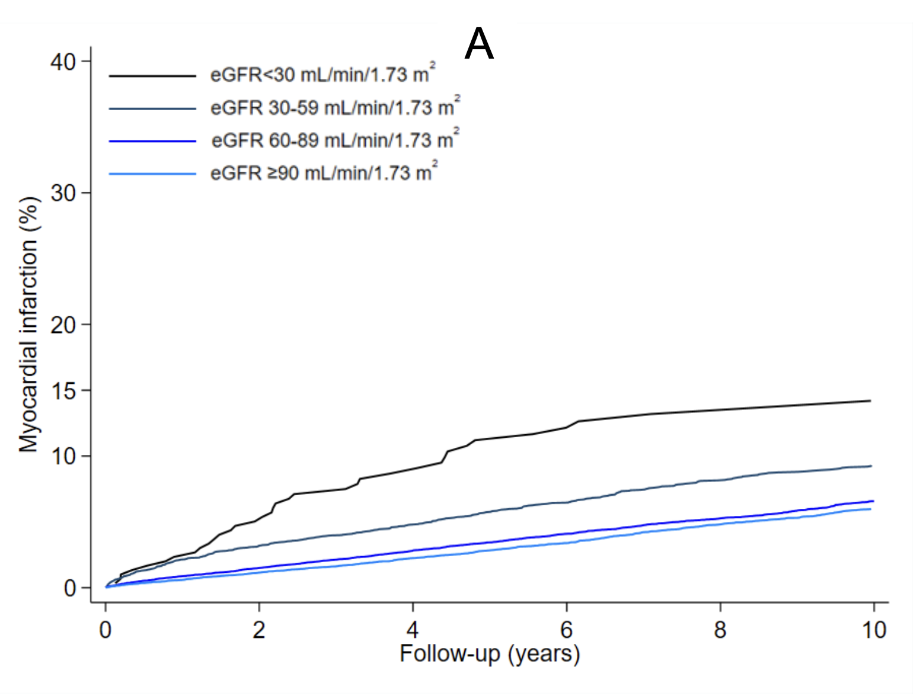
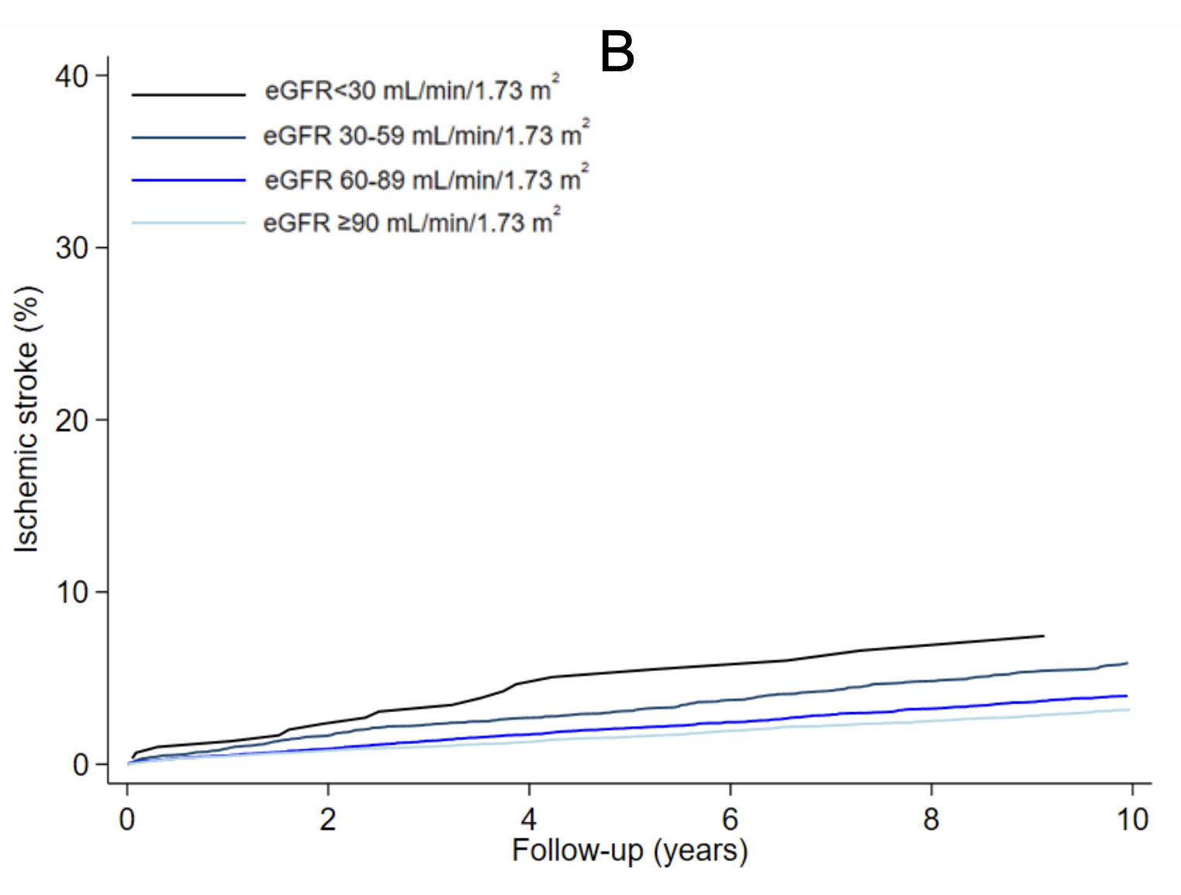
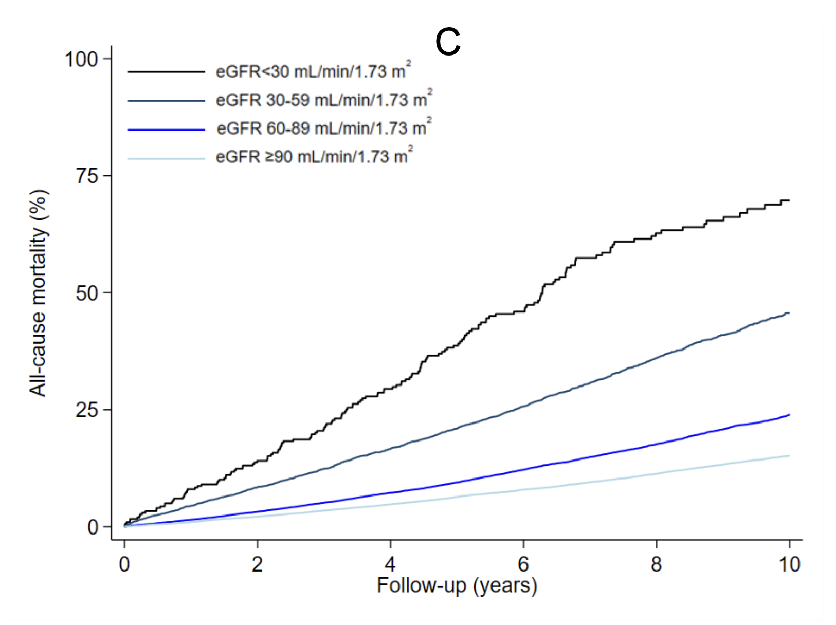

Supplementary table 1. Codes used for definition of covariates and outcomes.
ICD-10 codes
Ischemic stroke | DI63, DI64
Hemorrhagic stroke | DI60, DI61, DS06.6
Transitory ischemic attack | DG45
Atrial fibrillation | DI48
Peripheral artery disease | DI70, DI70.1-DI70.9. DI73.9
Diabetes mellitus | DE10-DE14, DH36.0, DO24.0-24.3, DO24.5-24.9, DG63.2, DN08.3
Hypertension | DI10, DI15.1, DI15.8, DI15.9
Heart failure with reduced ejection fraction | DI11.0, DI13.0, DI13.2, DI50
Myocardial infarction | DI21
Percutaneous coronary intervention | KFNG02, KFNG05, KFNG96
Coronary artery bypass grafting | KFNA-KFNE
Cancer (any tumor) | DC00-DC75
Dementia | DF00-DF03, DF10.73, DF11.73, DF12.73, DF13.73, DF14.73, DF15.73, DF16.73, DF18.73, DF19.73, DG23.1, DG30, DG31.0-DG31.1, DG31.8
Chronic obstructive pulmonary disease | DJ40-DJ47, DJ60-DJ67, DJ68.4, DJ70.1, DJ70.3, DJ84.1, DJ92.0, DJ96.1, DJ98.2, DJ98.3
Nephropathy | DR809, DB289A, DE102, DE112, DE122, DE132, DE142, DE143, DN06, DN07, DN08, DN14, DN16, DM103, DM350E, DN391
Retinopathy | DE103, DE113, DE123, DE133, DE143, DH280, DH334B, DH34, DH350, DH360
Neuropathy | DE104, DE114, DE124, DE134, DE144, DG56, DG57, DG58, DG59, DG609, DG603, DG61, DG62, DG63, DG900, DG909, DG99
Dialysis | DZ992, BJFD20-27, BJFZ40, BJFZ45, KPBL30, KPBL99, KPBL20
Cardiac death | I20-I25, I46, I47.2, I49, I50, R96, R98.9, R99.9

ATC codes
Aspirin | B01AC06, N02BA01
ADP-inhibitors | B01AC04, B01AC22, B01AC24
Vitamin K-antagonists | B01AA03, B01AA04
NOAC | B01AF02, B01AE07, B01AF01, B01AF03
Thiazide | C03AA, C03AB
Statins | C10AA
Calcium channel blockers | C08C, C08D
Beta blockers | C07
ARBs | C09C, C09D
ACE-inhibitors | C09A, C09B
Insulin | A10A
Non-insulin anti-diabetes agents | A10B

International Classification of Diseases, Tenth Revision (ICD-10) codes from the Danish National Patient Registry, codes for comedications from the Danish National Health Service Prescription Database using the Anatomical Therapeutic Chemical (ATC) classification, and causes of deaths from the Cause of Death Registry used for definition of cardiac death.

Supplementary table 2. Baseline characteristics of chronic coronary syndrome patients undergoing coronary angiography in Western Denmark with CAD.

CAD  eGFR (mL/min/1.73 m²) | <30  n=235 | 30-59  n=3,303 | 60-89  n=10,978 | ≥90  n=12,011
Age mean (years) (IQR) | 74 (66, 79) | 75 (70, 80) | 70 (64, 75) | 62 (55, 67)
Male | 133 (56.6) | 1507 (45.6) | 6895 (62.8) | 10005 (83.3)
Body mass index median (kg/m²) (IQR) | 27.0 (24.0, 29.0) | 26.0 (24.0, 29.0) | 26.0 (24.0, 29.0) | 28.0 (26.0, 31.0)
Systolic blood pressure mean (mmHg) (SD) | 148.0 (23.8) | 146.4 (22.5) | 146.0 (20.8) | 144.8 (19.9)
Diastolic blood pressure mean (mmHg) (SD) | 76.5 (12.8) | 76.7 (12.0) | 79.6 (11.6) | 82.1 (11.3)
Smoking
Active | 34 (14.5) | 516 (15.6) | 2039 (18.6) | 3521 (29.3)
Former/never | 180 (76.6) | 2,597 (78.6) | 8,502 (77.5) | 8,112 (67.6)
Comorbidities
Ischemic stroke | 17 (7.2) | 147 (4.5) | 254 (2.3) | 196 (1.6)
Hemorrhagic stroke | 0 (0.0%) | 8 (0.2%) | 26 (0.2%) | 17 (0.1%)
TIA | 11 (4.7) | 157 (4.8) | 343 (3.1) | 315 (2.6)
AFib | 39 (16.6) | 523 (15.8) | 1210 (11.0) | 930 (7.7)
PAD | 35 (14.9) | 411 (12.4) | 797 (7.3) | 659 (5.5)
Diabetes | 83 (35.3) | 789 (23.9) | 1958 (17.8) | 2671 (22.2)
Hypertension | 209 (88.9) | 2706 (81.9) | 7768 (70.8) | 7875 (65.6)
HFrEF | 50 (21.3) | 536 (16.2) | 863 (7.9) | 666 (5.5)
MI before CAG | 15 (6.4) | 133 (4.0) | 284 (2.6) | 288 (2.4)
MI <30 days after CAG | 15 (6.4) | 29 (0.9) | 91 (0.8) | 77 (0.6)
Previous PCI | 7 (3.0) | 76 (2.3) | 242 (2.2) | 283 (2.4)
Previous CABG | 3 (1.3) | 26 (0.8) | 76 (0.7) | 70 (0.6)
Cancer (any tumor) | 3 (1.3) | 26 (0.8) | 76 (0.7) | 70 (0.6)
Dementia | 0 (0.0) | 17 (0.5) | 21 (0.2) | 22 (0.2)
Chronic obstructive pulmonary disease | 23 (9.8) | 323 (9.8) | 814 (7.4) | 724 (6.0)
Previous nephropathy | 51 (21.7) | 134 (4.1) | 102 (0.9) | 94 (0.8)
Previous retinopathy | 34 (14.5) | 149 (4.5) | 292 (2.7) | 406 (3.4)
Previous peripheral polyneuropathy | 14 (6.0) | 69 (2.1) | 134 (1.2) | 160 (1.3)
CAD status at CAG
1 VD | 73 (31.1) | 1044 (31.6) | 3894 (35.5) | 4560 (38.0)
2 VD | 44 (18.7) | 726 (22.0) | 2466 (22.5) | 2645 (22.0)
3 VD | 85 (36.2) | 966 (29.2) | 2559 (23.3) | 2366 (19.7)
Diffuse VD | 33 (14.0) | 567 (17.2) | 2059 (18.8) | 2440 (20.3)
Medical treatment
Aspirin | 189 (80.4) | 2778 (84.1) | 9354 (85.2) | 10,279 (85.6)
ADP-inhibitors | 103 (43.8) | 1207 (36.5) | 3980 (36.3) | 4631 (38.6)
Vitamin K-antagonists | 35 (14.9) | 392 (11.9) | 906 (8.3) | 665 (5.5)
NOAC | 6 (2.6) | 72 (2.2) | 222 (2.0) | 164 (1.4)
Thiazide | 43 (18.3) | 866 (26.2) | 2117 (19.3) | 1786 (14.9)
Statins | 200 (85.1) | 2853 (86.4) | 9888 (90.1) | 10967 (91.3)
Calcium channel blockers | 135 (57.4) | 1530 (46.3) | 4484 (40.8) | 4491 (37.4)
Beta blockers | 180 (76.6) | 2391 (72.4) | 7328 (66.8) | 7648 (63.7)
ARBs | 97 (41.3) | 953 (28.9) | 2297 (20.9) | 2258 (18.8)
ACE-inhibitors | 106 (45.1) | 1357 (41.1) | 3617 (32.9) | 3699 (30.8)
Insulin | 53 (22.6) | 295 (8.9) | 597 (5.4) | 815 (6.8)
Non-insulin | 31 (13.2) | 455 (13.8) | 1312 (12.0) | 1962 (16.3)
CCS Scale
Grade I | 28 (11.9) | 446 (13.5) | 1722 (15.7) | 1928 (16.1)
Grade II | 146 (62.1) | 2077 (62.9) | 7183 (65.4) | 7915 (65.9)
Grade III | 54 (23.0) | 647 (19.6) | 1638 (14.9) | 1636 (13.6)
Grade IV | 1 (0.4) | 22 (0.7) | 47 (0.4) | 62 (0.5)
Missing | 6 (2.6) | 111 (3.4) | 388 (3.5) | 470 (3.9)
CCI Group
CCI 0 | 50 (21.3) | 1553 (47.0) | 6994 (63.7) | 8042 (67.0)
CCI 1 | 33 (14.0) | 695 (21.0) | 1995 (18.2) | 2191 (18.2)
CCI 2 | 48 (20.4) | 474 (14.4) | 1059 (9.6) | 954 (7.9)
CCI >2 | 104 (44.3) | 581 (17.6) | 930 (8.5) | 824 (6.9)

Values are indicated as number (%), unless otherwise stated. eGFR, estimated glomerular filtration rate. SD, standard deviation. IQR, interquartile range. TIA, transient ischemic attack. AFib, atrial fibrillation. PAD, peripheral artery disease. HFrEF, heart failure with reduced ejection fraction. MI, myocardial infarction. CAG, coronary angiography. PCI, percutaneous coronary intervention. CABG, coronary artery bypass grafting. CAD, coronary artery disease. VD, vessel disease. ADP, adenosine diphosphate receptor. NOAC, non-vitamin K antagonist oral anticoagulants. ARBs, angiotensin receptor blockers. ACE, angiotensin-converting enzyme. CCS, Canadian Cardiovascular Society. CCI, Charlson Comorbidity Index.

Supplementary table 3. Baseline characteristics of chronic coronary syndrome patients undergoing coronary angiography in Western Denmark without CAD.

No-CAD  eGFR (mL/min/1.73 m²) | <30  n=63 | 30-59  n=1,413 | 60-89  n=6,474 | ≥90  n=8,134
Age mean (years) (IQR) | 72 (64, 77) | 72 (65, 77) | 66 (59, 71) | 57 (50, 63)
Male | 24 (38.1) | 256 (18.1) | 1931 (29.8) | 4991 (61.4)
Body mass index median (kg/m²) (IQR) | 26.0 (23.0, 29.0) | 26.0 (23.0, 29.0) | 26.0 (23.0, 29.0) | 28.0 (25.0, 32.0)
Systolic blood pressure mean (mmHg) (SD) | 139.3 (22.0) | 143.5 (21.9) | 143.1 (20.6) | 140.3 (19.3)
Diastolic blood pressure mean (mmHg) (SD) | 75.9 (14.1) | 76.9 (11.8) | 79.6 (11.3) | 81.7 (11.1)
Smoking
Active | 7 (11.1) | 217 (15.4) | 1033 (16.0) | 2248 (27.6)
Former/never | 51 (80.9) | 1,126 (79.7) | 5,151 (79.5) | 5,631 (69.3)
Missing | 5 (7.9) | 70 (5.0) | 290 (4.5) | 255 (3.1)
Comorbidities
Ischemic stroke | 4 (6.3) | 47 (3.3) | 97 (1.5) | 79 (1.0)
Hemorrhagic stroke | 1 (1.6) | 3 (0.2) | 5 (0.1) | 6 (0.1)
TIA | 2 (3.2) | 44 (3.1) | 182 (2.8) | 162 (2.0)
AFib | 9 (14.3) | 237 (16.8) | 733 (11.3) | 681 (8.4)
PAD | 2 (3.2) | 61 (4.3) | 178 (2.7) | 163 (2.0)
Diabetes | 17 (27.0) | 224 (15.9) | 704 (10.9) | 1299 (16.0)
Hypertension | 55 (87.3) | 1057 (74.8) | 3958 (61.1) | 4516 (55.5)
HFrEF | 10 (15.9) | 120 (8.5) | 276 (4.3) | 256 (3.1)
MI before CAG | 0 (0.0) | 22 (1.6) | 58 (0.9) | 70 (0.9)
MI <30 days after CAG | 0 (0.0) | 3 (0.2) | 9 (0.1) | 5 (0.1)
Previous PCI | 0 (0.0) | 11 (0.8) | 29 (0.4) | 48 (0.6)
Previous CABG | 1 (1.6) | 0 (0.0) | 1 (0.01) | 6 (0.1)
Cancer (any tumor) | 6 (9.5) | 115 (8.1) | 347 (5.4) | 341 (4.2)
Dementia | 0 (0.0) | 10 (0.7) | 13 (0.2) | 10 (0.1)
Chronic obstructive pulmonary disease | 6 (9.5) | 143 (10.1) | 522 (8.1) | 596 (7.3)
Previous nephropathy | 6 (9.5) | 31 (2.2) | 28 (0.4) | 34 (0.4)
Previous retinopathy | 3 (4.8) | 38 (2.7) | 80 (1.2) | 186 (2.3)
Previous peripheral polyneuropathy | 1 (1.6) | 20 (1.4) | 48 (0.7) | 63 (0.8)
Medical treatment
Aspirin | 40 (63.5) | 1019 (72.1) | 4457 (68.8) | 5327 (65.5)
ADP-inhibitors | 3 (4.8) | 67 (4.7) | 278 (4.3) | 268 (3.3)
Vitamin K-antagonists | 12 (19.0) | 200 (14.2) | 563 (8.7) | 453 (5.6)
NOAC | 3 (4.8) | 29 (2.1) | 93 (1.4) | 98 (1.2)
Thiazide | 13 (20.6) | 372 (26.3) | 1299 (20.1) | 1189 (14.6)
Statins | 40 (63.5) | 894 (63.3) | 3888 (60.1) | 4625 (56.9)
Calcium channel blockers | 34 (54.0) | 591 (41.8) | 2122 (32.8) | 2334 (28.7)
Beta blockers | 40 (63.5) | 878 (62.1) | 3416 (52.8) | 3674 (45.2)
ARBs | 20 (31.7) | 375 (26.5) | 1198 (18.5) | 1294 (15.9)
ACE-inhibitors | 28 (44.4) | 412 (29.2) | 1492 (23.0) | 1961 (24.1)
Insulin | 8 (12.7) | 76 (5.4) | 208 (3.2) | 353 (4.3)
Non-insulin | 5 (7.9) | 115 (8.1) | 447 (6.9) | 920 (11.3)
CCS Scale
Grade I | 23 (36.5) | 455 (32.2) | 2364 (36.5) | 3057 (37.6)
Grade II | 32 (50.8) | 845 (59.8) | 3690 (57.0) | 4541 (55.8)
Grade III | 4 (6.3) | 61 (4.3) | 171 (2.6) | 205 (2.5)
Grade IV | 0 (0.0) | 1 (0.1) | 11 (0.2) | 12 (0.1)
Missing | 4 (6.3) | 51 (3.6) | 238 (3.7) | 319 (3.9)
CCI Group
CCI 0 | 21 (33.3) | 828 (58.6) | 4631 (71.5) | 5873 (72.2)
CCI 1 | 4 (6.3) | 276 (19.5) | 1069 (16.5) | 1369 (16.8)
CCI 2 | 21 (33.3) | 164 (11.6) | 493 (7.6) | 498 (6.1)
CCI >2 | 17 (27.0) | 145 (10.3) | 281 (4.3) | 394 (4.8)

Values are indicated as number (%), unless otherwise stated. eGFR, estimated glomerular filtration rate. SD, standard deviation. IQR, interquartile range. TIA, transient ischemic attack. AFib, atrial fibrillation. PAD, peripheral artery disease. HFrEF, heart failure with reduced ejection fraction. MI, myocardial infarction. CAG, coronary angiography. PCI, percutaneous coronary intervention. CABG, coronary artery bypass grafting. CAD, coronary artery disease. VD, vessel disease. ADP, adenosine diphosphate receptor. NOAC, non-vitamin K antagonist oral anticoagulants. ARBs, angiotensin receptor blockers. ACE, angiotensin-converting enzyme. CCS, Canadian Cardiovascular Society. CCI, Charlson Comorbidity Index.

Supplementary table 4. Incidence rate ratios of major adverse cardiovascular events for patients stratified by CAD and eGFR.
eGFR  (mL/min/  1.73 m²) | Patients | Events | Events per 100  person-years  (95% CI) | Unadjusted IRR  (95% CI) | Adjusted IRR*  (95% CI) | P for trend
MAJOR ADVERSE CARDIOVASCULAR EVENTS
No CAD
≥90 | 8,134 | 307 | 0.52 (0.46-0.58) | Reference | Reference
60-89 | 6,474 | 324 | 0.68 (0.61-0.76) | 1.32 (1.13-1.55) | 1.22 (1.02-1.45) | p<0.001
45-59 | 1,138 | 82 | 1.04 (0.84-1.29) | 2.01 (1.57-2.56) | 1.42 (1.08-1.87)
30-44 | 275 | 40 | 2.39 (1.76-3.26) | 4.63 (3.34-6.41) | 2.35 (1.63-3.40)
15-29 | 44 | 5 | 2.04 (0.85-4.90) | 3.94 (1.62-9.59) | 1.58 (0.52-4.80)
<15 | 19 | 3 | 2.78 (0.90-8.63) | 5.38 (1.72-16.81) | 3.86 (1.24-11.99)
CAD
≥90 | 12,011 | 1,272 | 1.67 (1.58-1.76) | Reference | Reference
60-89 | 10,978 | 1,450 | 2.09 (1.98-2.20) | 1.25 (1.16-1.35) | 1.08 (0.99-1.17) | p<0.001
45-59 | 2,406 | 471 | 3.34 (3.05-3.66) | 2.00 (1.80-2.23) | 1.42 (1.25-1.60)
30-44 | 897 | 241 | 5.50 (4.85-6.24) | 3.30 (2.87-3.79) | 1.93 (1.65-2.27)
15-29 | 198 | 62 | 7.27 (5.57-9.33) | 4.36 (3.38-5.63) | 2.59 (2.00-3.36)
<15 | 37 | 9 | 5.19 (2.70-9.97) | 3.11 (1.61-6.00) | 2.69 (1.45-5.01)

Risk of major adverse cardiovascular events after coronary angiography for patients with and without CAD stratified by kidney function. IRR, incidence rate ratio. eGFR, estimated glomerular filtration rate.
*We adjusted for age category (<65, 65-74, and ≥75), sex, BMI category (<18.5, 18.5-24, 25-29, and ≥30) (imputed), active smoking (imputed), hypertension, peripheral artery disease, previous ischemic stroke, Diabetes Mellitus, coronary artery disease category, oral anticoagulant treatment, antiplatelet treatment, statin treatment, heart failure with reduced ejection fraction, and atrial fibrillation.

Supplementary table 5. Incidence rate ratios of major adverse cardiovascular events for patients stratified by extent of CAD and eGFR
eGFR  (mL/min/  1.73 m²) | Patients | Events | Events per 100  person-years  (95% CI) | Unadjusted IRR  (95% CI) | Adjusted IRR*  (95% CI) | P for trend
MAJOR ADVERSE CARDIOVASCULAR EVENTS
Diffuse CAD
≥90 | 2,440 | 156 | 1.08 (0.92-1.26) | Reference | Reference
60-89 | 2,059 | 136 | 1.12 (0.95-1.33) | 1.04 (0.83-1.31) | 0.95 (0.73-1.23) | p<0.001
30-59 | 567 | 51 | 1.64 (1.25-2.16) | 1.53 (1.12-2.09) | 1.18 (0.81-1.72)
<30 | 33 | 6 | 5.06 (2.27-11.26) | 4.69(2.02-10.88) | 2.87 (1.18-6.98)
Single-vessel CAD
≥90 | 4,560 | 412 | 1.40 (1.27-1.54) | Reference | Reference
60-89 | 3,894 | 401 | 1.58 (1.43-1.74) | 1.13 (0.98-1.29) | 1.05 (0.90-1.22) | p<0.001
30-59 | 1,044 | 199 | 3.24 (2.82-3.73) | 2.32 (1.96-2.75) | 1.62 (1.31-2.00)
<30 | 73 | 19 | 5.49 (3.50-8.61) | 3.92 (2.50-6.16) | 2.78 (1.74-4.45)
Multivessel CAD
≥90 | 5,011 | 704 | 2.17 (2.02-2.34) | Reference | Reference
60-89 | 5,025 | 913 | 2.86 (2.68-3.05) | 1.31 (1.9-1.45) | 1.12 (1.01-1.25) | p<0.001
30-59 | 1,692 | 462 | 5.00 (4.56-5.47) | 2.30 (2.04-2.59) | 1.60 (1.39-1.85)
<30 | 129 | 46 | 8.19 (6.14-10.94) | 3.77 (2.79-5.10) | 2.60 (1.91-3.53)

Risk of major adverse cardiovascular events after coronary angiography stratified by CAD extent and kidney function. CAD extent was categorized as diffuse, non-significant CAD, obstructive single-vessel CAD, or obstructive multivessel CAD. IRR, incidence rate ratio. eGFR, estimated glomerular filtration rate.
*We adjusted for age category (<65, 65-74, and ≥75), sex, active smoking (imputed), hypertension, peripheral artery disease, previous ischemic stroke, Diabetes Mellitus, oral anticoagulant treatment, antiplatelet treatment, statin treatment, heart failure with reduced ejection fraction, and atrial fibrillation.

Supplementary table 6. Incidence rate ratios of major adverse cardiovascular events for patients stratified by CAD, LVEF and eGFR.
eGFR  (mL/min/  1.73 m²) | Patients | Events | Events per 100  person-years  (95% CI) | Unadjusted IRR  (95% CI) | Adjusted IRR*  (95% CI) | P for trend

MAJOR ADVERSE CARDIOVASCULAR EVENTS
No CAD and LVEF>40%
≥90 | 4,654 | 155 | 0.49 (0.42-0.57) | Reference | Reference
60-89 | 3,448 | 143 | 0.61 (0.52-0.72) | 1.26 (1.00-1.58) | 1.13 (0.88-1.45) | p<0.001
30-59 | 729 | 48 | 1.03 (0.78-1.37) | 2.11 (1.53-2.92) | 1.38 (0.92-2.05)
<30 | 28 | 3 | 1.69 (0.55-5.25) | 3.47 (1.05-11.45) | 1.80 (0.49-6.65)
No CAD and LVEF≤40%
≥90 | 106 | 10 | 1.35 (0.73-2.52) | Reference | Reference
60-89 | 105 | 15 | 2.29 (1.38-3.81) | 1.70 (0.77-3.76) | 1.33 (0.50-3.51) | p<0.001
30-59 | 47 | 5 | 1.99 (0.83-4.77) | 1.47 (0.51-4.22) | 0.43 (0.11-1.71)
<30 | 3 | 0 | - | - | -
CAD and LVEF>40%
≥90 | 7,607 | 681 | 1.50 (1.40-1.62) | Reference | Reference
60-89 | 6,324 | 697 | 1.87 (1.73-2.01) | 1.24 (1.12-1.38) | 1.04 (0.92-1.17) | p<0.001
30-59 | 1,698 | 312 | 3.47 (3.11-3.88) | 2.31 (2.02-2.64) | 1.50 (1.28-1.77)
<30 | 115 | 33 | 7.30 (5.19-10.26) | 4.85 (3.42-6.88) | 2.85 (1.98-4.09)
CAD and LVEF≤40%
≥90 | 348 | 63 | 3.16 (2.47-4.05) | Reference | Reference
60-89 | 397 | 95 | 4.33 (3.54-5.29) | 1.37 (0.99-1.88) | 1.35 (0.94-1.92) | p<0.001
30-59 | 235 | 61 | 5.72 (4.45-7.36) | 1.81 (1.27-2.58) | 1.75 (1.13-2.70)
<30 | 17 | 6 | 8.77 (3.94-19.52) | 2.77 (1.15-6.70) | 3.14 (1.32-7.44)

Risk of major adverse cardiovascular events after coronary angiography for patients with and without CAD, LVEF> 40% or LVEF≤40 % and stratified by kidney function. IRR, incidence rate ratio. eGFR, estimated glomerular filtration rate.
*We adjusted for age category (<65, 65-74, and ≥75), sex, BMI category (<18.5, 18.5-24, 25-29, and ≥30) (imputed), active smoking (imputed), hypertension, peripheral artery disease, previous ischemic stroke, Diabetes Mellitus, coronary artery disease category, oral anticoagulant treatment, antiplatelet treatment, statin treatment and atrial fibrillation.

Supplementary table 7. Incidence rate ratios of clinical outcomes.
eGFR  (mL/min/  1.73 m²) | Person-years | Events | Events per 100  person-years  (95% CI) | Unadjusted IRR  (95% CI) | Adjusted IRR*  (95% CI) | P for trend
MYOCARDIAL INFARCTION
≥90 | 137,231 | 877 | 0.64 (0.60-0.68) | Reference | Reference
60-89 | 118,430 | 884 | 0.75 (0.70-0.80) | 1.17 (1.06-1.28) | 1.10 (0.99-1.22) | p<0.001
30-59 | 28,602 | 363 | 1.27 (1.15-1.41) | 1.99 (1.76-2.25) | 1.53 (1.32-1.77)
<30 | 1,419 | 36 | 2.54 (1.83-3.52) | 3.97 (2.84-5.56) | 2.63 (1.86-3.72)
ISCHEMIC STROKE
≥90 | 138,641 | 474 | 0.34 (0.31-0.37) | Reference | Reference
60-89 | 119,611 | 538 | 0.45 (0.41-0.49) | 1.32 (1.16-1.49) | 1.07 (0.93-1.23) | p<0.001
30-59 | 29,045 | 221 | 0.76 (0.67-0.87) | 2.23 (1.90-2.61) | 1.30 (1.07-1.58)
<30 | 1,448 | 18 | 1.24 (0.78-1.97) | 3.64 (2.27-5.82) | 1.82 (1.12-2.96)
ALL-CAUSE MORTALITY
≥90 | 140,300 | 2,128 | 1.52 (1.45-1.58) | Reference | Reference
60-89 | 121,392 | 3,002 | 2.47 (2.39-2.56) | 1.63 (1.54-1.72) | 1.14 (1.07-1.21) | p<0.001
30-59 | 29,640 | 1,642 | 5.54 (5.28-5.81) | 3.65 (3.43-3.89) | 1.73 (1.61-1.87)
<30 | 1,500 | 162 | 10.80 (9.26-12.59) | 7.12 (6.13-8.27) | 3.01 (2.58-3.51)

Risk of myocardial infarction, ischemic stroke, major adverse cardiovascular events, and all-cause mortality stratified according to kidney function strata. eGFR, estimated glomerular filtration rate. IRR, incidence rate ratio.
*In the case of myocardial infarction, we adjusted for age category (<65, 65-74, and ≥75), sex, BMI category (<18.5, 18.5-24, 25-29, and ≥30) (imputed), active smoking (imputed), hypertension, peripheral artery disease, previous ischemic stroke, Diabetes Mellitus, coronary artery disease category, oral anticoagulant treatment, antiplatelet treatment, and statin treatment. In the case of ischemic stroke and MACE, we additionally adjusted for heart failure with reduced ejection fraction, atrial fibrillation. In the case of all-cause mortality, we adjusted for age category (<65, 65-74, and ≥75), sex, BMI (category) (imputed), active smoking (imputed), hypertension, coronary artery disease category, modified CCI group, oral anticoagulant treatment, antiplatelet treatment, and statin treatment.

Supplementary table 8. Incidence rate ratios of clinical outcomes.

eGFR  (mL/min/  1.73 m²) | Person-years | Events | Events per 100  person-years  (95% CI) | Unadjusted IRR  (95% CI) | Adjusted IRR*  (95% CI) | P for trend
MYOCARDIAL INFARCTION
No CAD
≥90 | 59,868 | 142 | 0.24 (0.20-0.28) | Reference | Reference
60-89 | 47,816 | 135 | 0.28 (0.24-0.33) | 1.19 (0.94-1.51) | 1.27 (0.98-1.65) | p<0.001
30-59 | 9,722 | 44 | 0.45 (0.34-0.61) | 1.91 (1.36-2.67) | 1.73 (1.17-2.55)
<30 | 366 | 3 | 0.82 (0.26-2.54) | 3.45 (1.11-10.76) | 2.82 (0.88-9.01)
CAD
≥90 | 77,363 | 735 | 0.95 (0.88-1.02) | Reference | Reference
60-89 | 70,614 | 749 | 1.06 (0.99-1.14) | 1.12 (1.01-1.24) | 1.08 (0.96-1.20) | p<0.001
30-59 | 18,880 | 319 | 1.69 1.51-1.89) | 1.78 (1.56-2.03) | 1.48 (1.27-1.74)
<30 | 1,052 | 33 | 3.14 (2.23-4.41) | 3.30 (2.32-4.70) | 2.57 (1.78-3.70)
ISCHEMIC STROKE
No CAD
≥90 | 59,794 | 134 | 0.22 (0.19-0.27) | Reference | Reference
60-89 | 47,774 | 138 | 0.29 (0.24-0.34) | 1.29 (1.02-1.64) | 1.17 (0.89-1.52) | p<0.001
30-59 | 9,699 | 55 | 0.57 (0.44-0.74) | 2.53 (1.85-3.46) | 1.62 (1.11-2.35)
<30 | 355 | 3 | 0.84 (0.27-2.62) | 3.77 (1.20-11.83) | 1.48 (0.37-5.94)
CAD
≥90 | 78,847 | 340 | 0.43 (0.39-0.48) | Reference | Reference
60-89 | 71,837 | 400 | 0.56 (0.50-0.61) | 1.29 (1.12-1.49) | 1.04 (0.88-1.23) | p<0.001
30-59 | 19,345 | 166 | 0.86 (0.74-1.00) | 1.99 (1.65-2.40) | 1.22 (0.97-1.52)
<30 | 1,093 | 15 | 1.37 (0.83-2.28) | 3.18 (1.90-5.34) | 1.83 (1.08-3.08)
ALL-CAUSE MORTALITY
No CAD
≥90 | 60,321 | 613 | 1.02 (0.94-1.10) | Reference | Reference
60-89 | 48,286 | 738 | 1.53 (1.42-1.64) | 1.50 (1.35-1.67) | 1.14 (1.01-1.29) | p<0.001
30-59 | 9,847 | 329 | 3.34 (3.00-3.72) | 3.29 (2.88-3.75) | 1.63 (1.38-1.92)
<30 | 369 | 25 | 6.78 (4.58-10.04) | 6.67 (4.50-9.90) | 3.00 (1.92-4.70)
CAD
≥90 | 79,979 | 1515 | 1.89 (1.80-1.99) | Reference | Reference
60-89 | 73,105 | 2264 | 3.10 (2.97-3.23) | 1.63 (1.53-1.74) | 1.15 (1.07-1.23) | p<0.001
30-59 | 19,794 | 1313 | 6.63 (6.28-7.00) | 3.50 (3.26-3.76) | 1.76 (1.62-1.91)
<30 | 1,132 | 137 | 12.10 (10.24-14.31) | 6.39 (5.44-7.50) | 3.02 (2.56-3.56)

Risk of myocardial infarction, ischemic stroke, and all-cause mortality after coronary angiography stratified by kidney function strata and coronary artery disease. eGFR, estimated glomerular filtration rate. IRR, incidence rate ratio. CAD, coronary artery disease.
*In the case of myocardial infarction, we adjusted for age category (<65, 65-74, and ≥75), sex, BMI category (<18.5, 18.5-24, 25-29, and ≥30) (imputed), active smoking (imputed), hypertension, peripheral artery disease, previous ischemic stroke, Diabetes Mellitus, coronary artery disease category, oral anticoagulant treatment, antiplatelet treatment, and statin treatment. In the case of ischemic stroke, we additionally adjusted for heart failure with reduced ejection fraction, atrial fibrillation. In the case of death, we adjusted for age category (<65, 65-74, and ≥75), sex, BMI (category) (imputed), active smoking (imputed), hypertension, coronary artery disease category, modified CCI group, oral anticoagulant treatment, antiplatelet treatment, and statin treatment.

Supplementary table 9. Incidence rate ratios of major adverse cardiovascular events with non-body surface area corrected kidney function.
eGFR  (mL/min/  1.73 m²) | Person-years | Events | Events per 100  person-years  (95% CI) | Unadjusted IRR  (95% CI) | Adjusted IRR*  (95% CI) | P for trend
MAJOR ADVERSE CARDIOVASCULAR EVENTS
≥90 | 84121 | 875 | 1.16 (1.11-1.22) | Reference | Reference
60-89 | 156992 | 2,231 | 1.52 (1.45-1.59) | 1.37 (1.26-1.48) | 1.04 (0.95-1.13) | p<0.001
30-59 | 38867 | 1,039 | 2.97 (2.78-3.18) | 2.57 (2.35-2.81) | 1.34 (1.20-1.49)
<30 | 1,904 | 121 | 5.73 (4.60-7.14) | 6.11 (5.04-7.40) | 2.58 (2.10-3.17)

Risk of major adverse cardiovascular events after coronary angiography stratified by kidney function strata. IRR, incidence rate ratio. eGFR, estimated glomerular filtration rate.
*We adjusted for age category (<65, 65-74, and ≥75), sex, BMI category (<18.5, 18.5-24, 25-29, and ≥30) (imputed), active smoking (imputed), hypertension, peripheral artery disease, previous ischemic stroke, Diabetes Mellitus, coronary artery disease category, oral anticoagulant treatment, antiplatelet treatment, statin treatment, heart failure with reduced ejection fraction, and atrial fibrillation.

Supplementary table 10. Incidence rate ratios of major adverse cardiovascular events without adjustment for body mass index.
eGFR  (mL/min/  1.73 m²) | Person-years | Events | Events per 100  person-years  (95% CI) | Unadjusted IRR  (95% CI) | Adjusted IRR*  (95% CI) | P for trend
MAJOR ADVERSE CARDIOVASCULAR EVENTS
≥90 | 84121 | 875 | 1.16 (1.11-1.22) | Reference | Reference
60-89 | 156992 | 2,231 | 1.52 (1.45-1.59) | 1.37 (1.26-1.48) | 1.10 (1.02-1.19) | p<0.001
30-59 | 38867 | 1,039 | 2.97 (2.78-3.18) | 2.57 (2.35-2.81) | 1.58 (1.43-1.75)
<30 | 1,904 | 121 | 5.73 (4.60-7.14) | 6.11 (5.04-7.40) | 2.57 (2.03-3.26)

Risk of major adverse cardiovascular events after coronary angiography stratified by kidney function strata. IRR, incidence rate ratio. eGFR, estimated glomerular filtration rate.
*We adjusted for age category (<65, 65-74, and ≥75), sex, active smoking (imputed), hypertension, peripheral artery disease, previous ischemic stroke, Diabetes Mellitus, coronary artery disease category, oral anticoagulant treatment, antiplatelet treatment, statin treatment, heart failure with reduced ejection fraction, and atrial fibrillation.

