Supplemental Material

Supplemental Method Note. Method for estimating slope index of inequality and relative index of inequality 4
Supplemental Table 1. Characteristics of patients with impaired glucose tolerance and or impaired fasting glucose at enrolment to the Diabetes Care Support Service, by overall and ethnicity 5
Supplemental Table-2. Incidence rates (per 1000 person-years) of clinical outcomes in enrol time period 1994-2008 and enrol time period 2009-2018 6
IGT indicates impaired glucose tolerance; IFG indicates impaired fasting glucose. NZE indicates New Zealand European. BMI indicates body mass index; SBP indicates systolic blood pressure. TC indicates total cholesterol. TG indicates triglyceride. 6
Supplemental Table 3. Complete case analysis: Adjusted incidence rates ratio and absolute risk differences for clinical outcomes in patients with impaired glucose tolerance and or impaired fasting glucose in New Zealand 10
Supplemental Figure 1. Adjusted rates ratio for rates trends of clinical outcomes in a New Zealand population with impaired glucose tolerance and or impaired fasting glucose enrolled to the Diabetes Care Support Service between 1994 and 2018, by overall, and sex 12
Supplemental Figure 2. Adjusted rates ratio for rates trends of clinical outcomes in a New Zealand population with impaired glucose tolerance and or impaired fasting glucose enrolled to the Diabetes Care Support Service between 1994 and 2018, by ethnicity 13
Supplemental Figure 3. Adjusted rates ratio for rates trends of clinical outcomes in a New Zealand population with impaired glucose tolerance and or impaired fasting glucose enrolled to the Diabetes Care Support Service between 1994 and 2018, by obesity status 14
Supplemental Figure 4. Adjusted rates ratio for rates trends of clinical outcomes in a New Zealand population with impaired glucose tolerance and or impaired fasting glucose enrolled to the Diabetes Care Support Service between 1994 and 2018, by smoking status 15
Supplemental Figure 5. Adjusted rates ratio for rates trends of clinical outcomes in a New Zealand population with impaired glucose tolerance and or impaired fasting glucose enrolled to the Diabetes Care Support Service between 1994 and 2018, by systolic blood pressure level 16
Supplemental Figure 6. Adjusted rates ratio for rates trends of clinical outcomes in a New Zealand population with impaired glucose tolerance and or impaired fasting glucose enrolled to the Diabetes Care Support Service between 1994 and 2018, by total cholesterol level 17
Supplemental Figure 7. Adjusted rates ratio for rates trends of clinical outcomes in a New Zealand population with impaired glucose tolerance and or impaired fasting glucose enrolled to the Diabetes Care Support Service between 1994 and 2018, by triglyceride level 18
Supplemental Figure 8. Adjusted rates ratio for rates trends of clinical outcomes in a New Zealand population with impaired glucose tolerance and or impaired fasting glucose enrolled to the Diabetes Care Support Service between 1994 and 2018, by HbA1c level 19
Supplemental Figure 9. Adjusted rates ratio for rates trends of clinical outcomes among people having impaired glucose tolerance, impaired fasting glucose, or both between 1994 and 2018 20
Supplemental Figure 10. Adjusted rates ratio for rates trends of clinical outcomes in a New Zealand population with impaired glucose tolerance and or impaired fasting glucose enrolled to the Diabetes Care Support Service between 1994 and 2018, by mean arterial pressure level 21
Supplemental Figure 11. Adjusted incidence rate (per 1000 person-years) of clinical outcomes in a New Zealand population with impaired glucose tolerance and or impaired fasting glucose enrolled to the Diabetes Care Support Service between 1994 and 2018, by overall, men, and women 22
Supplemental Figure 12. Adjusted incidence rate (per 1000 person-years) of clinical outcomes in a New Zealand population with impaired glucose tolerance and or impaired fasting glucose enrolled to the Diabetes Care Support Service between 1994 and 2018, by obesity status 23
Supplemental Figure 13. Adjusted incidence rate (per 1000 person-years) of clinical outcomes in a New Zealand population with impaired glucose tolerance and or impaired fasting glucose enrolled to the Diabetes Care Support Service between 1994 and 2018, by smoking status 24
Supplemental Figure 14. Adjusted incidence rate (per 1000 person-years) of clinical outcomes in a New Zealand population with impaired glucose tolerance and or impaired fasting glucose enrolled to the Diabetes Care Support Service between 1994 and 2018, by systolic blood pressure level 25
Supplemental Figure 15. Adjusted incidence rate (per 1000 person-years) of clinical outcomes in a New Zealand population with impaired glucose tolerance and or impaired fasting glucose enrolled to the Diabetes Care Support Service between 1994 and 2018, by total cholesterol level 26
Supplemental Figure 16. Adjusted incidence rate (per 1000 person-years) of clinical outcomes in a New Zealand population with impaired glucose tolerance and or impaired fasting glucose enrolled to the Diabetes Care Support Service between 1994 and 2018, by triglyceride level 27
Supplemental Figure 17. Adjusted incidence rate (per 1000 person-years) of clinical outcomes in a New Zealand population with impaired glucose tolerance and or impaired fasting glucose enrolled to the Diabetes Care Support Service between 1994 and 2018, by HbA1c level 28
Supplemental Figure 18. Adjusted incidence rate (per 1000 person-years) of clinical outcomes in a New Zealand population with impaired glucose tolerance and or impaired fasting glucose enrolled to the Diabetes Care Support Service between 1994 and 2018, by ethnicity 29
Supplemental Figure 19. Adjusted incidence rate (per 1000 person-years) of clinical outcomes in a New Zealand population with impaired glucose tolerance and or impaired fasting glucose enrolled to the Diabetes Care Support Service between 1994 and 2018, by mean artrial pressure level 30

Supplemental Method Note. Method for estimating slope index of inequality and relative index of inequality

Both slope index of inequality (SII) and relative index of inequality (RII) are population-weighted and regression-based inequality measurements, which are interpreted as the effect on the health of moving from the least to the most deprived group.
Regress the mortality rates and hospitalisation rates on the midpoint of IMD categories, weighted by proportion in the population:
$$Rates=β_{0}+β_{1}\left(IMD midpoint\right)+ε$$
– Slope Index of Inequality (SII) = $β_{1}$
– Relative Index of Inequality (RII) = 1 + (SII/ average of prevalence in the whole population IMD decile 1-5
Where:
$β_{0}$ is the intercept of the regression line and the Y-axis
$β_{1}$ is the coefficient that relates to the midpoint of the range of the distribution of IMD;
$ε$ is an error term.
Rates indicate marginal mortality rates and adjusted hospitalisation rates estimated from Poisson regression models with adjustment of covariates.

SII is at the value zero when there is no inequality. Greater values indicate higher levels of inequality. Positive values indicate a higher concentration of a condition among the most deprived group and negative values indicate a higher concentration among the least deprived. RII is at the value one when there is no inequality. Further values from one indicate higher levels of inequality. Values larger than one indicate a concentration of a condition among the most deprived group and values smaller than one indicate a concentration among the least deprived.

Supplemental Table 1. Characteristics of patients with impaired glucose tolerance and or impaired fasting glucose at enrolment to the Diabetes Care Support Service, by overall and ethnicity

 | All | European | Māori | Pasifika | Other
N | 29,894 | 15,258 | 4,123 | 5,781 | 4,732
Age at enrolment, years (SD) | 58.4 (14.3) | 64.3 (12·8) | 52.9 (12.7) | 50.4 (13·3) | 53.8 (13.1)
Female gender, n (%) | 15,617 (52.2) | 7,835 (51.4) | 2,306 (55.9) | 2,995 (51.8) | 2,481 (52.4)
Ethnicity | - | - | - | - | -
European, n (%) | 15,258 (51.0) | - | - | - | -
Māori, n (%) | 4,123 (13.8) | - | - | - | -
Pasifika, n (%) | 5,781 (19.3) | - | - | - | -
Other, n (%) | 4,732 (15.8) | - | - | - | -
Index of multiple deprivation
Least deprivation, n (%) | 5,579 (18.7) | 4,019 (26.3) | 251 (6.1) | 242 (4.2) | 1,067 (22.6)
Most deprivation, n (%) | 10,355 (34.6) | 2,887 (18.9) | 2,303 (55.9) | 3,943 (68.2) | 1,222 (25.8)
Current Smoker, n (%) | 4,195 (14.0) | 1,477 (9.7) | 1,407 (34.1) | 1,012 (17.5) | 299 (6.3)
Body mass index, kg/m² (SD) | 31.6 (7.0) | 30.2 (5.8) | 34.9 (7.6) | 36.3 (7.7) | 27.5 (4.2)
Obesity, n (%) | 15,414 (51.6) | 6,470 (42.4) | 3,231 (78.4) | 4,777 (82.6) | 936 (20.0)
Waist circumference, cm | 104.6 (49.9) | 103.5 (68.7) | 108.8 (11.9) | 110.1 (10.6) | 97.8 (12.5)
Systolic blood pressure, mmHg (SD) | 131 (16) | 133 (16) | 130 (17) | 129 (16) | 127 (16)
Diastolic blood pressure, mmHg (SD) | 79 (112 | 78 (13) | 81 (11) | 81 (10) | 78 (9)
HbA1c, mmol/mol (SD) / %(SD) | 42.6 (7.0) / 6.0 (2.8) | 42.0 (7.4) / 6.0 (2.8) | 43.4 (8.6) / 6.1 (2.9) | 43.4 (6.1) / 6.1 (2.7) | 42.8 (4.6) / 6.1 (2.6)
Mean arterial pressure, mmHg (SD) | 96 (10) | 96 (10) | 97 (11) | 96 (11) | 94 (10)
Total cholesterol, mmol/L (SD) | 5.0 (0.9) | 5.0 (1.0) | 5.0 (0.9) | 5.0 (0.9) | 5.0 (0.9)
Triglyceride, mmol/L (SD) | 1.8 (1.0) | 1.8 (0.9) | 2.0 (1.2) | 1.8 (1.2) | 1.8 (1.0)
Low density lipoprotein, mmol/L (SD) | 2.9 (0.9) | 2.9 (0.9) | 2.9 (0.9) | 3.0 (0.8) | 3.0 (0.9)
High density lipoprotein, mmol/L (SD) | 1.3 (0.4) | 1.3 (0.4) | 1.2 (0.3) | 1.2 (0.3) | 1.3 (0.3)
Antihypertensive treatment on entry, n (%) | 4,094 (13.70) | 2,629 (17.2) | 484 (11.7) | 493 (8.5) | 488 (10.3)
Statin treatment on entry, n (%) | 3,447 (11.53) | 2,170 (14.2) | 403 (9.8) | 400 (6.9) | 474 (10.0)
Antiplatelet or anticoagulant, n (%) | 200 (0.7) | 159 (1.0) | 21 (0.5) | 11 (0.2) | 9 (0.2)

Supplemental Table-2. Incidence rates (per 1000 person-years) of clinical outcomes in enrol time period 1994-2008 and enrol time period 2009-2018

IGT indicates impaired glucose tolerance; IFG indicates impaired fasting glucose. NZE indicates New Zealand European. BMI indicates body mass index; SBP indicates systolic blood pressure. TC indicates total cholesterol. TG indicates triglyceride.

 | All-cause mortality | Premature mortality | Cardiovascular mortality | Cancer mortality | Cardiovascular hospital admission | Myocardial infarction hospital admission | Stroke hospital admission | Heart failure hospital admission | Cancer hospital admission | End-stage kidney disease hospital admission
All patients
1994-2008 | 13.79 (11.89-15.90) | 2.55 (1.78-3.55) | 5.19 (4.05-6.54) | 4.82 (3.73-6.13) | 79.44 (77.11-81.82) | 24.73 (22.42-27.22) | 13.56 (11.84-15.47) | 36.22 (33.73-38.84) | 51.21 (49.26-53.23) | 14.83 (13.22-16.59)
2009-2018 | 6.00 (5.61-6.42) | 0.88 (0.74-1.05) | 2.21 (1.98-2.47) | 1.95 (1.73-2.20) | 136.31 (134.70-137.94) | 19.59 (18.87-20.32) | 15.38 (14.75-16.02) | 38.13 (37.16-39.12) | 157.01 (155.27-158.77) | 37.03 (36.08-38.00)
IFG
1994-2008 | 11.66 (6.79-18.67) | 1.36 (0.17-4.93) | 2.05 (0.42-5.99) | 3.42 (1.11-7.98) | 81.56 (74.26-89.37) | 23.33 (16.67-31.77) | 6.11 (2.93-11.23) | 43.69 (35.47-53.24) | 77.77 (70.39-85.71) | 14.22 (9.79-19.97)
2009-2018 | 11.02 (8.88-13.51) | 2.27 (1.36-3.54) | 4.06 (2.81-5.67) | 3.94 (2.71-5.53) | 128.38 (122.74-134.22) | 20.89 (17.99-24.11) | 18.20 (15.55-21.16) | 39.92 (36.12-44.01) | 136.00 (130.05-142.17) | 43.49 (39.52-47.75)
IGT
1994-2008 | 14.59 (12.43-17.01) | 2.94 (2.02-4.12) | 5.70 (4.39-7.28) | 5.17 (3.92-6.68) | 78.76 (76.20-81.37) | 23.29 (20.83-25.97) | 14.13 (12.20-16.28) | 36.29 (33.56-39.19) | 47.78 (45.69-49.93) | 15.55 (13.73-17.54)
2009-2018 | 5.44 (5.04-5.86) | 0.80 (0.65-0.97) | 2.02 (1.78-2.29) | 1.76 (1.53-2.00) | 136.13 (134.41-137.87) | 18.78 (18.04-19.55) | 15.10 (14.44-15.78) | 37.27 (36.26-38.31) | 158.73 (156.85-160.63) | 36.18 (35.18-37.19)
IFG+IGT
1994-2008 | 7.96 (3.44-15.69) | 0 | 3.97 (1.08-10.17) | 2.98 (0.61-8.71) | 83.85 (75.48-92.89) | 42.43 (31.88-55.36) | 17.47 (10.67-26.99) | 24.53 (17.36-33.67) | 51.96 (45.08-59.60) | 7.16 (3.43-13.17)
2009-2018 | 11.59 (8.90-14.83) | 0.73 (0.20-1.87) | 3.85 (2.38-5.88) | 3.48 (2.10-5.44) | 149.84 (142.77-157.18) | 34.97 (30.40-40.03) | 17.16 (14.02-20.78) | 53.39 (47.92-59.31) | 157.66 (150.57-165.00) | 45.29 (40.28-50.76)
Men
1994-2008 | 15.49 (12.61-18.82) | 2.74 (1.63-4.33) | 6.26 (4.49-8.49) | 5.34 (3.72-7.43) | 85.96 (82.68-89.35) | 31.43 (27.77-35.44) | 12.69 (10.30-15.46) | 42.31 (38.56-46.33) | 56.90 (54.04-59.87) | 18.54 (16.05-21.31)
2009-2018 | 6.28 (5.70-6.91) | 1.06 (0.83-1.33) | 2.44 (2.08-2.84) | 1.98 (1.66-2.35) | 151.50 (149.13-153.91) | 25.61 (24.43-26.83) | 16.28 (15.36-17.25) | 42.71 (41.24-44.21) | 152.81 (150.42-155.24) | 43.25 (41.78-44.75)
Women
1994-2008 | 12.23 (9.79-15.08) | 2.38 (1.39-3.81) | 4.20 (2.83-6.00) | 4.34 (2.95-6.16) | 71.81 (68.56-75.16) | 18.00 (15.25-21.10) | 14.34 (11.93-17.10) | 29.94 (26.76-33.40) | 45.07 (42.44-47.83) | 10.88 (8.93-13.13)
2009-2018 | 5.74 (5.21-6.32) | 0.72 (0.54-0.95) | 2.01 (1.70-2.36) | 1.92 (1.62-2.27) | 120.50 (118.34-122.69) | 14.10 (13.27-14.97) | 14.53 (13.69-15.41) | 33.79 (32.52-35.10) | 161.43 (158.90-163.99) | 31.11 (29.89-32.36)
Age ≤ 55 years
1994-2008 | 3.38 (1.97-5.42) | 3.38 (1.97-5.42) | 0.80 (0.22-2.04) | 1.59 (0.69-3.13) | 36.09 (32.63-39.81) | 9.79 (7.37-12.74) | 2.47 (1.31-4.22) | 8.87 (6.66-11.57) | 27.01 (24.34-29.88) | 5.50 (3.85-7.61)
2009-2018 | 1.25 (0.98-1.58) | 1.20 (0.94-1.52) | 0.53 (0.36-0.76) | 0.38 (0.24-0.57) | 67.38 (65.44-69.35) | 9.77 (8.99-10.60) | 4.50 (3.97-5.07) | 13.48 (12.56-14.44) | 79.29 (77.17-81.45) | 15.41 (14.43-16.43)
Age > 55 years
1994-2008 | 19.86 (16.99-23.07) | 2.07 (1.23-3.28) | 7.74 (6.00-9.82) | 6.69 (5.08-8.65) | 90.16 (87.39-92.99) | 32.15 (28.94-35.63) | 18.83 (16.36-21.56) | 46.85 (43.52-50.36) | 60.44 (57.95-63.02) | 19.16 (16.94-21.58)
2009-2018 | 9.34 (8.69-10.02) | 0.66 (0.50-0.86) | 3.39 (3.01-3.81) | 3.05 (2.69-3.45) | 171.85 (169.63-174.10) | 26.34 (25.27-27.45) | 22.57 (21.59-23.58) | 53.92 (52.44-55.43) | 196.65 (194.26-199.07) | 50.75 (49.33-52.50)
NZE
1994-2008 | 15.57 (13.02-18.48) | 2.01 (1.17-3.21) | 6.27 (4.70-8.20) | 5.32 (3.88-7.12) | 84.16 (81.21-87.19) | 32.92 (29.56-36.55) | 14.85 (12.58-17.42) | 37.16 (33.99-40.55) | 51.31 (48.97-53.73) | 15.68 (13.56-18.04)
2009-2018 | 8.54 (7.89-9.24) | 0.71 (0.53-0.93) | 3.06 (2.67-3.48) | 2.92 (2.54-3.34) | 154.43 (152.13-156.76) | 23.48 (22.40-24.60) | 17.73 (16.81-18.69) | 44.06 (42.63-45.53) | 155.41 (150.52-160.43) | 41.89 (40.51-43.31)
Māori
1994-2008 | 16.69 (10.46-25.27) | 6.03 (2.60-11.89) | 4.52 (1.66-9.84) | 6.79 (3.11-12.90) | 66.87 (60.92-73.24) | 14.24 (9.12-21.18) | 11.05 (6.55-17.46) | 37.86 (30.90-45.92) | 60.94 (54.38-68.08) | 21.78 (16.11-28.80)
2009-2018 | 5.88 (4.85-7.06) | 2.63 (1.95-3.45) | 2.26 (1.64-3.04) | 1.85 (1.30-2.56) | 160.61 (156.16-165.15) | 19.40 (17.51-21.44) | 18.83 (16.99-20.81) | 59.32 (56.14-62.63) | 186.15 (183.68-188.64) | 46.06 (43.25-48.99)
Pasifika
1994-2008 | 8.99 (5.24-14.39) | 3.16 (1.16-6.89) | 3.17 (1.16-6.89) | 3.16 (1.16-6.89) | 83.96 (77.36-90.97) | 14.56 (10.09-20.35) | 12.72 (8.52-18.27) | 47.16 (39.65-55.69) | 46.29 (40.55-52.62) | 14.49 (10.72-19.15)
2009-2018 | 2.58 (2.00-3.29) | 0.59 (0.33-0.97) | 1.13 (0.76-1.63) | 0.59 (0.33-0.97) | 104.30 (100.81-107.88) | 16.00 (14.51-17.62) | 12.23 (10.92-13.65) | 24.38 (22.53-26.33) | 97.23 (93.64-100.92) | 35.22 (33.04-37.51)
Other ethnic
1994-2008 | 8.94 (5.30-14.13) | 1.98 (0.54-5.07) | 2.97 (1.09-6.47) | 2.97 (1.09-6.47) | 56.29 (49.95-63.22) | 4.81 (2.40-8.60) | 10.48 (6.71-15.59) | 16.40 (11.77-22.25) | 45.32 (39.51-51.73) | 5.33 (2.91-8.94)
2009-2018 | 1.76 (1.26-2.39) | 0.31 (0.12-0.63) | 0.66 (0.37-1.09) | 0.44 (0.21-0.81) | 71.80 (68.63-75.09) | 11.07 (9.75-12.52) | 7.95 (6.84-9.18) | 13.17 (11.74-14.72) | 98.26 (94.63-101.99) | 13.94 (12.48-15.53)
Least deprived
1994-2008 | 12.07 (7.95-17.56) | 0.00 (0.00-1.64) | 5.79 (3.08-9.90) | 3.11 (1.25-6.42) | 64.14 (58.69-69.95) | 24.44 (18.90-31.09) | 8.23 (5.09-12.58) | 26.59 (21.51-32.51) | 41.80 (37.15-46.87) | 13.32 (9.52-18.14)
2009-2018 | 4.38 (3.62-5.26) | 0.34 (0.16-0.65) | 1.56 (1.12-2.12) | 1.48 (1.05-2.03) | 126.81 (123.18-130.52) | 17.66 (16.10-19.34) | 13.91 (12.55-15.39) | 32.86 (30.78-35.04) | 145.11 (141.24-149.06) | 31.62 (29.58-33.77)
Most deprive
1994-2008 | 15.36 (11.29-20.42) | 3.90 (2.01-6.81) | 4.88 (2.73-8.04) | 5.85 (3.47-9.25) | 84.67 (79.90-89.65) | 29.36 (24.24-35.24) | 10.16 (7.19-13.94) | 43.11 (37.72-49.06) | 51.81 (47.82-56.04) | 22.44 (18.58-26.87)
2009-2018 | 5.88 (5.20-6.63) | 1.33 (1.02-1.71) | 2.16 (1.76-2.63) | 1.61 (1.27-2.03) | 139.24 (136.31-142.22) | 18.07 (16.87-19.34) | 16.24 (15.11-17.43) | 40.59 (38.83-42.42) | 155.06 (151.89-158.28) | 40.90 (39.14-42.71)
BMI < 30 kg/m²
1994-2008 | 9.05 (6.91-11.65) | 1.42 (0.68-2.60) | 2.86 (1.72-4.46) | 6.24 (4.54-8.38) | 66.01 (62.96-69.18) | 16.55 (13.88-19.59) | 7.13 (5.35-9.30) | 41.62 (37.87-45.64) | 41.60 (39.08-44.24) | 13.00 (10.88-15.41)
2009-2018 | 3.88 (3.44-4.35) | 0.58 (0.41-0.79) | 1.38 (1.13-1.68) | 2.46 (2.10-2.86) | 126.32 (124.18-128.49) | 17.51 (16.57-18.48) | 12.41 (11.63-13.23) | 37.97 (36.57-39.41) | 142.05 (139.72-144.41) | 35.45 (34.16-36.77)
BMI ≥ 30kg/m²
1994-2008 | 18.27 (15.24-21.72) | 3.76 (2.43-5.55) | 7.38 (5.51-9.68) | 3.31 (2.07-5.01) | 91.74 (88.29-95.29) | 32.33 (28.68-36.32) | 19.11 (16.33-22.23) | 30.84 (27.63-34.32) | 60.22 (57.27-63.28) | 16.60 (14.23-19.25)
2009-2018 | 8.34 (7.66-9.06) | 1.16 (0.93-1.44) | 3.13 (2.72-3.58) | 1.49 (1.22-1.79) | 147.28 (144.86-149.73) | 21.85 (20.77-22.99) | 18.55 (17.56-19.57) | 38.28 (36.93-39.66) | 172.30 (169.71-174.92) | 38.74 (37.34-40.18)
Non-smoker
1994-2008 | 12.54 (10.51-14.85) | 1.77 (1.07-2.76) | 4.63 (1.50-10.79) | 4.19 (3.06-5.61) | 75.11 (72.48-77.82) | 21.94 (19.47-24.64) | 13.75 (11.80-15.92) | 27.73 (20.23-37.11) | 46.33 (44.15-48.58) | 14.15 (12.36-16.13)
2009-2018 | 5.77 (5.27-6.31) | 0.67 (0.51-0.87) | 1.60 (1.08-2.27) | 1.66 (1.39-1.95) | 118.13 (116.16-120.13) | 16.06 (15.23-16.93) | 14.51 (13.73-15.33) | 38.44 (35.84-41.19) | 140.98 (138.82-143.16) | 30.92 (29.80-32.08)
Ex-smoker
1994-2008 | 19.74 (13.90-27.21) | 4.23 (1.83-8.34) | 5.04 (3.78-6.57) | 7.43 (4.06-12.46) | 61.27 (53.62-69.70) | 45.34 (37.47-54.38) | 12.76 (7.29-20.72) | 32.87 (30.14-35.77) | 53.38 (47.31-60.45) | 10.55 (6.15-16.90)
2009-2018 | 6.70 (5.89-7.58) | 0.94 (0.65-1.30) | 2.28 (1.97-2.63) | 2.38 (1.91-2.93) | 133.51 (129.25-137.87) | 25.36 (23.76-27.02) | 12.95 (11.43-14.62) | 31.55 (30.40-32.72) | 156.30 (151.63-161.08) | 33.77 (31.33-36.36)
Current smoker
1994-2008 | 15.80 (9.21-25.31) | 7.41 (3.20-14.59) | 6.36 (3.28-11.10) | 6.49 (2.61-13.36) | 101.68 (95.81-107.81) | 12.91 (7.65-20.41) | 12.92 (8.58-18.67) | 54.10 (46.98-61.99) | 70.60 (65.11-76.43) | 20.29 (15.69-25.81)
2009-2018 | 5.68 (4.67-6.84) | 1.70 (1.17-2.39) | 2.38 (1.91-2.93) | 2.42 (1.78-3.22) | 174.39 (170.99-177.84) | 24.14 (22.04-26.39) | 18.62 (17.29-20.03) | 52.57 (50.38-54.83) | 190.98 (187.35-194.66) | 52.12 (49.96-54.35)
SBP<130 mmHg
1994-2008 | 10.73 (7.48-14.93) | 1.53 (0.50-3.56) | 2.75 (1.26-5.22) | 3.67 (1.90-6.41) | 87.86 (82.49-93.49) | 21.58 (19.14-24.25) | 5.54 (3.39-8.56) | 35.71 (34.15-37.32) | 47.21 (43.21-51.47) | 14.64 (12.84-16.61)
2009-2018 | 5.26 (4.66-5.92) | 1.03 (0.77-1.35) | 1.91 (1.55-2.32) | 1.70 (1.37-2.09) | 134.56 (131.81-137.34) | 17.13 (16.02-18.29) | 11.89 (10.99-12.86) | 35.32 (32.55-38.25) | 150.45 (147.48-153.47) | 31.98 (30.50-33.50)
SBP≥130mmHg
1994-2008 | 14.75 (12.50-17.28) | 2.88 (1.94-4.10) | 5.95 (4.56-7.63) | 5.18 (3.89-6.76) | 77.28 (74.71-79.92) | 35.53 (29.81-42.02) | 15.83 (13.72-18.17) | 39.50 (34.01-45.62) | 52.32 (50.08-54.63) | 15.57 (12.09-19.74)
2009-2018 | 6.44 (5.92-6.99) | 0.80 (0.62-1.01) | 2.39 (2.08-2.74) | 2.10 (1.81-2.42) | 137.21 (135.23-139.22) | 20.97 (20.05-21.93) | 17.36 (16.52-18.22) | 39.49 (38.26-40.75) | 160.21 (158.07-162.38) | 39.83 (38.60-41.08)
MAP<96 mmHg
1994-2008 | 11.9 (8.9 to 15.7) | 1.90 (0.82 to 3.74) | 4.28 (2.54 to 6.76) | 3.56 (2.00 to 5.88) | 95.11 (90.71 to 99.66) | 38.26 (33.12 to 43.98) | 9.56 (7.00 to 12.75) | 50.09 (44.93 to 55.69) | 58.22 (54.25 to 62.41) | 17.65 (14.43 to 21.34)
2009-2018 | 6.6 (5.9 to 7.3) | 0.96 (0.72 to 1.24) | 2.36 (1.99 to 2.79) | 2.15 (1.79 to 2.55) | 144.54 (141.95 to 147.17) | 18.55 (17.48 to 19.68) | 14.53 (13.59 to 15.52) | 40.86 (39.31 to 42.46) | 168.90 (166.60 to 171.79) | 37.35 (35.87 to 38.87)
MAP≥96 mmHg
1994-2008 | 14.6 (12.3 to 17.3) | 2.84 (1.87 to 4.14) | 5.59 (4.19 to 7.31) | 5.58 (4.00 to 7.07) | 71.63 (68.94 to 74.41) | 18.78 (16.39 to 21.43) | 15.23 (13.07 to 17.66) | 29.95 (27.14 to 32.75) | 48.60 (46.37 to 50.91) | 13.70 (11.87 to 15.72)
2009-2018 | 5.6 (5.1 to 6.1) | 0.83 (0.65 to1.05) | 2.10 (1.80 to 2.44) | 1.82 (1.53 to 2.13) | 130.65 (128.60 to 132.72) | 20.32 (19.37 to 21.30) | 15.98 (15.15 to 16.85) | 36.17 (34.93 to 37.44) | 149.12 (146.93 to 151.33) | 36.81 (35.58 to 38.08)
TC<5.0mmol/L
1994-2008 | 17.92 (14.57-21.82) | 1.98 (0.99-3.54) | 3.68 (2.49-5.26) | 3.56 (2.38-5.11) | 61.87 (59.04-64.81) | 18.89 (16.29-21.78) | 11.75 (9.68-14.12) | 26.88 (24.01-30.00) | 38.30 (36.03-40.69) | 11.61 (9.74-13.73)
2009-2018 | 7.36 (6.71-8.05) | 1.08 (0.84-1.36) | 1.72 (1.43-2.04) | 1.71 (1.43-2.04) | 111.98 (109.94-114.05) | 16.41 (15.53-17.33) | 11.98 (11.23-12.76) | 28.50 (27.35-29.68) | 141.76 (139.47-144.08) | 28.17 (27.04-29.34)
TC≥5.0mmHg
1994-2008 | 10.97 (8.81-13.50) | 2.95 (1.89-4.38) | 7.39 (5.3-10.02) | 6.67 (4.69-9.19) | 98.41 (94.68-102.24) | 33.16 (29.01-37.73) | 16.15 (13.26-19.48) | 47.42 (43.23-51.91) | 66.84 (63.53-70.29) | 19.04 (16.29-22.12)
2009-2018 | 4.85 (4.37-5.37) | 0.72 (0.54-0.94) | 2.80 (2.41-3.24) | 2.23 (1.88-2.63) | 161.77 (159.26-164.30) | 23.47 (22.31-24.68) | 19.35 (18.32-20.43) | 48.99 (47.39-50.63) | 173.51 (170.87-176.18) | 47.08 (45.52-48.69)
TG<1.8mmol/L
1994-2008 | 8.33 (5.89-11.43) | 2.52 (1.60-3.78) | 3.06 (1.67-5.13) | 2.40 (1.20-4.30) | 59.88 (56.51-63.40) | 18.48 (15.13-22.35) | 8.64 (6.28-11.59) | 25.75 (22.20-29.72) | 39.33 (36.44-42.38) | 12.42 (10.01-15.23)
2009-2018 | 4.22 (3.64-4.85) | 0.89 (0.71-1.10) | 1.54 (1.20-1.94) | 1.41 (1.09-1.80) | 128.12 (125.43-130.86) | 20.80 (19.51-22.14) | 12.32 (11.34-13.36) | 32.27 (30.71-33.89) | 146.48 (143.52-149.49) | 35.51 (33.89-37.19)
TG≥1.8mmol/L
1994-2008 | 16.53 (13.99-19.40) | 2.62 (1.35-4.58) | 6.25 (4.74-8.10) | 6.03 (4.54-7.85) | 90.12 (87.05-93.28) | 27.94 (24.93-31.21) | 15.79 (13.55-18.29) | 41.46 (38.21-44.91) | 57.53 (54.96-60.18) | 16.18 (14.09-18.49)
2009-2018 | 6.87 (6.35-7.42) | 0.87 (0.62-1.18) | 2.54 (2.23-2.88) | 2.21 (1.93-2.53) | 140.41 (138.41-142.43) | 19.00 (18.15-19.89) | 16.84 (16.04-17.66) | 40.94 (39.72-42.19) | 162.00 (159.85-164.16) | 37.77 (36.60-38.96)
HbA1c<43mmol/mol
1994-2008 | 12.57 (9.87-15.78) | 2.37 (1.29-3.97) | 4.91 (3.29-7.05) | 4.40 (2.87-6.45) | 74.25 (70.94-77.66) | 23.15 (19.82-26.88) | 15.90 (13.45-18.67) | 37.24 (33.85-40.87) | 52.33 (49.19-55.61) | 14.39 (12.28-16.77)
2009-2018 | 5.63 (5.08-6.23) | 0.82 (0.63-1.06) | 2.15 (1.82-2.53) | 1.81 (1.50-2.16) | 129.76 (127.56-131.98) | 17.99 (17.05-18.97) | 13.30 (12.50-14.14) | 33.29 (32.04-34.58) | 153.40 (150.90-155.94) | 34.70 (33.43-36.01)
HbA1c≥43mmol/mol
1994-2008 | 14.71 (12.13-17.67) | 2.69 (1.67-4.12) | 5.40 (3.89-7.29) | 5.14 (3.67-7.00) | 83.85 (80.61-87.19) | 25.97 (22.83-29.42) | 10.43 (8.18-13.12) | 34.99 (31.39-38.88) | 50.49 (48.00-53.08) | 15.37 (12.95-18.11)
2009-2018 | 6.34 (5.78-6.94) | 0.95 (0.73-1.21) | 2.27 (1.94-2.64) | 2.08 (1.77-2.44) | 143.11 (140.76-145.49) | 21.35 (20.27-22.48) | 17.65 (16.68-18.66) | 43.41 (41.91-44.94) | 160.23 (157.81-162.67) | 39.57 (38.16-41.03)

Supplemental Table 3. Complete case analysis: Adjusted incidence rates ratio and absolute risk differences for clinical outcomes in patients with impaired glucose tolerance and or impaired fasting glucose in New Zealand

£ indicates male gender as reference and IGT and or IFG , age, ethnicity, socioeconomic status, obesity status, smoking status, systolic blood pressure, total cholesterol, triglyceride, HbA1c, and clinical treatment were adjusted.
¶ indicates age ≤ 55 years as reference and IGT and or IFG , sex, ethnicity, socioeconomic status, obesity status, smoking status, systolic blood pressure, total cholesterol, triglyceride, HbA1c, and clinical treatment were adjusted.
† Indicates New Zealand European ethnicity as reference and IGT and or IFG , age, sex, socioeconomic status, obesity status, smoking status, systolic blood pressure, total cholesterol, triglyceride, HbA1c, and clinical treatment were adjusted.
‡ Indicates the least deprived group as reference and IGT and or IFG , age, sex, ethnicity, obesity status, smoking status, systolic blood pressure, total cholesterol, triglyceride, HbA1c, and clinical treatment were adjusted.
*Indicates body mass index less than 30 kg/m² as reference and IGT and or IFG , age, sex, ethnicity, socioeconomic status, smoking status, systolic blood pressure, total cholesterol, triglyceride, HbA1c, and clinical treatment were adjusted.
$ indicates non-smoker as reference and IGT and or IFG , age, sex, ethnicity, socioeconomic status, obesity status, systolic blood pressure, total cholesterol, triglyceride, HbA1c, and clinical treatment were adjusted.
£indicates systolic blood pressure < 130mmHg as reference, and IGT and or IFG , age, sex, ethnicity, socioeconomic status, obesity status, smoking status, total cholesterol, triglyceride HbA1c, and clinical treatment were adjusted.
⊥indicates total cholesterol<5.0mmol/L as reference and IGT and or IFG , age, sex, ethnicity, socioeconomic status, obesity status, smoking status, systolic blood pressure, triglyceride HbA1c, and clinical treatment were adjusted.
⎡indicates triglyceride<1.8mmol/L as reference, and IGT and or IFG , age, sex, ethnicity, socioeconomic status, obesity status, smoking status, systolic blood pressure, total cholesterol, HbA1c, and clinical treatment were adjusted.
!Indicates HbA1c<43mmol/mol as reference and IGT and or IFG , age, sex, ethnicity, socioeconomic status, obesity status, smoking status, systolic blood pressure, total cholesterol, triglyceride and clinical treatments were adjusted.
& indicates IFG as reference and IGT and or IFG, age, sex, ethnicity, socioeconomic status, obesity status, smoking status, systolic blood pressure, total cholesterol, HbA1c, triglyceride and clinical treatments were adjusted.
IFG indicated impaired fasting glucose; IGT indicates impaired glucose tolerance.

 | All-cause mortality | Premature mortality | Cardiovascular mortality | Cancer mortality | Cardiovascular hospital admission | Myocardial infarction hospital admission | Stroke hospital admission | Heart failure hospital admission | Cancer hospital admission | End-stage renal disease hospital admission
 | Adjusted incidence rates ratio (95% CI)
Women£ | 0.93 (0.86 to 0.99) | 0.74 (0.50 to 0.98) | 0.73 (0.59 to 0.90) | 0.83 (0.65 to 1.04) | 0.78 (0.76 to 0.80) | 0.64 (0.59 to 0.69) | 0.89 (0.82 to 0.96) | 0.85 (0.81 to 0.90) | 1.13 (1.10 to 1.16) | 0.70 (0.63 to 0.71)
Age > 55 years¶ | 5.56 (4.42 to 7.00) | 0.78 (0.58 to 0.98) | 4.33 (3.07 to 6.10) | 5.48 (3.57 to 8.43) | 2.57 (2.49 to 2.66) | 2.40 (2.17 to 2.65) | 3.98 (3.51 to 4.51) | 4.07 (3.76 to 4.40) | 2.34 (2.27 to 2.41) | 2.95 (2.73 to 3.18)
Māori† | 1.61 (1.31 to 1.98) | 2.02 (1.31 to 3.12) | 1.56 (1.14 to 2.23) | 1.06 (1.01 to 1.12) | 1.24 (1.19 to 1.28) | 1.08 (1.02 to 1.15) | 1.72 (1.52 to 1.95) | 1.54 (1.44 to 1.66) | 1.10 (1.06 to 1.14) | 1.37 (1.26 to 1.49)
Pasifika† | 0.60 (0.46 to 0.79) | 0.61 (0.26 to 0.96) | 0.94 (0.64 to 1.39) | 0.72 (0.53 to 0.91) | 0.88 (0.85 to 0.91) | 0.71 (0.63 to 0.81) | 1.28 (1.12 to 1.46) | 0.68 (0.63 to 0.75) | 0.75 (0.72 to 0.78) | 1.09 (1.00 to 1.19)
Other ethnic† | 0.37 (0.28 to 0.48) | 0.55 (0.21 to 0.95) | 0.51 (0.34 to 0.76) | 0.15 (0.07 to 0.33) | 0.56 (0.54 to 0.59) | 0.44 (0.37 to 0.51) | 0.56 (0.48 to 0.65) | 0.36 (0.32 to 0.41) | 0.67 (0.64 to 0.69) | 0.40 (0.36 to 0.46)
Most Deprived‡ | 1.90 (1.54 to 2.35) | 2.68 (1.42 to 5.07) | 2.22 (1.52 to 3.23) | 1.35 (1.08 to 1.63) | 1.17 (1.13 to 1.22) | 1.87 (1.65 to 2.12) | 1.32 (1.16 to 1.50) | 1.46 (1.34 to 1.58) | 1.35 (1.30 to 1.40) | 1.34 (1.23 to 1.46)
Obesity* | 2.00 (1.72 to 2.32) | 1.19 (0.81 to 1.74) | 2.00 (1.56 to 2.57) | 1.37 (1.09 to 1.84) | 1.07 (1.05 to 1.10) | 1.26 (1.16 to 1.37) | 1.37 (1.25 to 1.50) | 1.04 (1.00 to 1.08) | 1.02 (1.00 to 1.04) | 1.08 (1.02 to 1.15)
Ex-smoker$ | 1.12 (1.01 to 1.23) | 1.03 (0.66 to 1.59) | 0.98 (0.67 to 1.43) | 1.31 (0.87 to 1.96) | 1.15 (1.11 to 1.20) | 1.30 (1.19 to 1.41) | 0.98 (0.86 to 1.12) | 1.39 (1.28 to 1.51) | 1.14 (1.10 to 1.18) | 0.99 (0.90 to 1.08)
Current smoker$ | 1.28 (1.09 to 1.48) | 1.81 (1.18 to 2.76) | 1.26 (1.02 to 1.50) | 1.67 (1.28 to 2.19) | 1.21 (1.18 to 1.25) | 1.34 (1.20 to 1.50) | 1.07 (1.01 to 1.14) | 1.57 (1.48 to 1.67) | 1.27 (1.24 to 1.30) | 1.43 (1.35 to 1.52)
SBP≥130mmHg | 1.19 (1.04 to 1.37) | 1.07 (1.00 to 1.13) | 1.39 (1.09 to 1.75) | 1.09 (1.00 to 1.18) | 1.03 (1.01 to 1.06) | 1.11 (1.02 to 1.20) | 1.46 (1.33 to 1.60) | 1.08 (1.02 to 1.14) | 1.07 (1.05 to 1.10) | 1.25 (1.18 to 2.32)
MAP≥96mmHg | 0.90 (0.80 to 1.02) | 0.96 (0.70 to 1.32) | 0.94 (0.77 to 1.15) | 0.92 (0.75 to 1.15) | 0.87 (0.85 to 0.89) | 0.97 (0.90 to 1.04) | 1.12 (1.04 to 1.22) | 0.84 (0.80 to 0.88) | 0.88 (0.86 to 0.90) | 0.97 (0.92 to 1.02)
TC≥5.0mmHg⊥ | 1.37 (1.20 to 1.55) | 1.51 (1.08 to 2.09) | 1.55 (1.28 to 1.98) | 1.43 (1.16 to 1.86) | 1.34 (1.31 to 1.37) | 1.45 (1.35 to 1.57) | 1.61 (1.48 to 1.75) | 1.55 (1.47 to 1.63) | 1.23 (1.20 to 1.26) | 1.35 (1.28 to 1.43)
TG≥1.8mmol/L⎡ | 1.96 (1.67 to 2.29) | 1.08 (1.00 to 1.17) | 1.85 (1.47 to 2.49) | 1.58 (1.14 to 2.17) | 1.15 (1.13 to 1.18) | 1.13 (1.05 to 1.23) | 1.17 (1.07 to 1.28) | 1.33 (1.26 to 1.41) | 1.14 (1.11 to 1.17) | 1.11 (1.05 to 1.17)
HbA1c≥43mmol/mol! | 1.07 (1.00 to 1.14) | 1.26 (1.09 to 1.50) | 1.22 (1.10 to 1.35) | 1.23 (1.08 to 1.38) | 1.13 (1.10 to 1.17) | 1.23 (1.14 to 1.33) | 1.30 (1.20 to 1.41) | 1.40 (1.33 to 1.47) | 1.02 (1.00 to 1.04) | 1.18 (1.12 to 1.24)
IGT& | 0.71 (0.58 to 0.88) | 0.42 (0.26 to 0.66) | 0.82 (0.57 to 1.19) | 0.83 (0.56 to 1.23) | 1.05 (1.03 to 1.07) | 1.73 (1.48 to 2.02) | 1.20 (1.01 to 1.43) | 1.11 (1.03 to 1.23) | 1.08 (1.04 to 1.13) | 0.93 (0.54 to 1.03)
IFG+IGT& | 1.22 (0.90 to 1.65) | 0.32 (0.12 to 0.85) | 1.26 (0.74 to 2.12) | 1.09 (0.61 to 1.96) | 1.06 (1.00 to 1.12) | 2.12 (1.76 to 2.56) | 1.40 (1.10 to 1.78) | 1.15 (1.01 to 1.32) | 1.27 (1.20 to 1.35) | 0.92 (0.79 to 1.07)
Period: 2009-2018 | 0.45 (0.38 to 0.53) | 0.40 (0.27 to 0.60) | 0.52 (0.39 to 0.69) | 0.49 (0.36 to 0.65) | 1.67 (1.62 to 1.73) | 1.16 (1.03 to 1.30) | 1.43 (1.23 to 1.67) | 1.70 (1.56 to 1.86) | 3.11 (2.99 to 3.24) | 2.23 (1.99 to 2.49)
 | Adjusted absolute risk difference per 1000 person-years (95% CI)
Women£ | -0.14 (-0.27 to -0.003) | -0.32 (-0.53 to -0.10) | -0.91 (-1.43 to -0.39) | -0.38 (-0.85 to 0.08) | -57.39 (-62.84 to -51.95) | -8.81 (-10.30 to -7.32) | -2.00 (-3.27 to -0.64) | -6.78 (-8.98 to -4.57) | 33.13 (27.02 to 39.23) | -14.90 (-16.94 to -12.87)
Age > 55 years¶ | 7.77 (6.99 to 8.55) | -0.28 (-0.52 to -0.05) | 2.58 (2.10 to 3.07) | 2.26 (1.84 to 2.68) | 179.53 (174.26 to 184.80) | 14.64 (13.15 to 16.12) | 16.82 (15.57 to 18.06) | 45.61 (43.54 to 47.69) | 190.25 (184.32 to 196.19) | 32.97 (31.00 to 34.94)
Māori† | 4.51 (2.15 to 6.86) | 0.85 (0.15 to 1.56) | 0.84 (0.25 to 0.84) | 0.37 (0.08 to 0.66) | 57.79 (47.63 to 67.95) | 1.68 (0.02 to 3.35) | 10.97 (7.97 to 13.98) | 24.72 (19.97 to 29.48) | 27.50 (17.38 to 37.63) | 14.11 (10.08 to 18.14)
Pasifika† | -2.96 (-4.26 to -1.67) | -0.53 (-0.93 to -0.14) | -0.59 (-1.44 to 0.03) | -0.66 (-1.05 to -0.27) | -29.43 (-38.02 to -20.84) | -6.49 (-8.73 to -4.82) | 4.29 (1.79 to 6.78) | -14.41 (-17.51 to -11.31) | -74.31 (-83.74 to -64.88) | 3.43 (0.01 to 6.84)
Other ethnic† | -4.69 (-5.58 to -3.79) | -0.50 (-0.92 to -0.07) | -1.50 (-1.79 to -0.65) | -2.07 (-2.48 to -1.66) | -106.49 (-113.66 to -99.33) | -12.77 (-14.54 to -10.52) | -6.75 (-8.27 to -5.23) | -28.88 (-31.37 to -26.40) | -98.98 (-107.40 to -90.57) | -22.57 (-24.84 to -20.29)
Most Deprived‡ | 4.29 (2.89 to 5.59) | 0.74 (0.27 to 1.20) | 1.74 (0.98 to 2.50) | 0.44 (0.19 to 0.69) | 38.06 (29.50 to 46.62) | 11.70 (9.45 to 13.96) | 4.40 (2.37 to 6.43) | 16.35 (12.90 to 19.80) | 78.28 (69.03 to 87.52) | 11.11 (7.94 to 14.29)
Obesity* | 4.43 (3.50 to 5.36) | 0.23 (-0.14 to 0.61) | 1.48 (0.92 to 2.04) | 0.61 (0.12 to 1.11) | 16.65 (10.78 to 22.51) | 4.46 (2.85 to 6.07) | 4.95 (3.50 to 6.40) | 0.43 (0.02 to 0.84) | 5.02 (2.36 to 7.67) | 2.89 (0.67 to 5.10)
Ex-smoker$ | 1.76 (0.62 to 2.91) | 0.57 (-0.001 to 1.14) | -0.24 (-0.84 to 0.36) | 0.13 (-0.64 to 0.91) | 32.95 (23.86 to 42.05) | 5.18 (3.42 to 6.94) | -0.31 (-2.37 to 1.76) | 13.80 (10.00 to 17.60) | 33.68 (23.92 to 43.44) | -0.48 (-3.47 to 2.51)
Current smoker$ | 2.03 (0.45 to 3.61) | 0.77 (0.20 to 1.35) | 0.63 (0.24 to 1.03) | 0.47 (0.11 to 0.83) | 46.70 (40.23 to 53.18) | 5.98 (3.45 to 8.51) | 1.12 (0.32 to 1.93) | 20.34 (17.58 to 23.10) | 66.51 (59.22 to 73.80) | 14.37 (11.85 to 16.88)
SBP≥130mmHg£ | 1.18 (0.30 to 2.07) | 0.12 (0.004 to 0.23) | 0.74 (0.22 to 1.25) | 0.38 (0.08 to 0.69) | 7.64 (1.80 to 13.49) | 2.01 (0.46 to 3.56) | 5.91 (4.59 to 7.23) | 3.26 (0.96 to 5.57) | 18.39 (12.22 to 24.56) | 8.37 (6.35 to 10.39)
MAP≥96 mmHg | -0.7 (-1.6 to 0.1) | -0.04 (-0.4 to 0.3) | -0.15 (-0.66 to 0.36) | -0.17 (-0.66 to 0.31) | -32.22 (-37.60 to -26.83) | -0.66 (-2.18 to 0.87) | 1.85 (0.58 to 3.12) | -7.71 (-9.89 to -5.52) | -33.60 (-39.44 to -27.76) | -1.27 (-3.29 to 0.75)
TC≥5.0mmHg⊥ | 2.17 (1.28 to 3.06) | 0.43 (0.08 to 0.78) | 1.07 (0.54 to 1.60) | 0.75 (0.25 to 1.14) | 68.41 (62.89 to 73.94) | 7.55 (6.00 to 9.09) | 7.95 (6.55 to 9.34) | 19.23 (16.95 to 21.50) | 53.69 (47.70 to 59.68) | 11.70 (9.66 to 13.75)
TG≥1.8mmol/L⎡ | 4.07 (3.22 to 4.87) | 0.18 (0.06 to 0.30) | 1.31 (0.81 to 1.80) | 0.87 (0.40 to 1.34) | 33.09 (27.44 to 38.72) | 2.49 (0.91 to 4.06) | 2.53 (1.13 to 3.94) | 11.97 (9.70 to 14.24) | 33.67 (27.52 to 39.81) | 3.84 (1.74 to 5.95)
HbA1c≥43mmol/mol! | 0.55 (0.09 to 1.00) | 0.34 (0.17 to 0.52) | 0.60 (0.06 to 1.14) | 0.44 (0.20 50 0.69) | 28.87 (23.30 to 34.44) | 4.26 (2.69 to 5.82) | 4.39 (3.00 to 5.78) | 15.06 (12.74 to 17.37) | 14.95 (11.07 to 20.98) | 6.45 (4.38 to 8.52)
IGT& | -2.43 (-4.19 to -0.66) | -1.37 (-2.39 to -0.35) | -0.48 (-1.47 to 0.50) | -0.42 (-1.39 to 0.55) | 10.94 (16.12 to 20.27) | 9.37 (7.24 to 11.49) | 2.63 (0.32 to 4.94) | 4.62 (0.73 to 8.51) | 19.68 (9.66 to 29.70) | -2.71 (-6.78 to 1.34)
IFG+IGT& | 1.85 (-1.05 to 4.75) | -1.59 (-2.79 to -0.39) | 0.70 (-0.19 to 2.56) | 0.23 (-1.30 to 1.77) | 13.81 (1.75 to 27.44) | 14.45 (10.66 to 18.23) | 5.27 (1.42 to 9.13) | 6.37 (0.62 to 12.11) | 65.25 (50.04 to 80.46) | -3.42 (-9.40 to 2.56)
Period: 2009-2018 | -7.11 (-9.06 to -5.16) | -1.40 (-2.27 to -0.53) | -1.99 (-3.09 to -0.89) | -2.03 (-3.12 to -0.95) | 102.08 (96.68 to 107.48) | 2.94 (0.64 to 5.25) | 4.90 (3.09 to 6.73) | 19.76 (17.00 to 22.53) | 205.73 (200.66 to 210.79) | 22.63 (20.35 to 24.90)

Supplemental Figure 1. Adjusted rates ratio for rates trends of clinical outcomes in a New Zealand population with impaired glucose tolerance and or impaired fasting glucose enrolled to the Diabetes Care Support Service between 1994 and 2018, by overall, and sex
Rates in 1994 were used as a reference for the rates ratios. Age and birth cohort effects were adjusted by use of age-period-cohort models. Solid lines indicate point estimations and shaded areas indicate the 95% CIs. Black, red and blue line indicates overall, men, and women population, respectively.
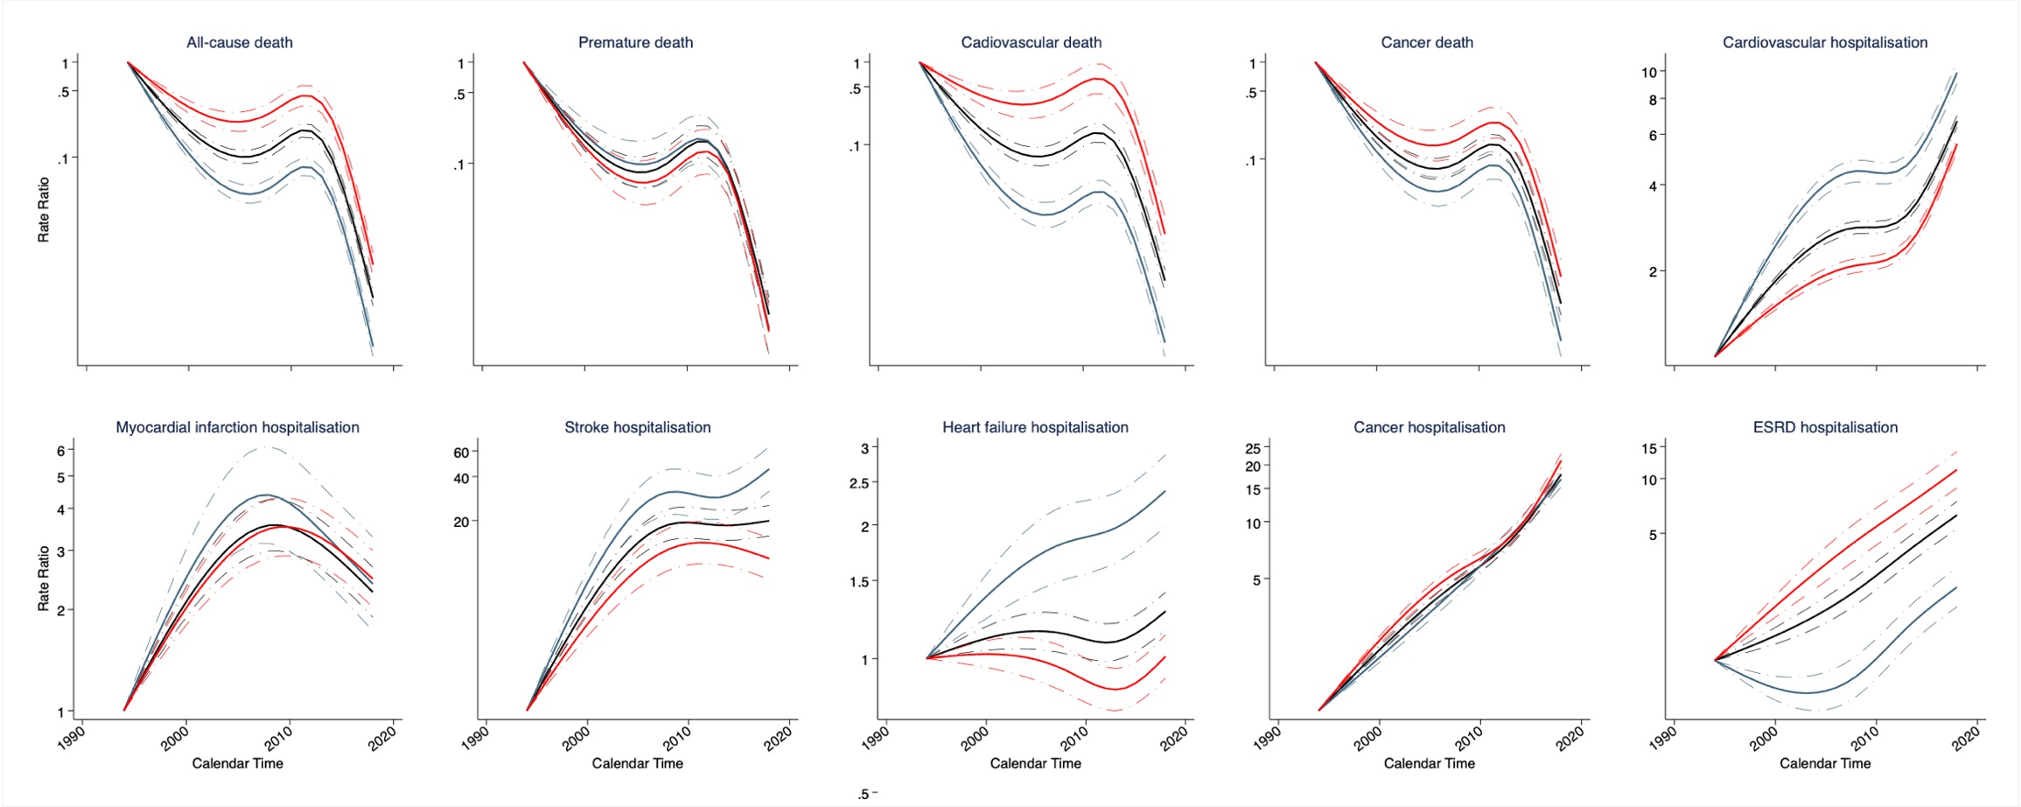

Supplemental Figure 2. Adjusted rates ratio for rates trends of clinical outcomes in a New Zealand population with impaired glucose tolerance and or impaired fasting glucose enrolled to the Diabetes Care Support Service between 1994 and 2018, by ethnicity
Rates in 1994 were used as a reference for the rates ratios. Age and birth cohort effects were adjusted by the use of age-period-cohort models. Solid lines indicate point estimations and shaded areas indicate the 95% CIs. Green, red, blue, and grey line indicates New Zealand European, Māori, Pasifika, and other ethnic population, respectively.
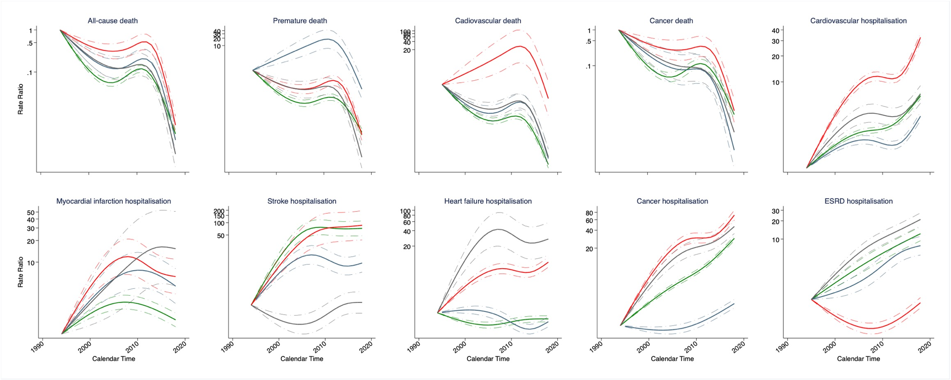

Supplemental Figure 3. Adjusted rates ratio for rates trends of clinical outcomes in a New Zealand population with impaired glucose tolerance and or impaired fasting glucose enrolled to the Diabetes Care Support Service between 1994 and 2018, by obesity status
Rates in 1994 were used as a reference for the rates ratios. Age and birth cohort effects were adjusted by use of age-period-cohort models. Solid lines indicate point estimations and shaded areas indicate the 95% CIs. Green and red line indicates the population with body mass index < 30kg/m² and the population with body mass index ≥30 kg/m², respectively.
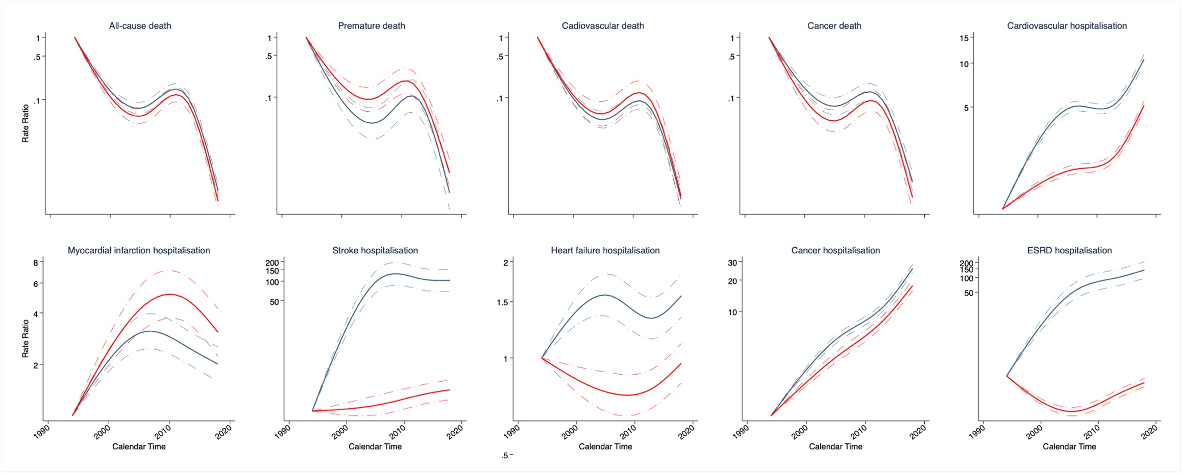

Supplemental Figure 4. Adjusted rates ratio for rates trends of clinical outcomes in a New Zealand population with impaired glucose tolerance and or impaired fasting glucose enrolled to the Diabetes Care Support Service between 1994 and 2018, by smoking status
Rates in 1994 were used as a reference for the rates ratios. Age and birth cohort effects were adjusted by the use of age-period-cohort models. Solid lines indicate point estimations and shaded areas indicate the 95% CIs. Green, blue, and red line indicates non-smoker, ex-smoker, and current smoker, respectively.
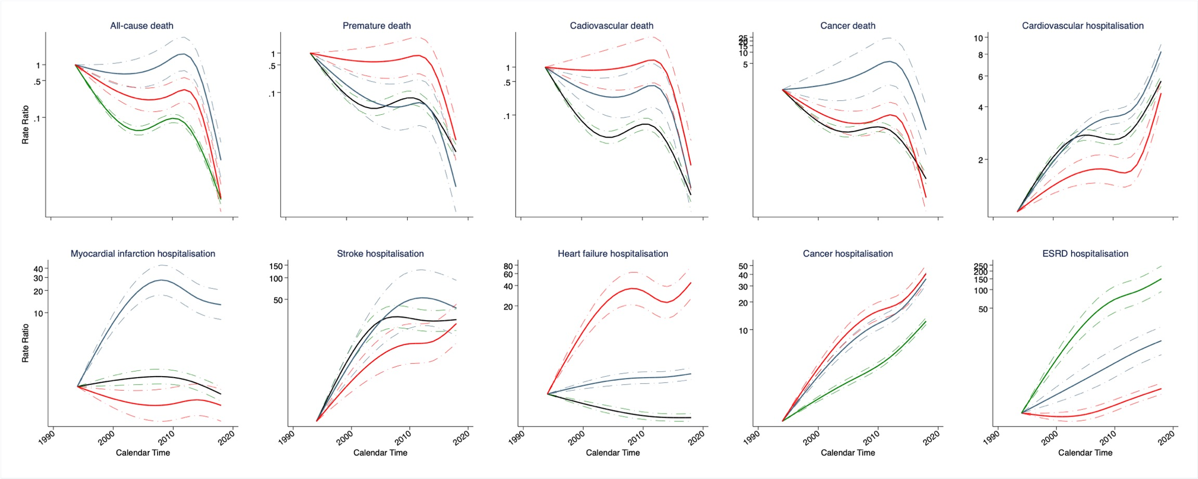

Supplemental Figure 5. Adjusted rates ratio for rates trends of clinical outcomes in a New Zealand population with impaired glucose tolerance and or impaired fasting glucose enrolled to the Diabetes Care Support Service between 1994 and 2018, by systolic blood pressure level
Rates in 1994 were used as a reference for the rates ratios. Age and birth cohort effects were adjusted by use of age-period-cohort models. Solid lines indicate point estimations and shaded areas indicate the 95% CIs. Blue and red line indicates SBP<130mmHg and SBP≥130mmHg, respectively.
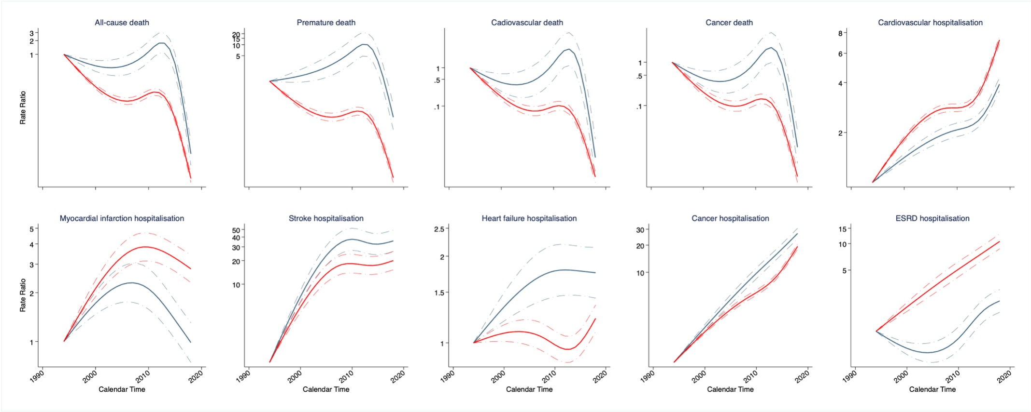

Supplemental Figure 6. Adjusted rates ratio for rates trends of clinical outcomes in a New Zealand population with impaired glucose tolerance and or impaired fasting glucose enrolled to the Diabetes Care Support Service between 1994 and 2018, by total cholesterol level
Rates in 1994 was used a reference for rates ratio. Age and birth cohort effects were adjusted by the use of age-period-cohort models. Solid lines indicate point estimations and shaded areas indicate the 95% CIs. Blue and red line indicates total cholesterol<5.0mmol/L and total cholesterol≥5.0mmol/L, respectively.
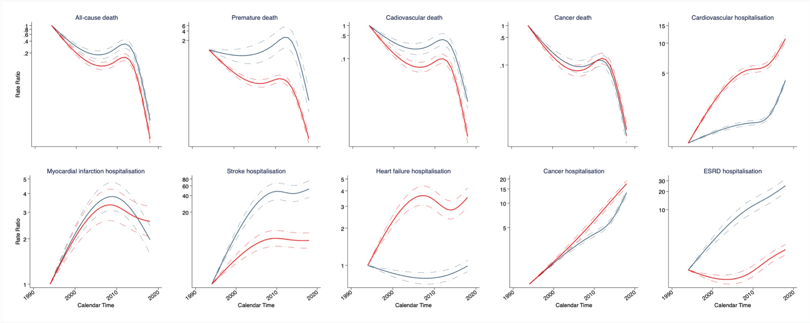

Supplemental Figure 7. Adjusted rates ratio for rates trends of clinical outcomes in a New Zealand population with impaired glucose tolerance and or impaired fasting glucose enrolled to the Diabetes Care Support Service between 1994 and 2018, by triglyceride level

Rates in 1994 was used a reference for rates ratio. Age and birth cohort effects were adjusted by use of age-period-cohort models. Solid lines indicate point estimations and shaded areas indicate the 95% CIs. Blue and red line indicates triglyceride<1.8mmol/L and triglyceride≥1.8mmol/L, respectively.
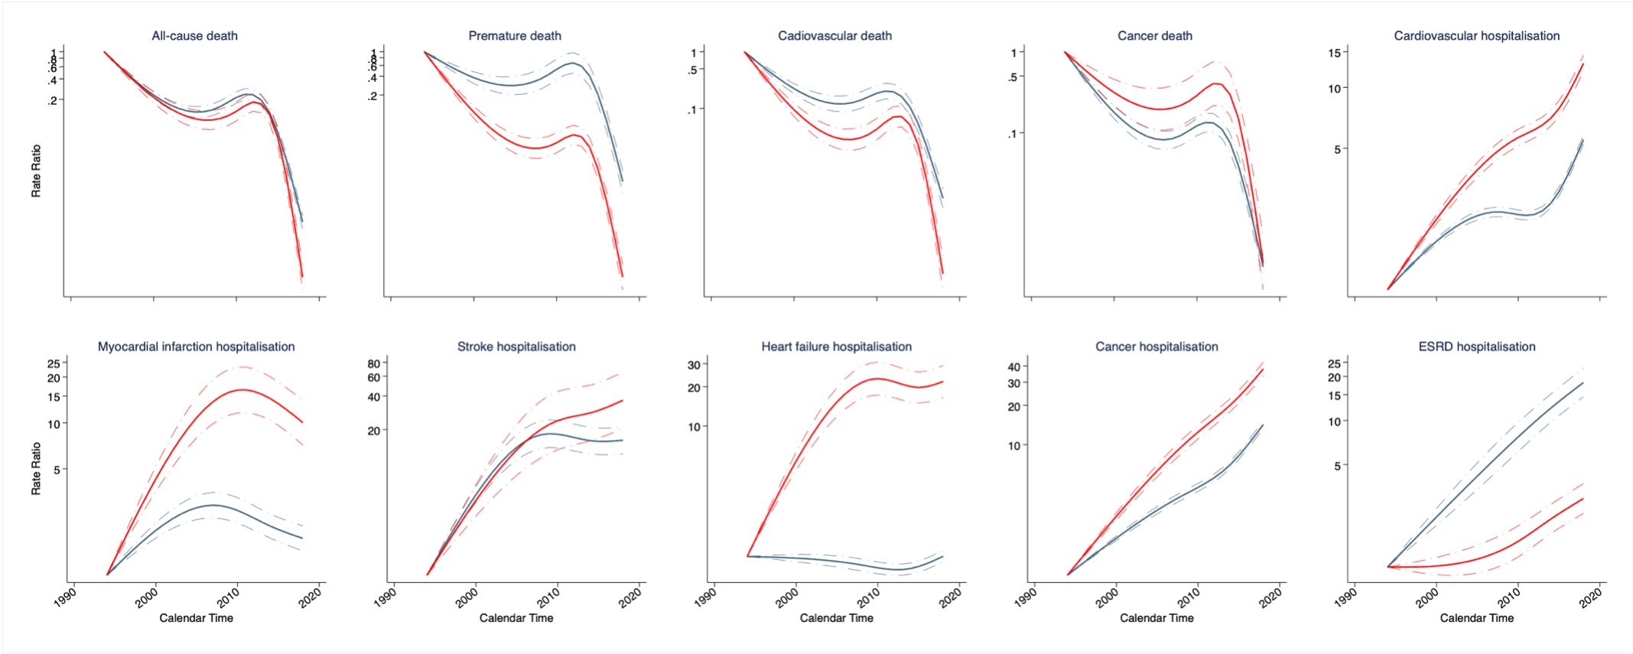

Supplemental Figure 8. Adjusted rates ratio for rates trends of clinical outcomes in a New Zealand population with impaired glucose tolerance and or impaired fasting glucose enrolled to the Diabetes Care Support Service between 1994 and 2018, by HbA1c level
Rates in 1994 were used as a reference for the rates ratios. Age and birth cohort effects were adjusted by the use of age-period-cohort models. Solid lines indicate point estimations and shaded areas indicate the 95% CIs. The blue and red line indicates HbA1c<43mmol/mol and triglyceride≥43mmol/mol, respectively.
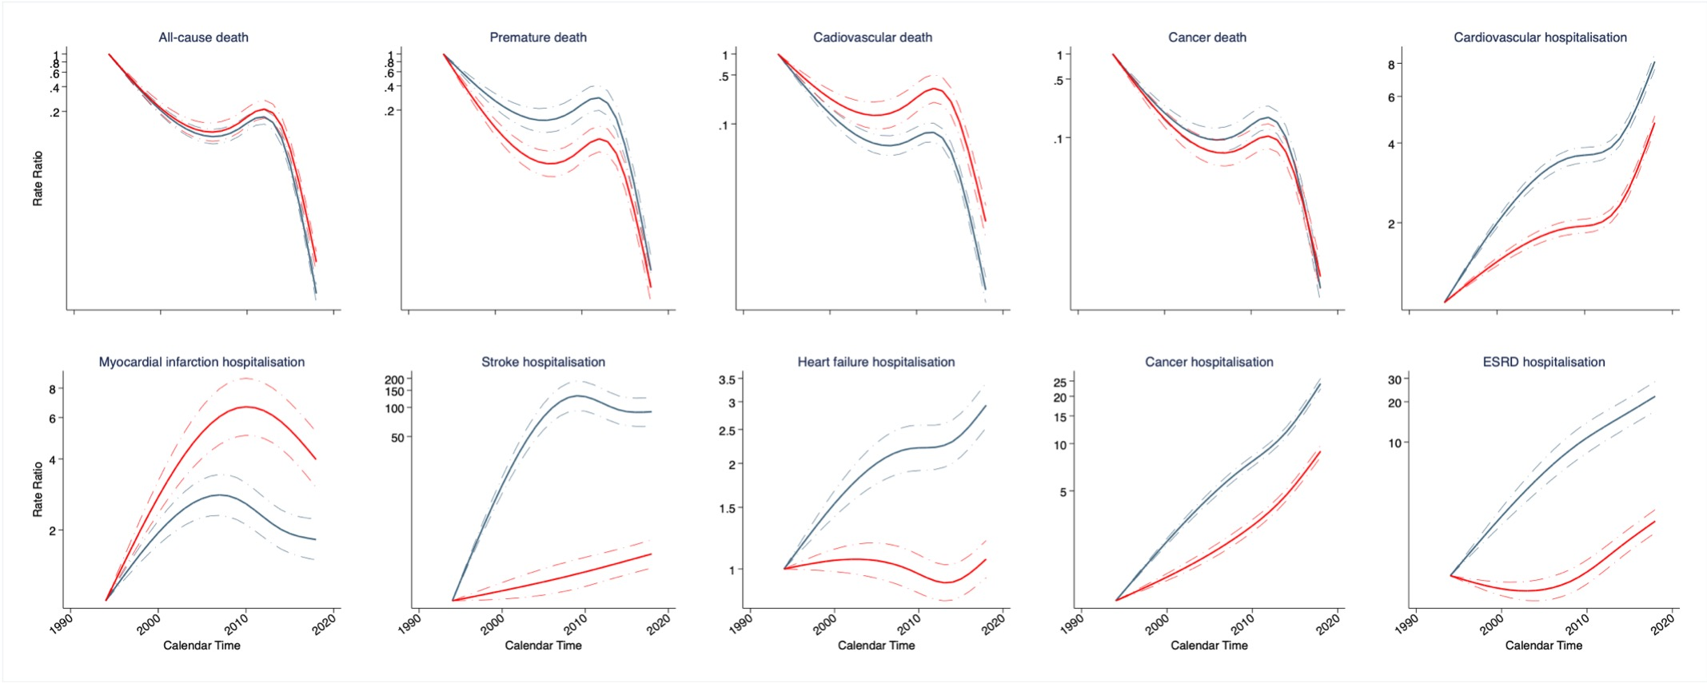

Supplemental Figure 9. Adjusted rates ratio for rates trends of clinical outcomes among people having impaired glucose tolerance, impaired fasting glucose, or both between 1994 and 2018
Rates in 1999, 1994, and 2002 were used a reference for rates ratio in IFG, IGT, and IFG+IGT as these years are the first available data for IFG, IGT and IFG+IGT, respectively. Age and birth cohort effects were adjusted by the use of age-period-cohort models. Solid lines indicate point estimations and shaded areas indicate the 95% CIs. Green, blue, and red line indicates IFG, IGT, and IFG+IGT, respectively. IFG indicates impaired fasting glucose. IGT indicates impaired glucose tolerance.
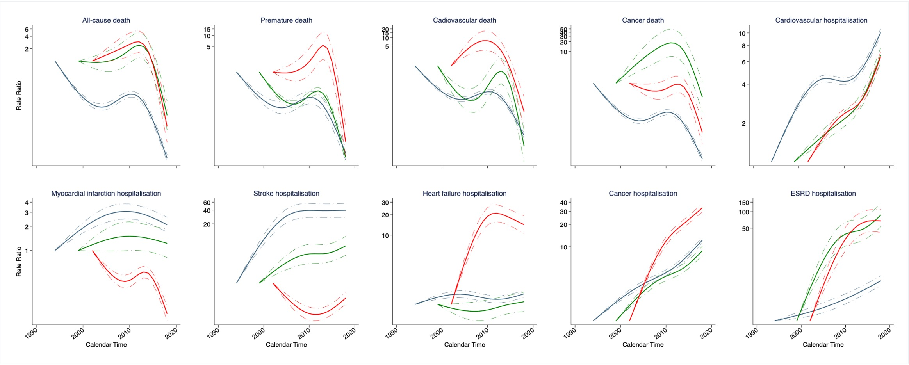

Supplemental Figure 10. Adjusted rates ratio for rates trends of clinical outcomes in a New Zealand population with impaired glucose tolerance and or impaired fasting glucose enrolled to the Diabetes Care Support Service between 1994 and 2018, by mean arterial pressure level
Rates in 1994 were used as a reference for the rates ratios. Age and birth cohort effects were adjusted by the use of age-period-cohort models. Solid lines indicate point estimations and shaded areas indicate the 95% CIs. The blue and red line indicates MAP<96 mmHg and MAP≥96 mmHg, respectively.

Supplemental Figure 11. Adjusted incidence rate (per 1000 person-years) of clinical outcomes in a New Zealand population with impaired glucose tolerance and or impaired fasting glucose enrolled to the Diabetes Care Support Service between 1994 and 2018, by overall, men, and women
Patients were aged 30–85 years. Period and birth cohort effects were adjusted by use of age-period-cohort models. Solid lines indicate point estimations and shaded areas indicate the 95% CIs. Black, red and blue line indicates overall, men, and least women population, respectively.
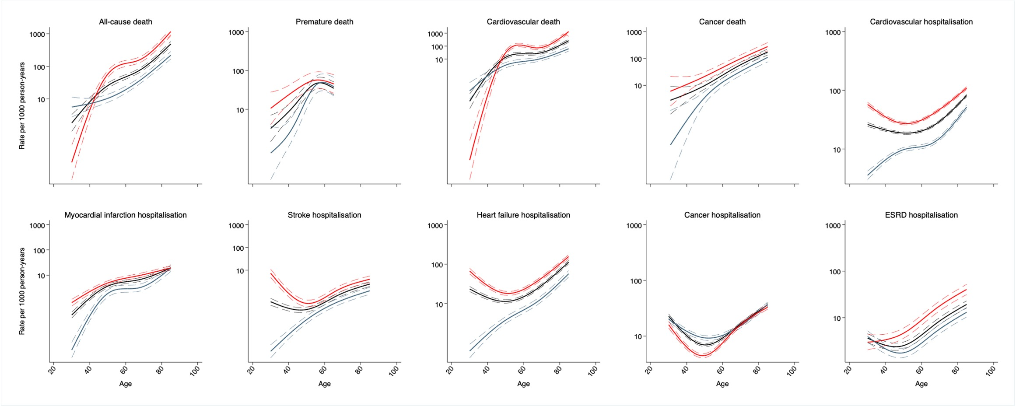

Supplemental Figure 12. Adjusted incidence rate (per 1000 person-years) of clinical outcomes in a New Zealand population with impaired glucose tolerance and or impaired fasting glucose enrolled to the Diabetes Care Support Service between 1994 and 2018, by obesity status
Patients were aged 30–85 years. Period and birth cohort effects were adjusted by use of age-period-cohort models. Solid lines indicate point estimations and shaded areas indicate the 95% CIs. Green and red line indicates population with body mass index < 30kg/m² and population with body mass index ≥30 kg/m², respectively.
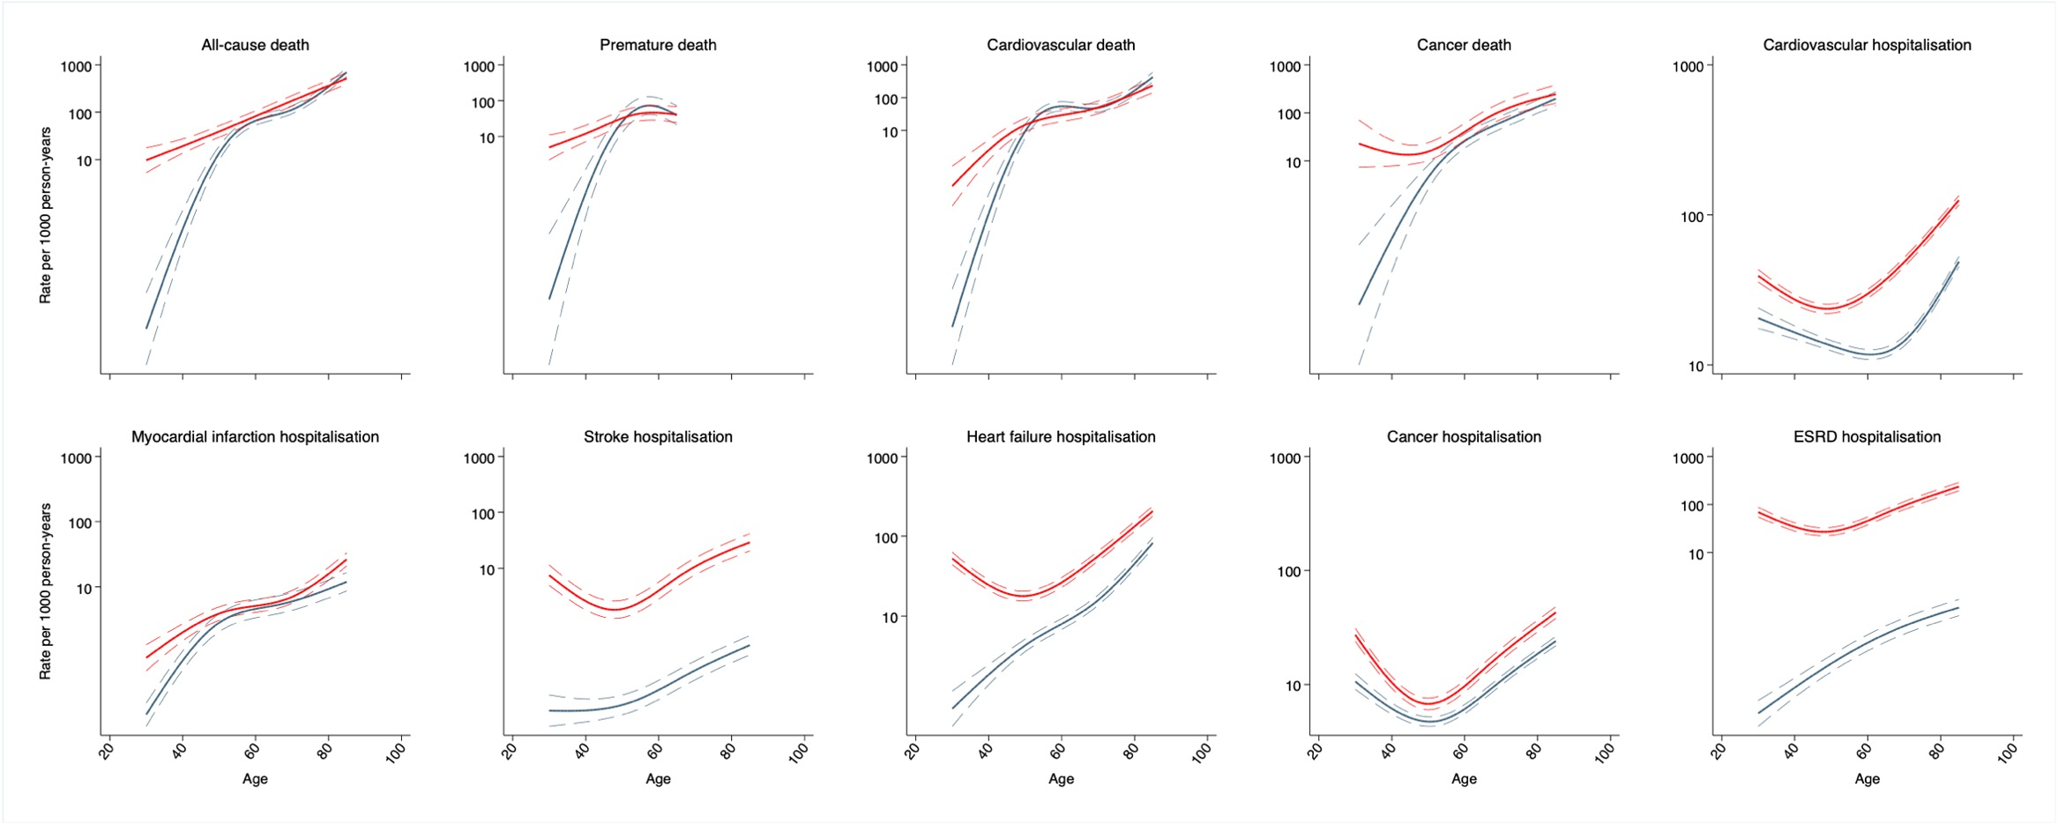

Supplemental Figure 13. Adjusted incidence rate (per 1000 person-years) of clinical outcomes in a New Zealand population with impaired glucose tolerance and or impaired fasting glucose enrolled to the Diabetes Care Support Service between 1994 and 2018, by smoking status
Patients were aged 30–85 years. Period and birth cohort effects were adjusted by use of age-period-cohort models. Solid lines indicate point estimations and shaded areas indicate the 95% CIs. Green, blue, and red line indicates non-smoker, ex-smoker, and current smoker, respectively.
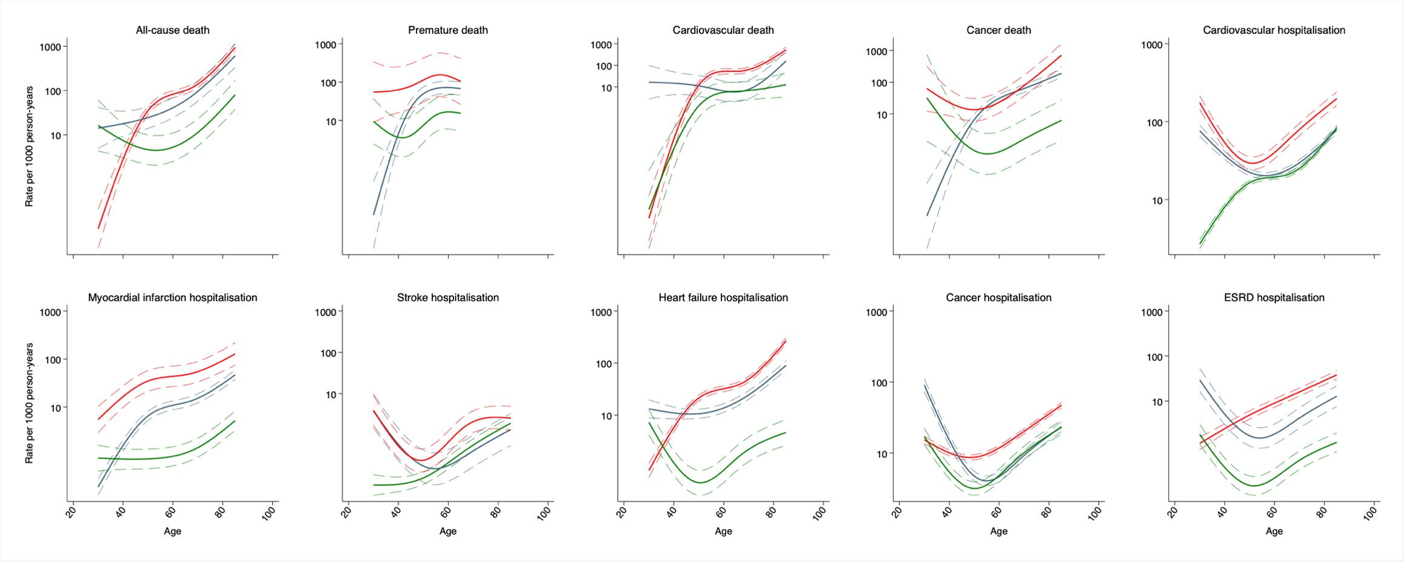

Supplemental Figure 14. Adjusted incidence rate (per 1000 person-years) of clinical outcomes in a New Zealand population with impaired glucose tolerance and or impaired fasting glucose enrolled to the Diabetes Care Support Service between 1994 and 2018, by systolic blood pressure level
Patients were aged 30–85 years. Period and birth cohort effects were adjusted by use of age-period-cohort models. Solid lines indicate point estimations and shaded areas indicate the 95% CIs. Red and blue line indicates SBP<130mmHg and SBP≥130mmHg, respectively.
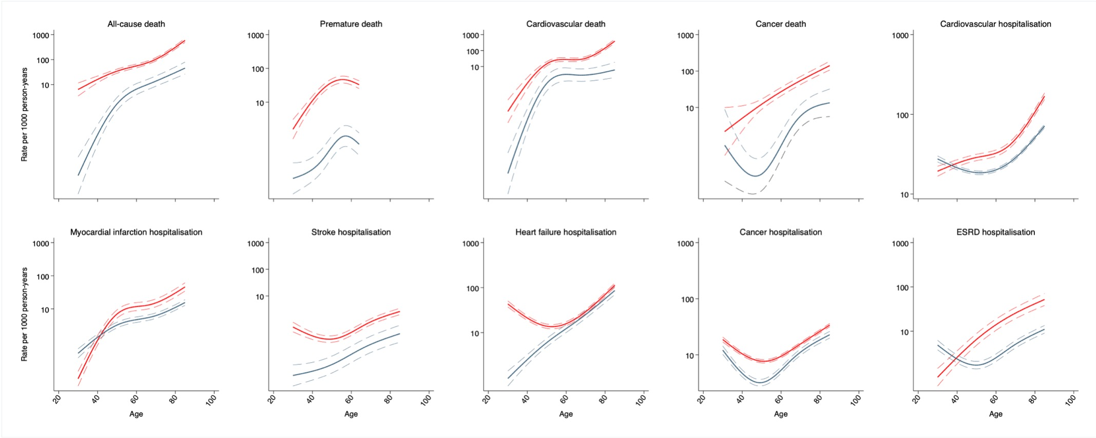

Supplemental Figure 15. Adjusted incidence rate (per 1000 person-years) of clinical outcomes in a New Zealand population with impaired glucose tolerance and or impaired fasting glucose enrolled to the Diabetes Care Support Service between 1994 and 2018, by total cholesterol level
Patients were aged 30–85 years. Period and birth cohort effects were adjusted by use of age-period-cohort models. Solid lines indicate point estimations and shaded areas indicate the 95% CIs. Red and blue line indicates total cholesterol<5.0mmol/L and total cholesterol≥5.0mmol/L, respectively.
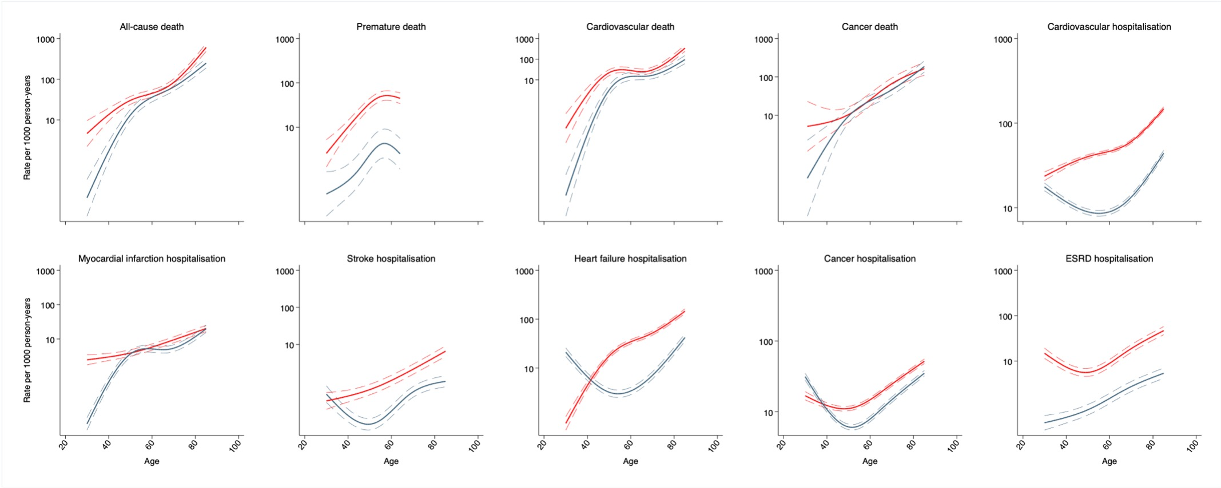

Supplemental Figure 16. Adjusted incidence rate (per 1000 person-years) of clinical outcomes in a New Zealand population with impaired glucose tolerance and or impaired fasting glucose enrolled to the Diabetes Care Support Service between 1994 and 2018, by triglyceride level
Patients were aged 30–85 years. Period and birth cohort effects were adjusted by use of age-period-cohort models. Solid lines indicate point estimations and shaded areas indicate the 95% CIs. Red and blue line indicates triglyceride<1.8mmol/L and triglyceride≥1.8mmol/L, respectively.
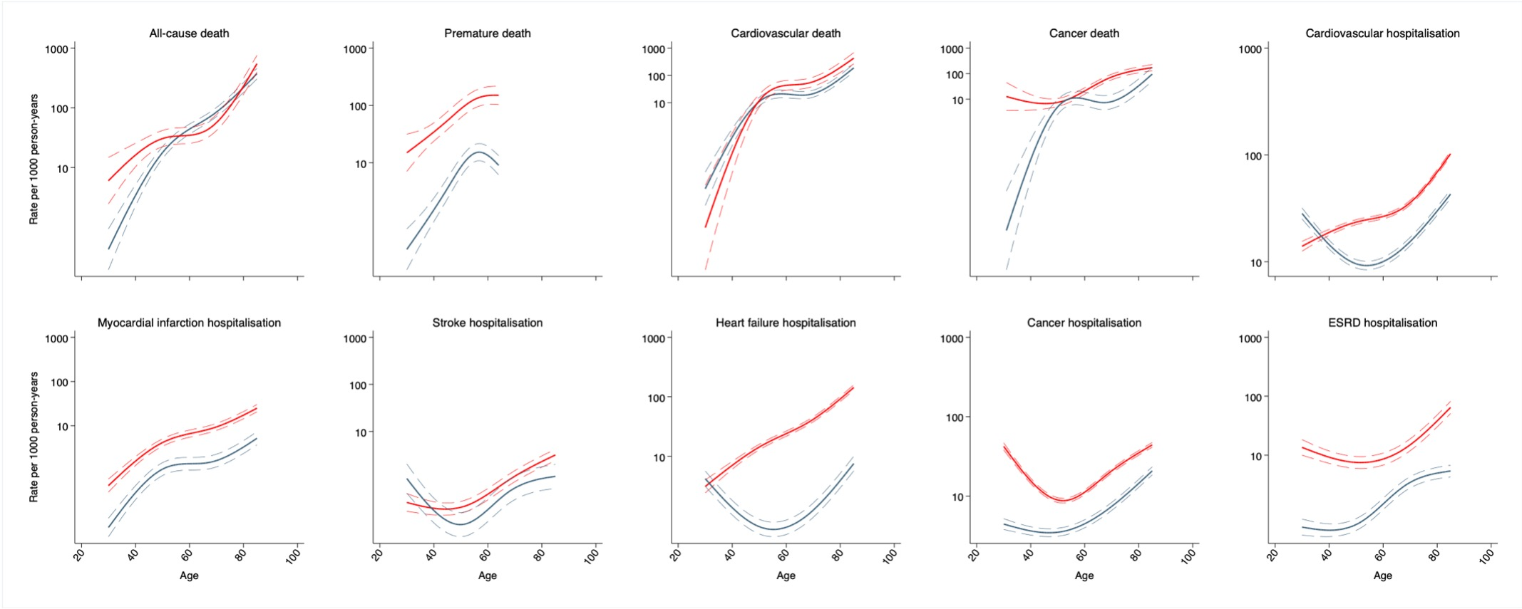

Supplemental Figure 17. Adjusted incidence rate (per 1000 person-years) of clinical outcomes in a New Zealand population with impaired glucose tolerance and or impaired fasting glucose enrolled to the Diabetes Care Support Service between 1994 and 2018, by HbA1c level
Patients were aged 30–85 years. Period and birth cohort effects were adjusted by use of age-period-cohort models. Solid lines indicate point estimations and shaded areas indicate the 95% CIs. Red and blue line indicates HbA1c<43mmol/mol and HbA1c≥43mmol/mol, respectively.
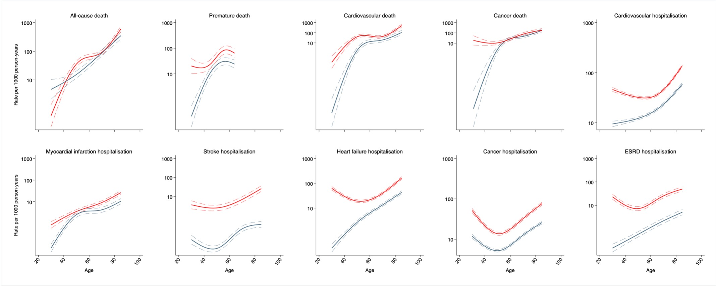

Supplemental Figure 18. Adjusted incidence rate (per 1000 person-years) of clinical outcomes in a New Zealand population with impaired glucose tolerance and or impaired fasting glucose enrolled to the Diabetes Care Support Service between 1994 and 2018, by ethnicity
Patients were aged 30–85 years. Period and birth cohort effects were adjusted by use of age-period-cohort models. Solid lines indicate point estimations and shaded areas indicate the 95% CIs. Green, red, blue, and grey line indicates New Zealand European, Māori, Pasifika, and other ethnic population, respectively.
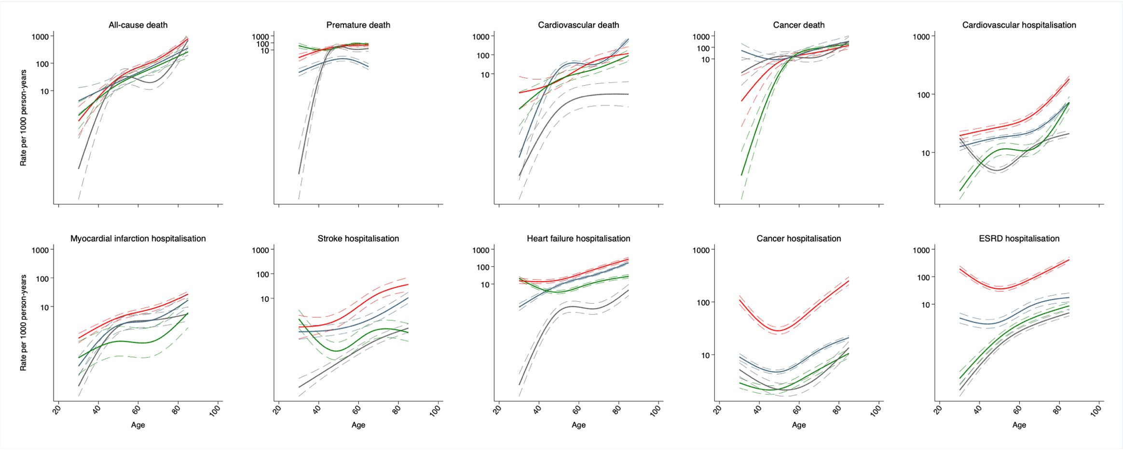

Supplemental Figure 19. Adjusted incidence rate (per 1000 person-years) of clinical outcomes in a New Zealand population with impaired glucose tolerance and or impaired fasting glucose enrolled to the Diabetes Care Support Service between 1994 and 2018, by mean artrial pressure level
Patients were aged 30–85 years. Period and birth cohort effects were adjusted by use of age-period-cohort models. Solid lines indicate point estimations and shaded areas indicate the 95% CIs. Red and blue line indicates MAP<96mmHg and MAP≥96mmHg, respectively.

