Supporting information

Figure S1. Pareto charts obtained by DoE for (A) PI and (B) EE %.

Table S1. Physicochemical and organoleptic characterization and stability of GC-TH and GC-TH-NLC along storage for 6 months
 | GC-TH |  |  |  | GC-TH-NLC
t (months) | Appearance | Colour | Odour | pH | Appearance | Colour | Odour | pH
0 | semi-solid translucid | transparent | characteristic | 5.56 | semi-solid opaque | off-white | characteristic | 5.43
1 | semi-solid translucid | transparent | characteristic | 5.51 | semi-solid opaque | off-white | characteristic | 5.33
3 | semi-solid translucid | transparent | characteristic | 5.47 | semi-solid opaque | off-white | characteristic | 5.28
6 | semi-solid translucid | transparent | characteristic | 5.43 | semi-solid opaque | off-white | characteristic | 5.22

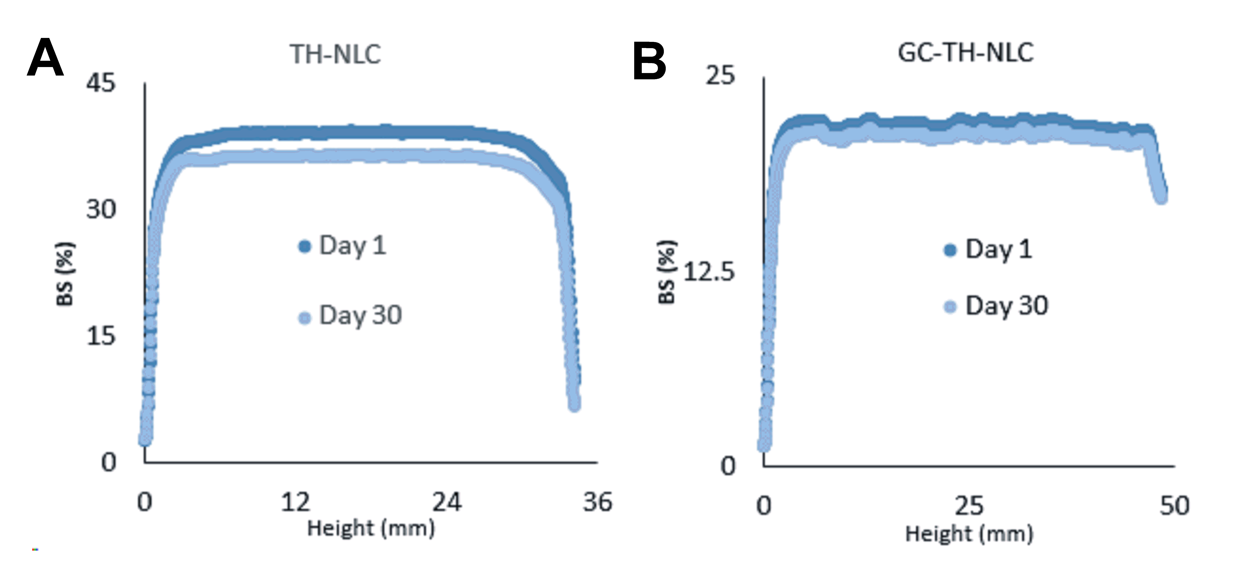
Figure S2. Backscattering signal of (A) TH-NLC and (B) GC-TH-NLC after 1 month storage at 4 ± 2 °C and 23 ± 2 °C, respectively.

