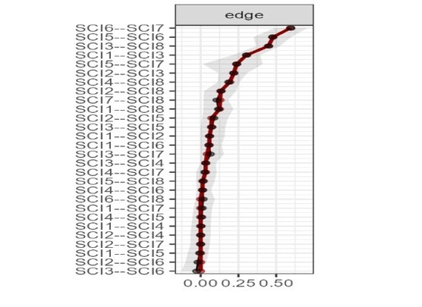
Supplementary Figure 1 Accuracy of edge weights

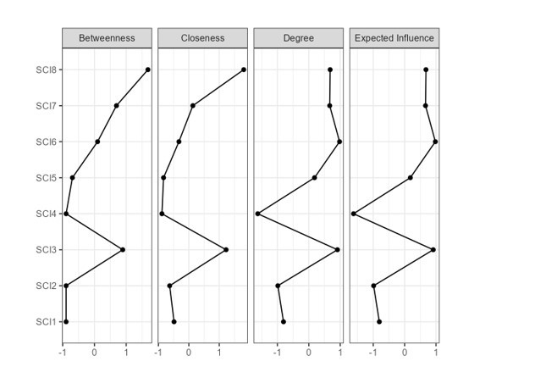

Supplementary Figure 2 Centrality Plots (Betweenness, Closeness, and Degree/ strength) in the Network for the Association in the Network of Each Node of the Turkish Sleep Condition Indicator Abbreviations: SCI, sleep condition indicator

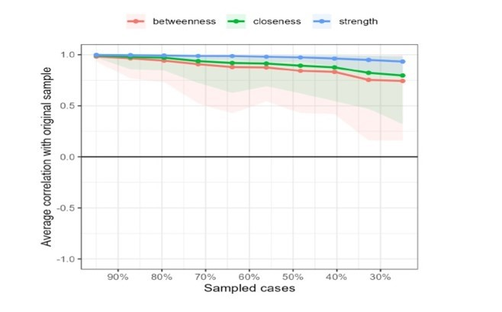

Supplementary Figure 3 Stability of centrality indices of the Turkish Sleep Condition Indicator

Supplementary Table 1 Measurement Invariance of the Turkish Sleep Condition Indicator Across Gender, Having Clinical Insomnia and Poor Sleep Quality.
Model | χ² | df | Δχ² | Δdf | p | CFI | ΔCFI
Sex
Configural | 9.665 | 26 |  |  |  | 1.000
Metric | 14.640 | 31 | 4.975 | 5 | 0.419 | 1.000 | .000
Scalar | 17.218 | 36 | 2.578 | 5 | 0.765 | 1.000 | .000
Having Insomnia
Configural | 10.577 | 26 |  |  |  | 1.000
Metric | 19.402 | 31 | 8.825 | 5 | 0.116 | 1.000 | .000
Scalar | 29.491 | 36 | 10.089 | 5 | 0.073 | 1.000 | .000
Having poor sleep quality
Configural | 8.172 | 26 |  |  |  | 1.000
Metric | 11.200 | 31 | 3.028 | 5 | 0.696 | 1.000 | .000
Scalar | 15.580 | 36 | 4.38 | 5 | 0.496 | 1.000 | .000
Abbreviations: χ2, chi-square value; df, degrees of freedom; CFI, comparative fit index.

