Supplementary Figure 1 Methodology flow chart of study experimental procedures.
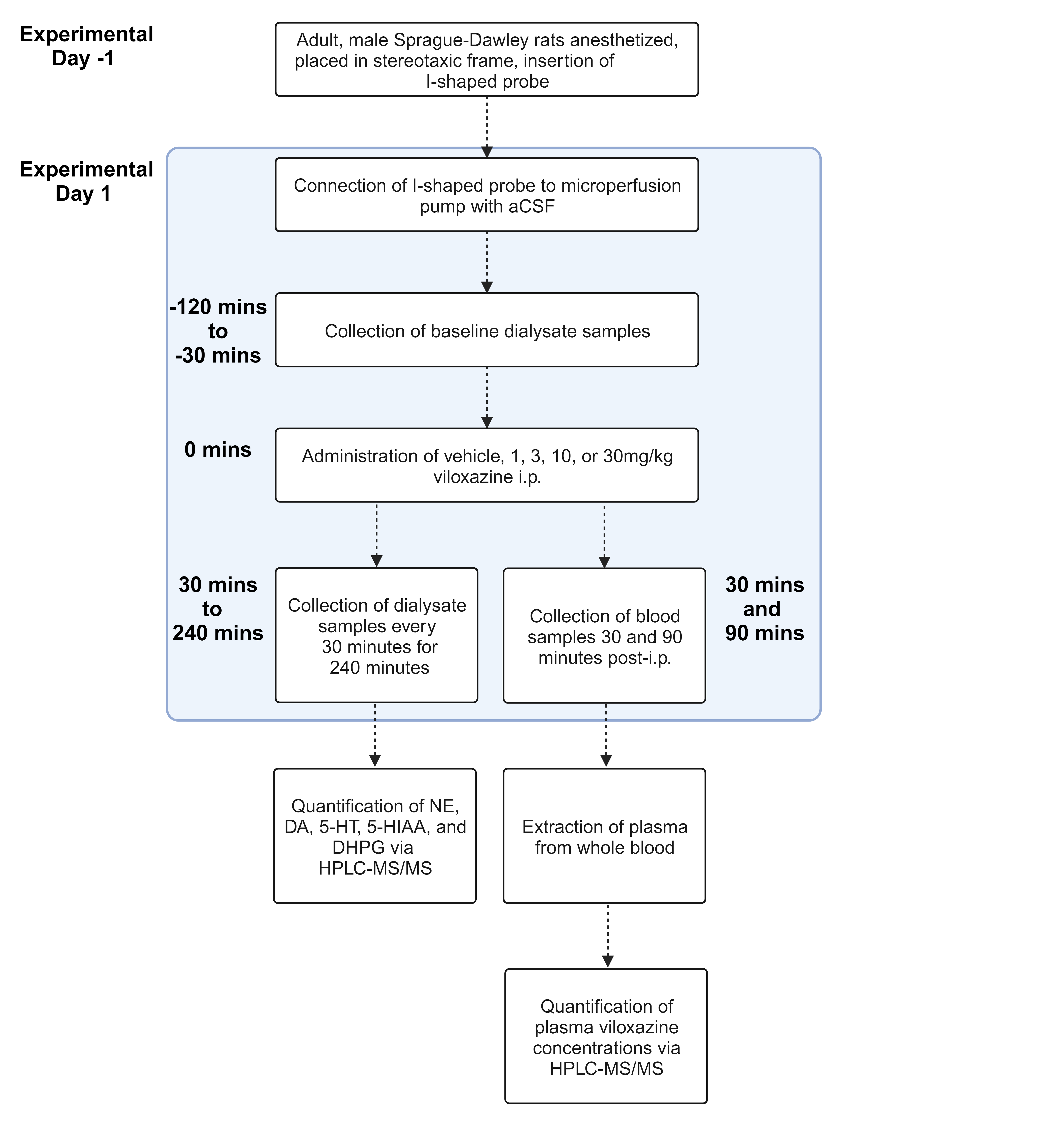

Supplementary Figure 2 Extracellular viloxazine levels in the PFC up to four hours after intraperitoneal administration. Dialysate samples (ISF) were collected at 30-minute intervals for the determination of viloxazine levels following IP administration of viloxazine 1 mg/kg (n=5), 3 mg/kg (n=5), 10 mg/kg (n=4), and 30 mg/kg (n=5). All data represent mean ± SEM.

