Results
Nomogram development and comparisons of other staging systems
To develop a nomogram, we used the cox regression model to screen these parameters, and selected the most accessible factors in clinical practice as prognostic factors: ANC, SIRI, LMR, NLR. A Nomogram to predict the 1-, 3-, and 4- year survival rates was proposed based on results of the cox regression model (Supplementary Fig. 1). In analysis of 1 year survival rates, the AUC of the nomogram was 0.804 (0.68 - 0.93), which was higher than that of ISS 0.67 (0.53 - 0.81). In analysis of 3 years survival rates, the AUC of the nomogram was 0.66 (0.52 - 0.76). In analysis of 4 years survival rates, the AUC of the nomogram was 0.66 (0.51 - 0.80), which was higher than that of ISS 0.61 (0.47 - 0.75) (Supplementary Fig. 2A, B, C). The calibration curve revealed that the 1-, 3- and 4- year survival rates predicted by the nomogram were highly consistent with the actual observation results (Supplementary Fig. 3A), indicating that the nomogram has reliable repeatability.
Validation of the nomogram
The stepwise nomogram was further validated using internal bootstrap validation.
The 1-, 3- and 4-year survival rates revealed by the calibration curves of the nomogram were graphically consistent with the actual observations (Supplementary Fig. 3B). In general, our model showed a good fitting and calibration with the ideal curve.

Supplementary Figure 1 Nomogram prediction of PFS of MM after ASCT.

B
A

C

Supplementary Figure 2 The AUCs of ISS and nomogram predicted 1-year(A), 3-year (B) and 4-year (C) survival rates by ROC analysis in the cohort.

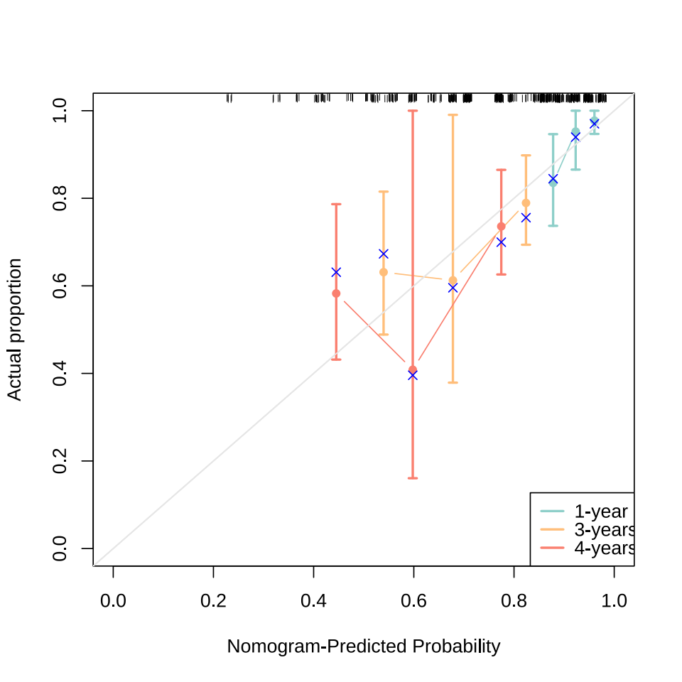
A
B

Supplementary Figure 3 The Calibration plots of the nomogram at 1-year, 3-year and 4-year in the cohort (A). The Calibration curve for predicted probability of the nomogram was measured by bootstrapping for 1000 repetitions (B). The X axis is the predicted probability of the nomogram, and the Y axis is the observed probability.

