Supplementary materials
Figure S1. Protein–protein interaction networks of differentially expressed genes.

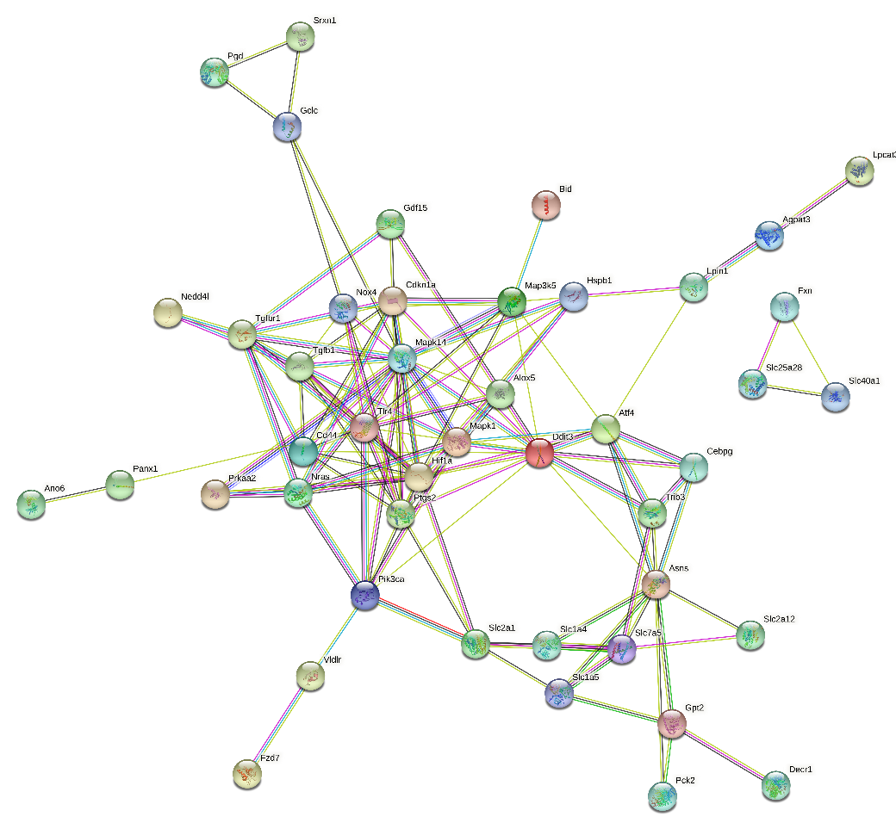

Circles represent genes, lines represent interactions between geneencoded proteins and line colors represent evidence of interactions between proteins.

