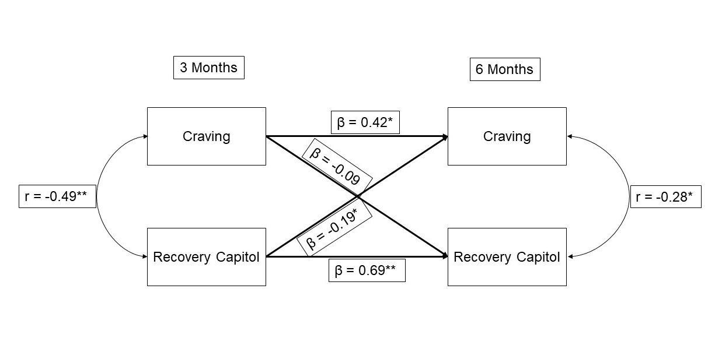

Supplemental Figure 1: Path Coefficients (Standardized) – Month 3 to Month 6
Notes: Recovery Capitol = Assessment of Recovery Capital total score; Craving = Brief Addiction Monitor (BAM) question #8. n = 101, consisting of complete data sample used in analysis. *p < 0.05; **p < 0.01.
Abbreviations: r, Pearson’s correlation coefficient; β, pathway coefficient.

