SUPPLEMENTARY MATERIAL

Supplementary methods

Sample size and power calculation
From similar studies of systemic corticosteroids (oral or parenteral) in patients with asthma,^{1,2} an event probability of 0.087 for type 2 diabetes mellitus could be expected. Assuming 30,000 matched pairs for the type 2 diabetes mellitus risk cohort and a two-sided alpha of 5%, there would be 90% and 80% power to detect hazard ratios (HRs) of 1.09 and 1.08, respectively. It was assumed that power for all other adverse outcomes would be similar to that of type 2 diabetes mellitus.
1. Price DB, Trudo F, Voorham J, et al. Adverse outcomes from initiation of systemic corticosteroids for asthma: long-term observational study. J Asthma Allergy. 2018;11:193-204.
2. Sweeney J, Patterson CC, Menzies-Gow A, et al. Comorbidity in severe asthma requiring systemic corticosteroid therapy: cross-sectional data from the Optimum Patient Care Research Database and the British Thoracic Difficult Asthma Registry. Thorax. 2016;71(4):339-346.

Supplementary Figure 1 Patient selection.
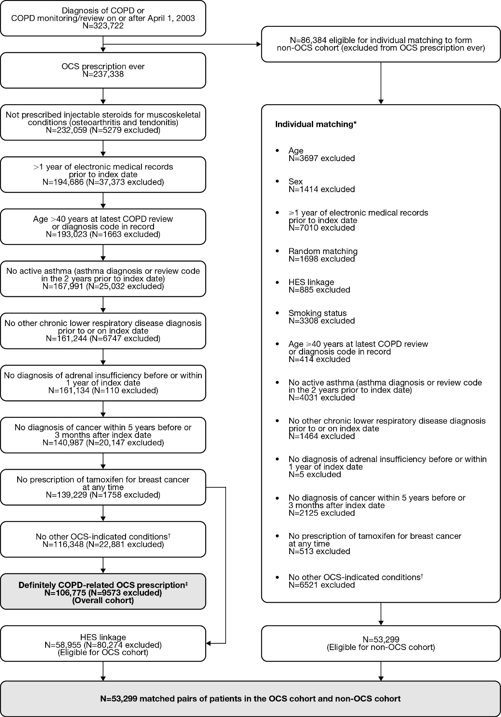
*The approach to matching and exclusion was not stepwise. Potential controls were randomly assigned based on the matching criteria. †Other OCS-indicated conditions: asthma, nasal polyps, pericarditis, temporal arteritis, vasculitis, autoimmune hepatitis, Crohn’s disease, ulcerative colitis, autoimmune bullous diseases, eczema, dermatitis, psoriasis, ankylosing spondylitis, gout, osteoarthritis, polymyalgia rheumatica, rheumatoid arthritis, psoriatic arthritis, Sjogren’s syndrome, systemic lupus erythematosus, Bell’s palsy, multiple sclerosis, myasthenia gravis, iritis, scleritis, uveitis, nephrotic syndrome, and sarcoidosis. ‡COPD-related OCS prescriptions were prescriptions of oral prednisolone in patients with a diagnostic code for COPD, a vague acute respiratory code (including chest infection, cough, wheezing, or breathlessness), or a prescription for antibiotics on the same day as the OCS prescription. COPD, chronic obstructive pulmonary disease; HES, Hospital Episode Statistics; N, number of patients; OCS, oral corticosteroid.

Supplementary Figure 2 Relative risk of adverse outcomes in the OCS cohort versus the non-OCS cohort (unadjusted).*
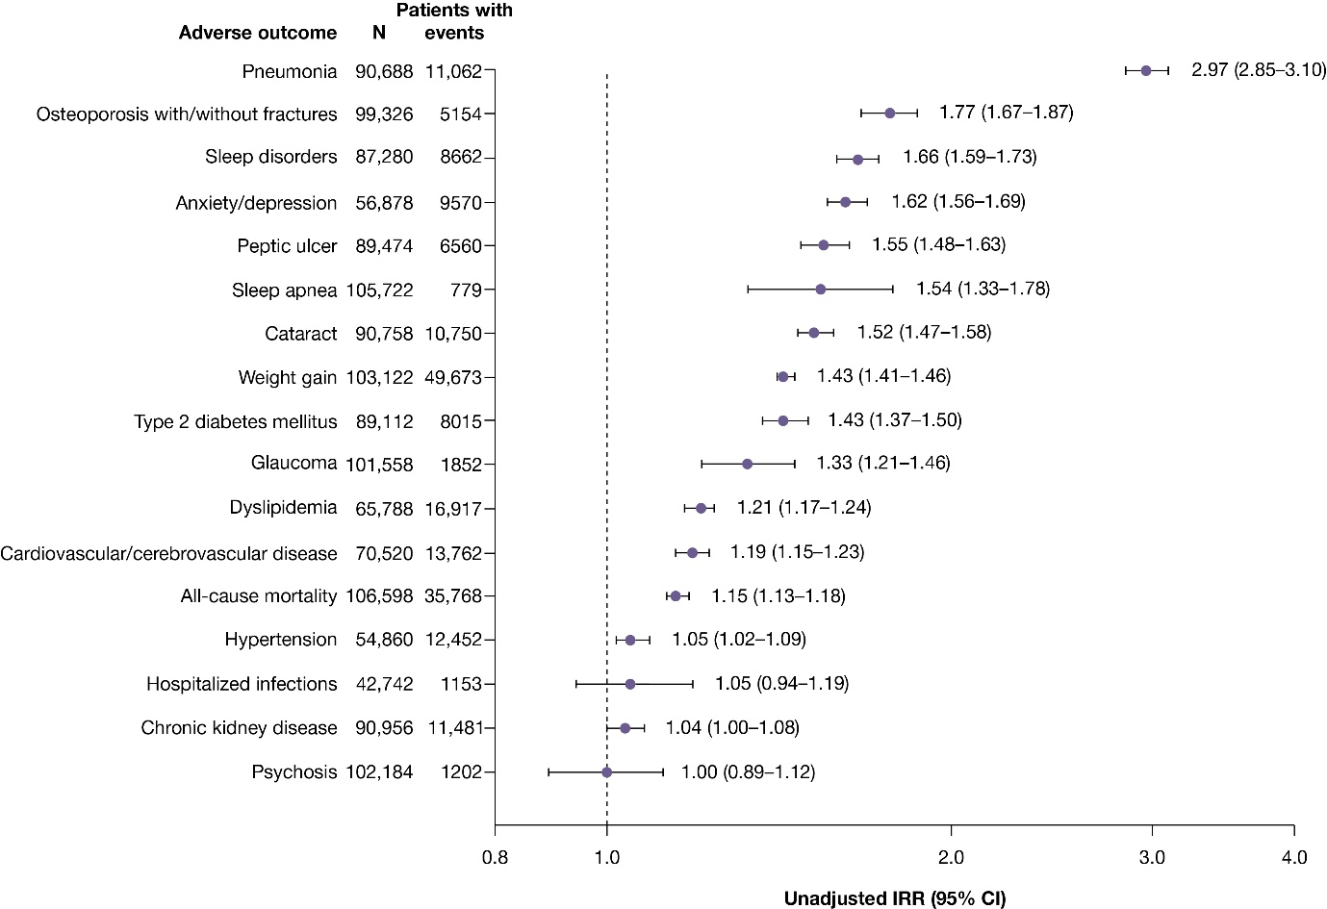
*N, PY, events, and IRs (patients with events per 100 PY) for the OCS cohort and non-OCS cohort and IR differences (OCS cohort vs non-OCS cohort) are provided in supplementary table 2. CI, confidence interval; IRR, incidence rate ratio; N, number of patients in the risk cohort for each adverse outcome; OCS, oral corticosteroid(s); PY, patient-year(s).
Supplementary Table 1 Inclusion and Exclusion Criteria for Worsening or Recurrence of Adverse Outcomes
Outcome | Inclusion Criteria Applied Any Time Prior to Index Date* | Exclusion Criteria During Pre-Index Period* | Definition Applied After Index Date (Follow-Up Period)
Type 2 diabetes mellitus worsening | Diagnosis of type 2 diabetes mellitus, and/or antidiabetic medication (not including insulin prescriptions) and/or ≥2 HbA_{1c} readings >6.5% | - Diabetes resolved code following the diagnostic code  - Insulin prescriptions ever prior to index date  - Diagnosis of type 1 diabetes ever prior to index date  - Diagnosis of polycystic ovary syndrome and ≥1 metformin prescription ever prior to index date | Mean increase in HbA_{1c} (≥0.5%) and/or additional antidiabetic medication prescriptions and/or insulin prescription
Osteoporosis worsening | Diagnosis of osteoporosis or osteoporotic fractures (hip, wrist, spinal) and treatment for osteoporosis | Osteoporosis or osteoporotic fractures (hip, wrist, spinal) resolved code following the diagnostic code | Onset of new osteoporotic fractures: hip fracture and/or wrist fracture and/or spinal fracture
Pneumonia recurrence | − | Diagnosis of pneumonia in the last 4 weeks prior to index date | Diagnosis of pneumonia
HbA_{1c}, hemoglobin A_{1c}; ICD-10, International Classification of Diseases 10th Revision.
*Diagnoses and resolved codes were defined as diagnostic Read codes or ICD-10 codes.
Supplementary Table 2 Incidence of Adverse Outcomes in the Matched Non-OCS Cohort and OCS Cohort
Adverse outcome | Non-OCS Cohort |  |  |  |  | OCS Cohort |  |  |  | IR Difference (95% CI)
Adverse outcome | N | PY | Patients With Events | IR  (Patients With Events per 100 PY) | N |  | PY | Patients With Events | IR  (Patients With Events per 100 PY) | IR Difference (95% CI)
Pneumonia | 45,344 | 498,110 | 2935 | 0.59 | 45,344 |  | 464,181 | 8127 | 1.75 | 1.16 (1.12–1.20)
Osteoporosis with/without fractures | 49,663 | 537,501 | 1891 | 0.35 | 49,663 |  | 524,587 | 3263 | 0.62 | 0.27 (0.24–0.30)
Sleep disorders | 43,640 | 463,103 | 3352 | 0.72 | 43,640 |  | 442,411 | 5310 | 1.20 | 0.48 (0.43–0.52)
Anxiety/depression | 28,439 | 300,649 | 3803 | 1.26 | 28,439 |  | 280,834 | 5767 | 2.05 | 0.79 (0.72–0.85)
Peptic ulcer | 44,737 | 478,611 | 2626 | 0.55 | 44,737 |  | 461,770 | 3934 | 0.85 | 0.30 (0.27–0.34)
Sleep apnea | 52,861 | 572,787 | 308 | 0.05 | 52,861 |  | 569,062 | 471 | 0.08 | 0.03 (0.02–0.04)
Cataract | 45,379 | 489,041 | 4353 | 0.89 | 45,379 |  | 471,583 | 6397 | 1.36 | 0.47 (0.42–0.51)
Weight gain | 51,561 | 410,763 | 21,881 | 5.33 | 51,561 |  | 363,843 | 27,792 | 7.64 | 2.31 (2.20–2.43)
Type 2 diabetes mellitus | 44,556 | 482,341 | 3350 | 0.69 | 44,556 |  | 469,495 | 4665 | 0.99 | 0.30 (0.26–0.34)
Glaucoma | 50,779 | 550,643 | 798 | 0.14 | 50,779 |  | 545,784 | 1054 | 0.19 | 0.05 (0.03–0.06)
Dyslipidemia | 32,894 | 331,354 | 7842 | 2.37 | 32,894 |  | 317,719 | 9075 | 2.86 | 0.49 (0.41–0.57)
Cardiovascular/  cerebrovascular disease | 35,260 | 381,459 | 6396 | 1.68 | 35,260 |  | 368,512 | 7366 | 2.00 | 0.32 (0.26–0.38)
All-cause mortality | 53,299 | 577,772 | 16,650 | 2.88 | 53,299 |  | 575,439 | 19,118 | 3.32 | 0.44 (0.38–0.50)
Hypertension | 27,430 | 287,588 | 6130 | 2.13 | 27,430 |  | 281,382 | 6322 | 2.25 | 0.12 (0.04–0.19)
Hospitalized infections | 21,371 | 169,262 | 539 | 0.32 | 21,371 |  | 182,950 | 614 | 0.34 | 0.02 (-0.02–0.06)
Chronic kidney disease | 45,478 | 370,224 | 5117 | 1.38 | 45,478 |  | 443,898 | 6364 | 1.43 | 0.05 (0.00–0.10)
Psychosis | 51,092 | 399,083 | 572 | 0.14 | 51,092 |  | 438,695 | 630 | 0.14 | 0.00 (-0.02–0.02)
CI, confidence interval; IR, incidence rate; N, number of patients in the risk cohort for each adverse outcome; OCS, oral corticosteroid(s); PY, patient-year(s).

