Table S1. Summary of key findings on definition of health states
- It is not common in clinical practice to categorize patients according to their CPS impairment (e.g. by SDMT score).
- Neurologists typically consider “mild”, “moderate“, “severe” categories as relating to functional ability (e.g. ability to continue working).
- Considering quantitative categorization of patients with CPS impairment:
- HCPs generally do not categorize patients by raw SDMT score (e.g., ≤60, ≤50, ≤40 etc).
- HCPs occasionally consider patients’ scores in relation to age-adjusted averages (e.g. ~1.5 SD below mean average may be “mild”, ~2 SD below mean average may be “moderate”, and so on).
- HCPs also estimated how many patients with CPS impairment would fall into each category (on a percentage basis).
CPS: cognitive processing speed; HCP: health care professional; SD: standard deviation; SDMT: Symbol Digit Modalities Test.

Table S2. Summary of key findings on a) symptomology, b) functional impairment, and c) effect on emotion, as used in development of health state descriptions
a)
- Patients report general symptoms such as “brain fog”, cognitive fatigue (worsened by stress), difficulty learning new information, inattention, and sensory overload.
- Word-finding difficulties are reported, alongside general difficulty with verbal expression, and difficulty in following conversations with multiple participants.
- Work and home life may be affected by slowed ability to think things through or complete tasks, and reduced ability to multitask.
- Patients may be overwhelmed with tasks, and may scale down plans.
- Patients may also face difficulties planning (worsened if sufficient time is not available).
- Mild is associated with subtle impairment and more variability. Moderate is associated with more noticeable impairment and consistent presence of symptoms, and is more limiting. Severe is obvious to most people, and is associated with significant difficulties.
b)
- Work is substantially affected due to difficulties with complex tasks, efficiency and speed, accuracy, planning multi-step processes, and maintaining attention and avoiding fatigue. Technical roles are more affected, as there is less tolerance for slowing or errors.
- Social interactions may be fatiguing (especially in group settings); maintaining and making relationships are more difficult.
- Activities such as shopping and cooking are more simplified or pre-planned. Assistance may be required with complex tasks such as finances.
- Hobbies may be affected by difficulties with following along with books or TV shows.
- Patients at mild can continue with their routine and problem-solving activities (more slowly); small modifications may be needed at work. At moderate, patients may have difficulties functioning on their own – help is likely needed with complex tasks (e.g. finances, organization); more substantial modifications are needed at work. At severe, a patient requires assistance with many tasks, and relies on others for planning and organization; keeping or gaining employment is difficult, and this patient is likely not working.
c)
- Impairment can lead to mood problems such as anxiety and depression, as patients become frustrated that their ability and lifestyle is changing, and feel stress due to the effects of their condition.
- Career-focused patients may resent having to give up work, and miss their sense of purpose in life. Patients may feel overwhelmed at work, which is stressful. Work may also take longer, which affects patients negatively. Giving up work (or beginning to receive disability benefits) may be a relief.
- Patients may be annoyed at failing to keep up with conversations or engage with others normally. Social anxiety and introversion is possible due to avoiding stimulation (especially crowds). Family members or friends may be frustrated with slowing, or annoyed at picking up tasks.
- In mild, changes may be annoying rather than depressing. As impairment becomes moderate, patients can become irritable, or lonely due to reduced interaction. Emotional impact generally increases with more severe impairment; however, patients with severe impairment may be less cognizant and therefore no more depressed or anxious.

Table S3. Summary of key findings used in validation of health state descriptions
- Changes in family role should be added (e.g. caregiving). This is particularly relevant in the context of MS, as most patients are women, who face societal expectations to participate in such activities.
- Difficulties with driving should be added. Slowed reaction time due to CPS impairment leads to difficulties with driving.
- “Daily activities” should be explained further (e.g. finances, planning, cooking, cleaning, use of technology).
CPS: cognitive processing speed; MS: multiple sclerosis.

Table S4. Introductory text (presented prior to health state descriptions)
You suffer from a condition that reduces your mental processing speed. This means your ability to understand and react quickly is reduced. Because of this, your ability to complete tasks is also reduced.
This condition affects your work or hobbies that depend on cognition. In other words, you are less able to complete technically demanding activities at work, meaning that some work tasks are more difficult for you (depending on your level of impairment). For example, you may find it exceptionally difficult to follow the plot of novels or films, track a conversation while performing another task, or complete several tasks in a fixed amount of time.
Social aspects of your life may also be affected. For example, it may be more difficult for you to follow conversations, especially in a group. You may be more reliant on the help of others, which can affect your relationships.
As a result of your condition, you have difficulties doing some of the things you used to do. In particular, keeping up with many demands. This condition, and the limitations it places on you, may also affect you emotionally and you may feel overwhelmed. You may feel sad, anxious, or frustrated about how your abilities are compromised.

Table S5. Health state descriptions* (side-by-side; presented individually during interviews)
#1 (“mild CPS impairment”; SDMT 43–40) | #2 (“moderate CPS impairment”; SDMT 39–32) | #3 (“severe CPS impairment”; SDMT ≤31)
You suffer from a condition that reduces your mental processing speed.  Your mental speed is reduced by between ¼ (one quarter) and ⅓ (one third), compared to the average adult in the United Kingdom. | You suffer from a condition that reduces your mental processing speed.  Your mental speed is reduced by between ⅓ (one third) and ½ (one half), compared to the average adult in the United Kingdom. | You suffer from a condition that reduces your mental processing speed.  Your mental speed is reduced by more than ½ (one half) compared to the average adult in the United Kingdom.
The reduction in your mental speed is subtle to you and others, and creates some/subtle difficulties for you in your activities and work. | The reduction in your mental speed is noticeable to you and others, and creates consistent/moderate difficulties for you in your activities and work. | The reduction in your mental speed is obvious to you and others, and creates substantial/severe difficulties for you in your activities and work.
You often feel that you can’t quickly respond or find the right words in conversation.  You have some difficulty collecting your thoughts while conversing with multiple people, which may discourage you from participating. | You very often feel that you can’t quickly respond or find the right words in conversation.  You have moderate difficulty collecting your thoughts while conversing with multiple people, which may discourage you from participating. | You constantly feel that you can’t quickly respond or find the right words in conversation.  You have a lot of difficulty collecting your thoughts while conversing with multiple people, which may discourage you from participating.
Your ability to plan out and complete tasks, or make decisions, is somewhat reduced.  This is worsened when trying to multitask.  As a result, you have some difficulty keeping up with daily life, and sometimes feel overwhelmed. | Your ability to plan out and complete tasks, or make decisions, is moderately reduced.  This is worsened when trying to multitask.  As a result, you have moderate difficulty keeping up with daily life, and often feel overwhelmed. | Your ability to plan out and complete tasks, or make decisions, is extremely reduced.  This is worsened when trying to multitask.  As a result, you have extreme difficulty keeping up with daily life, and very often feel overwhelmed.
As a result, some work roles are difficult for you. | As a result, many work roles are difficult for you. | As a result, almost all work roles are difficult for you.
The above difficulties with work may make you anxious  If you leave your work as a result, you may feel that you have lost your sense of purpose. | The above difficulties with work may make you anxious  If you leave your work as a result, you may feel that you have lost your sense of purpose. | The above difficulties with work may make you anxious  If you leave your work as a result, you may feel that you have lost your sense of purpose.
You also sometimes need help with complex activities at home, to avoid being overwhelmed.  (Examples include personal finances, organisation, dealing with emergencies, and using technology.)  As a result, you may feel less independent. | You also often need help with complex activities at home, to avoid being overwhelmed.  (Examples include personal finances, organisation, dealing with emergencies, and using technology.)  As a result, you may feel less independent. | You also very often need help with complex activities at home, to avoid being overwhelmed.  (Examples include personal finances, organisation, dealing with emergencies, and using technology.)  As a result, you may feel less independent.
Because your ability to react to events is slightly reduced, you have some difficulty driving safely. | Because your ability to react to events is moderately reduced, you have a lot of difficulty driving safely. | Because your ability to react to events is greatly reduced, you have extreme difficulty driving safely.
Due to the changes in your ability and the help that you require, your relationship with your family is also slightly changed.  For example, your ability to care for other family members is slightly reduced. | Due to the changes in your ability and the help that you require, your relationship with your family is also moderately changed.  For example, your ability to care for other family members is moderately reduced. | Due to the changes in your ability and the help that you require, your relationship with your family is also greatly changed.  For example, your ability to care for other family members is greatly reduced.
You also have some difficulty with hobbies that involve processing information, such as reading novels or watching films. | You also have a lot of difficulty with hobbies that involve processing information, such as reading novels or watching films. | You also have extreme difficulty with hobbies that involve processing information, such as reading novels or watching films.
Due to the difficulties you face with conversations and hobbies, you sometimes struggle with (or avoid) social situations.  This can make you feel isolated. | Due to the difficulties you face with conversations and hobbies, you often struggle with (or avoid) social situations.  This can make you feel isolated. | Due to the difficulties you face with conversations and hobbies, you very often struggle with (or avoid) social situations.  This can make you feel isolated.
Overall, you may feel sad, anxious, overwhelmed, or frustrated about these changes in your abilities and lifestyle. | Overall, you may feel sad, anxious, overwhelmed, or frustrated about these changes in your abilities and lifestyle. | Overall, you may feel sad, anxious, overwhelmed, or frustrated about these changes in your abilities and lifestyle.
*Each health state description included selected sections of bolded text, which improved comprehensibility through highlighting key differences between the three health states.
CPS: cognitive processing speed; SDMT: Symbol Digit Modalities Test.
Figure S1. TTO utility values for health states after removal of any 0.0 or 1.0 value
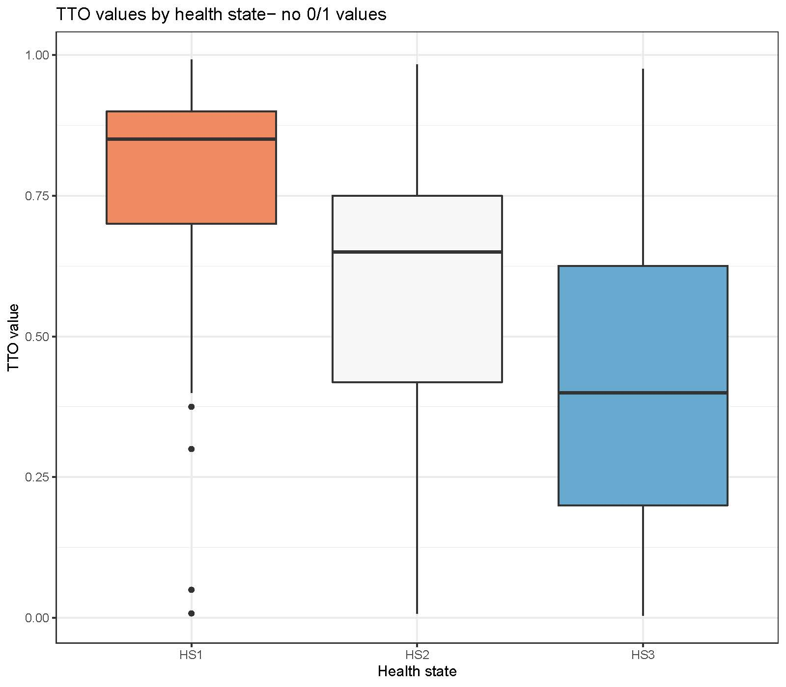TTO: time trade-off.
Figure S2. TTO utility values for health states after removal of any value two or more standard deviations away from the health state mean
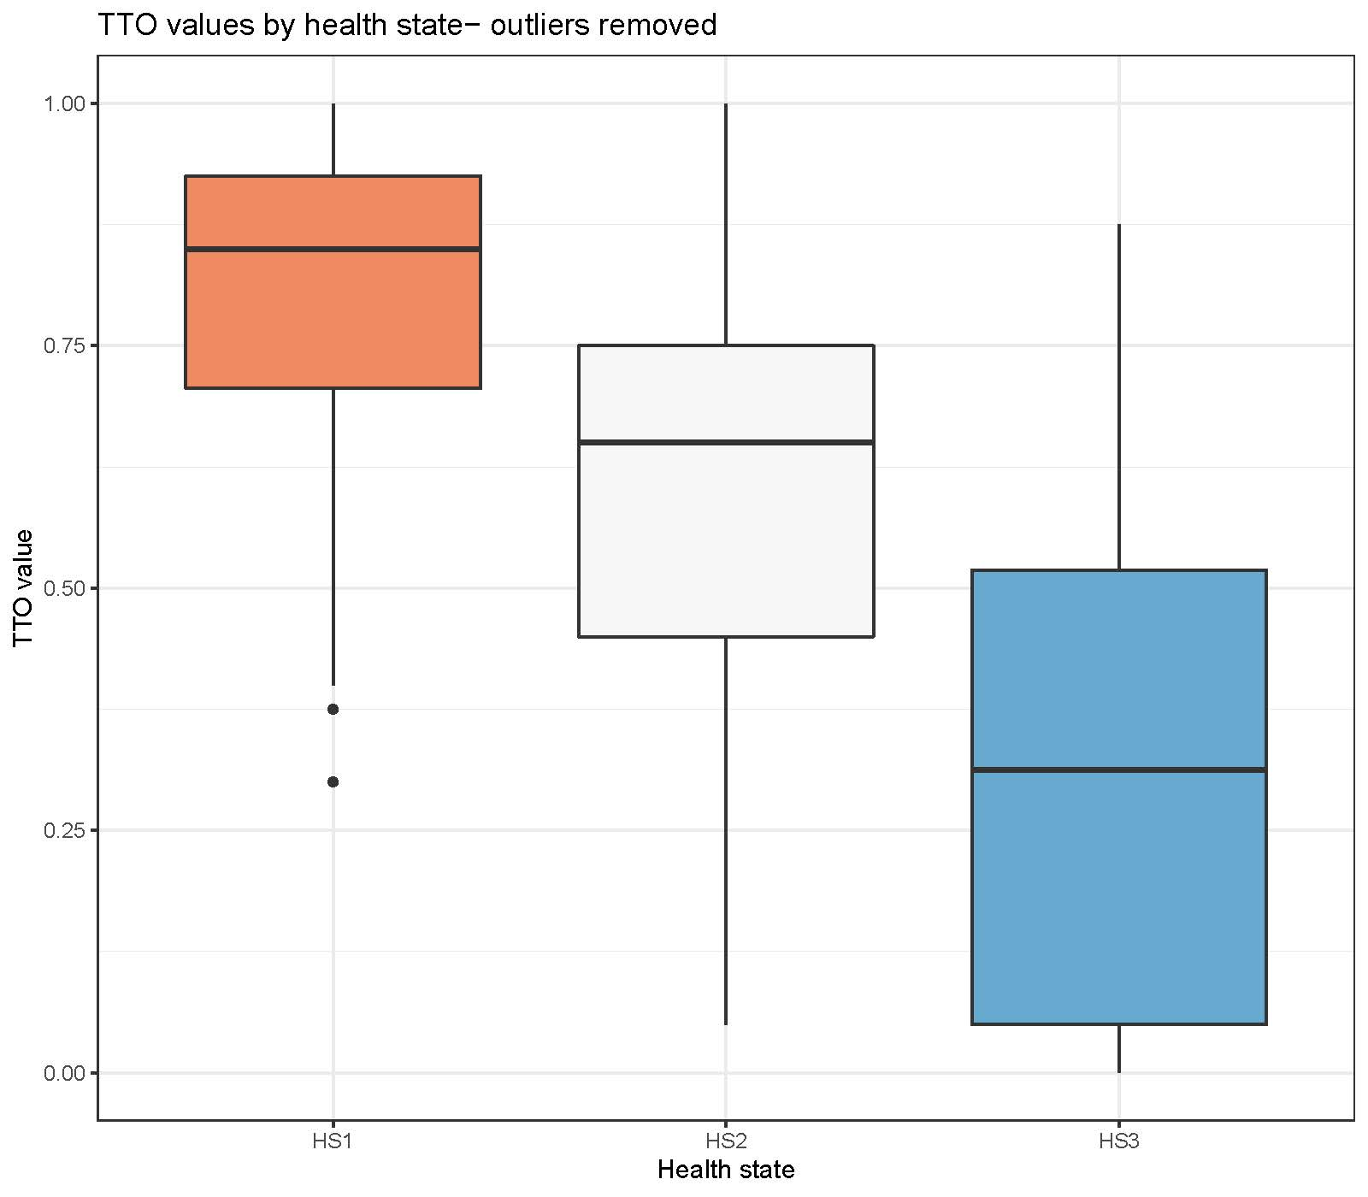TTO: time trade-off.

