Supporting information
Key Modulation of ROS and HSP for Effective Therapy against Hypoxic Tumor with Multifunctional Nanosystem

Bangzhen Ma¹ ² Yisheng Zhao³ Xiaoli Liu⁴ Mengping Huo² Jinghong Wang² Jiwei Ma²
Yang Zhang^{2*} Chengkun Qin^{1 2*}

1 Shandong Provincial Hospital, Shandong University, Jinan, Shandong,250021, China.
2 Shandong Provincial Hospital Affiliated to Shandong First Medical University, Jinan, Shandong,250021, China.
3 School of Pharmaceutical Sciences, Key Laboratory for Natural Active Pharmaceutical Constituents Research in Universities of Shandong Province, Shandong Analysis and Test Center, Qilu University of Technology (Shandong Academy of Sciences), Jinan, Shandong,250353, China
4 Department of Hernia and Abdominal Wall Surgery, Beijing Chaoyang Hospital, Capital Medical University, Beijing, 100043, China.
*Correspondence: Chengkun Qin : Shandong Provincial Hospital,324 Jingwu Road, Huaiyin District, Jinan City, Shandong Province, China. Tel:+86 053168776159, Email: qinchengkun_slyy@163.com; Yang Zhang : Shandong Provincial Hospital,324 Jingwu Road, Huaiyin District, Jinan City, Shandong Province, China. Tel:+86 053168777846, Email:zhangyang@sdfmu.edu.cn.
Supplementary Figure Legends

Figure S1. TEM images：Nanoparticle composites exhibit excellent dispersion characteristics under high-magnification TEM.

Figure S2. TEM images： the distribution of carbon elements

Figure S3. TEM images：. the distribution of nitrogen elements

Figure S4. TEM images：the distribution of oxygen elements

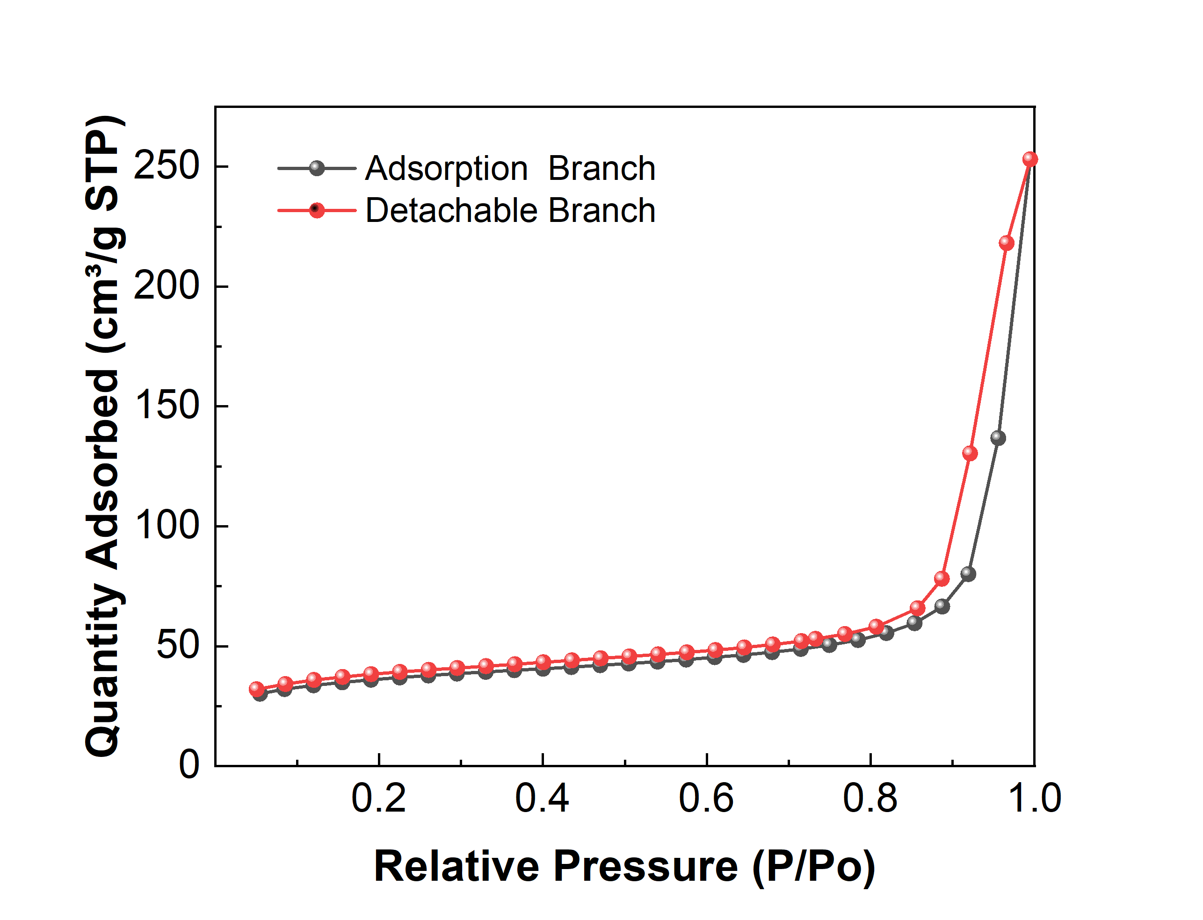
Figure S5. Analysis by the BET method revealed a significant hysteresis loop in the adsorption-desorption isotherm, indicating the presence of mesopores in the nanocomposite particles due to capillary condensation phenomenon.

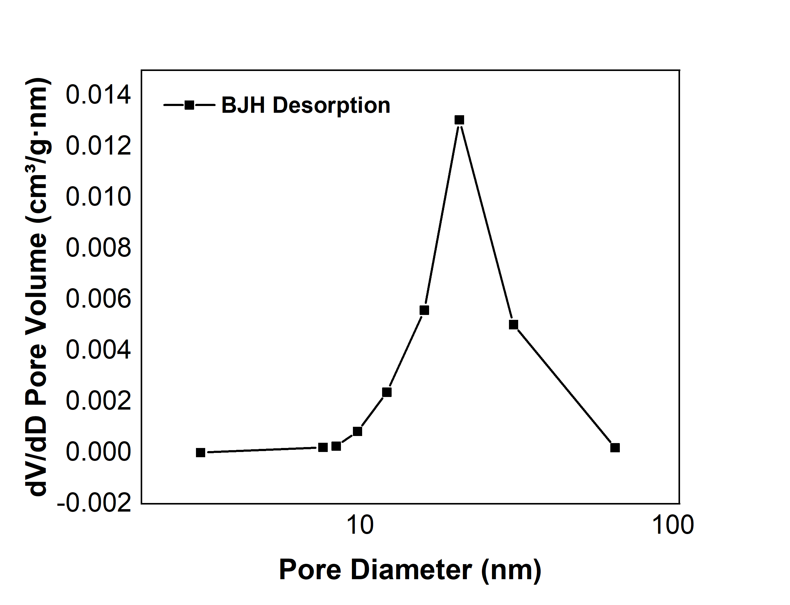
Figure S6. Analysis of the desorption branch curve using the BJH method revealed an average pore size of 26.8nm for the nanocomposite particles

Figure S7. SEM images： The nanocomposite particles exhibit uniform size distribution with peak sizes centered around 100 nm.
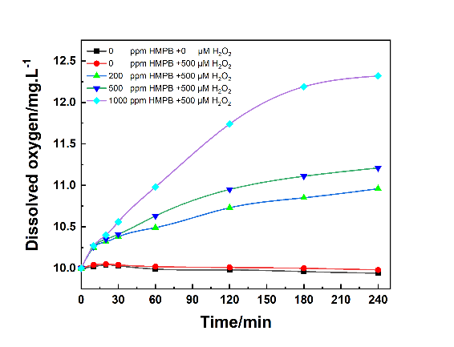
Figure S8. Curves showing the oxygen concentration versus time in a mixed solution containing H₂O₂ (500 μM) and HMPB at concentrations of 0, 200, 500, and 1,000 ppm.

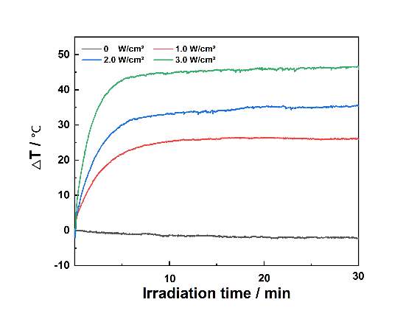
Figure S9. Curves showing the time-course temperature variation of the HMPB@TCPP-Cu solution upon irradiation at laser densities of 0, 1, 2, and 3 W/cm².

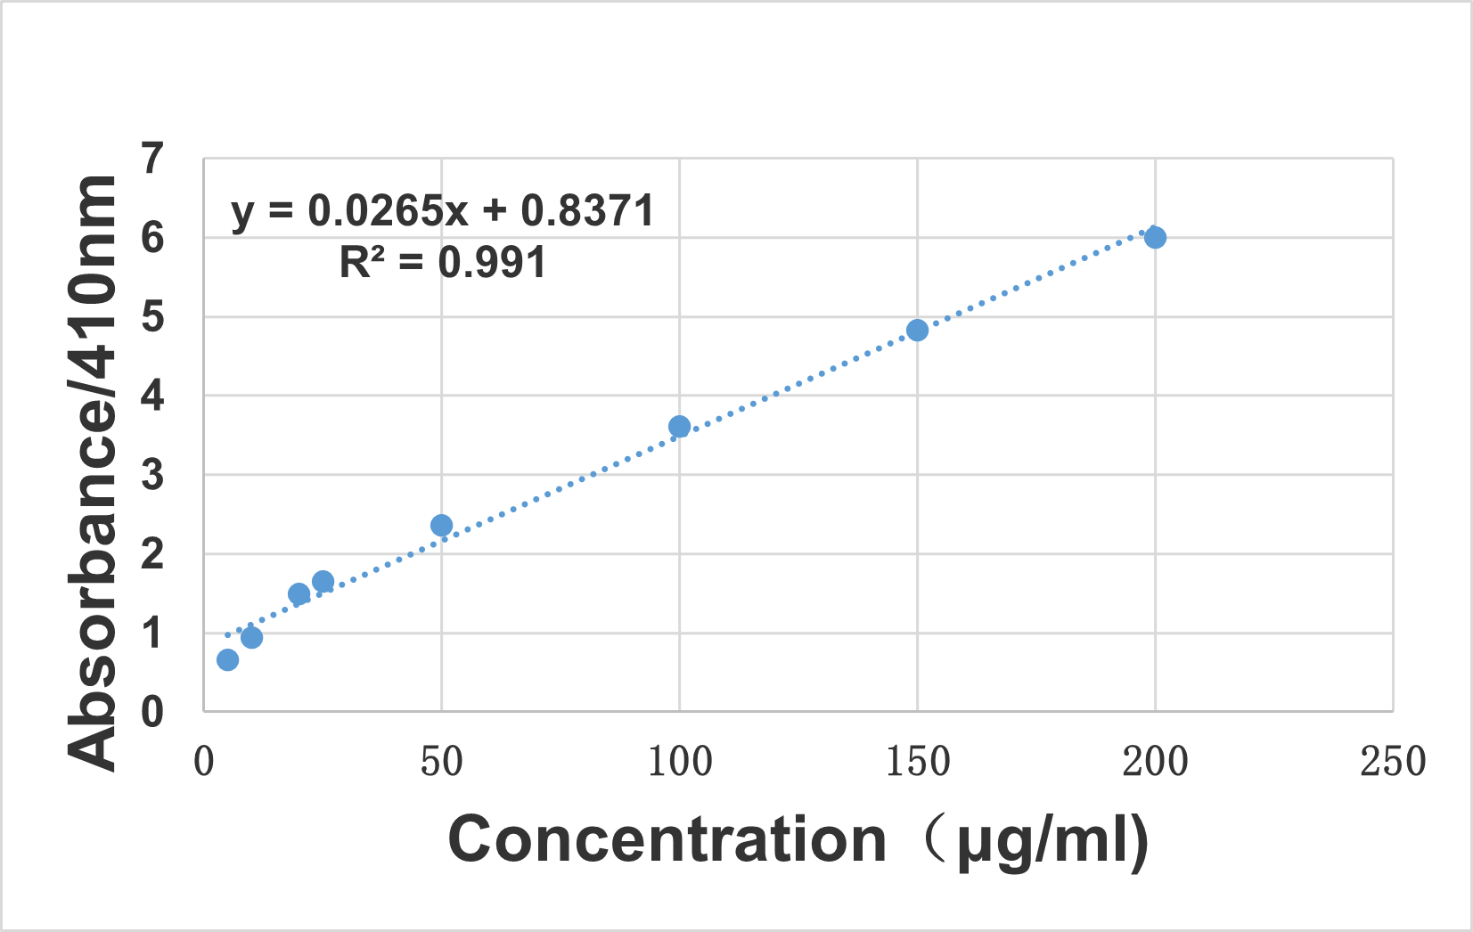
Figure S10. The standard curve of absorbance values for TCPP-Cu solution

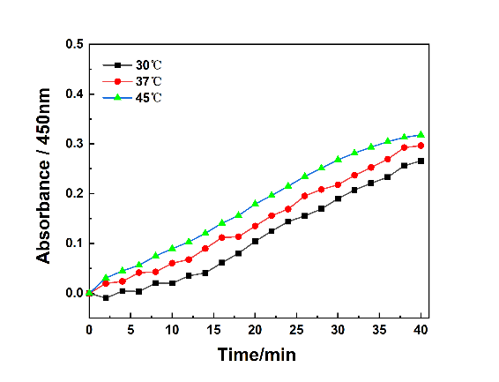
Figure S11. Time-course absorbance curves showing the amount of hydroxyl radicals produced by the reaction of HMPB@TCPP-Cu (200 ppm) and H₂O₂ (500 μM) at a pH of 5.0 and varying temperatures: 30, 37, and 45 °C.

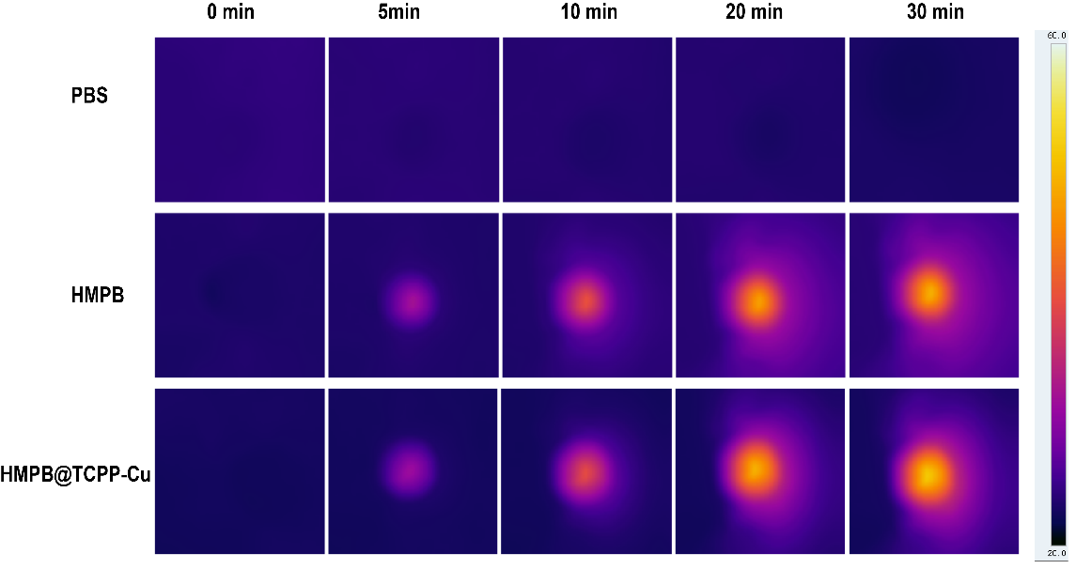
Figure S12. Time-course thermal images of the change in solution temperature culture dishes containing HuH6 cells subjected to laser irradiation.
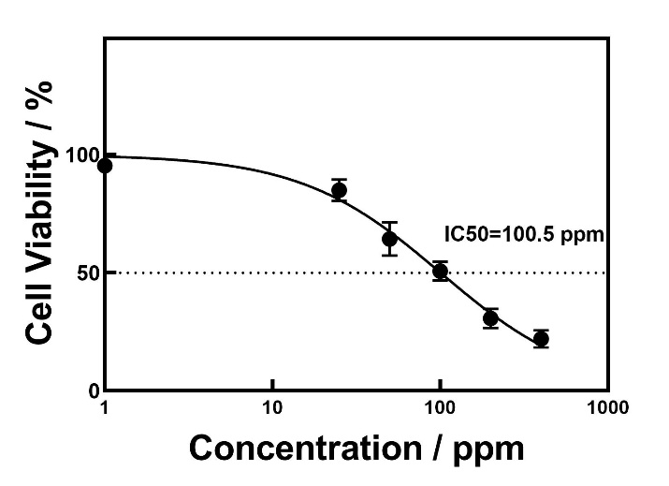
Figure S13. The cell viability curve of HuH6 cells against the concentration of HMPB@TCPP-Cu was plotted, and the IC-50 value of HMPB@TCPP-Cu was calculated to be 100.5 ppm
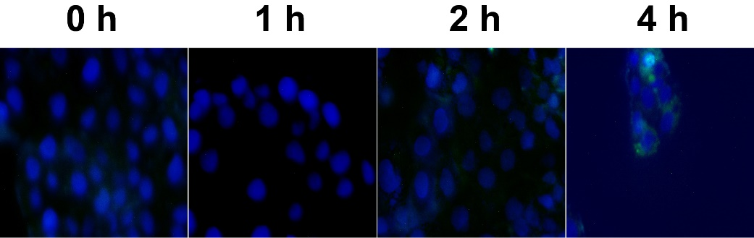
Figure S14. Representative images showing the time-course phagocytosis of HuH6 cells on FITC-labeled HMPB@TCPP-Cu nanoparticles.

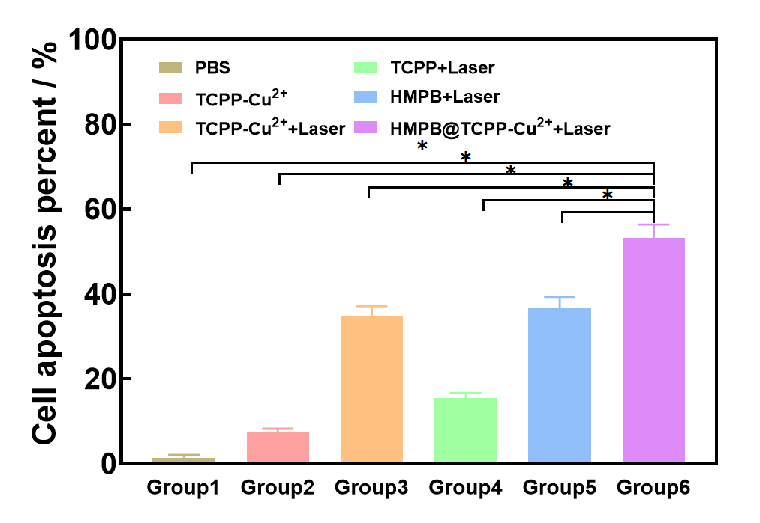
Figure S15. Quantitative analysis of cell apoptosis was performed on HuH6 cells from each experimental group after Annexin V/PI staining, followed by statistical analysis of the data obtained from flow cytometry.

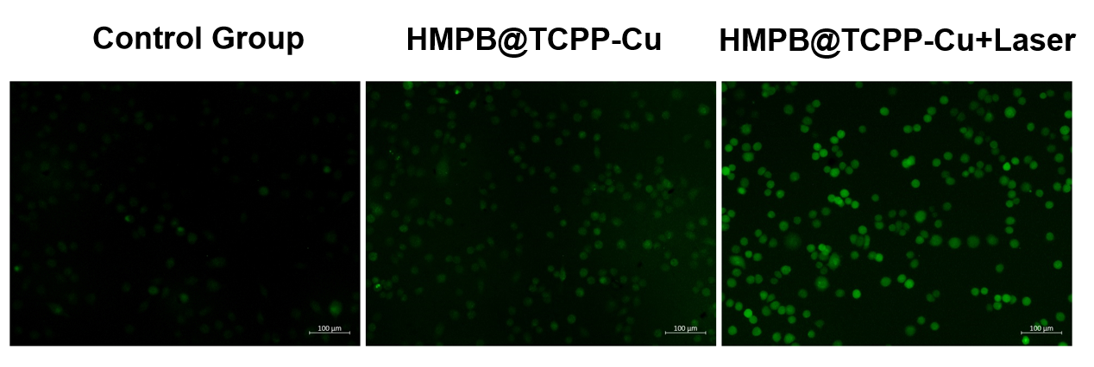
Figure S16. In vitro experiment to detect the content of ROS generation at cellular level.

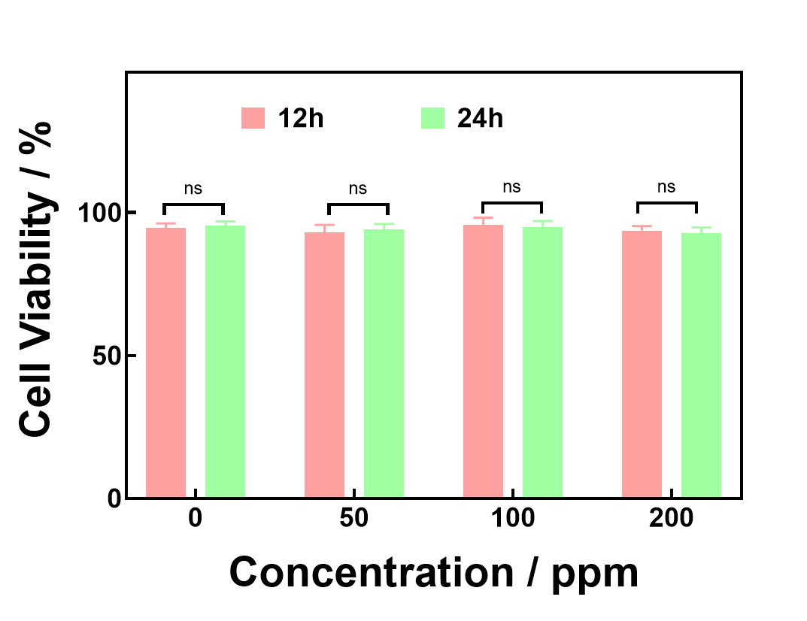
Figure S17. In vitro experiment to determine the cytotoxicity of nanoparticle complexes at the cellular level.
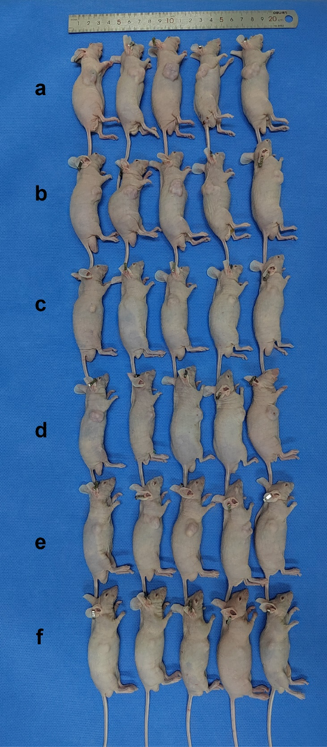
Figure S18. Representative images of tumor-bearing nude mice treated with: A. PBS; B. TCPP-Cu; C. TCPP-Cu+Laser; D. TCPP+Laser; E. HMPB+Laser; and F. HMPB@TCPP-Cu+Laser.

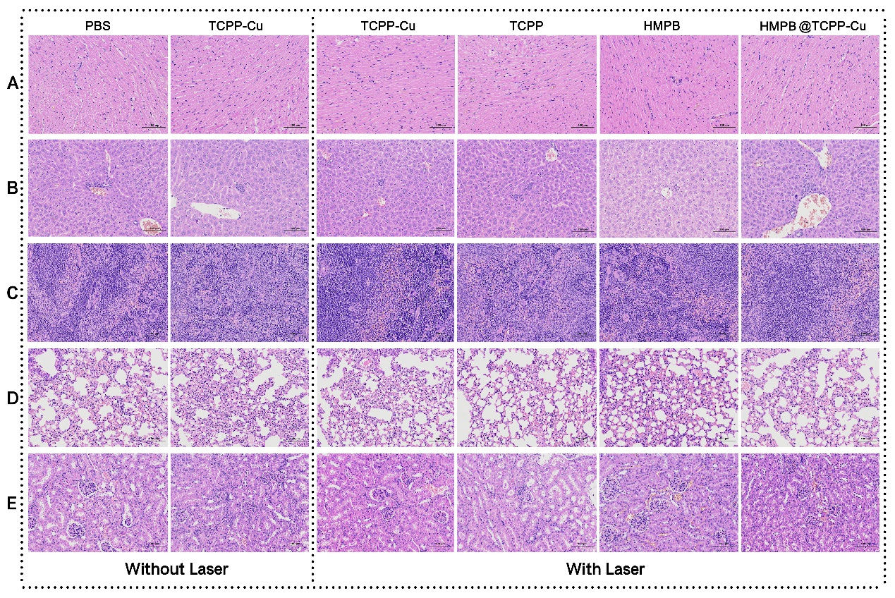
Figure S19. Representative images of HE staining of organ section tissues of nude mice in each experimental group after treatment. A. Heart; B. Liver; C. Spleen; D. Lungs; E. Kidney.

