Supporting Information

Materials, cells and animals
Chemicals were purchased from J&K (Beijing, China). Poly (D, L-lactide-co-glycolide) (PLGA, 50:50, Mw = 5000-15000 Da) was purchased from Dalian Meilun Biotechnology Co. LTD (Dalian, China). Histopaque-1077 was purchased from Sigma-Aldrich (St Louis, MO, USA). Coumarin-6 and sodium cholate were purchased from Aladdin (Shanghai, China). MTT, BCA kit and TUNEL apoptosis assay kit were purchased from Beyotime® Biotechnology (Shanghai, China). Anti-CXCR4 and anti-Integrin beta 1 were purchased from Abcam (Cambridge Science Park, UK). Anti ATP1A1 was purchased from BOSTER (Wuhan, China). PTX was purchased from Macklin (Shanghai, China). All solvents were purchased from Sinopharm Chemical Reagent Co. Ltd (Shanghai, China).
4T1 (mouse mammary carcinoma) was obtained from ATCC (Rockville, MD) and cultured in RPMI-1640 medium containing 10% fetal bovine serum (FBS). Female BALB/c mice (6-8 weeks) were purchased from Animal experimental center of Huaxing (Zhengzhou, China) and housed in clean room. All animal studies were approved by the Institutional Animal Care and Use Committee, Henan Agricultural University.

Synthesis of hQ-PTX₂
Synthesis of compound 2
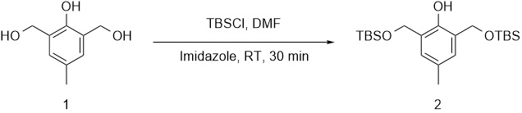
Compound 1 (5.00 g, 29.7 mmol), imidazole (4.45 g, 65.5 mmol) and TBSCl (9.42 g, 62.5 mmol) were dissolved in DMF (60 mL) and further stirred at room temperature (RT) for 30 min under the protection of N₂. When TLC showed reaction completion, the reaction mixture was quenched with water and extracted with ether. The organic layer was separated, washed with brine, dried over anhydrous Na₂SO₄, and concentrated under reduced pressure. The residue was purified by column chromatography with elution using petroleum ether/ethyl acetate (40:1~20:1) to give the intermediate (10.5 g, 91.0% yield) as a colorless oil. ¹H NMR (400 MHz, DMSO-d₆): δ 8.00 (s, 1H), 6.89 (s, 1H), 4.62 (s, 4H), 2.42 (s, 3H), 0.83 (s, 18H), 0.00 (s, 12H).
Synthesis of compound 4
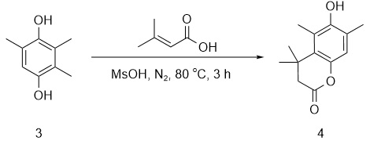
A mixture of compound 3 (10.0 g, 65.7 mmol) and 3-methylbut-2-enoic acid (7.23 g, 72.7 mmol) in MsOH (50 mL) was stirred at 80 ºC for 3 h. Upon reaction completion monitored by TLC, the pH of reaction mixture was adjusted to 8, and extracted with DCM. The organic layer was separated, dried over anhydrous Na₂SO₄ and concentrated under reduced pressure. The residue was purified by recrystallization in the mixture (PE/EA, v/v = 3/1) to give the intermediate as a yellow solid (12.0 g, 83.0% yield). ¹H NMR (400 MHz, CDCl₃): δ 4.60 (s, 1H), 2.54 (s, 2H), 2.35 (s, 3H), 2.20 (d, J = 15.2 Hz, 3H), 1.45 (s, 6H).
Synthesis of compound 5
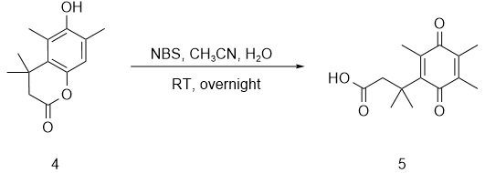
Compound 4 (12.0 g, 54.5 mmol) and NBS (12.2 g, 68.9 mmol) were dissolved in a mixture (MeCN/H₂O, v/v = 5/1, 120 mL) and stirred at RT overnight. When LC-MS indicated that the reaction was complete, the reaction mixture was extracted with DCM. The organic layer was separated, dried over anhydrous Na₂SO₄ and concentrated under reduced pressure to give the intermediate as a yellow oil (14.1 g, 100% yield). LC-MS (ESI) [M+H]⁺ : 249.0.
Synthesis of compound 6
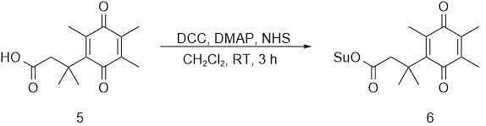
DCC (11.6 g, 56.4 mmol) and DMAP (0.688 g, 5.64 mmol) were added to a CH₂Cl₂ solution (350 mL) of compound 5 (14.0 g, 56.4 mmol) and NHS (7.13 g, 62.4 mmol). The resulting mixture was stirred at RT for 3 h. After reaction was completed, the reaction solution was concentrated, diluted with cold EA, filtered, and then concentrated to yield the intermediate as a yellow solid (20.3 g, crude).
Synthesis of compound 7
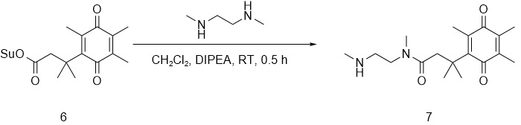
The mixture of compound 6 (20.0 g, 57.6 mmol), DIPEA (22.3 g, 173 mmol) and N1, N2-dimethylethane-1,2-diamine (50.7 g, 576 mmol) in CH₂Cl₂ (100 mL) was stirred at RT for 0.5 h. The reaction mixture was quenched with water and extracted with DCM. The organic layer was separated, dried over anhydrous Na₂SO₄, and concentrated under reduced pressure to give the intermediate as a yellow oil (13.1 g, 71.1% yield). LC-MS (ESI) [M+H]⁺ 321.2.

Synthesis of compound 8
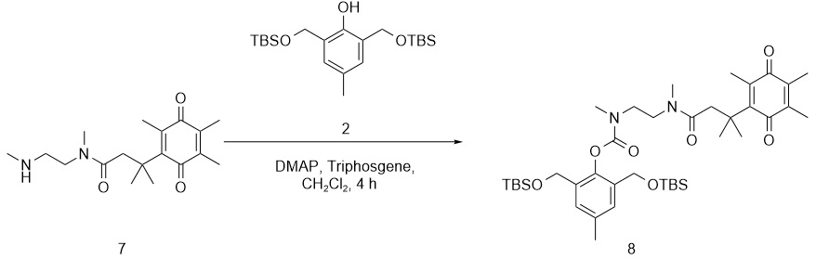
Compound 2 (11.5 g, 29.0 mmol), triphosgene (3.01 g, 10.1 mmol) and DMAP (10.6 g, 87.0 mmol) were dissolved in CH₂Cl₂ (500 mL) and stirred at RT for 15 min. Then compound 7 (9.30 g, 29.0 mmol) was added to the mixture and stirred at RT for 4 h. The reaction mixture was concentrated under reduced pressure and purified by column chromatography with elution using petroleum ether/ethyl acetate (20:1 ~ 10:1), resulting in the product as a yellow solid (14.3 g, 66.4% yield). ¹H NMR (400 MHz, CDCl₃): δ 7.13 (s, 2H), 4.58-4.54 (m, 3H), 3.48-3.29 (m, 4H), 3.14-2.83 (m, 8H), 2.28 (s, 3H), 1.88- 1.83 (m, 6H), 1.29 (s, 6 H), 0.85 (s, 18H), 0.00 (s, 12H).
Synthesis of compound 9
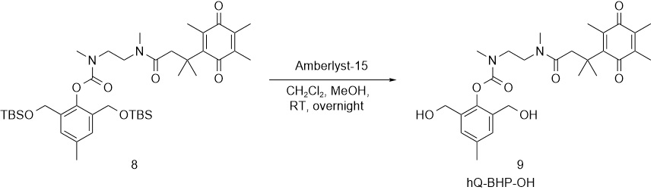
Compound 8 (14.3 g, 19.2 mmol) was stirred with Amberlyst-15 (1.80 g) in a mixture (CH₂Cl₂/MeOH, v/v = 4/1, 150 mL) at RT overnight. TLC showed that the reaction was complete. The reaction mixture was concentrated and purified by column chromatography with elution using petroleum ether/ethyl acetate (v/v, 3/1) to give the product as a yellow solid (5.10 g, 51.5% yield). ¹H NMR (400 MHz, CDCl₃): δ 7.23-7.20 (m, 2H), 4.56-4.49 (m, 4H), 3.58-3.48 (m, 4H), 3.24-3.09 (m, 3H), 3.04-2.88 (m, 5H), 2.35 (s, 3H), 2.13-2.12 (m, 3H), 1.95-1.82 (m, 6H), 1.43-1.42 (m, 6H).

Synthesis of compound 10
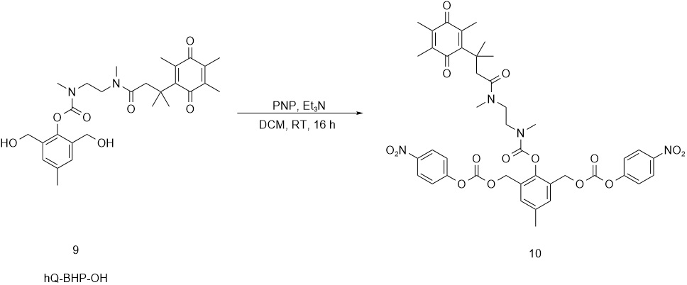
PNP (6.80 g, 33.7 mmol) was added to the DCM solution of compound 9 (3.70 g, 7.20 mmol) and TEA (0.300 mL, 21.6 mmol). The reaction was stirred at RT for 16 h. The reaction mixture was purified by column chromatography with elution using petroleum ether/ethyl acetate (5:1 ~ 1:1) to give the product (2.00 g, 26.7% yield), which was used for the next step directly. LC-MS (ESI) [M+H]⁺ : 845.4.
Synthesis of compound 11
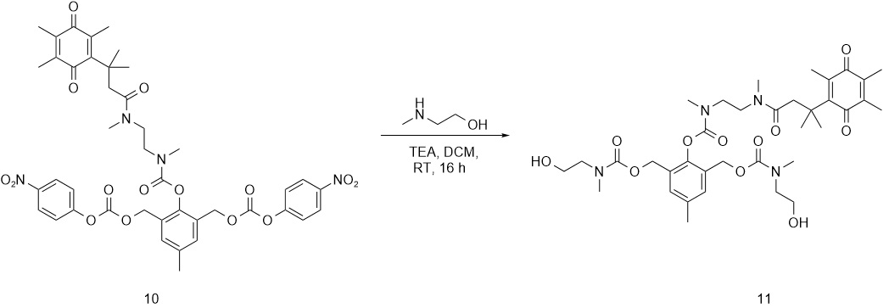
Compound 10, 2-(methylamino) ethan-1-ol (178 mg, 2.36 mmol) and TEA (0.590 mL, 3.54 mmol) were stirred at RT in DCM (12 mL) for 16 h. The reaction mixture was concentrated, purified by column chromatography with elution using DCM/methanol (20:1 ~ 10:1) to give the product as a yellow solid (456 mg, 54.0% yield). LC-MS (ESI) [M+H]⁺ : 717.5.

Synthesis of compound 12
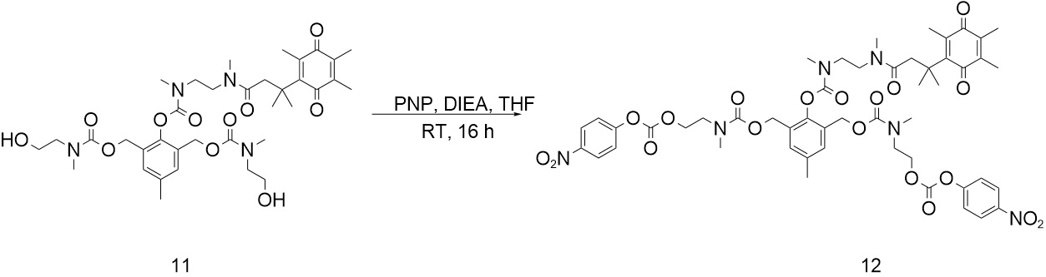
PNP (892 mg, 4.44 mmol) was added to the THF solution (11 mL) of compound 11 (795 mg, 1.11 mmol) and DIEA (0.560 mL, 3.33 mmol), and stirred at RT for 16 h. The reaction mixture was concentrated, purified by column chromatography with elution using DCM/ethyl acetate (20:1 ~ 10:1) to give the product as a yellow sold (574 mg, 51.7% yield). ¹H NMR (400 MHz, DMSO-d6): δ 8.27-8.26 (m, 4H), 7.55-7.40 (m, 4H), 7.20-7.10 (m, 2H), 5.15-4.93 (m, 4H), 4.36 (s, 4H), 3.60 -3.32 (m, 10H), 3.10-2.90 (m, 14H), 2.51-2.50 (m, 1H), 2.25-2.15 (m, 3H), 2.40-2.30 (m, 5H), 1.32-1.18 (m, 6H).
Synthesis of hQ-PTX₂
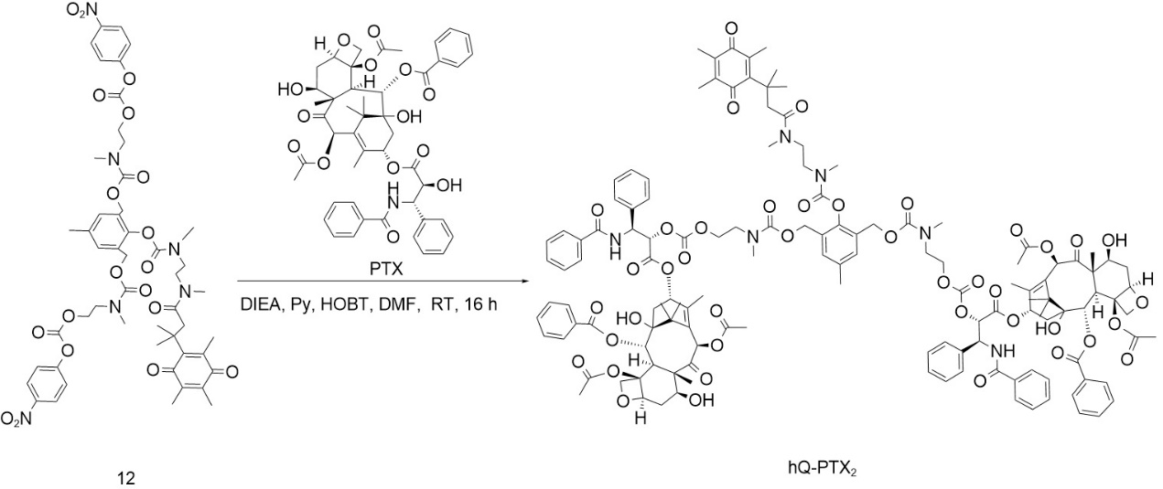
DIEA (100 μL, 6.00 mmol) and pyridine (110 μL, 6.00 mmol) were added to a DMF (2 mL) solution of PTX (800 mg, 0.930 mmol), compound 12 (200 mg, 0.200 mmol) and HOBT (40.0 mg, 0.300 mmol). After stirring at RT for 16 h, the reaction mixture was purified by prep-HPLC (FA) to give the final product (150 mg, 30.3% yield). LC-MS (ESI) [M+H]+ 1/ 2: 1239.3. HPLC: 100% purity (370 nm); 91.5% purity (232 nm); 90.3% purity (214 nm). ¹H NMR (400 MHz, DMSO-d6): δ 9.27 (d, J = 6.8 Hz, 2H), 7.98 (d, J = 7.2 Hz, 2H), 7.85-7.51(m, 3H), 7.74-7.64 (m, 6H), 7.53-7.40 (m, 15H), 7.19-7.17 (m, 5H), 6.30 (s, 2H), 5.84 (t, J = 8.4 Hz, 2H), 5.54 (t, J = 8.8 Hz, 2H), 5.43-5.33 (m, 4H), 4.91-4.86 (m, 8H), 4.63 (s, 2H), 4.26 (s, 4H), 4.20-3.99 (m, 6H), 3.59-3.56 (m, 3H), 3.44 (s, 4H), 2.99-2.91 (m, 5H), 2.89-2.73 (m, 8H), 2.32-2.25 (m, 12H), 2.09-2.04 (m, 7H), 2.00-1.98 (m, 3H), 1.85-1.64 (m, 14H), 1.64 (t, J = 12.8 Hz, 3H), 1.50 (s, 8H), 1.31-1.29 (m, 5H), 1.03-0.99 (m, 12H).

Preparation of neutrophil membranes
Neutrophils were collected by following the reported procedure.¹ The peripheral blood (1 mL) of mice was collected and diluted with hank's balanced salt solution (HBSS, v/v = 1/10). After mixing with histopaque-1077 (10 mL), the mixture was centrifuged (450 g, 50 min) to collect the middle cloudy layer. The cloudy layer was lysed with red blood cell lysis solution, and centrifuged (400 g, 10 min) to yield neutrophils. To obtain neutrophil membrane, the neutrophils were resuspended in starting buffer and sonicated on ice.² Following centrifugation at 1000 g for 10 min, 10000 g for 20 min, 100000 g for 1 h, the precipitate was collected and lyophilized, thus yielding neutrophil membranes (NM).

Determination of membrane associated protein
In order to determine the total membrane proteins content of neutrophil membrane coated PLGA NPs (NM-NPs), NM-NPs were prepared with various NM/PLGA weight ratios as described above. Then NM-NPs were collected by centrifugation (14500 g, 50 min), and the protein content on the NPs was detected by BCA kit. Besides, the expression of the relevant proteins on the neutrophil membranes was assessed by coomassie blue staining and western blot assays. The neutrophils (NEs), NM and NM-NPs were lysed on ice for 10 min in RIPA lysis buffer containing protease inhibitors. The lysates were centrifuged at 13000 g for 10 min at 4 °C, and the supernatants were collected to determine protein content by BCA kit. The protein expression in the supernatants was analyzed by SDS-PAGE and western blot, respectively.³

Detection of PDT-induced ROS and hypoxic level in vitro
4T1 cells were seeded at 1.5 × 10⁴ cells/well in 24-well plates and cultured for 24 h. After incubation with NMC-NPs (10 μg Ce6/mL) for 4 h, cells were irradiated, washed with PBS, incubated with DCFH-DA (10 μM) for 30 min before confocal laser scanning microscopy (CLSM) observation. Alternatively, NMC-NPs-treated cells were treated with hypoxia/oxidative stress detection mix according to the protocol,⁴ irradiated and further incubated for 30 min following CLSM observation.

Determination of hypoxic level in vivo
To assess the hypoxic level of tumors under light irradiation, the NMC-NPs (5 mg Ce6/kg) were injected intratumorally into 4T1 tumor-bearing mice. 1 h later, tumors were irradiated, and injected intraperitoneally with pimonidazole (60 mg/kg) at 1 h post-irradiation. The tumors were collected after 1 h injection, and tumor sections were stained with anti-pimonidazole antibody to observe with fluorescence microscope.

Biosafety of NPs
4T1 cells were plated in 96-well plates at 2 × 10⁴ cells/well and cultured for 24 h. NPs and NM-NPs were added at various different concentration, and the cells were incubated for 72 h to assess cell viability by MTT assay.

Statistical analysis
Data could be expressed as mean ± standard deviation. The student’s t-test was used for statistical comparisons. The differences were set to be significant at *p < 0.05 and very significant at **p < 0.01 and ***p < 0.001.

References
1. Kang T, Zhu Q, Wei D, et al. Nanoparticles coated with neutrophil membranes can effectively treat cancer metastasis. ACS Nano. 2017;11(2):1397-1411. doi:10.1021/acsnano.6b06477
2. Cui Z, Wang HY, Zhao MH. Natural autoantibodies against glomerular basement membrane exist in normal human sera. Kidney Int. 2006;69(5):894-899. doi:10.1038/sj.ki.5000135
3. Zhang Q, Dehaini D, Zhang Y, et al. Neutrophil membrane-coated nanoparticles inhibit synovial inflammation and alleviate joint damage in inflammatory arthritis. Nat Nanotechnol. 2018;13(12):1182-1190. doi:10.1038/s41565-018-0254-4
4. Dong Y, Zhou L, Shen Z, et al. Iodinated cyanine dye-based nanosystem for synergistic phototherapy and hypoxia-activated bioreductive therapy. Drug Delivery. 2022;29(1):238-253. doi:10.1080/10717544.2021.2023701

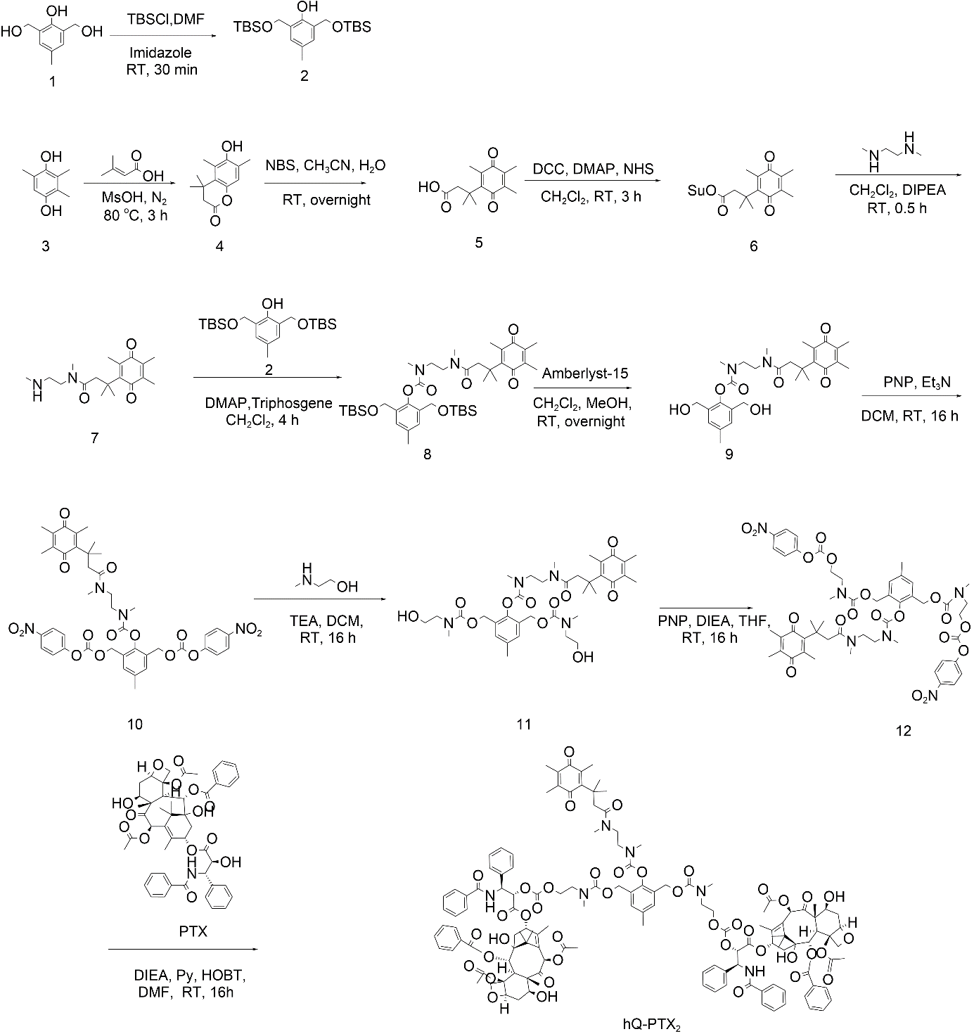
Scheme S1 Synthetic route of hQ-PTX₂.

Table S1 The full name and abbreviated name of NPs.
Full name | Abbreviated name
PLGA nanoparticles | NPs
Neutrophil membrane-coated PLGA nanoparticles | NM-NPs
Ce6-loadeded PLGA nanoparticles | C-NPs
Neutrophil membrane-coated, Ce6-loaded PLGA nanoparticles | NMC-NPs
hQ-PTX₂-loaded PLGA nanoparticles | P-NPs
Neutrophil membrane-coated, hQ-PTX₂-loaded PLGA nanoparticles | NMP-NPs
hQ-PTX₂- and Ce6- co-loaded PLGA nanoparticles | PC-NPs
Neutrophil membrane-coated, hQ-PTX₂- and Ce6- co-loaded PLGA nanoparticles | NMPC-NPs

Table S2 The IC₅₀ (μg/mL) of PTX and Ce6 in NPs and CI values between PTX and Ce6 in various NPs toward 4T1 cells.
 | IC₅₀ (μg/mL) | CI
PTXª | 6.4 | 0.85
Ce6^{b} | 5.8 | 0.85
PTX^{c} | 3.5 | 0.85
Ce6^{c} | 1.8 | 0.85
ª NMP-NPs; ^{b} NMC-NPs; ^{c} NMPC-NPs.

Table S3 The IC₅₀ (μg/mL) of PTX in NMP-NPs towards 4T1 cells under normoxic and hypoxic environment.
 | IC₅₀ (μg/mL)
Normoxia | 6.4
Hypoxia | 3.3
Table S4 The IC₅₀ of PTX in NMPC-NPs toward 4T1 cells with or without VC pretreatment.
 | IC₅₀ (μg/mL)
w/o VC | 3.5
w/ VC | 7.1

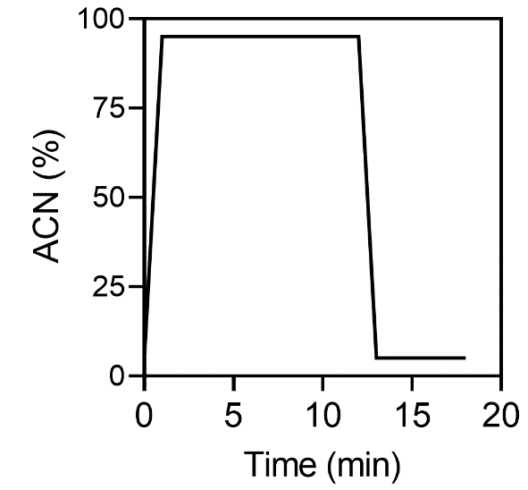
Figure S1 Time line of HPLC method as shown by acetonitrile gradient change.

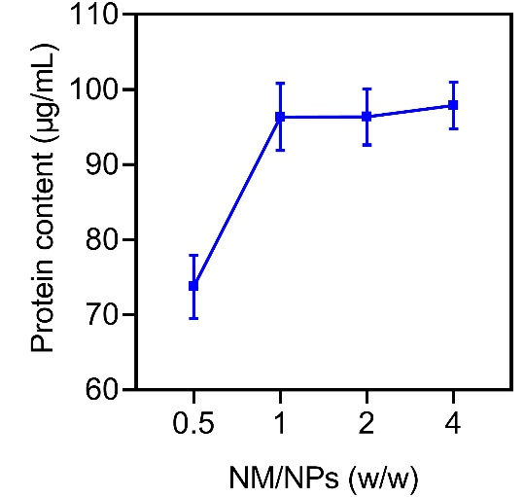
Figure S2 Protein content of NM-NPs at various NM/NPs weight ratios (n = 3).

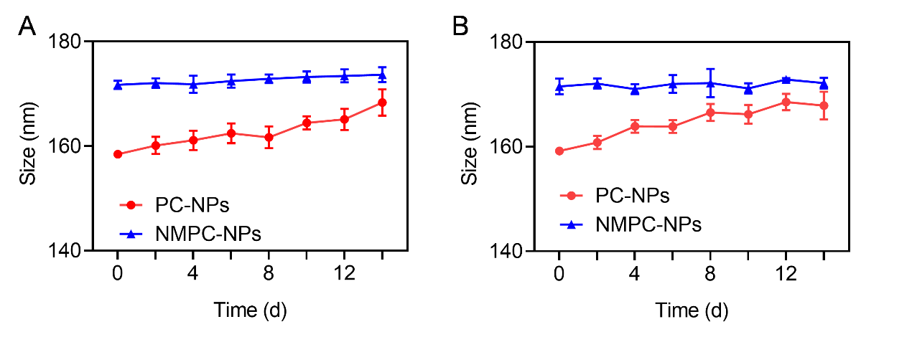
Figure S3 Alternation of particle size of PC-NPs and NMPC-NPs in PBS (A) and serums (B) (n = 3).
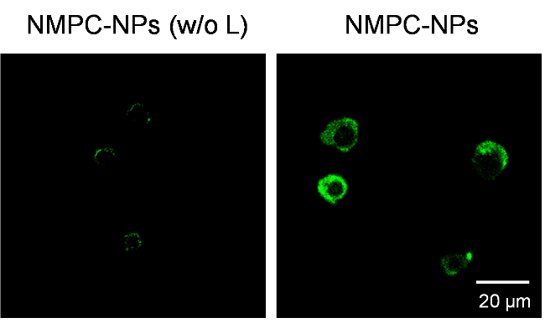
Figure S4 CLSM images of 4T1 cells incubated with NMPC-NPs for 4 h with or without irradiation. Cells were stained with ROS detection probes.

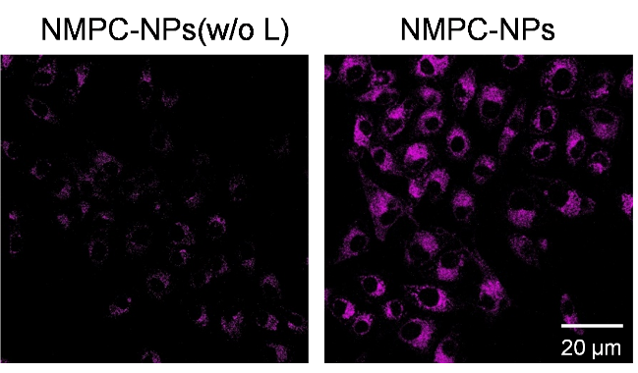
Figure S5 CLSM images of 4T1 cells incubated with NMPC-NPs for 4 h with or without irradiation. Cells were stained with hypoxia detection probes.

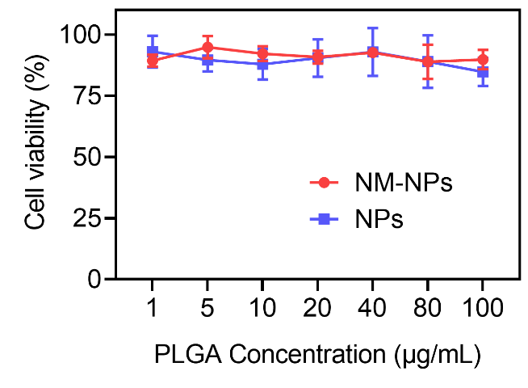
Figure S6 Biosafety of NPs and NM-NPs to 4T1 cells (n = 3).
Figure S7 The level of TNF-α and IL-6 in tumors harvested at different time points (n = 3). Tumors were treated as described in Figure 5.

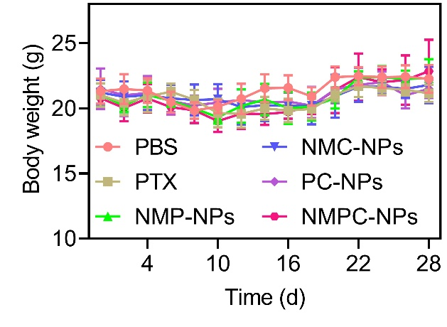
Figure S8 Body weight changes of mice treated as described in Figure 6 (n = 8).

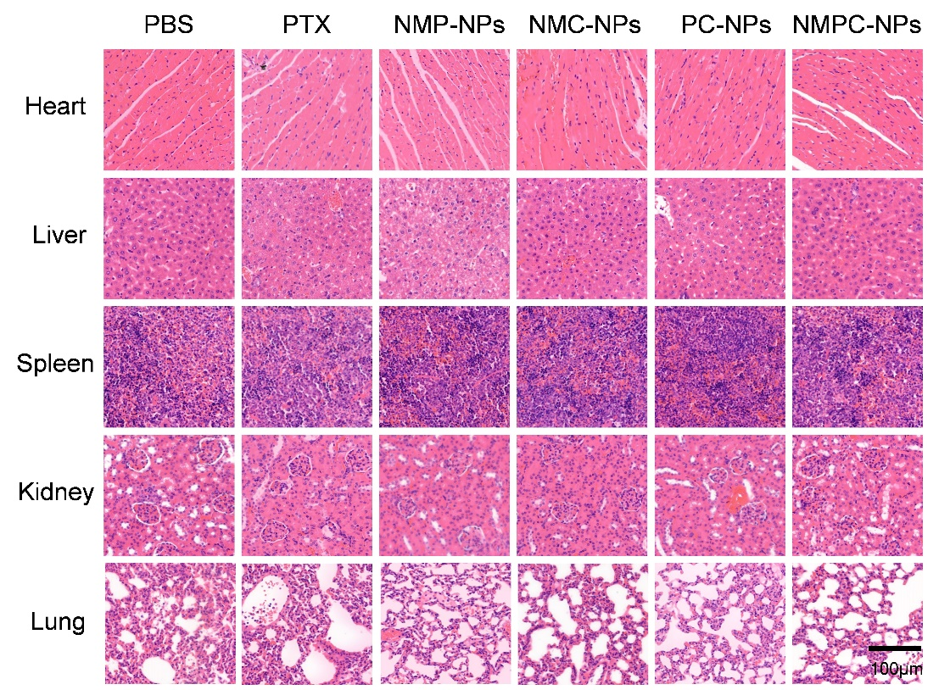
Figure S9 H&E staining of major organs sections collected from mice treated as described in Figure 6 on day 26.

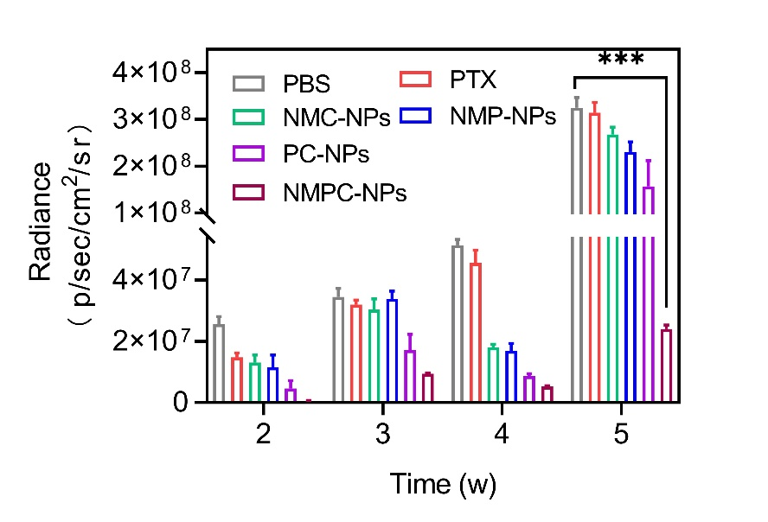
Figure S10. Quantified bioluminescence intensity of other organs in mice treated as described in Figure 8 (n = 5). Data expressed as means ± SD. ***p < 0.001.

