Supplemental Experimental Procedures
Supplement 1
Standard curve at pH 6.8 phosphate buffer (simulated intestinal fluid)
The standard curve was prepared to by diluting the pure Metformin solution from 1 µg/ml to 10 µg/ml. The standard curve obtained at 233 nm had a slope of 0.133 & R2 value of 0.9973.
Figure S6 represents the standard curve of Metformin HCl in standard solution.
Equation of the standard curve: y = 0.133x + 0.0572
Where, y = Absorbance and x = Concentration (μg/ml)

Supplemental Figures
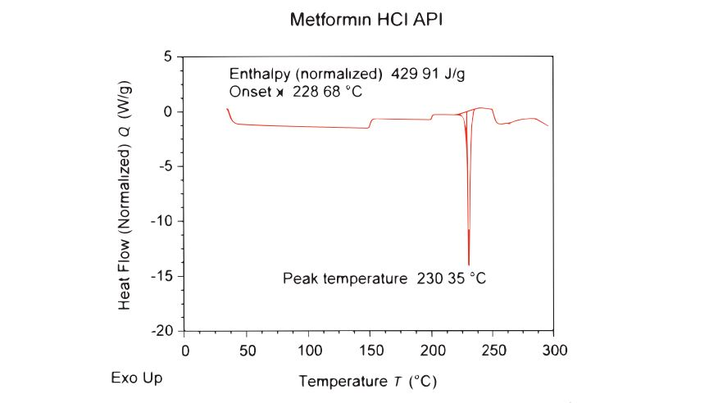
Figure S1. DSC thermogram of pure metformin HCl, related to figure 3.
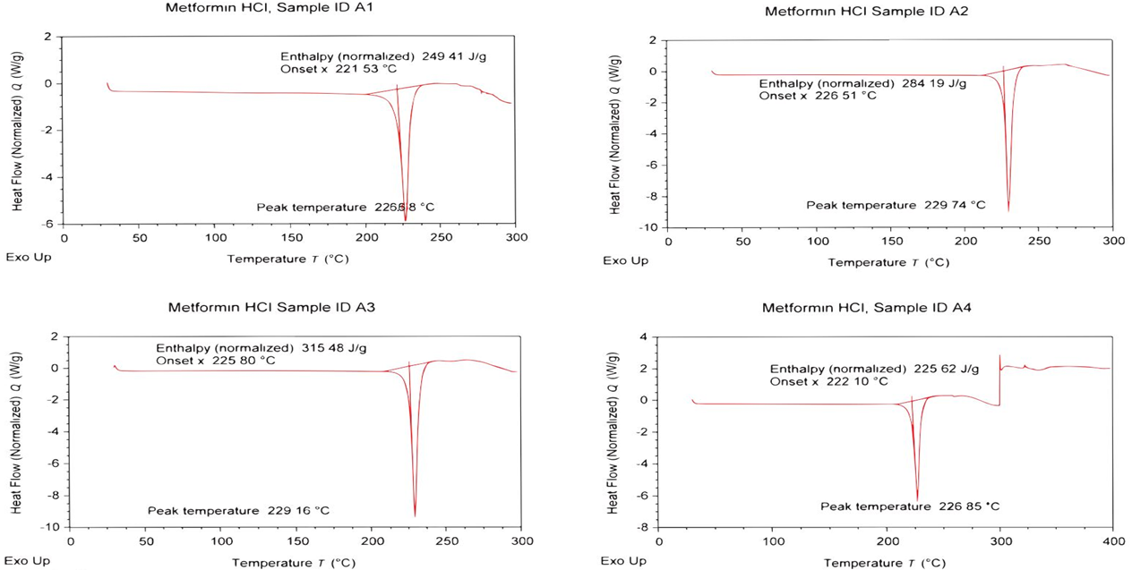
Figure S2. DSC thermogram of all batches metformin HCl loaded microspheres (A1, A2, A3 and A4), related to figure 3.
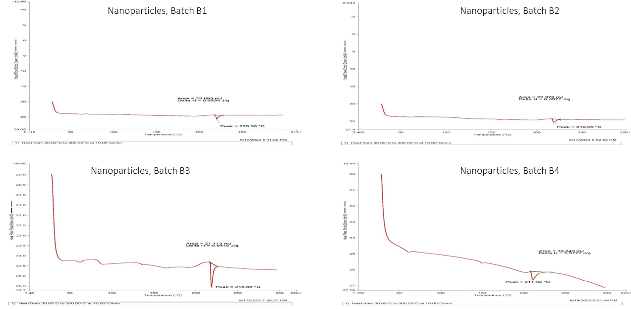
Figure S3. DSC thermogram of all batches metformin HCl loaded nanoparticles (B1, B2, B3 and B4), related to figure 3.

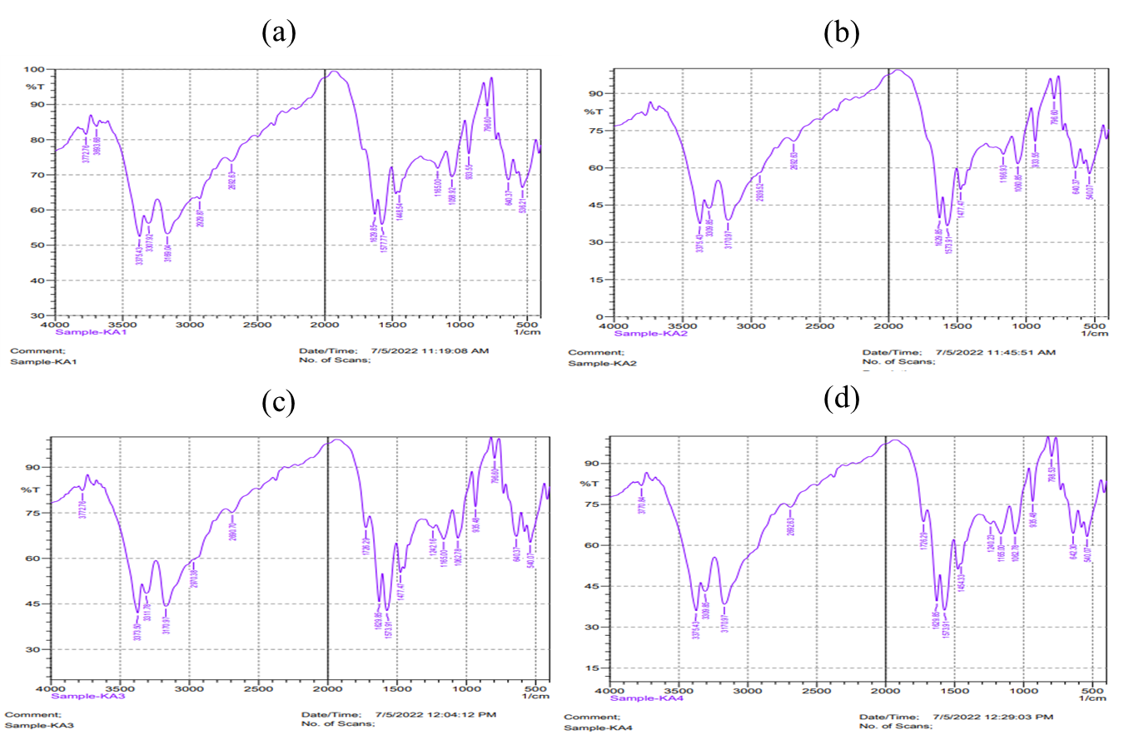
Figure S4. FTIR spectrum of metformin HCl loaded microspheres of batch (a) A1, (b) A2, (c) A3 and (d) A4, related to figure 4.
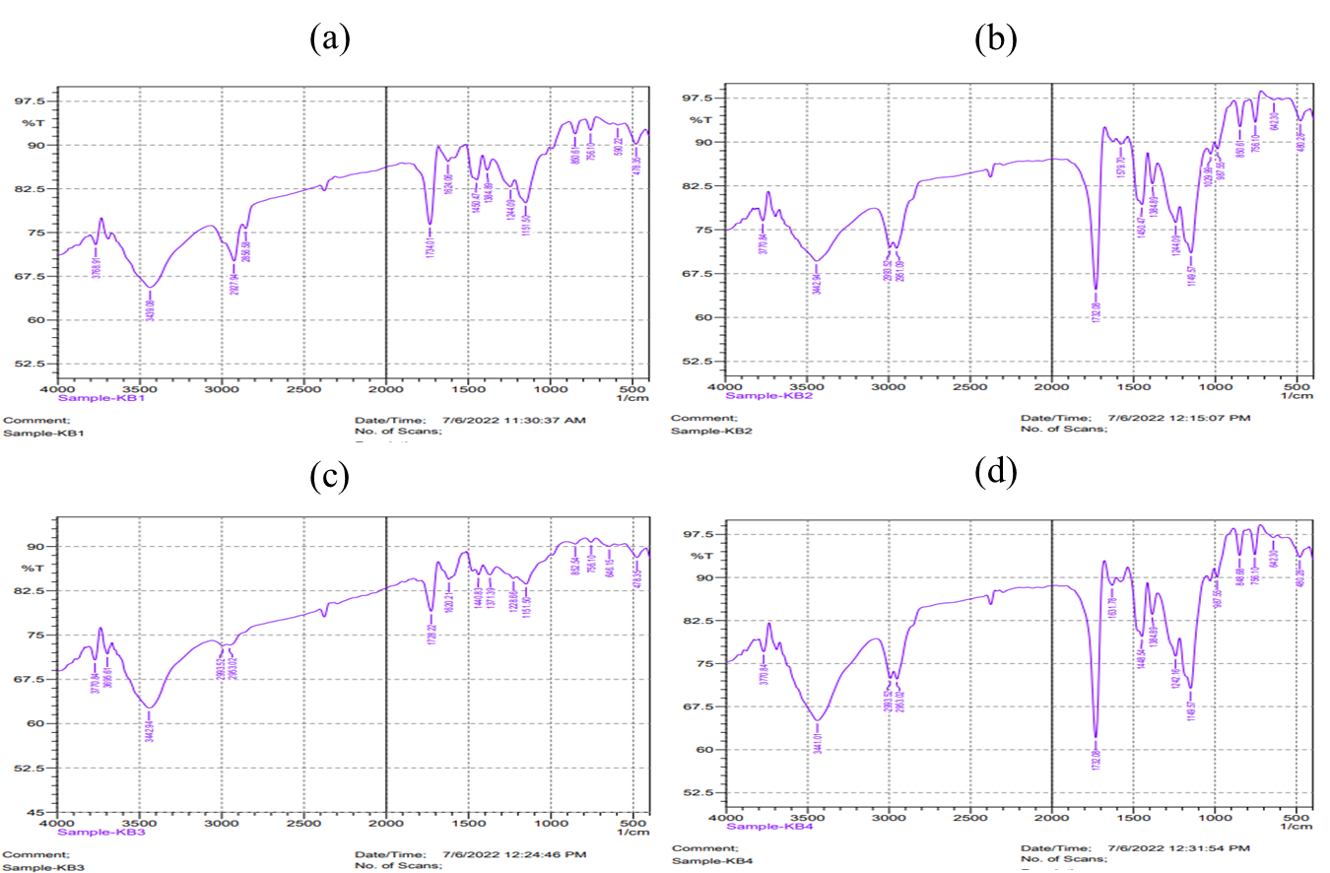
Figure S5. FTIR spectrum of metformin HCl loaded nanoparticles of batch (a) B1, (b) B2, (c) B3 and (d) B4, related to figure 4.

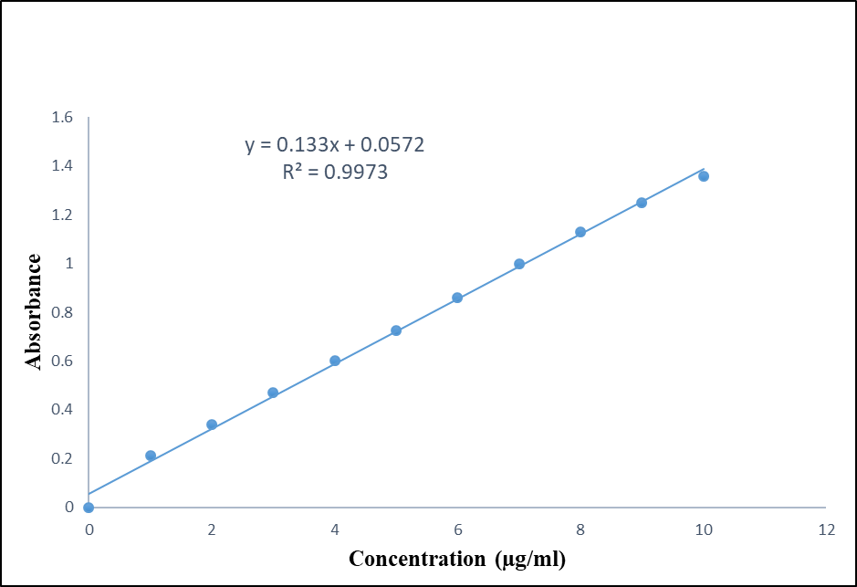
Figure S6. Standard curve of metformin HCl in phosphate buffer (pH 6.8).
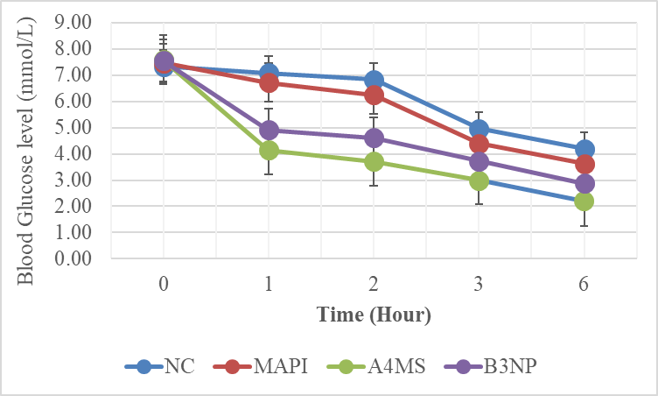
Figure S7. Effect of metformin HCl API powder (MAPI), selected formulation A4 of microspheres (A4MS) and B3 of nanoparticles (B3NP) (n=6) on blood sugar level in mice model during hypoglycemic study.

Supplemental Tables
Table S1. Zero order release profile of 4 batches of metformin HCl microspheres and nanoparticles (n=3).
Time (Hour) | Cumulative % of Drug Release
Time (Hour) | Microspheres |  |  |  | Nanoparticles
Time (Hour) | A1 | A2 | A3 | A4 | B1 | B2 | B3 | B4
0 | 0.00% | 0.00% | 0.00% | 0% | 0.00% | 0.00% | 0.00% | 0%
1 | 26.54% | 26.54% | 27.93% | 31.62% | 11.56% | 16.16% | 18.53% | 18.53%
2 | 59.43% | 35.05% | 29.95% | 51.38% | 13.72% | 20.99% | 19.54% | 25.88%
3 | 67.97% | 47.63% | 38.32% | 65.40% | 23.13% | 30.49% | 25.88% | 28.63%
4 | 70.80% | 49.79% | 47.65% | 78.12% | 25.28% | 31.72% | 29.54% | 34.08%
5 | 72.21% | 55.38% | 51.42% | 87.61% | 26.33% | 34.10% | 42.24% | 36.83%
6 | 81.97% | 60.98% | 57.47% | 89.72% | 30.52% | 36.48% | 45.02% | 38.66%
7 | 84.81% | 78.43% | 60.76% | 91.82% | 34.72% | 37.68% | 51.38% | 39.57%
8 | 89.70% | 83.40% | 64.96% | 96.01% | 35.79% | 40.05% | 67.71% | 49.54%
9 | 93.21% | 88.30% | 84.48% | 103.88% | 46.24% | 50.72% | 71.43% | 65.82%
10 | 102.98% | 100.17% | 94.35% | 108.64% | 56.75% | 61.44% | 91.37% | 81.94%

Table S2. First order release profile of 4 formulations of metformin HCl microspheres and nanoparticles.

Time (Hour) | Log Cumulative % of Drug Release
Time (Hour) | Microspheres |  |  |  | Nanoparticles
Time (Hour) | A1 | A2 | A3 | A4 | B1 | B2 | B3 | B4
0 | 0 | 0 | 0 | 0 | 0 | 0 | 0 | 0
1 | 1.42 | 1.42 | 1.45 | 1.71 | 1.06 | 1.21 | 1.27 | 1.27
2 | 1.77 | 1.54 | 1.48 | 1.89 | 1.14 | 1.32 | 1.29 | 1.41
3 | 1.83 | 1.68 | 1.58 | 1.92 | 1.36 | 1.48 | 1.41 | 1.46
4 | 1.85 | 1.70 | 1.68 | 1.92 | 1.40 | 1.50 | 1.47 | 1.53
5 | 1.86 | 1.74 | 1.71 | 1.94 | 1.42 | 1.53 | 1.63 | 1.57
6 | 1.91 | 1.79 | 1.76 | 1.95 | 1.48 | 1.56 | 1.65 | 1.59
7 | 1.93 | 1.89 | 1.78 | 1.96 | 1.54 | 1.58 | 1.71 | 1.60
8 | 1.95 | 1.92 | 1.81 | 1.98 | 1.55 | 1.60 | 1.83 | 1.69
9 | 1.97 | 1.95 | 1.93 | 2.03 | 1.67 | 1.71 | 1.85 | 1.82
10 | 2.01 | 2.00 | 1.97 | 2.04 | 1.75 | 1.79 | 1.96 | 1.91

Table S3. Higuichi plot of 4 formulations of metformin HCl microspheres and nanoparticles.

Square Root of Time (Hour) | Cumulative % of Drug Release
Square Root of Time (Hour) | Microspheres |  |  |  | Nanoparticles
Square Root of Time (Hour) | A1 | A2 | A3 | A4 | B1 | B2 | B3 | B4
0 | 0 | 0 | 0 | 0 | 0 | 0 | 0 | 0
1.00 | 26.54 | 26.54 | 27.93 | 51.62 | 11.56 | 16.16 | 18.53 | 18.53
1.41 | 59.43 | 35.05 | 29.95 | 78.38 | 13.72 | 20.99 | 19.54 | 25.88
1.73 | 67.97 | 47.63 | 38.32 | 83.40 | 23.13 | 30.49 | 25.88 | 28.63
2.00 | 70.80 | 49.79 | 47.65 | 84.12 | 25.28 | 31.72 | 29.54 | 34.08
2.24 | 72.21 | 55.38 | 51.42 | 87.61 | 26.33 | 34.10 | 42.24 | 36.83
2.45 | 81.97 | 60.98 | 57.47 | 89.72 | 30.52 | 36.48 | 45.02 | 38.66
2.65 | 84.81 | 78.43 | 60.76 | 91.82 | 34.72 | 37.68 | 51.38 | 39.57
2.83 | 89.70 | 83.40 | 64.96 | 96.01 | 35.79 | 40.05 | 67.71 | 49.54
3.00 | 93.21 | 88.30 | 84.48 | 107.88 | 46.24 | 50.72 | 71.43 | 65.82
3.16 | 102.98 | 100.17 | 94.35 | 108.64 | 56.75 | 61.44 | 91.37 | 81.94

Table S4. Korsmeyer-Peppas plot of 4 formulations of metformin HCl loaded microspheres and nanoparticles.

Log of Time (Hour) | Log of fraction of Drug Release
Log of Time (Hour) | Microspheres |  |  |  | Nanoparticles
Log of Time (Hour) | A1 | A2 | A3 | A4 | B1 | B2 | B3 | B4
0 | 0 | 0 | 0 | 0 | 0 | 0 | 0 | 0
0.00 | -0.58 | -0.58 | -0.55 | -0.50 | -0.94 | -0.79 | -0.73 | -0.73
0.30 | -0.23 | -0.46 | -0.52 | -0.29 | -0.86 | -0.68 | -0.71 | -0.59
0.48 | -0.17 | -0.32 | -0.42 | -0.18 | -0.64 | -0.52 | -0.59 | -0.54
0.60 | -0.15 | -0.30 | -0.32 | -0.11 | -0.60 | -0.50 | -0.53 | -0.47
0.70 | -0.14 | -0.26 | -0.29 | -0.06 | -0.58 | -0.47 | -0.37 | -0.43
0.78 | -0.09 | -0.21 | -0.24 | -0.05 | -0.52 | -0.44 | -0.35 | -0.41
0.85 | -0.07 | -0.11 | -0.22 | -0.04 | -0.46 | -0.42 | -0.29 | -0.40
0.90 | -0.05 | -0.08 | -0.19 | -0.02 | -0.45 | -0.40 | -0.17 | -0.31
0.95 | -0.03 | -0.05 | -0.07 | 0.02 | -0.33 | -0.29 | -0.15 | -0.18
1.00 | 0.01 | 0.00 | -0.03 | 0.04 | -0.25 | -0.21 | -0.04 | -0.09
Table S5: Successive fractional dissolution time of microspheres (A1, A2, A3 and A4) and nanoparticles (B1, B2, B3 and B4)
Formulations | T25% (h) | T50% (h) | T75% (h) | T80% (h) | T90% (h)
A1 | 2.159 | 4.317 | 6.476 | 6.908 | 7.771
A2 | 2.427 | 4.854 | 7.281 | 7.767 | 8.738
A3 | 2.648 | 5.296 | 7.944 | 8.474 | 9.533
A4 | 1.952 | 3.904 | 5.856 | 6.246 | 7.027
B1 | 4.724 | 9.449 | 14.173 | 15.118 | 17.008
B2 | 4.147 | 8.294 | 12.441 | 13.270 | 14.929
B3 | 3.015 | 6.029 | 9.044 | 9.647 | 10.853
B4 | 3.445 | 6.891 | 10.336 | 11.025 | 12.403

Table S6. The permeability profiles of metformin HCl API powder (MAPI), selected formulation A4 of microspheres (A4MS) and B3 of nanoparticles (B3NP).

Time (Hour) | Log Cumulative % of Drug Permeation
Time (Hour) | MAPI | A4MS | B3NP
0 | 0.00 | 0.00 | 0.00
1 | 15.48 | 28.92 | 16.38
2 | 20.02 | 36.18 | 19.23
3 | 27.24 | 43.00 | 24.85
6 | 57.69 | 64.97 | 60.39

Table S7. Data of metformin HCl transferred through non-everted intestinal sac (n=3) from metformin HCl API powder (MAPI), selected formulation A4 of microspheres (A4MS) and B3 of nanoparticles (B3NP)
Formulation | R2 | Intercept | Papp (cm/s ×10⁻⁵) | Total Permeation
MAPI | 0.996 | 0.17 | 7.23 | 57.69%
A4MS | 0.999 | 21.55 | 10.65 | 64.97%
B3NP | 0.986 | 4.23 | 9.59 | 60.39%

