Supplementary Figures
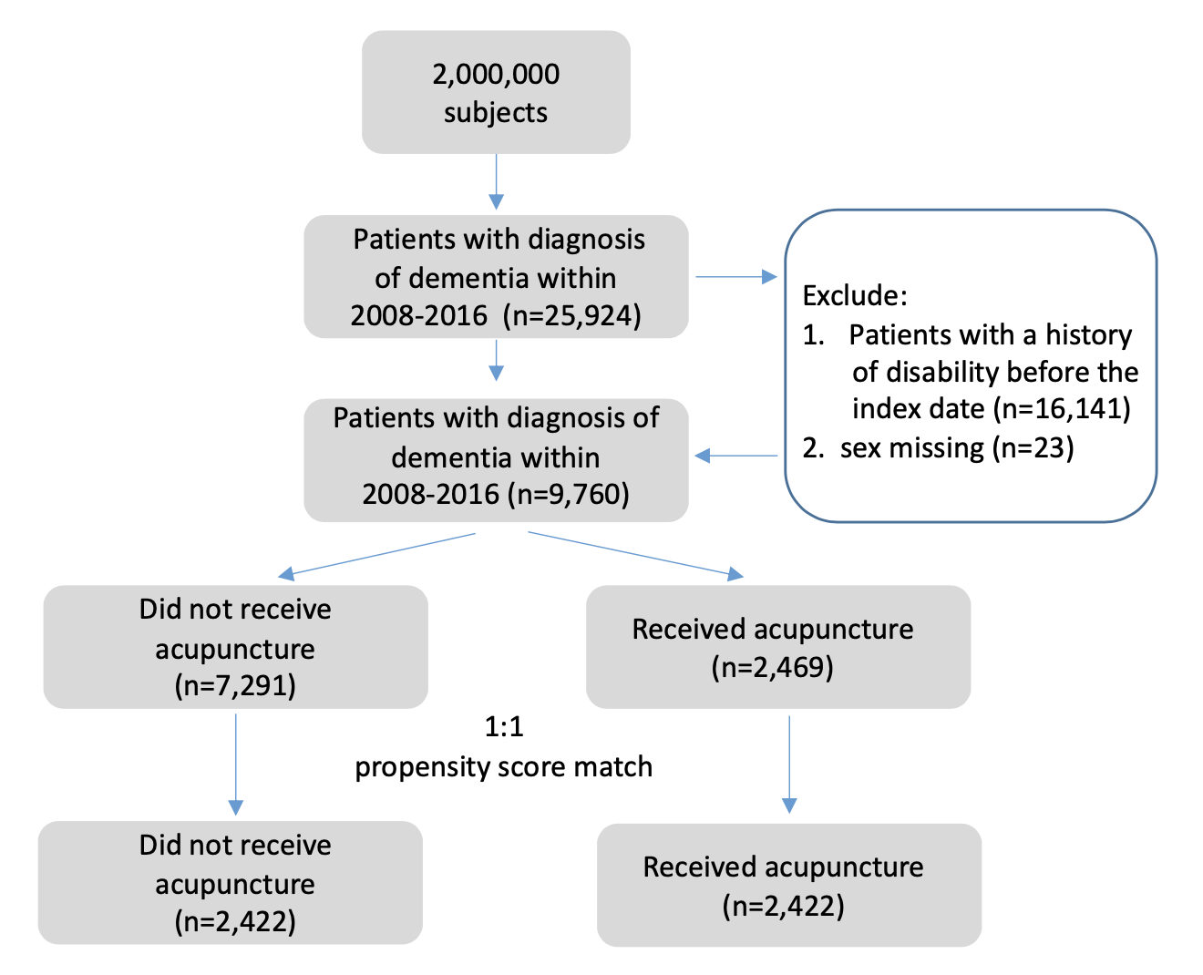Supplementary Figure 1. The flowchart of selection of participants

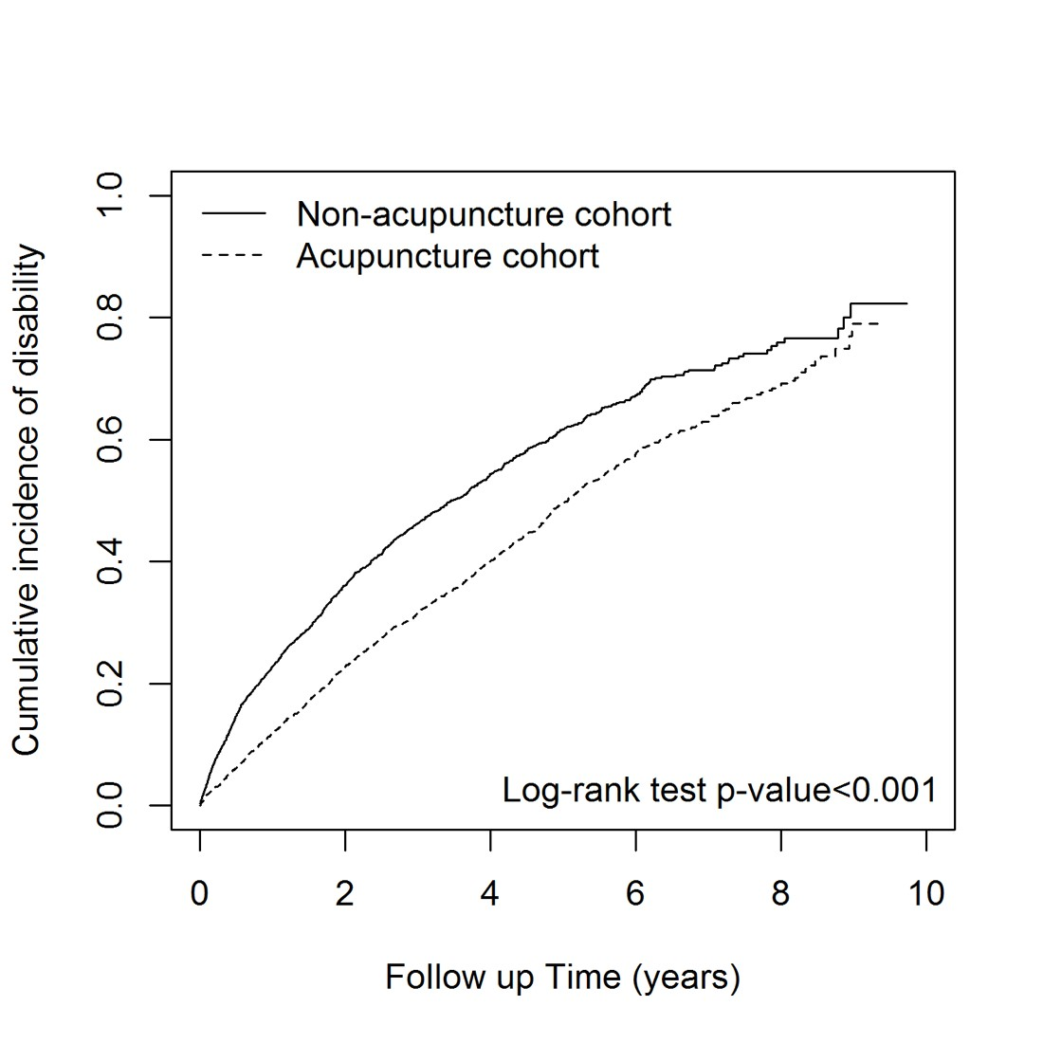
Supplementary Figure 2. The difference of cumulative incidence of disability between acupuncture and non-acupuncture cohorts

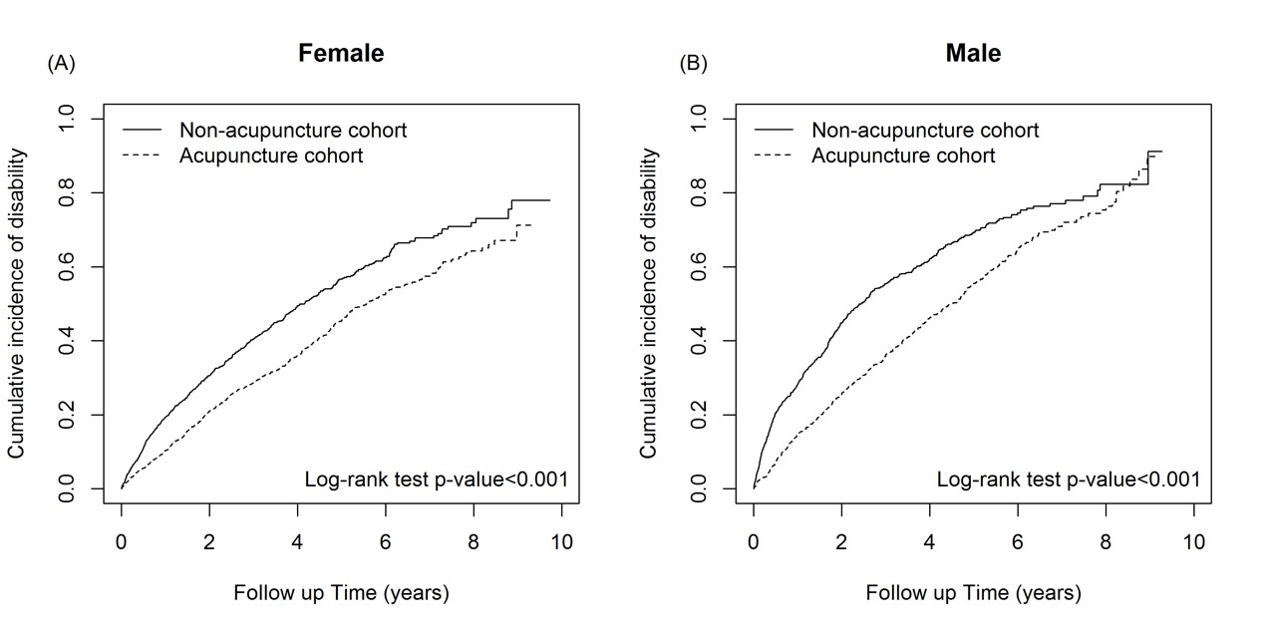
Supplementary Figure 3. The difference of cumulative incidence of disability between acupuncture and non-acupuncture cohorts: (A) female and (B) male

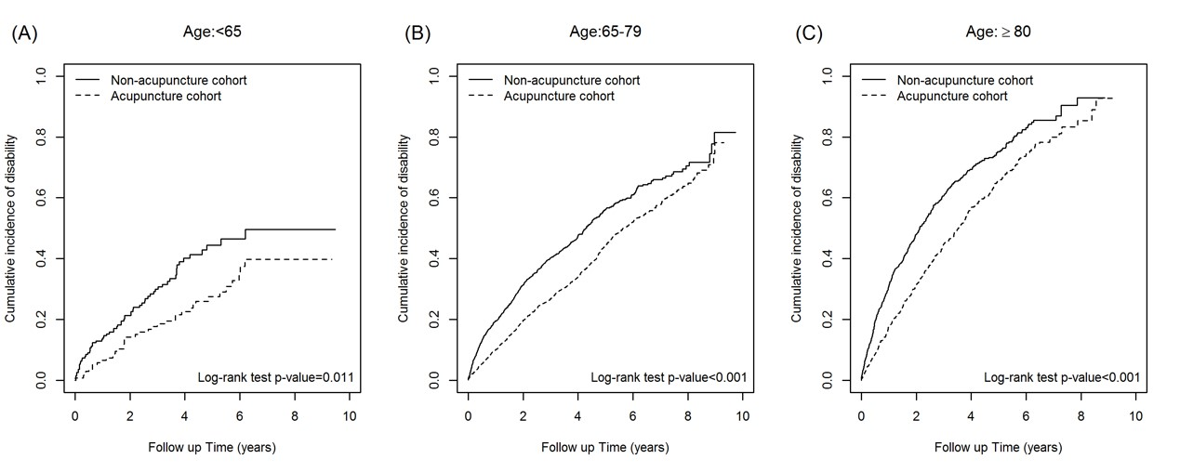
Supplementary Figure 4. The difference of cumulative incidence of disability between acupuncture and non-acupuncture cohorts: (A) <65-year-old, (B) 65-79-year-old, and (C) ≥80-year-old

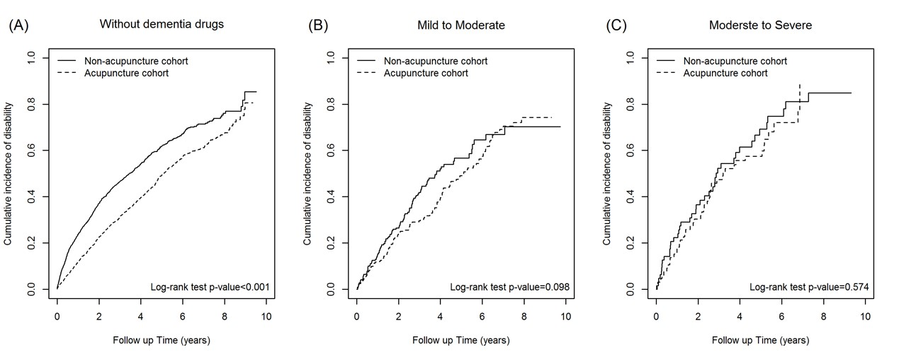
Supplementary Figure 5. The difference of cumulative incidence of disability between acupuncture and non-acupuncture cohorts: (A) no dementia drugs, (B) drugs for mild to moderate dementia, and (C) drugs for moderate to severe dementia

Supplementary Tables
Supplementary Table 1. Distributions of different types of acupuncture
Types | Frequency | Percent
Manual acupuncture | 2,052 | 86.36%
Electroacupuncture | 36 | 1.52%
Combination of manual acupuncture and electroacupuncture | 288 | 12.12%

Supplementary Table 2. Cox model with hazard ratios and 95% confidence intervals of disability associated with different types of acupuncture
 | Disability
Variable | Event | PY | IR | cHR | (95% CI) | p-value | aHR | (95% CI) | p-value
Acupuncture intervention
No | 1,263 | 5,824 | 216.85 | 1.00 | (reference) | - | 1.00 | (reference) | -
Manual acupuncture | 932 | 6,720 | 138.69 | 0.65 | (0.59, 0.70)*** | <0.001 | 0.63 | (0.58, 0.69)*** | <0.001
Electroacupuncture | 14 | 141 | 99.53 | 0.47 | (0.28, 0.79)** | 0.0047 | 0.51 | (0.3, 0.87)* | 0.0128
Combination of manual acupuncture  and electroacupuncture | 134 | 1,023 | 130.98 | 0.61 | (0.51, 0.73)*** | <0.001 | 0.61 | (0.51, 0.72)*** | <0.001
*:p-value < 0.05.
**: p-value < 0.01.
***: p-value < 0.001.
Abbreviations: PY: Person-Year, IR: Incidence rate, per 1000 persons/years; HR: Hazard ratio; CI: confidence interval.

