Figure S1. Representative images of the bands produced from PCR-RFLP regarding the genotype status of rs2071559 in KDR gene

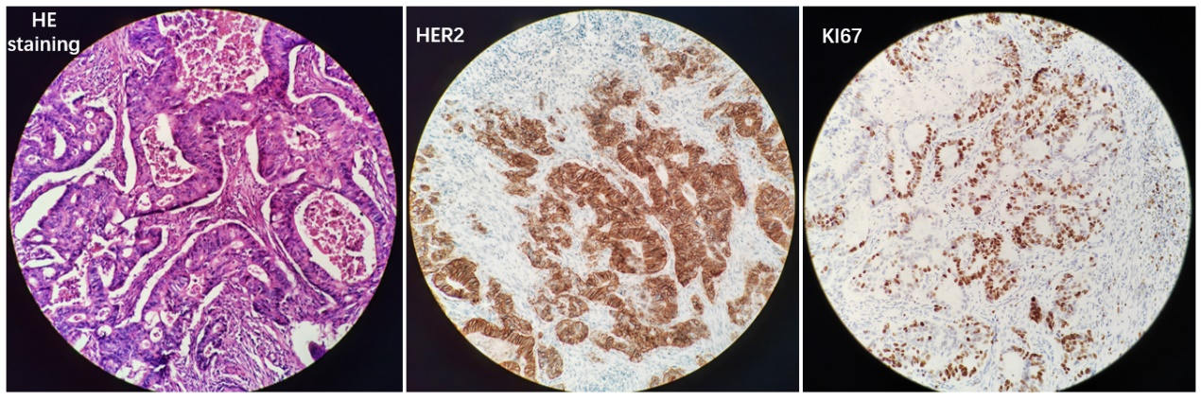
Figure S2. HE staining and immunochemistry results of one patient with HER2 positive GC
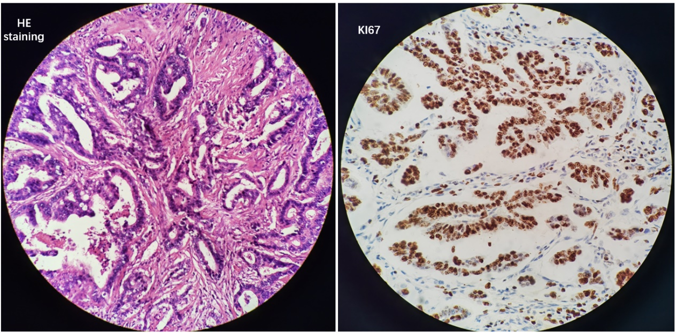
Figure S3. HE staining and immunochemistry results of another one patient with KI67 positive GC

Table S1. The subsequent treatment of 169 patients with gastric cancer when relapsed and association analysis for rs2071559 genotype status in KDR
Subsequent treatment | Total  (N=169, %) | Rs2071559 genotype status |  | χ² | P
Subsequent treatment | Total  (N=169, %) | AA (N=104) | AG/GG (N=65) | χ² | P
Yes  No | 79 (46.7)  90 (53.3) | 47 (45.2)  57 (54.8) | 32 (49.2)  33 (50.8) | 0.262 | 0.609
Subsequent regimens  chemotherapy  PD-1/PD-L1-related regimens  Traditional Chinese medicine  Anti-angiogenesis-related regimens  NA | 79  31 (39.2)  23 (29.1)  12 (15.2)  8 (10.1)  5 (6.3) | AA (N=47)  19 (40.4)  13 (27.7)  7 (14.9)  5 (10.6)  3 (6.4) | AG/GG (N=32)  12 (37.5)  10 (31.3)  5 (15.6)  3 (9.4)  2 (6.3) | 0.068  0.119  0.008  0.033  0.001 | 0.794  0.730  0.929  0.855  0.981

Table S2. Correlation analysis between rs2071559 genotype status and adverse reactions of S-1 based adjuvant chemotherapy
Adverse reactions | Total (N=169) | Rs2071559 genotype status |  | χ² | P
Adverse reactions | Total (N=169) | AA (N=104) | AG/GG (N=65) | χ² | P
Any adverse reactions | 88 (52.1) | 53 (51.0) | 35 (53.8) | 0.133 | 0.715
Grade ≥3 adverse reactions | 43 (25.4) | 27 (25.9) | 16 (24.6) | 0.038 | 0.845
Hematological toxicity | 61 (36.1) | 38 (36.5) | 23 (35.4) | 0.023 | 0.879
Fatigue | 49 (29.0) | 31 (29.8) | 18 (27.7) | 0.087 | 0.768
Nausea and vomiting | 41 (24.3) | 24 (23.1) | 17 (26.2) | 0.206 | 0.650
Neuropathy | 28 (16.5) | 18 (17.3) | 10 (15.4) | 0.107 | 0.744
Hepatotoxicity | 18 (10.7) | 12 (11.5) | 6 (9.2) | 0.224 | 0.636

