Hypoxia and Singlet Oxygen Dual-Responsive Micelles for Photodynamic and Chemotherapy Therapy Featured with Enhanced Cellular Uptake and Triggered Cargo Delivery
Xuliang Guo, Lefei Han, Wenyu Chen, Huixin He, Weijin Zhang, Chaoqi Huang and Xiu Wang

Scheme S1. The synthetic route of dually hypoxia-responsive mPEG-Azo-P(Asp-NI) copolymer.

Scheme S2. The synthetic route of dually hypoxia-responsive mPEG-Azo-P(Asp-NI)-Ce6 copolymer.
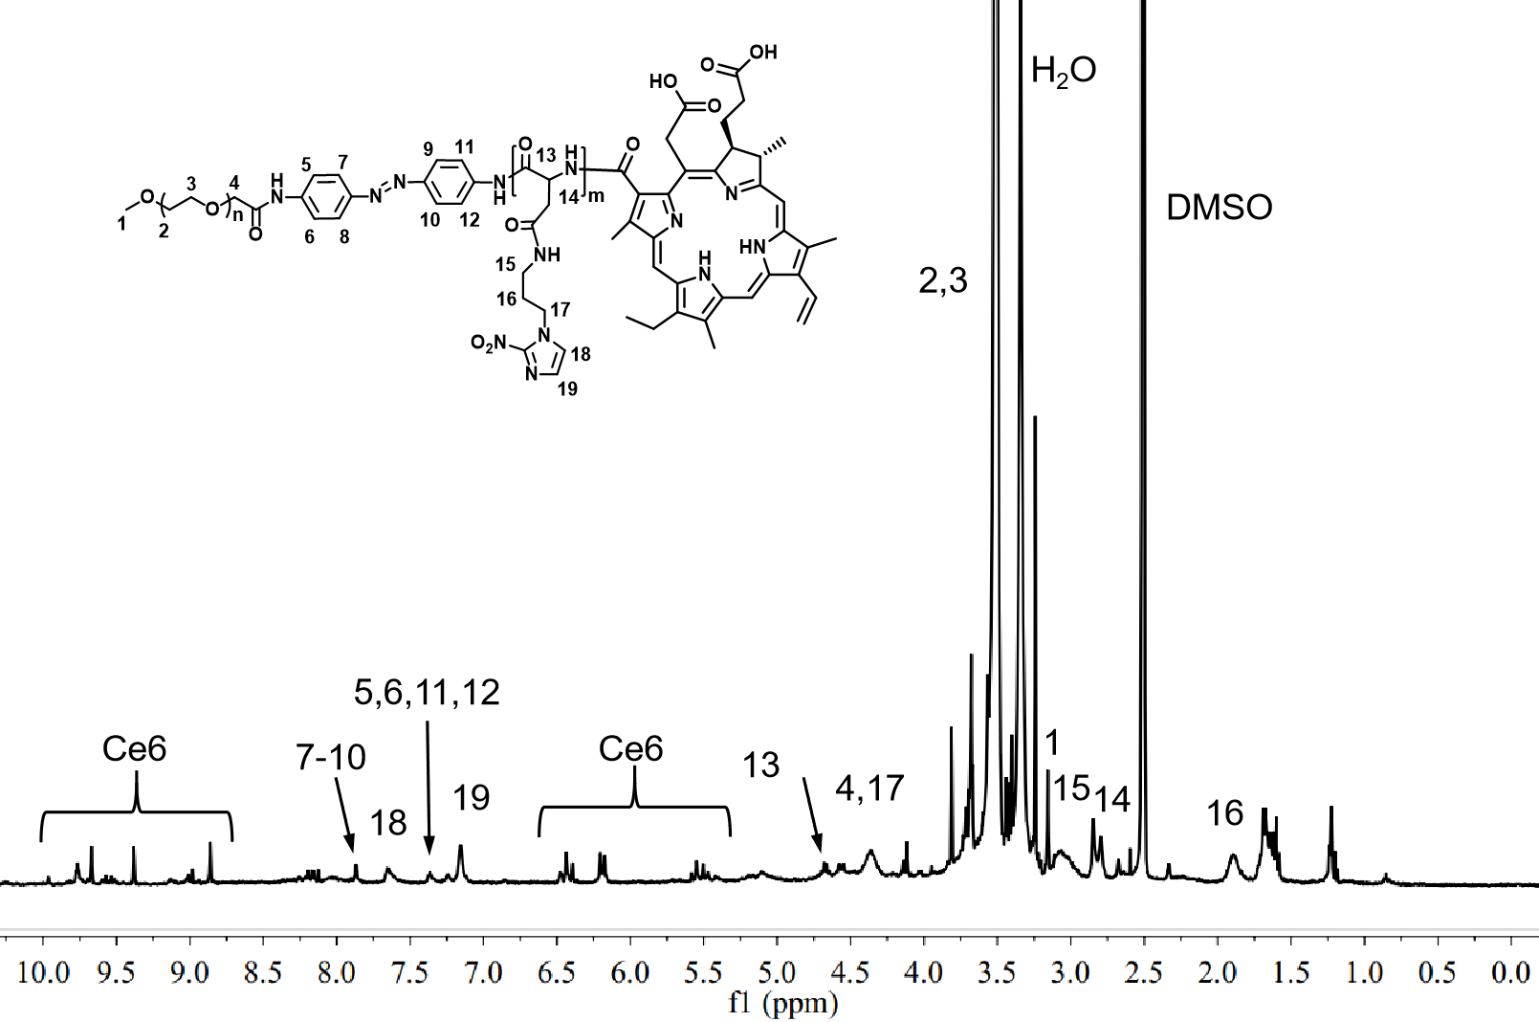
Figure S1. ¹H NMR spectrum of mPEG-Azo-P(Asp-NI)-Ce6 (DMSO-d₆).
Figure S2. Ce6 and TPZ loading of the responsive micelles.

Figure S3. Scanning Electron Microscope (SEM) images of (A) DHM-Ce6 and (B) DHM-Ce6 @TPZ (scale bar: 500 nm).
Figure S4. Summary of Ce6’s ﬂuorescence intensity in 4T1 cells treated by DHM-Ce6@TPZ under normoxia or hypoxia (**p < 0.01, ***p < 0.001, n = 3).
Figure S5. Viability of 4T1 cells in response to DHM with or without laser irradiation under normoxia (n = 4).

Figure S6. Viability of 4T1 cells in response to DHM-Ce6 without laser irradiation under normoxia or hypoxia (n = 4).

Figure S7. IC₅₀ summary of two formulations under normoxia or hypoxia (*p < 0.05, ***p < 0.001, n = 3).

Figure S8. The fluorescence intensity of DCF probe in 4T1 cells treated by different formulations under normoxia (A) or hypoxia (B) (n = 3). *p < 0.05, ***p < 0.001.

Figure S9. Viability of 3T3 cells in response to DHM-Ce6 and DHM-Ce6@TPZ micelles without laser irradiation under normoxia (n = 4).

Figure S10. Flow cytometry analysis of the 4T1 cells under different conditions. The cells were treated by two formulations including DHM-Ce6 and DHM-Ce6@TPZ micelles (n = 4).

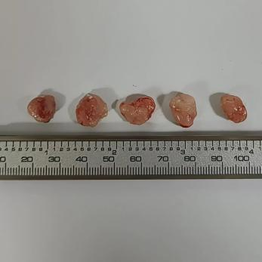
Figure S11. Tumor images at the end of treatment in the Ce6 (Laser ON) group.
Table S1. Summary of IC₅₀ values of DHM-Ce6 and DHM-Ce6@TPZ against 4T1 cells.
Index | DHM-Ce6 | DHM-Ce6@TPZ
Normoxia+Laser on  IC₅₀/Ce6 (μg mL⁻¹) | 0.412±0.056 | 0.363±0.042
Hypoxia+Laser on  IC₅₀/Ce6 (μg mL⁻¹) | 0.875±0.058 | 0.211±0.019

