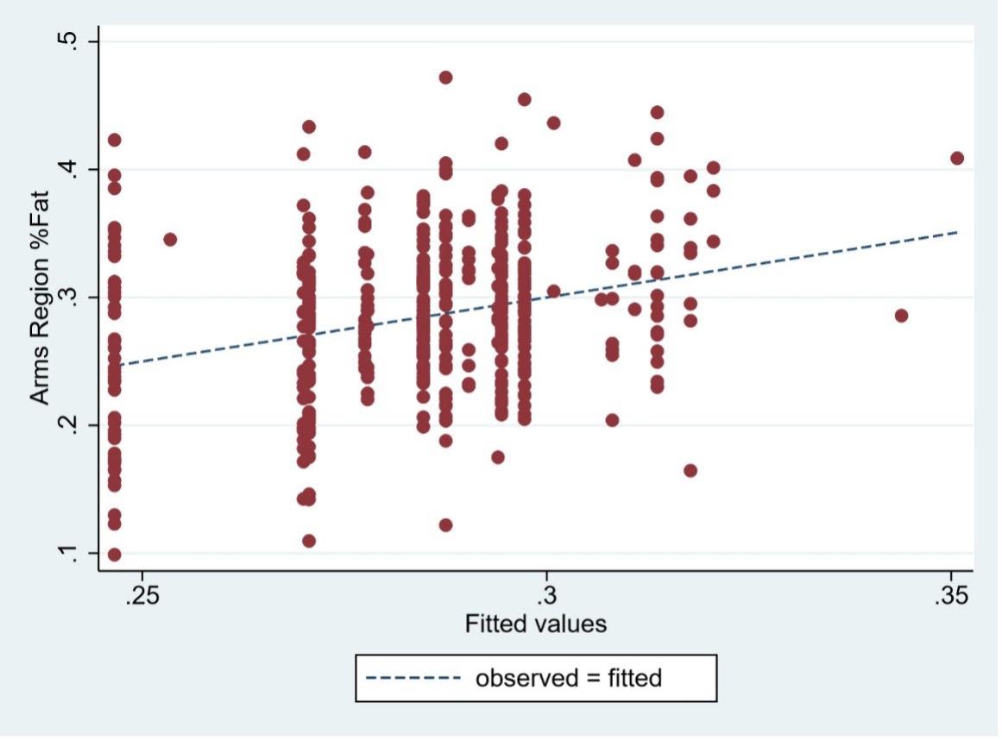

Supplemental Figure 1: Observed versus fitted regression values for arms region fat in males

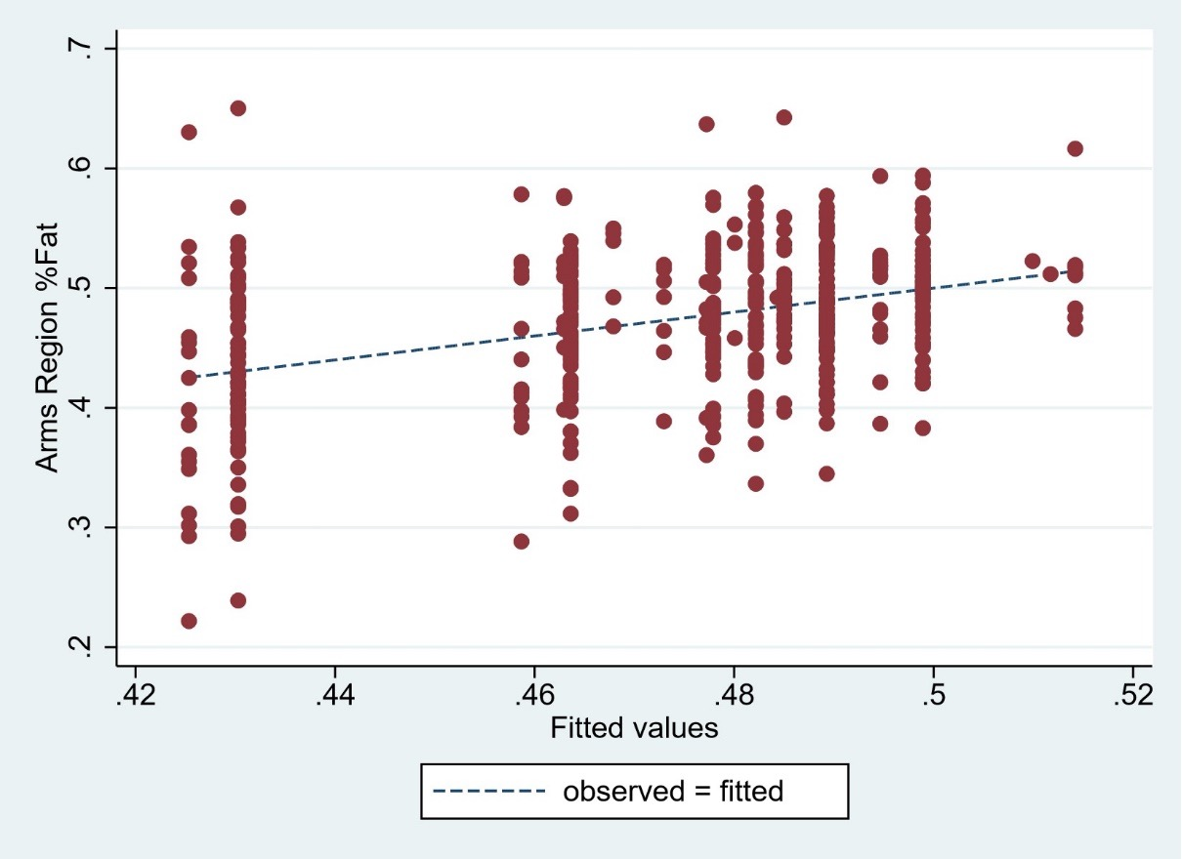

Supplemental Figure 2: Observed versus fitted regression values for arms region fat in females

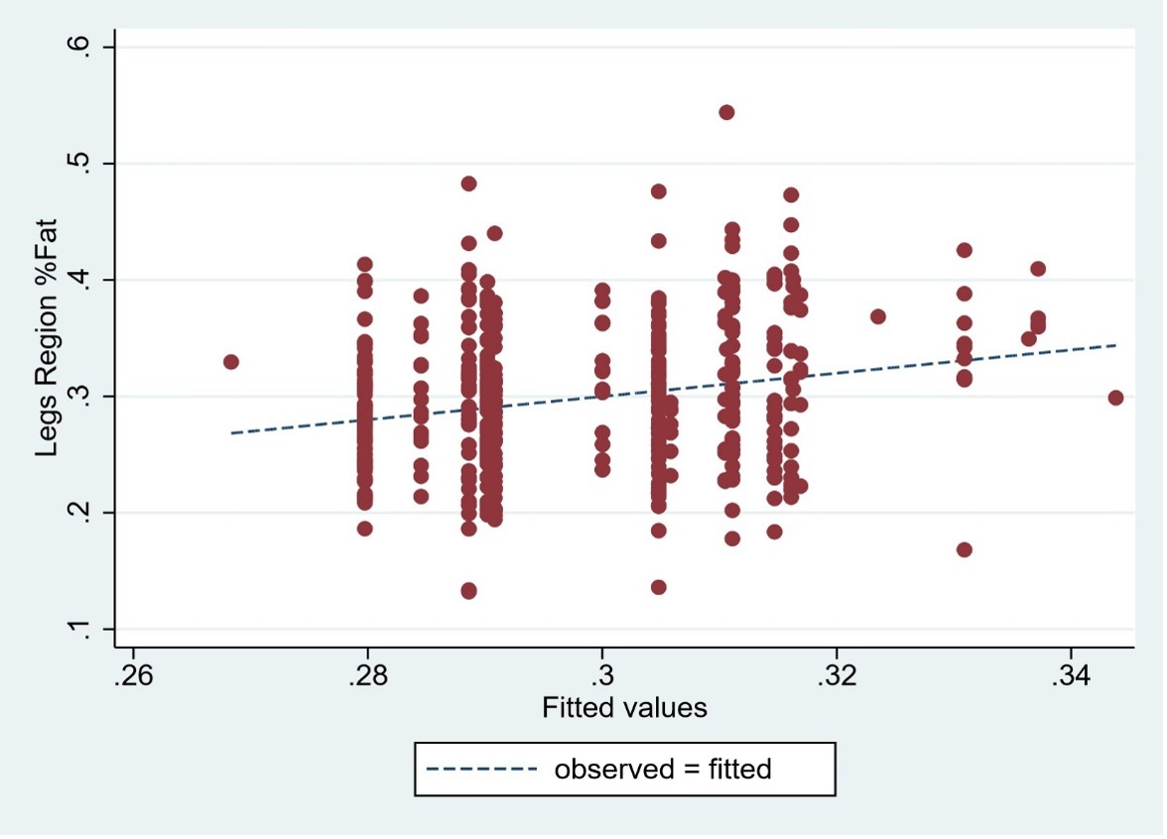

Supplemental Figure 3: Observed versus fitted regression values for legs region fat in males

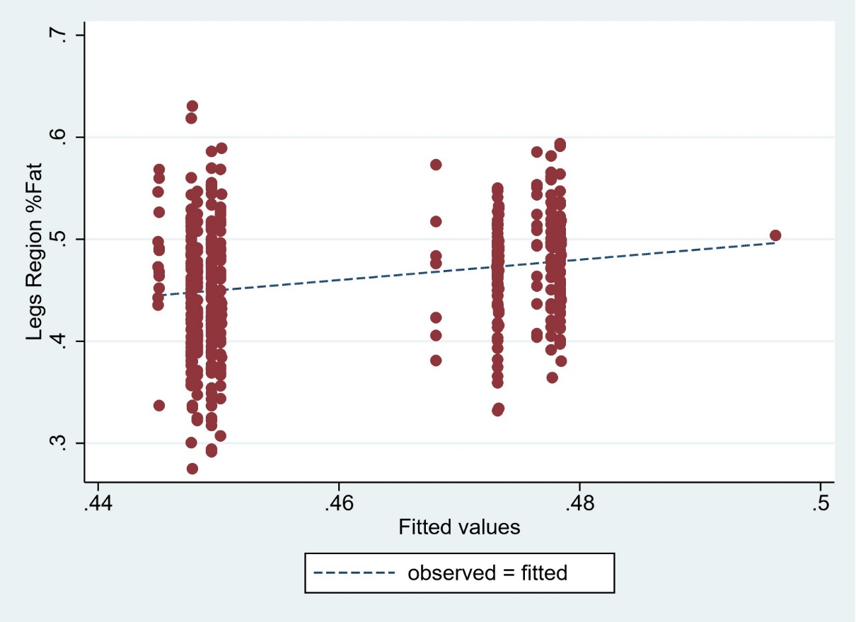

Supplemental Figure 4: Observed versus fitted regression values for legs region fat in females
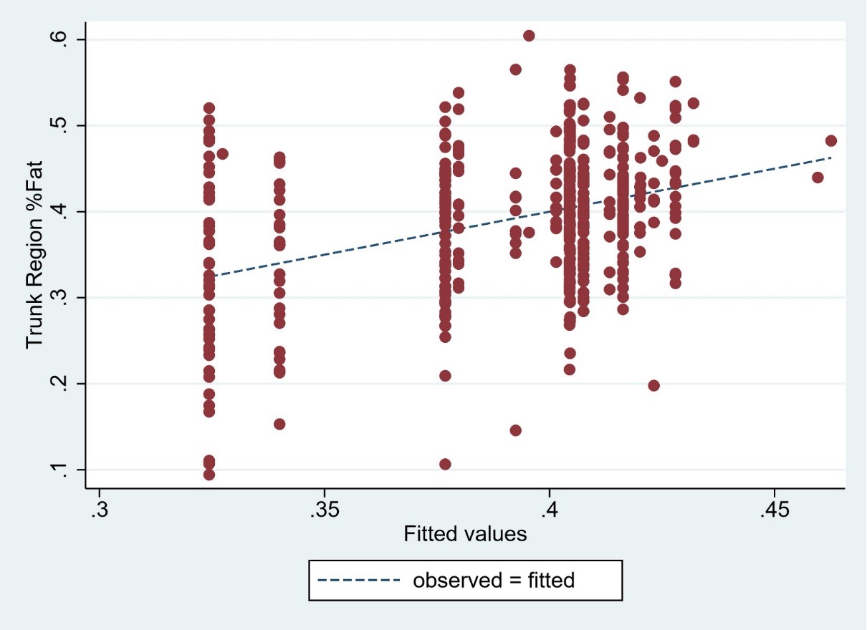

Supplemental Figure 5: Observed versus fitted regression values for trunk region fat in males

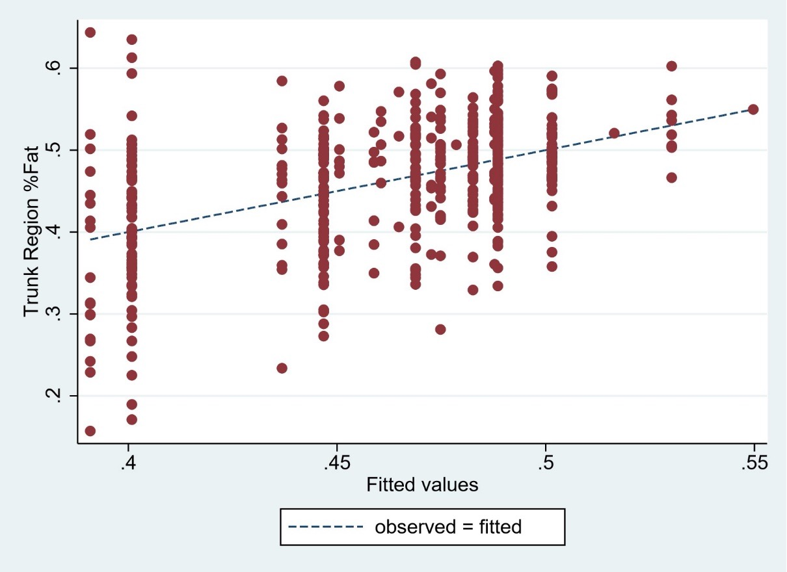

Supplemental Figure 6: Observed versus fitted regression values for trunk region fat in females
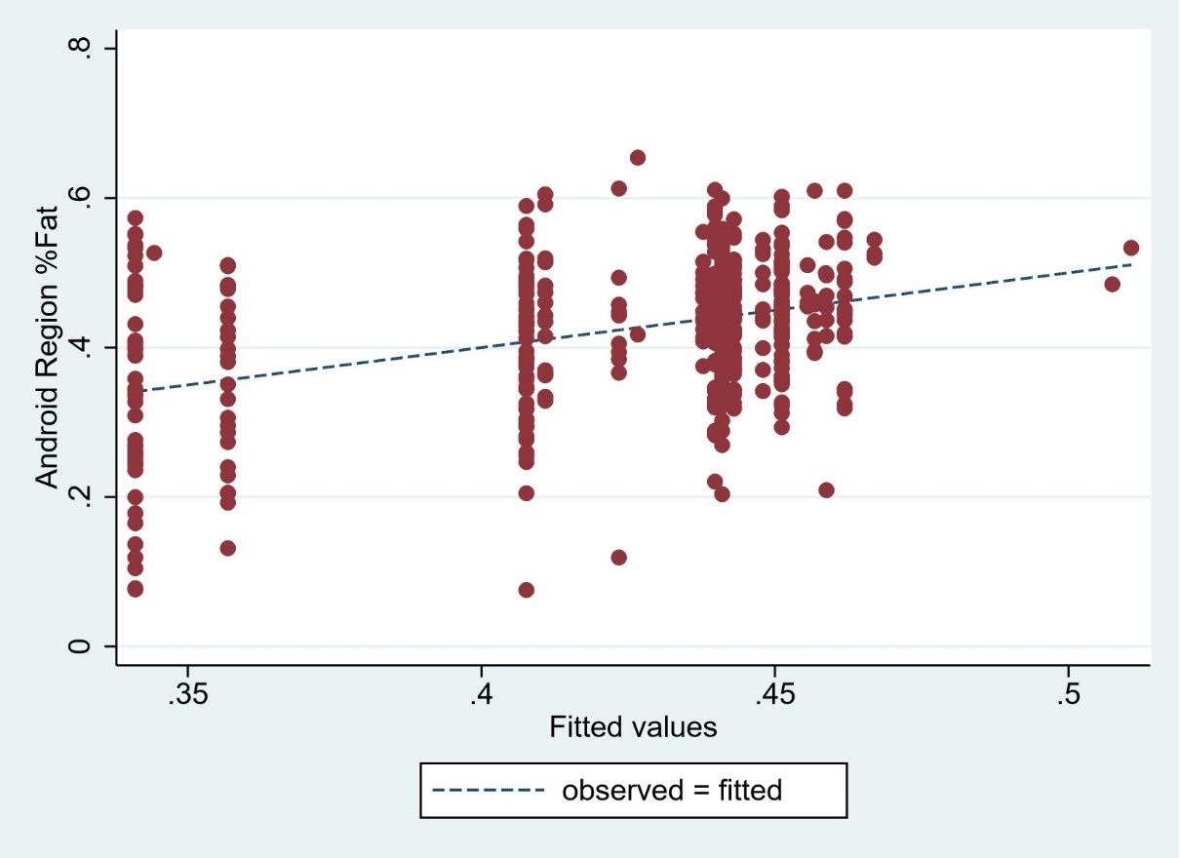

Supplemental Figure 7: Observed versus fitted regression values for android region fat in males
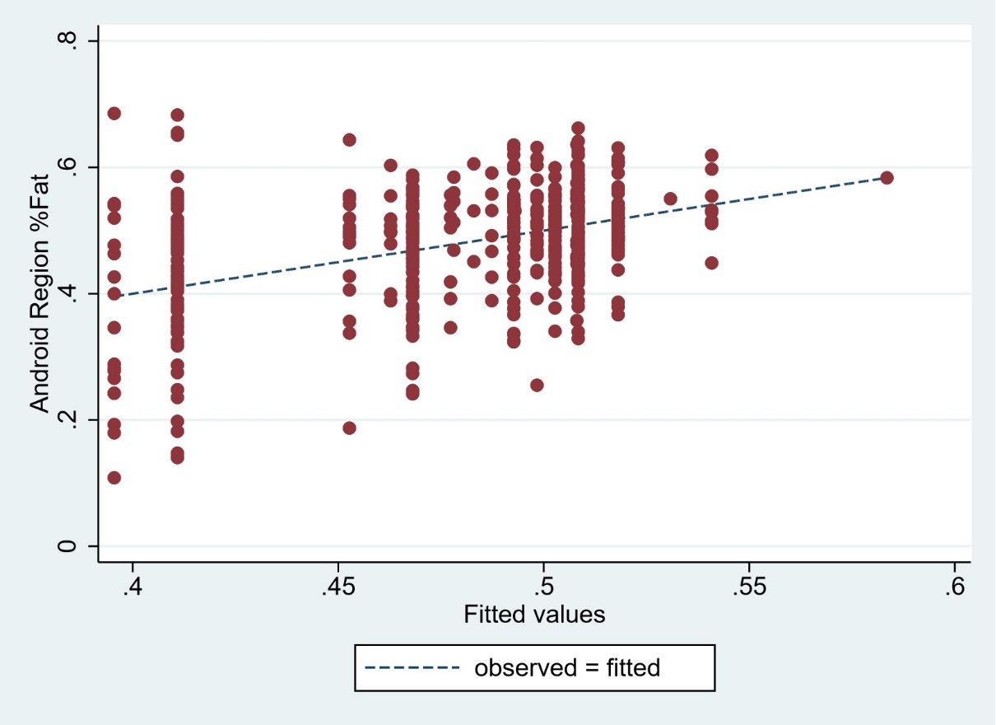

Supplemental Figure 8: Observed versus fitted regression values for android region fat in females
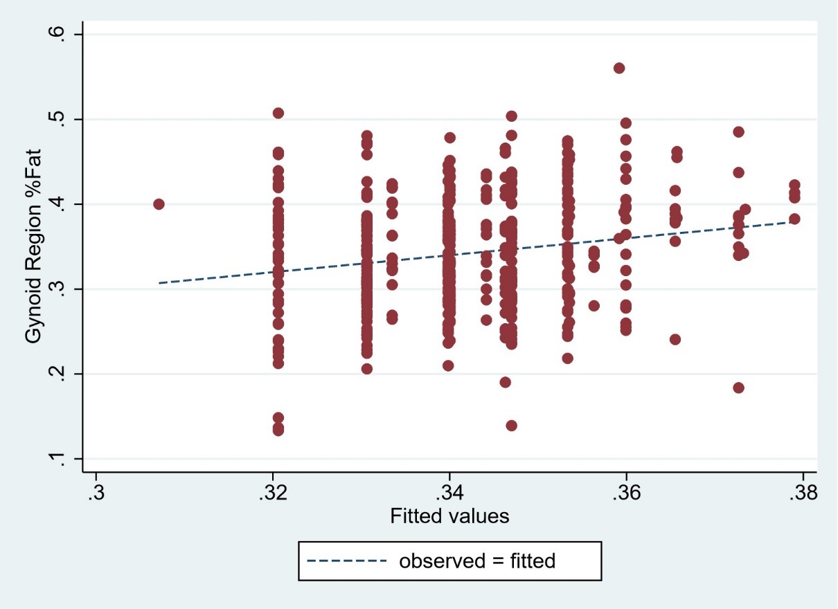

Supplemental Figure 9: Observed versus fitted regression values for gynoid region fat in males

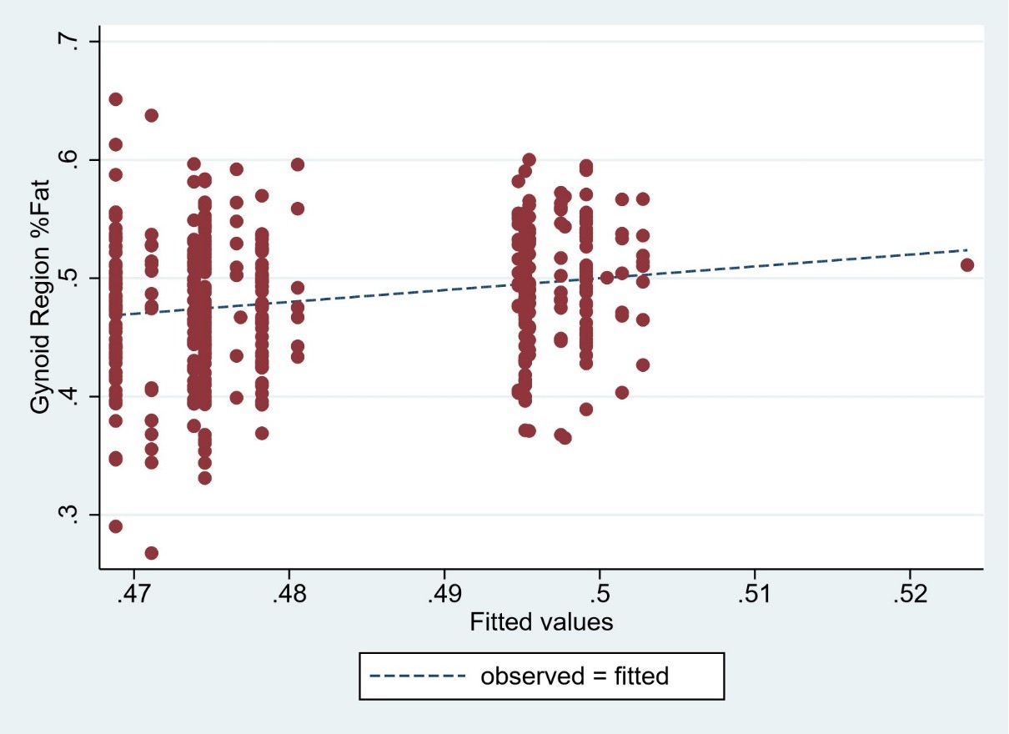
Supplemental Figure 10: Observed versus fitted regression values for gynoid region fat in females
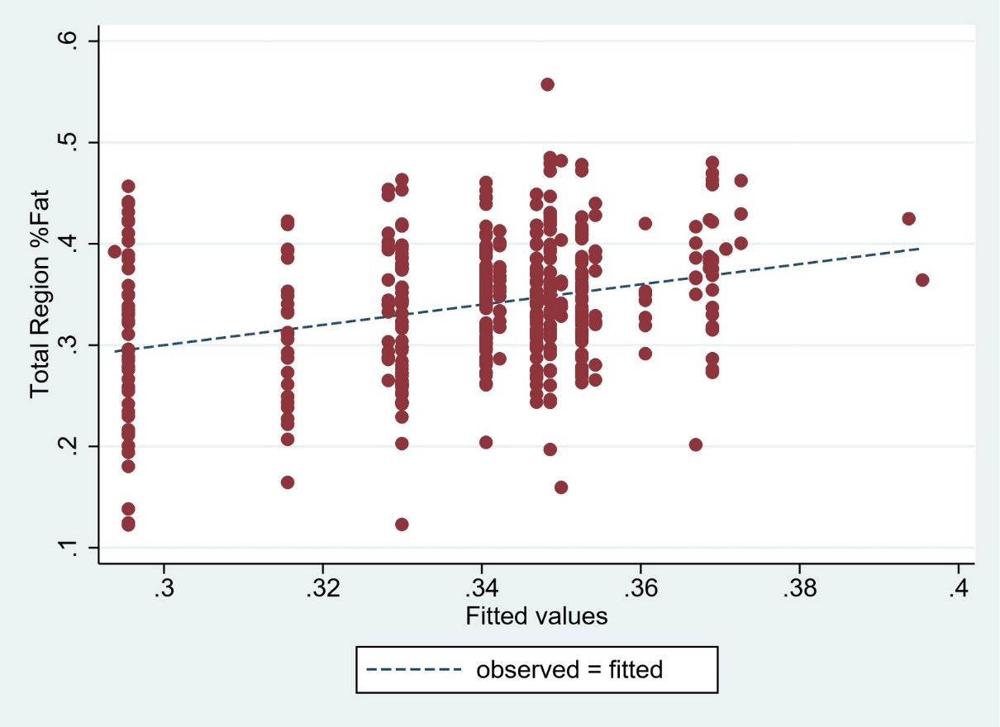

Supplemental Figure 11: Observed versus fitted regression values for total region fat in males

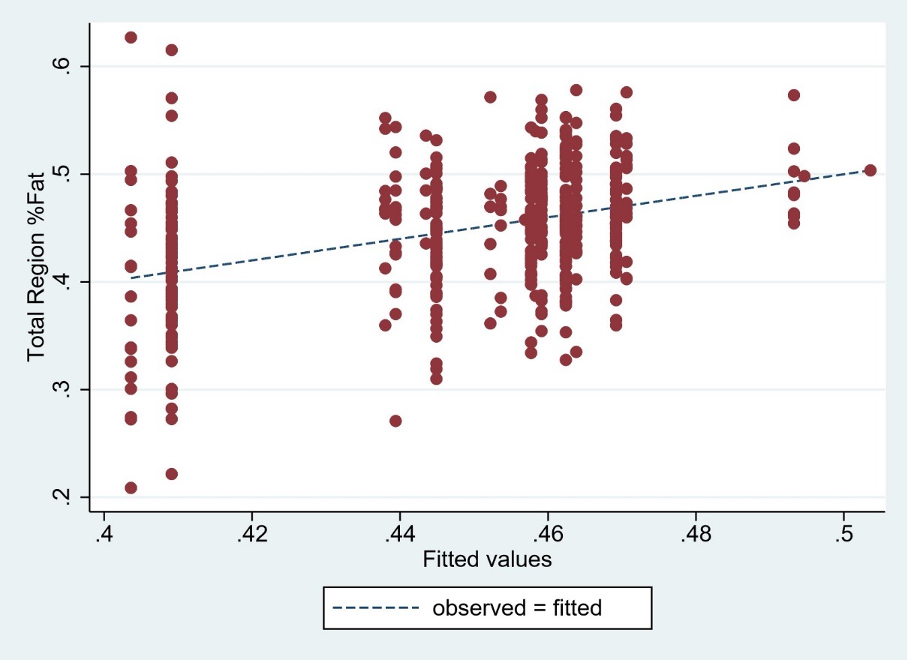

Supplemental Figure 12: Observed versus fitted regression values for total region fat in females
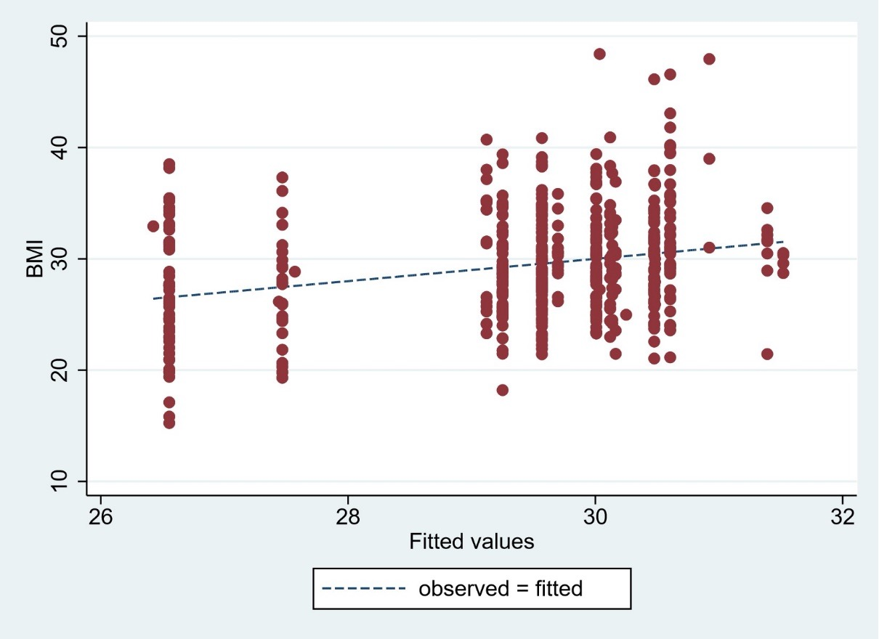

Supplemental Figure 13: Observed versus fitted regression values for BMI in males
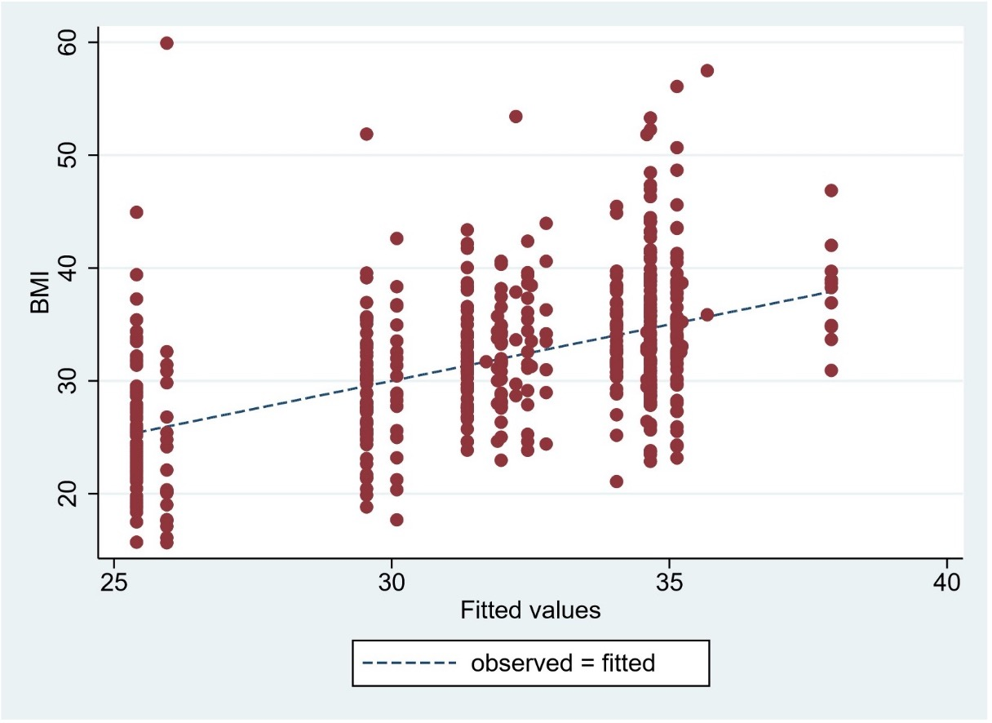

Supplemental Figure 14: Observed versus fitted regression values for BMI in females

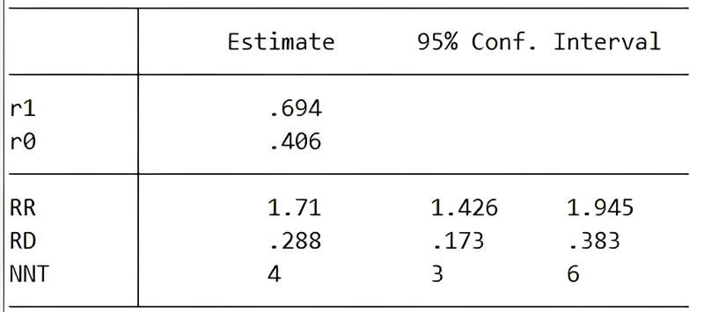

Supplemental Figure 15: Risk having high Waist hip ratio in diabetic in males

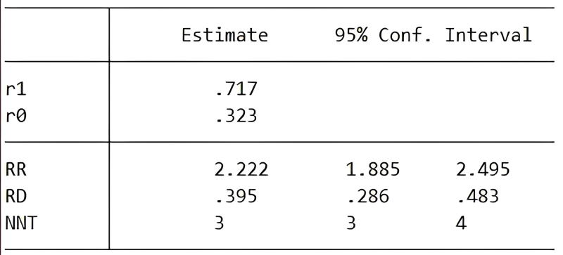

Supplemental Figure 16: Risk having high Waist hip ratio in diabetic in females

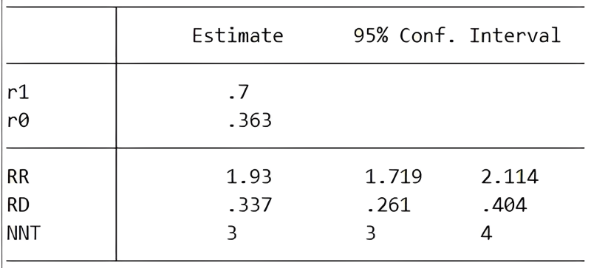
Supplemental Figure 17: Risk having high Waist hip ratio in diabetic combined for both genders

