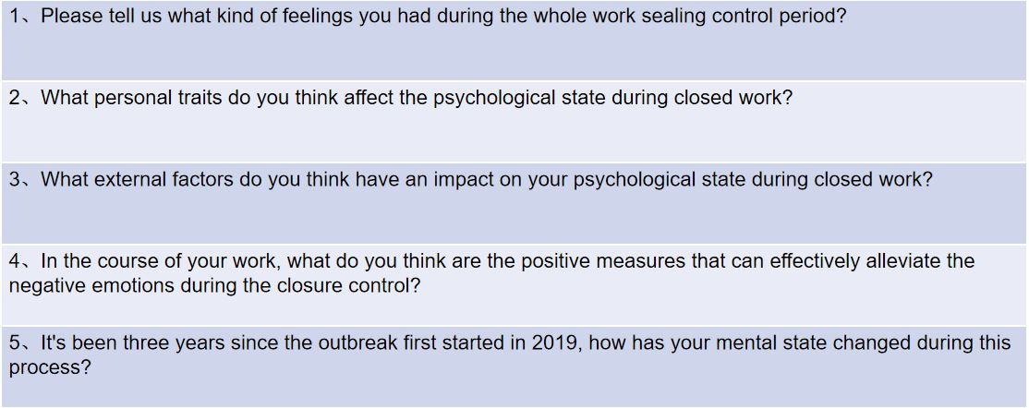
Supplementary Figure 1. The interview topic guide.

Supplementary Table 1.Consolidated criteria for reporting qualitative studies (COREQ): 32-item checklist
No Item | Guide questions/description | Answers
Domain 1: Research team and reflexivity
Personal Characteristics
1. Interviewer/facilitator | Which author/s conducted the interview or focus group? | Xi Yang and Zhao Yin
2. Credentials | What were the researcher’s credentials? E.g. PhD, MD | Xi Yang , MS; Zhao Yin, MS.
3. Occupation | What was their occupation at the time of the study? | Hospital pharmacist
4. Gender | Was the researcher male or female? | Female (Xi Yang) and Male (Zhao Yin)
5. Experience and training | What experience or training did the researcher have? | Theoretical training and experience of conducting several qualitative studies with other groups.
Relationship with participants
6. Relationship established | Was a relationship established prior to study commencement? | Yes
7. Participant knowledge of the  interviewer | What did the participants know about the researcher? e.g. personal goals, reasons for doing the research | Reasons for doing the research
8. Interviewer characteristics | What characteristics were reported about the interviewer/facilitator? e.g. Bias, assumptions, reasons and interests in the research topic | Reasons and interests in the research topic
Domain 2: study design
Theoretical framework
9. Methodological orientation and Theory | What methodological orientation was stated to underpin the study? e.g. grounded theory, discourse analysis, ethnography, phenomenology, content analysis | Phenomenology.
Participant selection
10. Sampling | How were participants selected? e.g. purposive, convenience, consecutive, snowball | Purposive
11. Method of approach | How were participants approached? e.g. face-to-face, telephone, mail, email | Face-to-face interview
12. Sample size | How many participants were in the study? | 30
13. Non-participation | How many people refused to participate or dropped out? Reasons? | No one refused and dropped out.
Setting
14. Setting of data collection | Where was the data collected? e.g. home, clinic, workplace | Workplace.
15. Presence of non-participants | Was anyone else present besides the participants and researchers? | No
16. Description of sample | What are the important characteristics of the sample? e.g. demographic data, date | Yes, demographic data.
Data collection
17. Interview guide | Were questions, prompts, guides provided by the authors? Was it pilot tested? | Yes
18. Repeat interviews | Were repeat interviews carried out? If yes, how many? | No
19. Audio/visual | Did the research use audio or visual recording to collect the data? | Audio recording
20. Field notes | Were field notes made during and/or after the interview or focus group? | Yes
21. Duration | What was the duration of the interviews or focus group? | 50-70 min
22. Data saturation | Was data saturation discussed? | Yes
23. Transcripts returned | Were transcripts returned to participants for comment and/or correction? | Yes
Domain 3: analysis and findings
Data analysis
24. Number of data coders | How many data coders coded the data? | Two
25. Description of the coding tree | Did authors provide a description of the coding tree? | No
26. Derivation of themes | Were themes identified in advance or derived from the data? | Derived from the data
27. Software | What software, if applicable, was used to manage the data? | NVIVO 12
28. Participant checking | Did participants provide feedback on the findings? | Yes
Reporting
29. Quotations presented | Were participant quotations presented to illustrate the themes / findings? Was each quotation identified? e.g. participant number | Yes
30. Data and findings consistent | Was there consistency between the data presented and the findings? | Yes
31. Clarity of major themes | Were major themes clearly presented in the findings? | Yes
32. Clarity of minor themes | Is there a description of diverse cases or discussion of minor themes? | Yes
Notes: Adapted from Tong A, Sainsbury P, Consolidated criteria for reporting qualitative research (COREQ): a 32-item checklist for interviews and focus groups, International Journal for Quality in Health Care, 2007, vol 19, issue 6, pages 349–357, by permission of Oxford University Press.²⁷

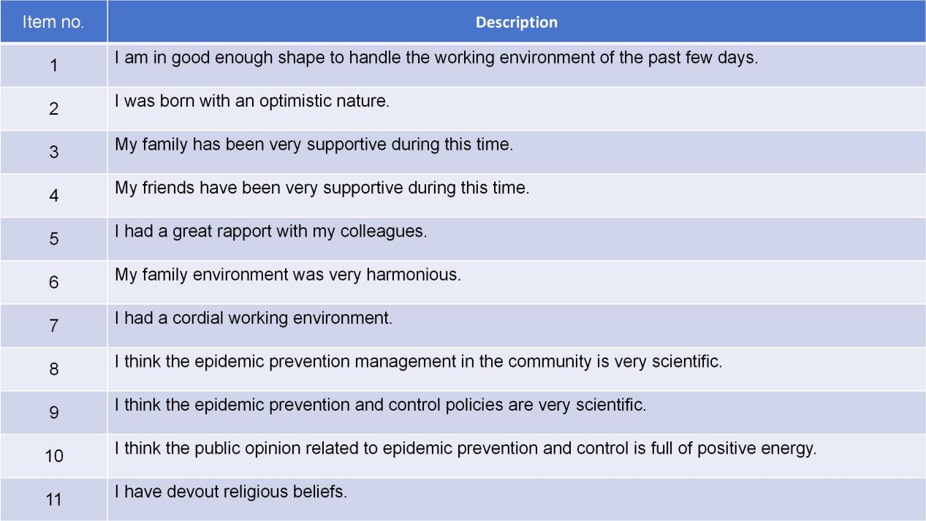
Supplementary Figure 2. 11 self-imposed questions. All of which carry a 5-point range of responses, as follows: totally disagree (1), disagree (2), generally agree (3), agree (4), and totally agree (5).

Supplementary Figure 3a. Generalized Anxiety Disorder grade among study participants (n=146).

Supplementary Figure 3b. Psychological Resilience Grade among study participants (n=146).

Supplementary Table 2. The results of self-designed questions in the network questionnaire
Self-designed questions | Totally agree | agree | Generally agree | Disagree | Totally disagree | Totally agree and agree(%) | Disagree and totally disagree(%) | average | Coefficient of variation
Q1 | 57 | 53 | 25 | 8 | 3 | 75.34 | 7.53 | 4.05 | 0.24
Q2 | 38 | 48 | 46 | 11 | 3 | 58.90 | 9.59 | 3.73 | 0.27
Q3 | 77 | 49 | 19 | 0 | 1 | 86.30 | 0.68 | 4.38 | 0.17
Q4 | 70 | 56 | 17 | 2 | 1 | 86.30 | 2.05 | 4.32 | 0.18
Q5 | 67 | 63 | 15 | 1 | 0 | 89.04 | 0.68 | 4.34 | 0.16
Q6 | 69 | 53 | 22 | 2 | 0 | 83.56 | 1.37 | 4.29 | 0.18
Q7 | 58 | 51 | 32 | 4 | 1 | 74.66 | 3.42 | 4.10 | 0.22
Q8 | 25 | 31 | 56 | 15 | 19 | 38.36 | 23.29 | 3.19 | 0.38
Q9 | 24 | 34 | 59 | 14 | 15 | 39.73 | 19.86 | 3.26 | 0.35
Q10 | 18 | 26 | 46 | 34 | 22 | 30.14 | 38.36 | 2.89 | 0.42
Q11 | 7 | 12 | 27 | 31 | 69 | 13.01 | 68.49 | 2.02 | 0.59

Q1: I am in good enough shape to handle the working environment of the past few day; Q2: I was born with an optimistic nature; Q3: My family has been very supportive during this time; Q4: My friends have been very supportive during this time; Q5: I had a great rapport with my colleagues; Q6: My family environment was very harmonious; Q7: I had a cordial working environment; Q8: I think the epidemic prevention management in the community is very scientific; Q9:I think the epidemic prevention and control policies are very scientific; Q10: I think the public opinion related to epidemic prevention and control is full of positive energy; Q11: I have devout religious beliefs.

