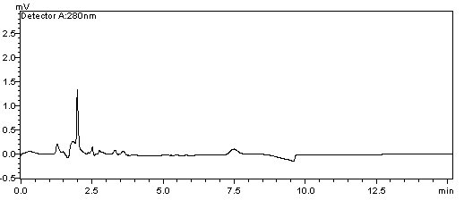
A
B
C
Tet
Tet

Fig.S1 Chromatograms of S-LPs (A), Tet standard substance (B), and S-LPs@Tet (C).

Tab.S1 Precision, reproducibility, recovery, and stability of Tet detected by HPLC method (n = 6).
Components | Concentration (ng/mL) | Precision (%, RSD) | Reproducibility (%, RSD) | Recovery (%) | Stability (%, RSD)
Tet | 0.39 | 1.15 | 1.48 | 97.23 | 3.15
Tet | 12.50 | 0.97 | 1.59 | 98.71 | 2.57
Tet | 50.00 | 0.64 | 1.03 | 99.25 | 2.08

