SUPPLEMENTARY MATERIALS
Supplementary File 1: Detailed Description of Instrument Development
Supplementary File 2: Post-encounter Patient Interview Guide
Supplementary File 3: Post-encounter Patient Survey
Supplementary File 1: Detailed Description of Instrument Development
Instruments to be used in the comparison of methods for identifying patient preferences (MIPPS; survey, interview guide, and video coding scheme) were developed using an iterative user-centered design process that began with a period of information-gathering from clinical partners on the structure of a typical SCS consultation, logistics of SCS trial and implantation, benefits and risks of the procedure and device, and other considerations relevant to patients considering this treatment. In addition, we video-recorded or directly observed a set of actual patient-clinician encounters and conducted debrief interviews with some patients immediately following the visit to learn more about patient perceptions of risks and benefits related to the spinal cord stimulator and their decision making process. Some nurse education visits were also recorded to enrich the study team’s understanding of patient questions and concerns related to SCS. During nurse education visits, which are a mandatory component of SCS eligibility at Mayo Clinic, candidates for SCS have an opportunity to discuss current levels of pain, identify functional goals, ask questions, receive more detailed information about the risks and benefits of a spinal cord stimulator, and discuss expectations for pain management with a specially trained nurse-educator.
This formative phase was followed by the creation of prototype versions of the instruments that were then field tested and refined in real decision making conversations. During this phase, 30 patient-clinician encounters were video-taped, transcribed, and arranged within prototype video coding schemes. Similarly, 5 patients were interviewed following their visit with their clinician using prototype interview guides, and 9 patients used prototype surveys. These were iteratively refined until the study team judged that each instrument balanced feasibility of administration and adequacy of preference data acquisition. The video observations provided a view into the encounter that informed the questions asked in the interviews and surveys. The final instruments were then used to compare the DFE and IPE methods in real decision-making encounters.
Two particularly notable points were found during the development of the prototype interventions:
1. Preference identification: In the videos, and to a lesser extent in the interviews it was challenging to determine if an utterance did or did not indicate a preference. It was very rare to observe patients within encounters state preferences in definitive terms, for example “I like x” or “I prefer y”. It was more common, for instance, for a preference to be indicated by what seemed to be a clinician’s acceptable answer to a patient’s question (e.g., Patient: “With [the SCS] implanted, if I were to go through with this, is this like where, when you have one of the heart—the actual literal heart things in there where you can’t go through certain things, like that it could reset?” Clinician: “Yeah. The reason I’m recommending Medtronic is because it’s compatible with MRI”), or by reflection on something in prior experience being desirable or undesirable (e.g., “[My primary care doctor and I] talked about, ‘Do we do another back injection?’ I just feel frustrated by them because, in [my town], they don't give you any medication to have it done, and it's painful.”). Similarly, when something appeared desirable or undesirable to a patient, what that desirability was directly in comparison to was often unclear (e.g., “That spinal stimulation sounds like very complicated procedure.”). For these reasons we set a low threshold for identifying utterances in the videos or interviews that were potentially indicative of a preference.
2. Framework used for comparing preferences: It was necessary to find a common base for comparing what a preference referred to across MIPPs. We found Burke’s pentad of motives to be the most practicable as it uses a small number of categories that were understood similarly by different instrument users. Burke’s pentad is highly influential in the field of Rhetoric, where it used to interpret the motives that people have for doing (or in our utilization, preferring) one action over another. It has recently been used in a study examining patients’ decisional reasons for selecting an anticoagulation therapy for atrial fibrillation.²⁰ The pentad identifies 5 terms to which motives/preferences are attributed: Act (an action, such as the time needed to travel to a clinic for device implantation), Agent (a person, such as an acquaintance that recommends SCS), Agency (an instrument, such as the SCS device and its attributes, e.g. physical size), Scene (the context rendering something desirable/undesirable such as the failure of other therapies to provide relief from chronic pain), and Purpose (the reason for an action such as to increase physical mobility.) Themes, relating to these five terms were developed during instrument development and extended as necessary during the comparison of the MIPPs.
Supplementary File 2: Post-encounter Patient Interview Guide
- To start, tell me what brought you here today to the pain clinic.
  - Can you describe your experience with previous pain control treatments (e.g., medications, injections)?

- Did you discuss SCS during your visit today?
  - If no: Stop the interview and thank participant for their time.
  - If yes: Describe the discussion you had about SCS.
    - What was on your mind during this discussion?
    - What questions did you have about SCS for your clinician?

- Did you make a decision today about moving forward with the SCS trial implantation?
  - What did you decide?
  - What led you to decide to…?
  - Who helped you come to a decision?

- What are the most important benefits that SCS offers for you? In other words, what do you hope for from SCS?

- What are the most important downsides that you see related to the SCS? In other words, what worries you about SCS?

- Which of these aspects of the SCS did you consider the most when thinking about/making this decision (refer to bubble sheet, and mention that the patient can bring up other aspects that are not listed)? Did you discuss these with your clinician today? Why or why not?

- What questions or topics did you not have a chance to ask your clinician today (refer to bubble sheet, and mention that the patient can bring up other aspects that are not listed)?

- Is there anything else you would like to share with us about the SCS and/or your decision making process for selecting a pain treatment?

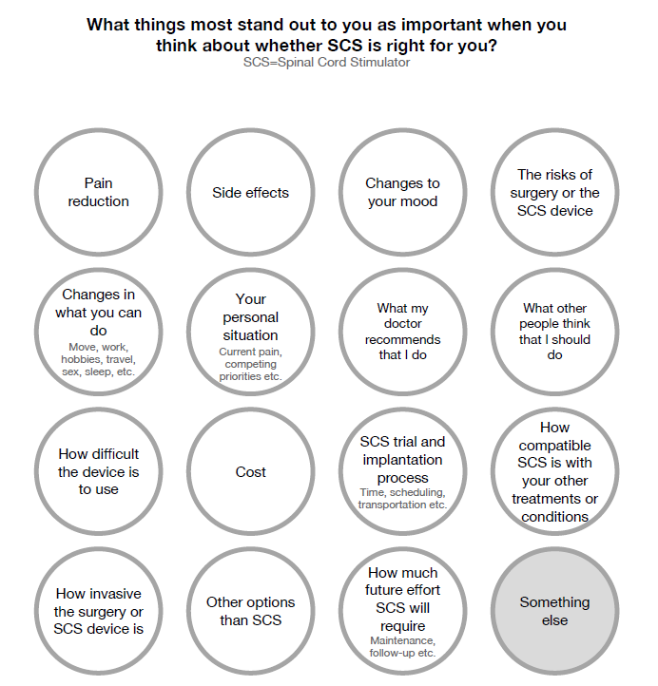

Supplementary File 3: Post-encounter Patient Survey
Thank you for agreeing to complete this survey. Your answers will help us understand what Mayo Clinic patients like and dislike about spinal cord stimulation (SCS) as a possible option for managing chronic pain.
In this survey, you will be asked to select a response to 34 short questions that are similar to:
How important is it to you that SCS would improve your pain?
€ Not at all important € Moderately important € Very important
This survey will take approximately 10 minutes to complete.
Let’s begin!

A spinal cord stimulator (SCS) is an implanted device that sends low levels of electricity directly into your spinal cord to relieve pain in different areas of the body.
Spinal cord stimulators require two procedures: one to test the device (called the “trial”) and the second to permanently implant the device (called the “implantation”).
A remote control allows you to turn stimulation on and off or increase and decrease the level of stimulation. Depending on the specific device, you may have to recharge the battery of the spinal cord stimulator occasionally at home.
Q1 Did you discuss spinal cord stimulation (SCS) with your health care provider today?
- Yes
- No

Skip To: End of Survey If Did you discuss spinal cord stimulation (SCS) with your health care provider today? = No
Q2 There are many different types of treatment available to patients with chronic pain, including medications, injections, devices, and physical or psychological therapy.
Which of the following treatments have you used in the past or are currently using for your chronic pain? Please check all that apply.
- Opioid medications (e.g., oxycodone, hydrocodone, morphine)
- Other medications (e.g., muscle relaxants, over-the-counter pain medications like ibuprofen or acetaminophen, antidepressants, anticonvulsants)
- Physical therapy or rehabilitation
- Psychological therapy or counseling
- Injections
- Surgery
- Alternative therapies (e.g., acupuncture, herbs, supplements, massage, etc.)
- Other (please describe): __________________________________________________
- None of the above

Q3 At this point in time, have you made a decision about moving forward with spinal cord stimulation (SCS)?
- I have decided not to move forward with SCS
- I have decided to move forward with SCS
- I have not made a decision about whether or not to move forward with SCS
- Other (please describe): __________________________________________________

Q4 When thinking about spinal cord stimulation (SCS) as a pain management option, how important is it to you that SCS would improve...
 | Not very important | Somewhat important | Very important
My pain
My mood
My ability to move comfortably
My ability to sit comfortably
My ability to sleep
My ability to engage in hobbies
My ability to work
My ability to travel
My ability to participate in social activities

Q5 When making decisions about health and health care, some things affect what people decide more than others.
In this section, we would like you to tell us which things most affect whether you decide to get a spinal cord stimulation (SCS) device or not.
 | Does not affect my decision | Somewhat affects my decision | Strongly affects my decision
How the SCS device works
The size of the SCS device
The effort required to keep the SCS device charged
How easy SCS is to use
The compatibility of the SCS device with my other medical treatments or conditions
How I feel about having the SCS device inside my body

Q6 When making decisions about health and health care, some things affect what people decide more than others.
In this section, we would like you to tell us which things most affect whether you decide to get a spinal cord stimulation (SCS) device or not.
 | Does not affect my decision | Somewhat affects my decision | Strongly affects my decision
What my medical professionals have told me about SCS
What people who are not my medical professionals have told me about SCS
What my medical professionals recommend I should do
What people who are not my medical professionals think that I should do

Q7 When making decisions about health and health care, some things affect what people decide more than others.
In this section, we would like you to tell us which things most affect whether you decide to get a spinal cord stimulation (SCS) device or not.
 | Does not affect my decision | Somewhat affects my decision | Strongly affects my decision
How much SCS costs
How I feel about having surgery to implant the SCS device
What I currently know about the risks of SCS surgery
What I currently know about any side effects that SCS may have
If I have time for the SCS surgery and follow-up visits
If I have someone who can help me travel to the medical center for SCS surgery

Q8 When making decisions about health and health care, some things affect what people decide more than others.
In this section, we would like you to tell us which things most affect whether you decide to get a spinal cord stimulation (SCS) device or not.
 | Does not affect my decision | Somewhat affects my decision | Strongly affects my decision
How likely SCS is to reduce my pain
How likely SCS is to allow me to engage in activities that are currently difficult for me
How likely it is that I won't have to take strong pain medications with SCS
How likely SCS is to improve my mood
How well other things that I have tried have helped with my pain

Q9 Is there anything else that you can tell us about what you like or dislike about spinal cord stimulation (SCS) as an option to help manage your pain?
________________________________________________________________
________________________________________________________________
________________________________________________________________
________________________________________________________________

