Supplementary Figures
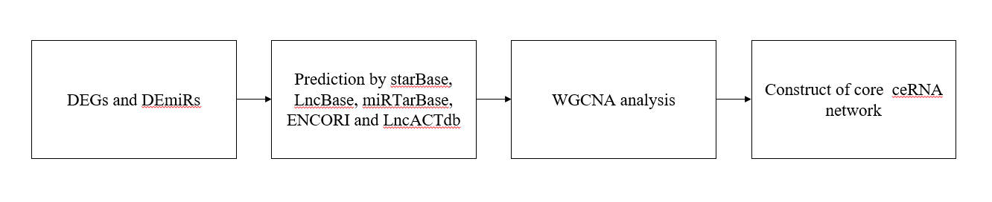
Figure S1 Flow chat of the analysis thoughts. DEG, differentially expressed genes; DEmiRs, differentially expressed miRNAs

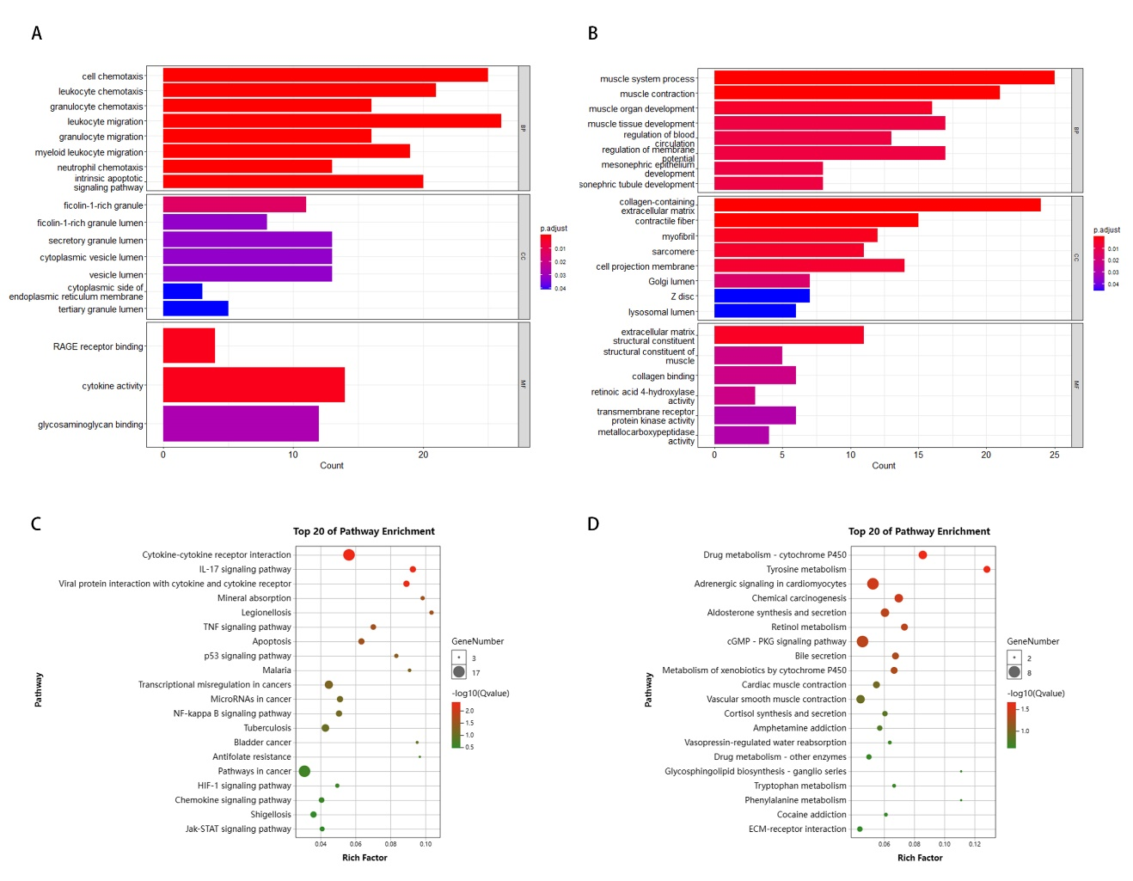
Figure S2: Identification of DEGs in GO/ KEGG pathway enrichment analysis. (A) GO enrichment analysis of upregulation DEGs. (B) GO enrichment analysis of downregulation DEGs. (C) The KEGG pathway enrichment analysis of upregulation DEGs. (D) The KEGG pathway enrichment analysis of downregulation DEGs.

Figure S3: GSEA analysis of COPD related pathways and genes. (A, B) GSEA indicated significant enrichment of COPD related pathway. (C) Heatmap of COPD core genes for enrichment of JAK/STAT pathway. (D) Using the STRING online database, the core genes PPI network was constructed. (E) Top 10 hub genes from the core genes ranked by ‘CytoHubba’ methods.

Figure S4: The correlation between mRNA and the gold stage of COPD patients.

Figure S5: The correlation between miRNA and the gold stage of COPD patients.
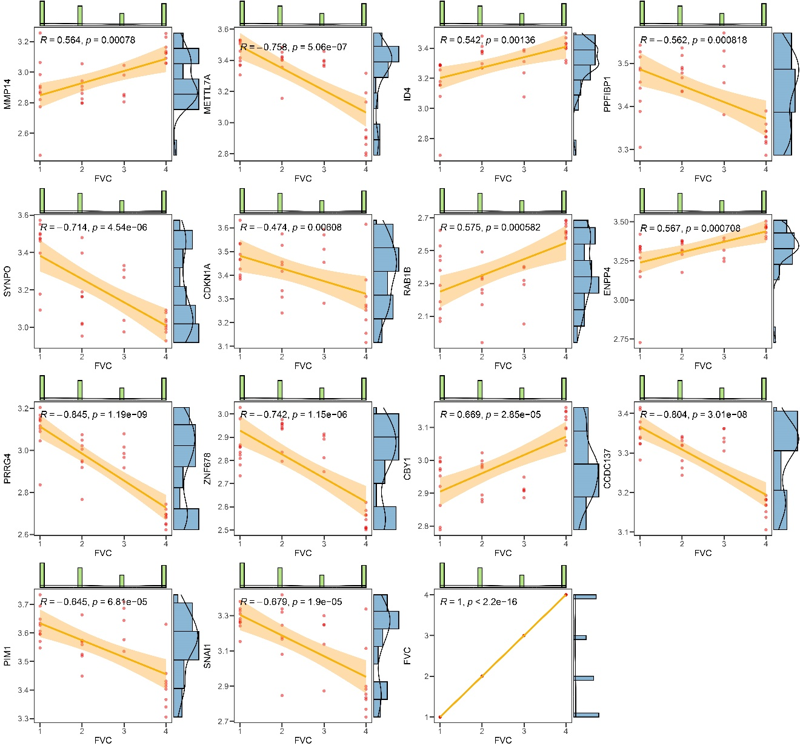
Figure S6: The correlation between mRNA and the FVC Group of COPD patients.
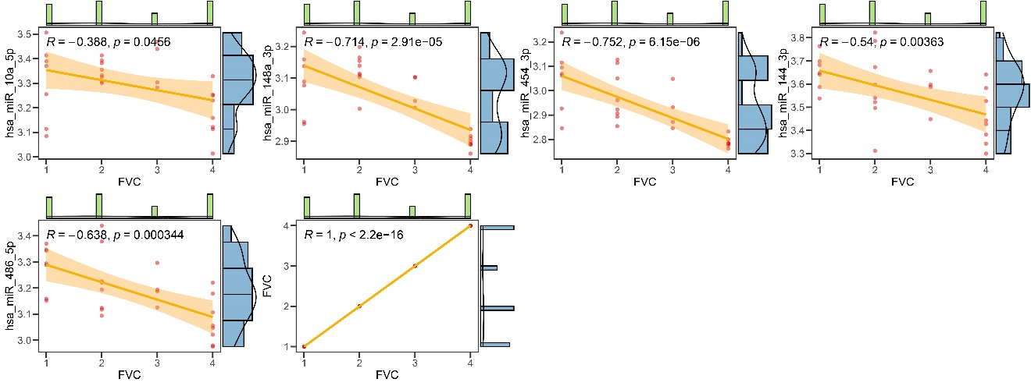
Figure S7: The correlation between miRNA and the FVC Group of COPD patients.
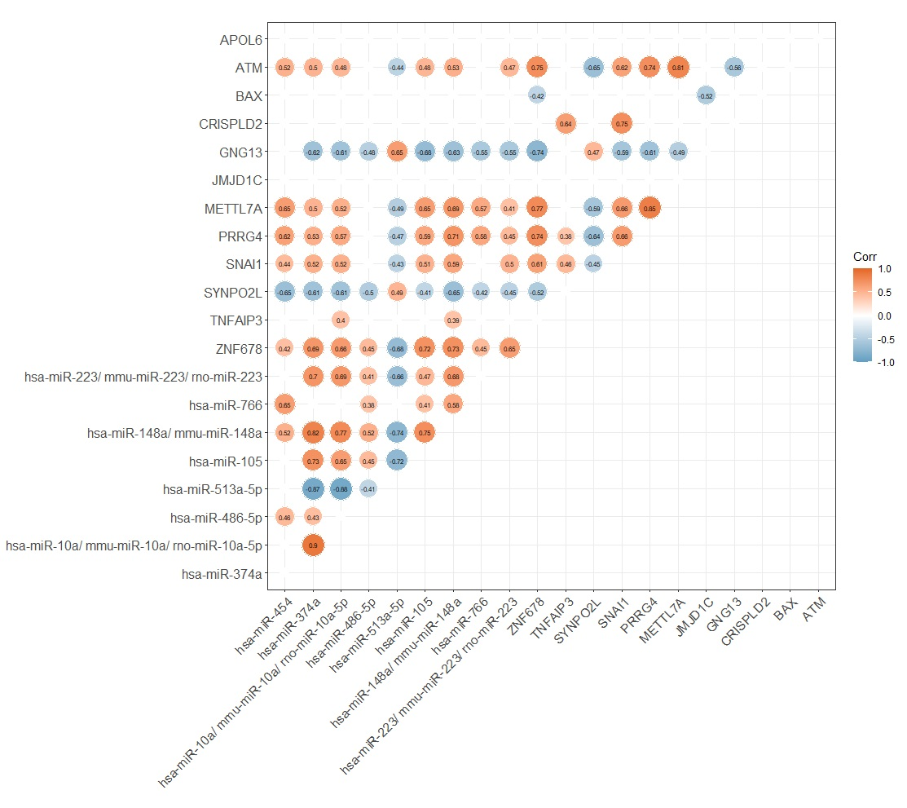
Figure S8: The correlation between miRNA and mRNA.

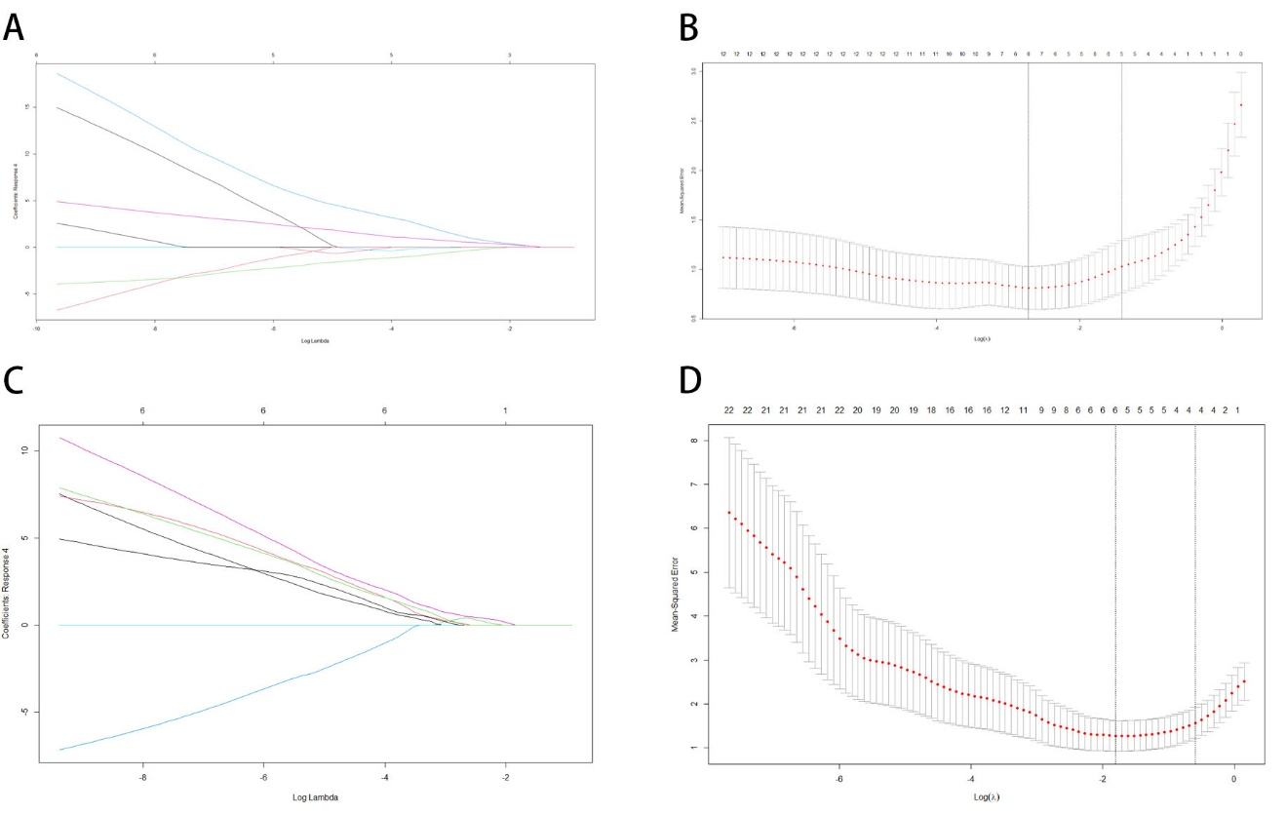
Figure S9: The construction of the risk model and identification of disease-related by Least absolute shrinkage and selection operator (LASSO) regression in mRNAs and miRNAs. (A, B) The trajectory graph of each variable in mRNAs. Calculation of tuning parameters based on partial likelihood deviation of ten-fold cross-validation. The vertical dashed line is drawn at the optimal value by the minimum standard and the 1-se standard. (C, D) The trajectory graph of each variable in miRNAs. Calculation of tuning parameters based on partial likelihood deviation of ten-fold cross-validation. The vertical dashed line is drawn at the optimal value by the minimum standard and the 1-se standard.
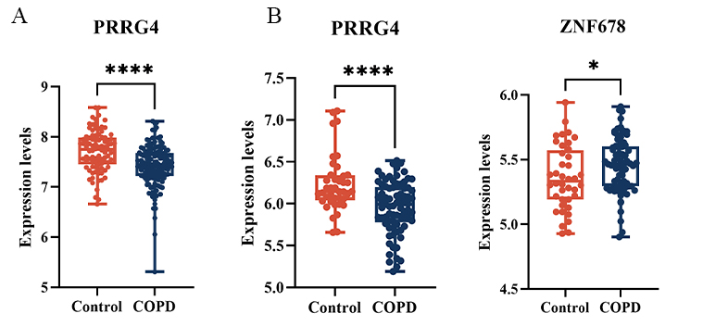
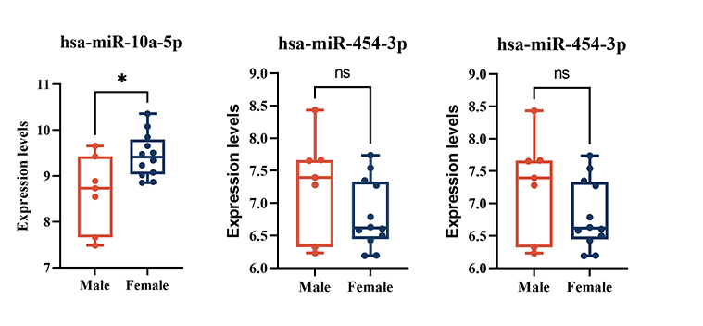
Figure S10: Validation of hub genes in another two GSE datasets. (A) Differential expression of PRRG4 in the GSE47460 dataset. (B) Differential expression of PRRG4 and ZNF678 between the COPD samples and healthy control samples in the GSE151052 dataset. *p<0.050,****p<0.0001.

Figure S11: The expression level of hub miRNAs in male and female COPD patients in the GSE38974 dataset. *p<0.050, ns: no significant difference.

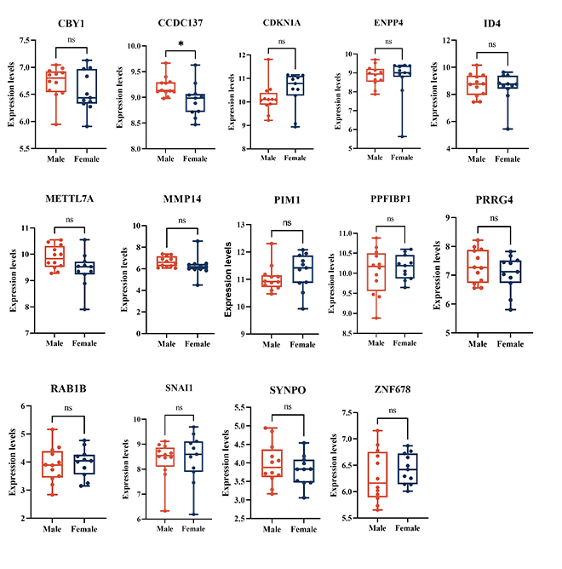
Figure S12: The expression level of hub mRNAs in male and female COPD patients in the GSE38974 dataset. *p<0.050, ns: no significant difference.

Table S1 KEGG pathway enrichment analysis by GSEA.
KEGG pathway names | NES | NOM p-val | FDR
CYTOKINE_CYTOKINE_RECEPTOR_INTERACTION | 2.114 | <0.001 | 0.002
OLFACTORY_TRANSDUCTION | 2.004 | <0.001 | 0.006
NOD_LIKE_RECEPTOR_SIGNALING_PATHWAY | 1.912 | <0.001 | 0.016
HEMATOPOIETIC_CELL_LINEAGE | 1.749 | 0.002 | 0.060
JAK_STAT_SIGNALING_PATHWAY | 1.689 | <0.001 | 0.084
P53_SIGNALING_PATHWAY | 1.687 | <0.001 | 0.070
TOLL_LIKE_RECEPTOR_SIGNALING_PATHWAY | 1.658 | <0.001 | 0.077
CYTOSOLIC_DNA_SENSING_PATHWAY | 1.508 | 0.023 | 0.218
CITRATE_CYCLE_TCA_CYCLE | 1.504 | 0.027 | 0.199
CHEMOKINE_SIGNALING_PATHWAY | 1.497 | <0.001 | 0.187
APOPTOSIS | 1.496 | 0.026 | 0.171
GLYCEROLIPID_METABOLISM | 1.461 | 0.034 | 0.204
COMPLEMENT_AND_COAGULATION_CASCADES | 1.381 | 0.042 | 0.322
PANTOTHENATE_AND_COA_BIOSYNTHESIS | 1.370 | 0.108 | 0.320
FATTY_ACID_METABOLISM | 1.349 | 0.077 | 0.343
RIG_I_LIKE_RECEPTOR_SIGNALING_PATHWAY | 1.334 | 0.072 | 0.352
PPAR_SIGNALING_PATHWAY | 1.309 | 0.076 | 0.389
PATHOGENIC_ESCHERICHIA_COLI_INFECTION | 1.302 | 0.092 | 0.383
PRIMARY_BILE_ACID_BIOSYNTHESIS | 1.283 | 0.162 | 0.408
NEUROACTIVE_LIGAND_RECEPTOR_INTERACTION | 1.281 | 0.022 | 0.393
NES: normalized enrichment score; NOM p-val: Nominal P Value; FDR: The false discovery rate.

Table S2 Identification of hub genes by cytoHubba.
Gene names | MCC | DMNC | MNC | Degree | EPC | Ec Centrivity | Bottle Neck | Closeness | Radiality | Betweenness | Stress | Clustering Coefficient
IL3 | 362880.0 | 0.85919 | 9.0 | 9.0 | 4.974 | 1.0 | 1.0 | 9.0 | 1.22222 | 0.0 | 0.0 | 1.0
IL5 | 362880.0 | 0.85919 | 9.0 | 9.0 | 4.914 | 1.0 | 1.0 | 9.0 | 1.22222 | 0.0 | 0.0 | 1.0
IL4R | 362880.0 | 0.85919 | 9.0 | 9.0 | 4.903 | 1.0 | 1.0 | 9.0 | 1.22222 | 0.0 | 0.0 | 1.0
IL10 | 362880.0 | 0.85919 | 9.0 | 9.0 | 4.908 | 1.0 | 1.0 | 9.0 | 1.22222 | 0.0 | 0.0 | 1.0
CSF3 | 362880.0 | 0.85919 | 9.0 | 9.0 | 4.883 | 1.0 | 1.0 | 9.0 | 1.22222 | 0.0 | 0.0 | 1.0
IL9 | 362880.0 | 0.85919 | 9.0 | 9.0 | 4.972 | 1.0 | 1.0 | 9.0 | 1.22222 | 0.0 | 0.0 | 1.0
IL13 | 362880.0 | 0.85919 | 9.0 | 9.0 | 4.835 | 1.0 | 1.0 | 9.0 | 1.22222 | 0.0 | 0.0 | 1.0
JAK2 | 362880.0 | 0.85919 | 9.0 | 9.0 | 4.925 | 1.0 | 1.0 | 9.0 | 1.22222 | 0.0 | 0.0 | 1.0
IL6 | 362880.0 | 0.85919 | 9.0 | 9.0 | 4.866 | 1.0 | 1.0 | 9.0 | 1.22222 | 0.0 | 0.0 | 1.0
CSF2 | 362880.0 | 0.85919 | 9.0 | 9.0 | 4.838 | 1.0 | 1.0 | 9.0 | 1.22222 | 0.0 | 0.0 | 1.0

