Supplementary data

ORIGINAL RESEARCH
Shi et al

Single-cell profiling of tumor-associated neutrophils in advanced non-small cell lung cancer

Jinpeng Shi¹*, Jiayu Li¹*, Haowei Wang¹*, Xuefei Li², Qi Wang¹, Chao Zhao², Lei Cheng², Ruoshuang Han¹, Peixin Chen¹, Haoyue Guo¹, Zhuoran Tang¹, Caicun Zhou¹, Zhemin Zhang¹, Fengying Wu¹

¹Department of Medical Oncology, Shanghai Pulmonary Hospital & Thoracic Cancer Institute, School of Medicine, Tongji University, Shanghai, China; ²Department of Lung Cancer and Immunology, Shanghai Pulmonary Hospital, School of Medicine, Tongji University, Shanghai, China

*These authors contributed equally to this work

Supplementary Table 1 Details of the clinicopathological characteristics of enrolled patients (n = 9)
Case | Sex | Age | Smoking history | ECOG PS | Histology | Stage | Gene alteration | Previous treatment#
P1 | Male | 55 | Smoker | 1 | LUSC | recurrent | WT | 0
P2 | Male | 67 | Non-smoker | 1 | LUSC | IIIB | WT | 0
P3 | Female | 52 | Non-smoker | 1 | LUSC | IVB | WT | 0
P4 | Male | 68 | Smoker | 1 | LUSC | IVA | WT | 2
P5 | Male | 70 | Smoker | 2 | LUAD | IIIC | 19del | 0
P6 | Male | 40 | Smoker | 1 | LUSC | IVA | NA | 0
P7 | Female | 71 | Non-smoker | 1 | LUSC | IVA | L585R | 0
P8 | Male | 62 | Smoker | 1 | LUSC | IIIB | NA | 0
P9 | Male | 64 | Non-smoker | 1 | LUAD | IVB | WT | 0
ECOG PS, Eastern Cooperative Oncology Group performance status; LUSC, lung squamous cell carcinoma; LUAD, lung adenocarcinoma; WT, wild type; NA, not assessed.

Supplementary Table 2 Cell numbers of each patient for neutrophil subtypes in Figures 2B–C
Category | P1 | P2 | P3 | P4 | P5 | P6 | P7 | P8 | P9
N1 | 47 | 10 | 150 | 87 | 16 | 15 | 103 | 61 | 16
N2 | 7 | 8 | 0 | 77 | 2 | 60 | 222 | 8 | 5
N3 | 17 | 8 | 19 | 96 | 0 | 45 | 117 | 11 | 2
N4 | 10 | 8 | 13 | 28 | 6 | 44 | 125 | 13 | 3
N5 | 5 | 16 | 83 | 59 | 10 | 3 | 39 | 20 | 15
N6 | 3 | 2 | 6 | 10 | 0 | 9 | 34 | 16 | 1
N7 | 0 | 0 | 0 | 3 | 0 | 1 | 26 | 0 | 0
Total | 89 | 52 | 271 | 360 | 34 | 177 | 666 | 129 | 42
Pts, patients; Subs, subtypes.

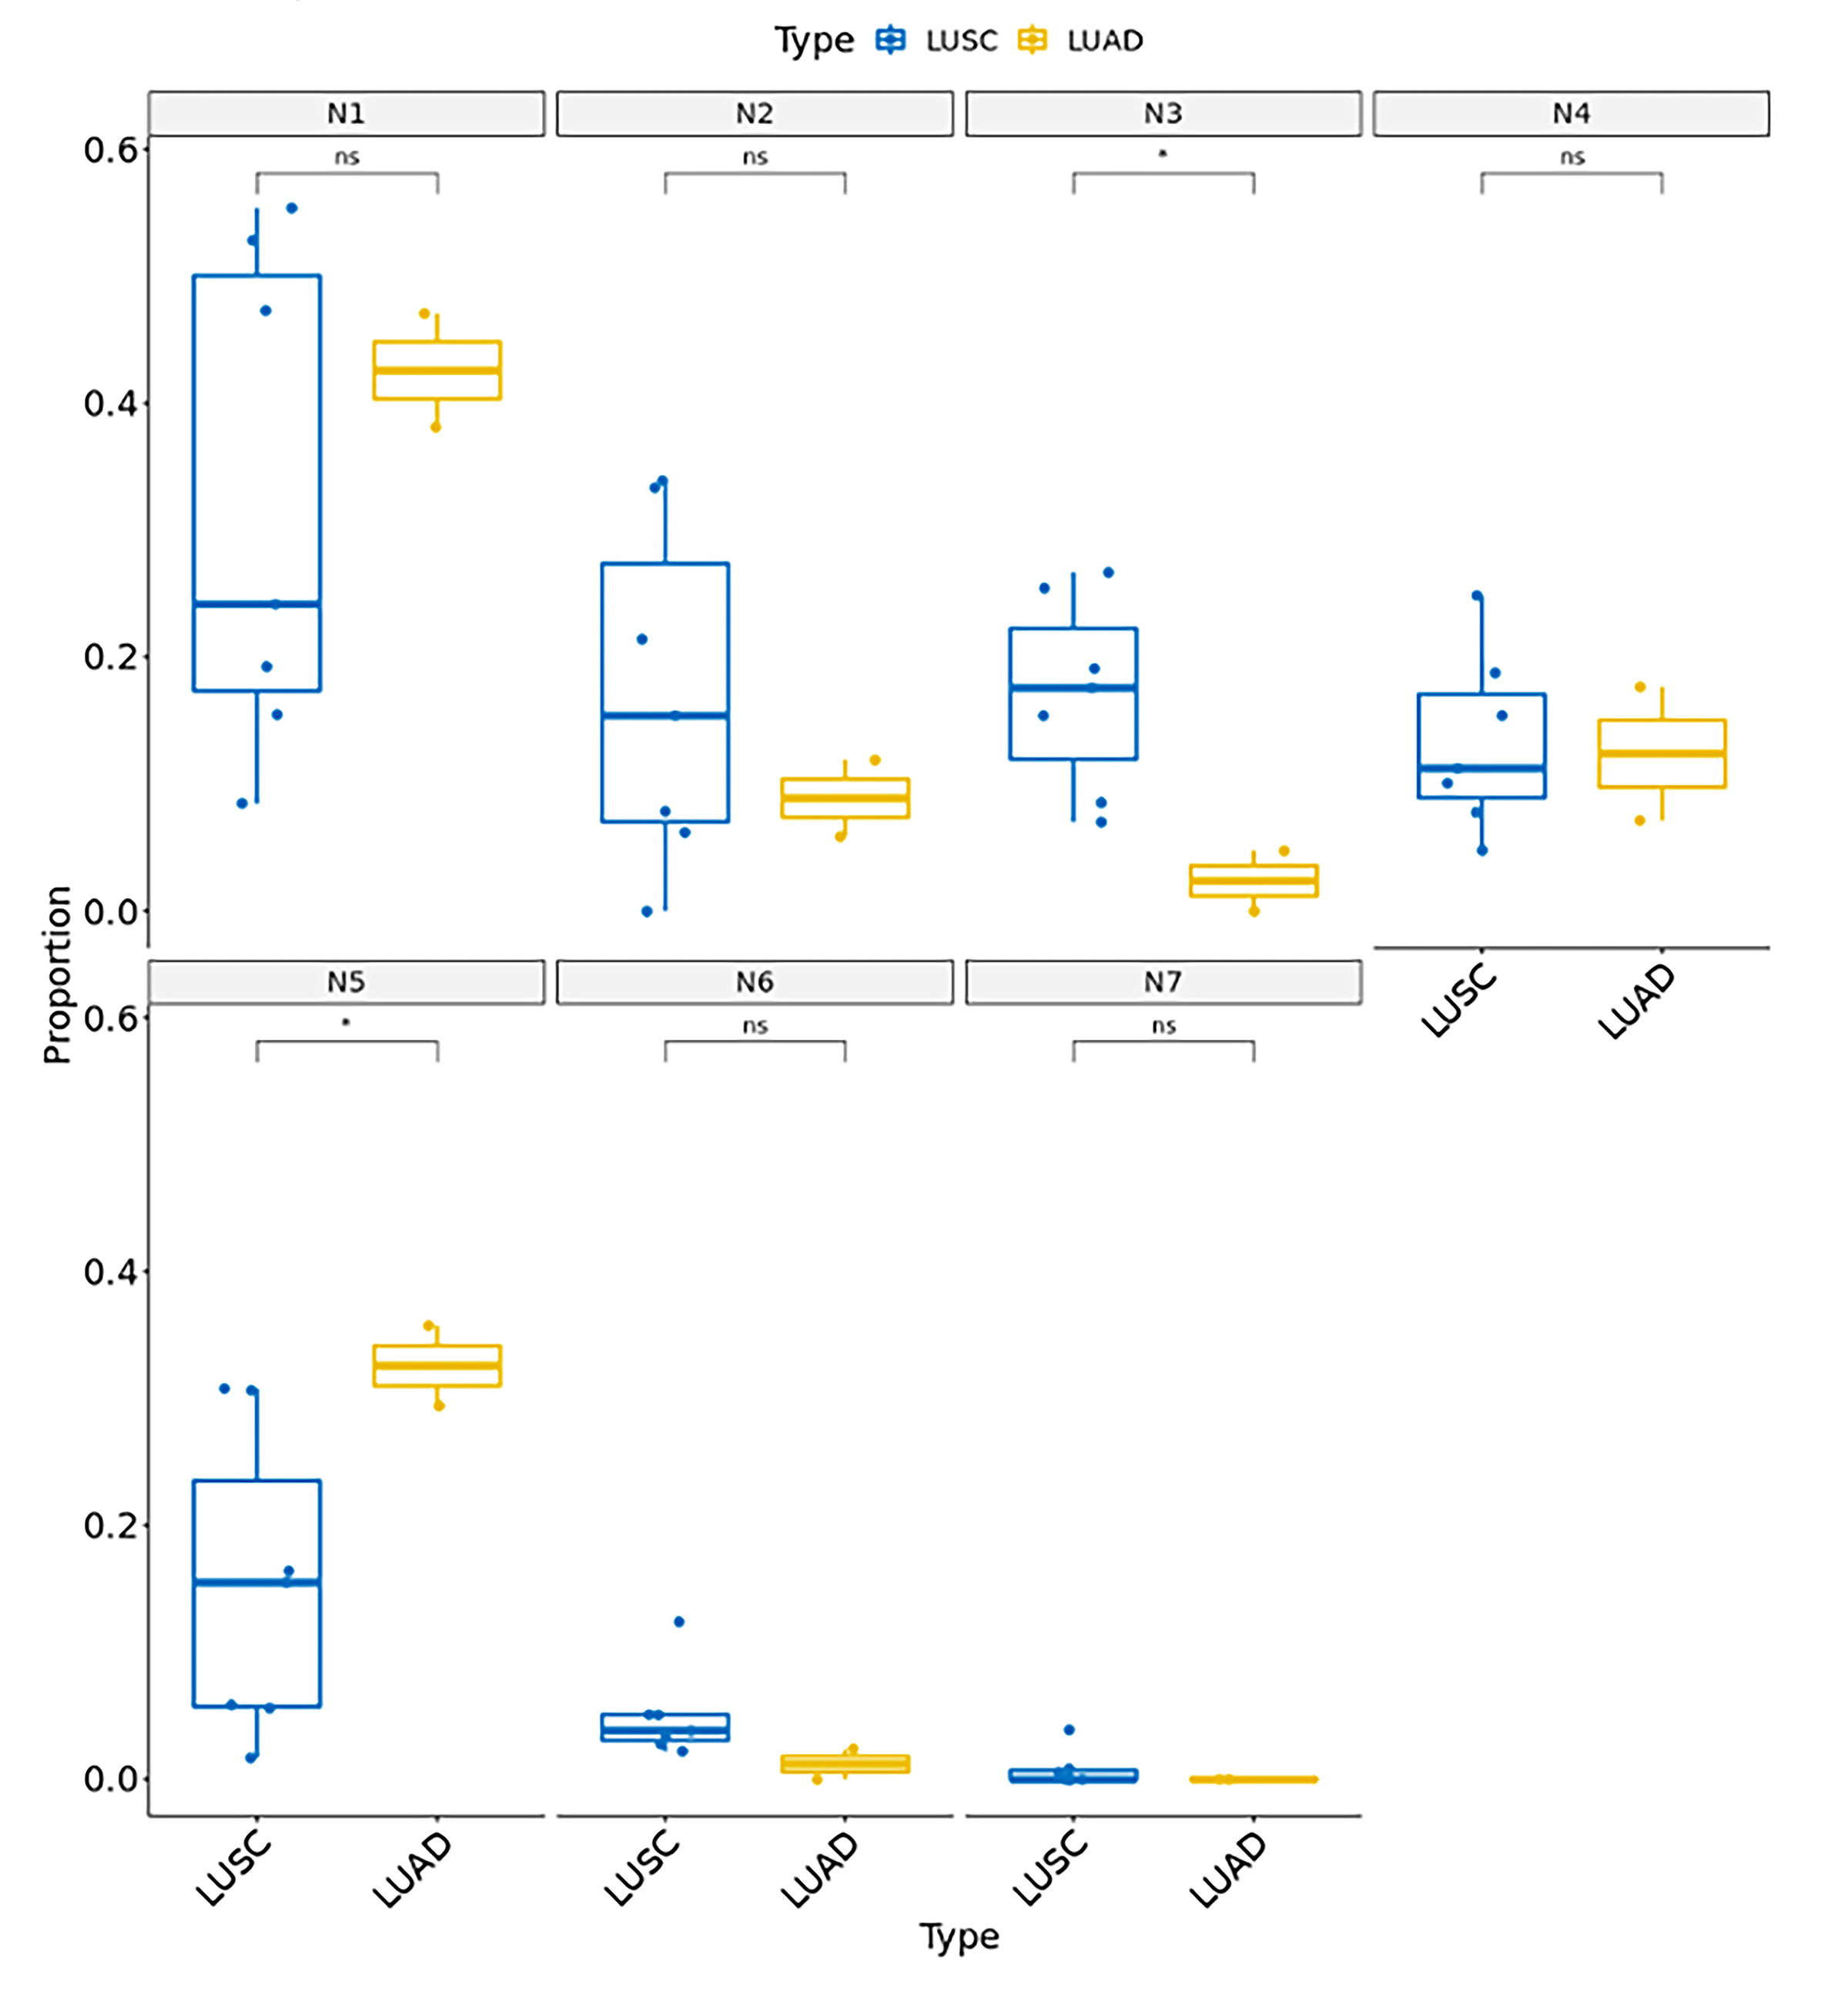
Supplementary Figure 1 Composition analysis of neutrophil subtypes in different patient groups divided by histology. LUSC, lung squamous cell carcinoma; LUAD, lung adenocarcinoma; ns, not significant; *, P < 0.05.
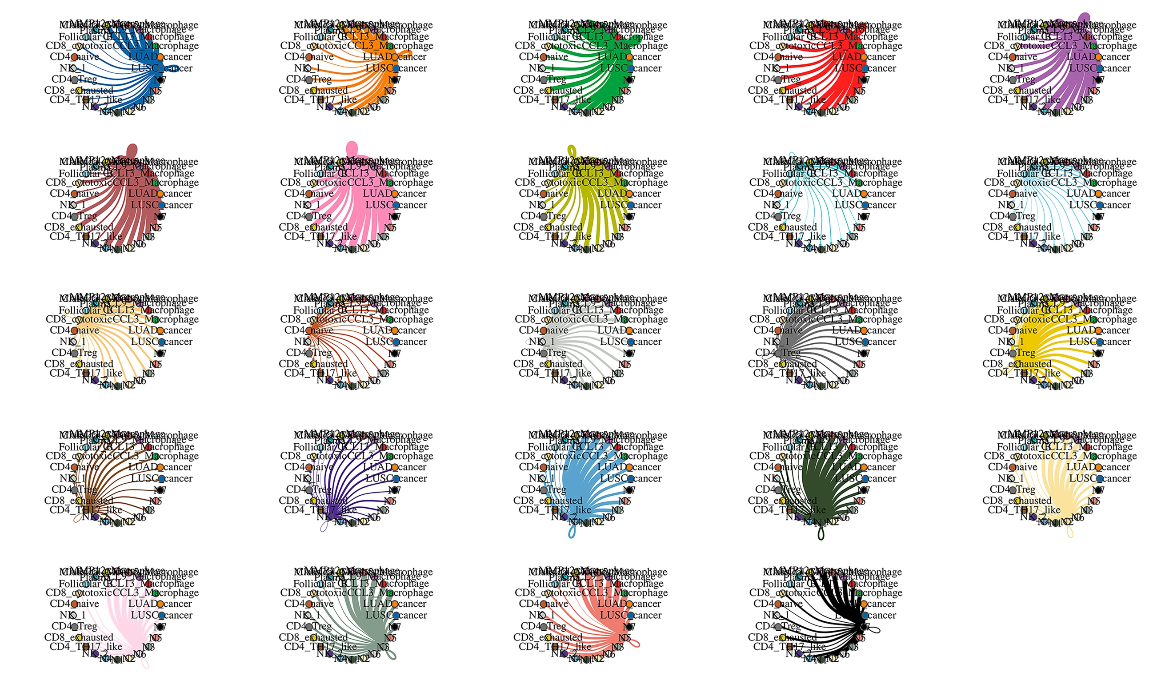
Supplementary Figure 2 Cell interaction networks between each ligand cell and other receptor cells. Nodes represent types of ligand cells, and edge weights were calculated based on the number of interactions between two cell types. The colors of edges correspond to ligand cells.

